WERURWE 2017
CNOSR : INTEKO RUSANGE IDASANZWE
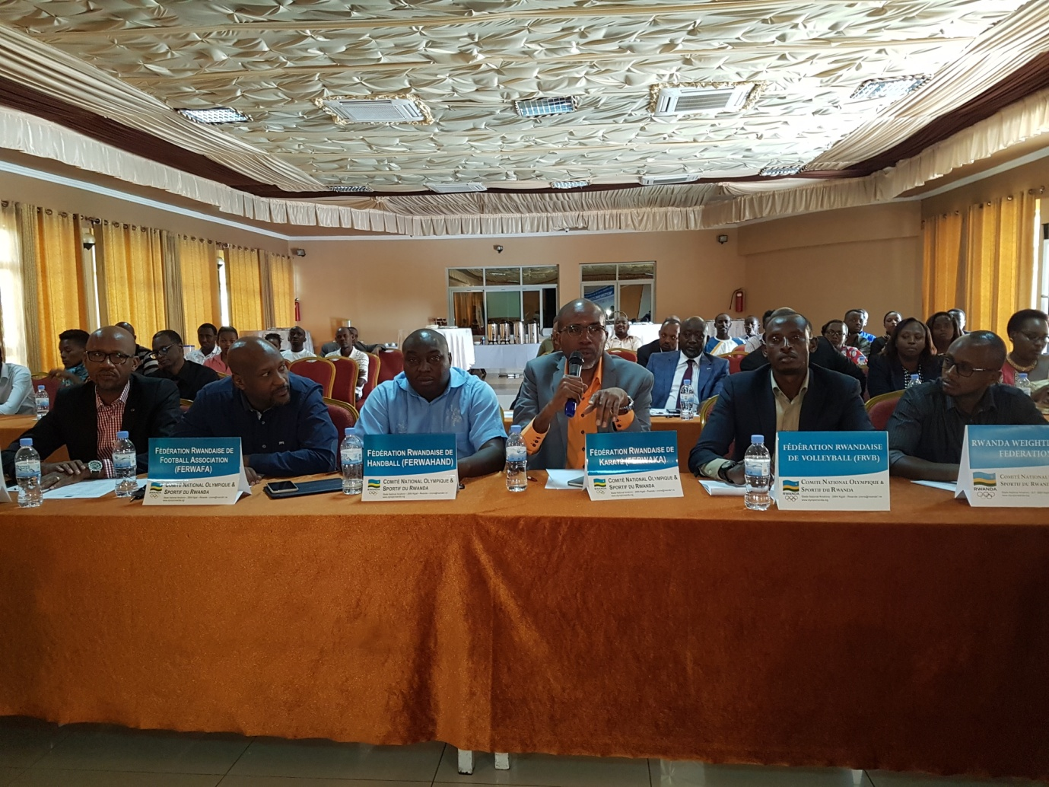

Inama idasanzwe y’inteko rusange ya Comité National Olympique et Sportif du Rwanda yateranye kuwa 11.03.2017 yabayemo amatora y’abayobozi bashya mu myanya ikurikira :
Perezida : Amb. MUNYABAGISHA VALENS
Visi Perezida wa mbere :RWEMALIKA FELICITE
Visi Perezida wa kabiri : BIZIMANA FESTUS
Umunyamabanga Mukuru : BIZIMANA DOMINIQUE
Umubitsi Mukuru : INGABIRE ALICE
Abajyanama : E’GAIRMA HERMINE na NZABANTERURA EUGENE
Umugenzuzi w’imari : UMWALI JOSETTE

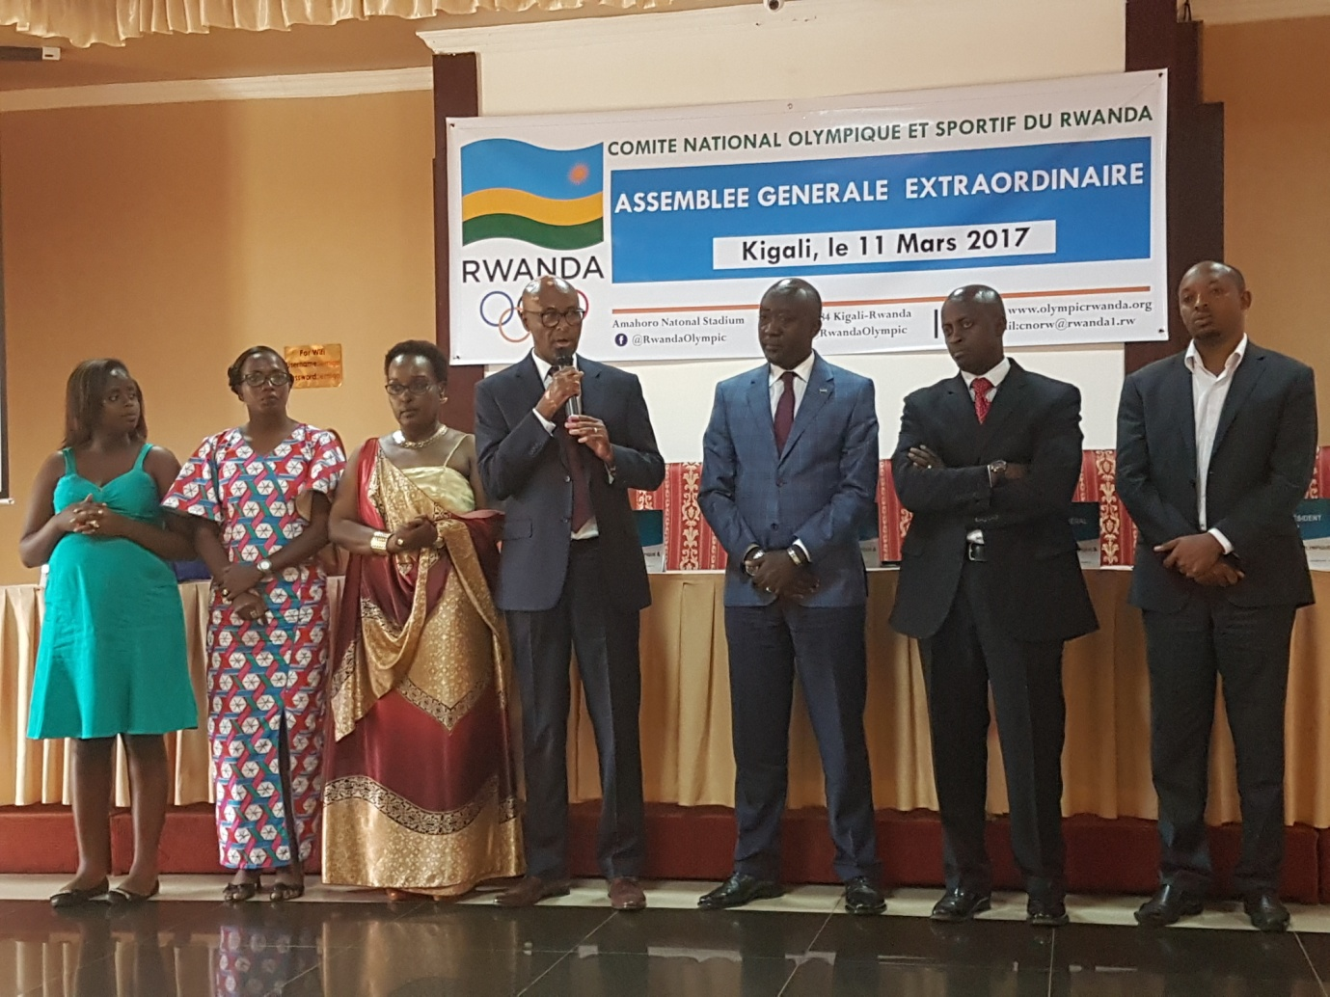

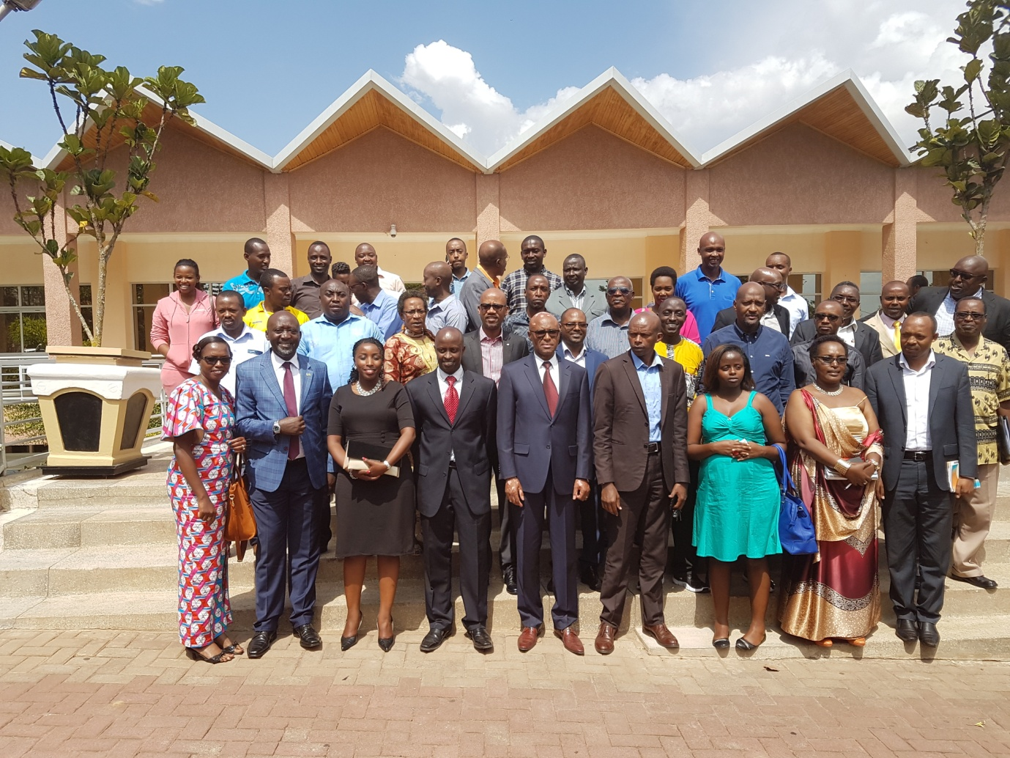

ACNOA : INTEKO RUSANGE ZONE V
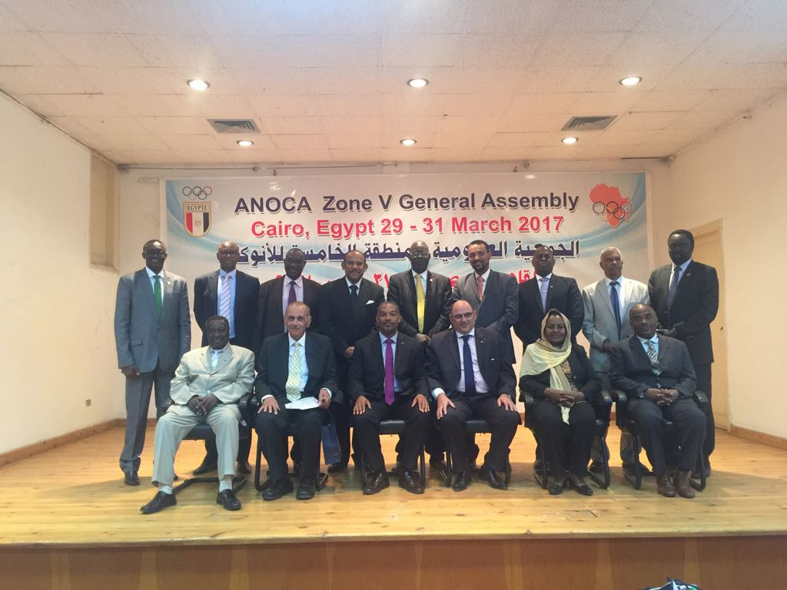
I Cairo muri Egypte kuva kuwa 29 kugeza kuwa 31.03.2017 hateraniye inama y’inteko rusange ya ANOCA / ACNOA ( Association of National Olympic Committees of Africa / Association des Comités Nationaux Olympiques d’Afrique) yahuje abayobozi ba CNO zo mu bihugu bigize zone V. U Rwanda rwahagarariwe na Perezida wa CNOSR, Amb. MUNYABAGISHA Valens.
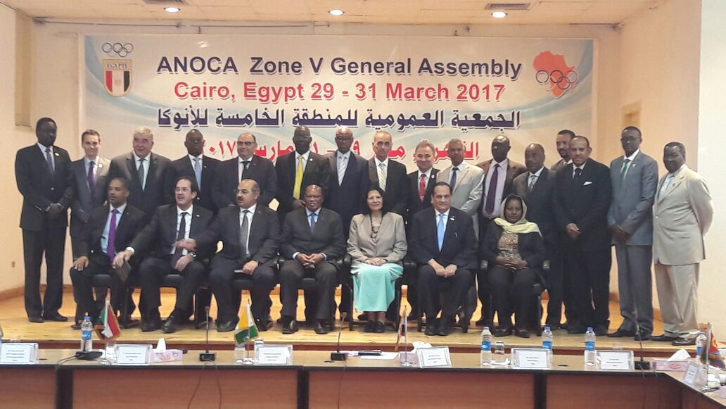

COMMONWEALTH GAMES FEDERATION AFRICA REGIONAL MEETING 2017
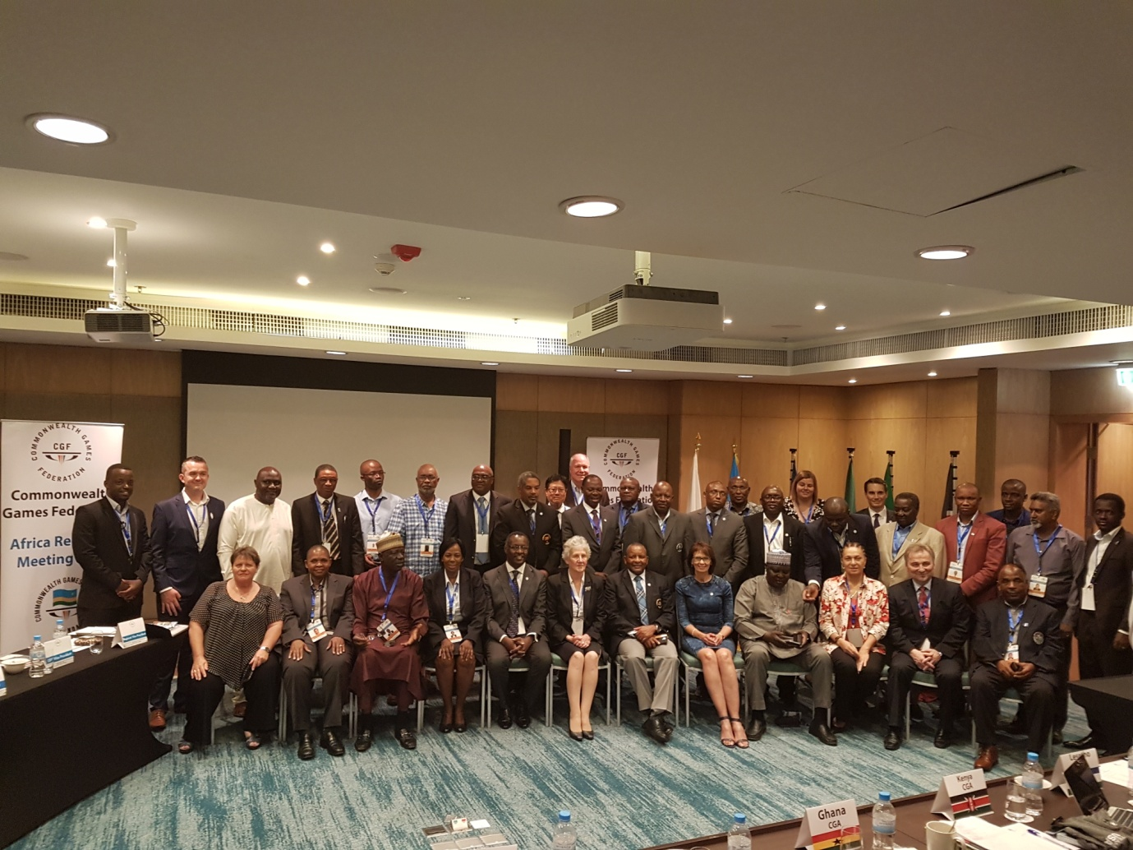
Intumwa z’ibihugu by’Afurika bigize Commonwealth Games Federation zahuriye mu nama yabereye i Kigali kuwa 02 no kuwa 03.2017 yarimo na Ms LOUISE MARTIN, umuyobozi mukuru wa CGF.
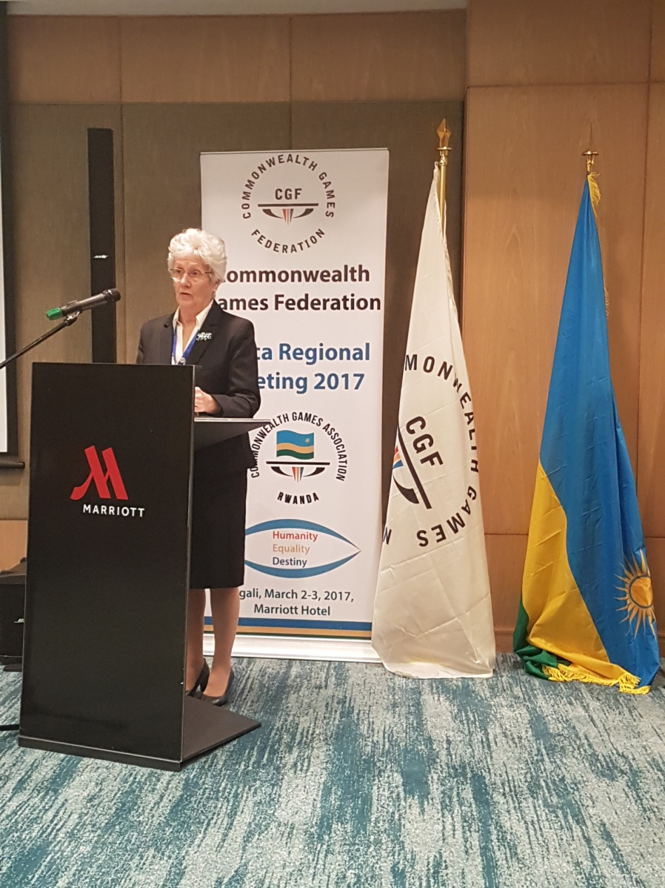

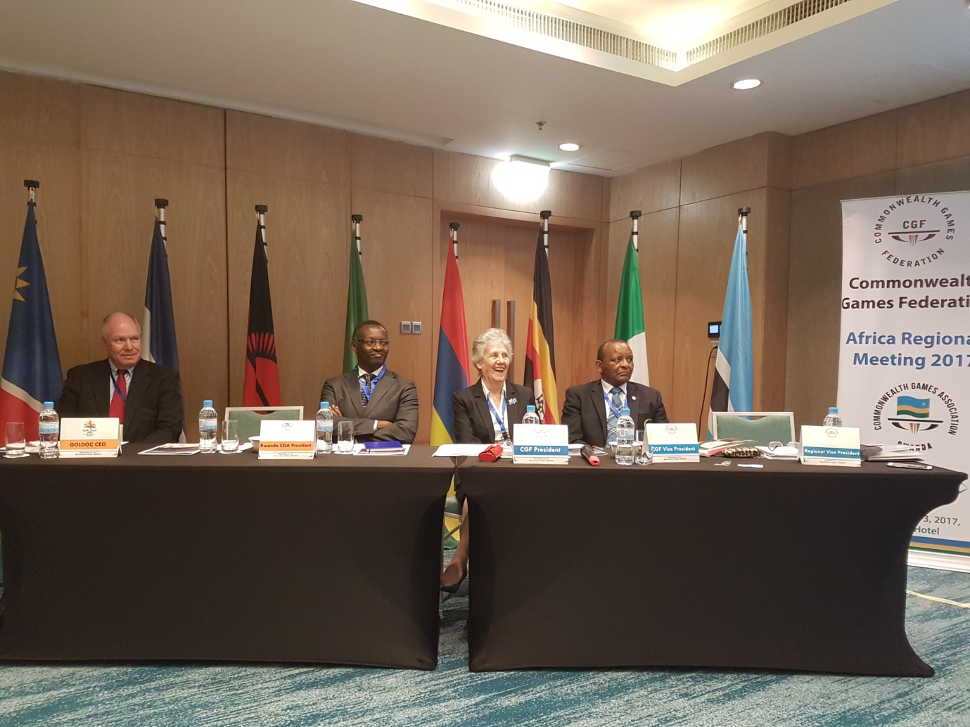
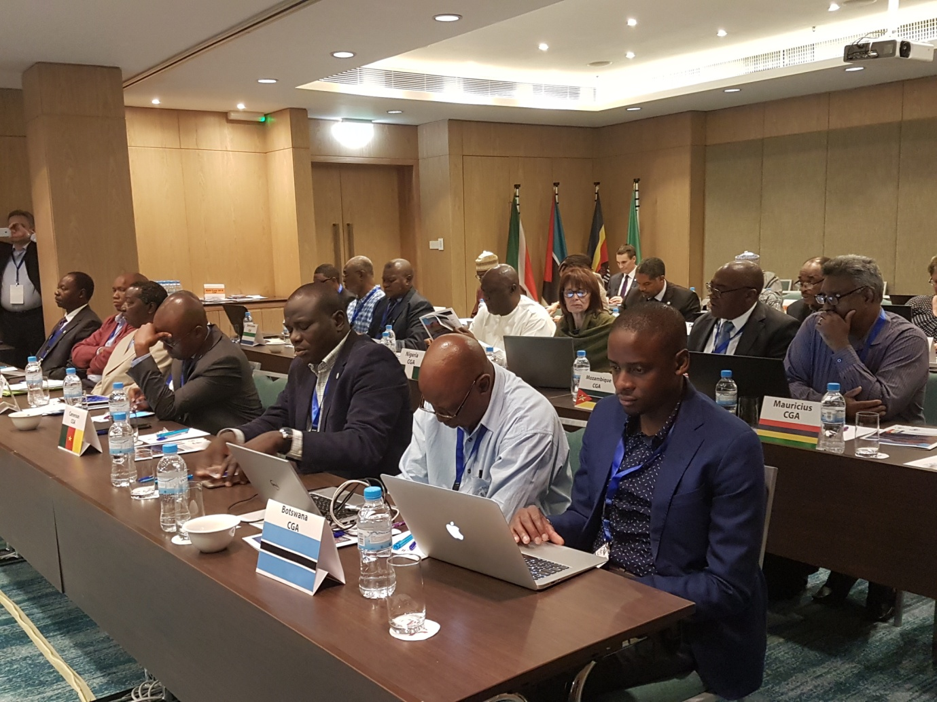
Abaje muri iyo nama baturutse mu bihugu by’Afurika 18 binyamuryango bya Commonwealth Games Federation, banasuye urwibutso rwa jenoside yakorewe abatutsi rw’i Kigali bunamira abahashyinguwe
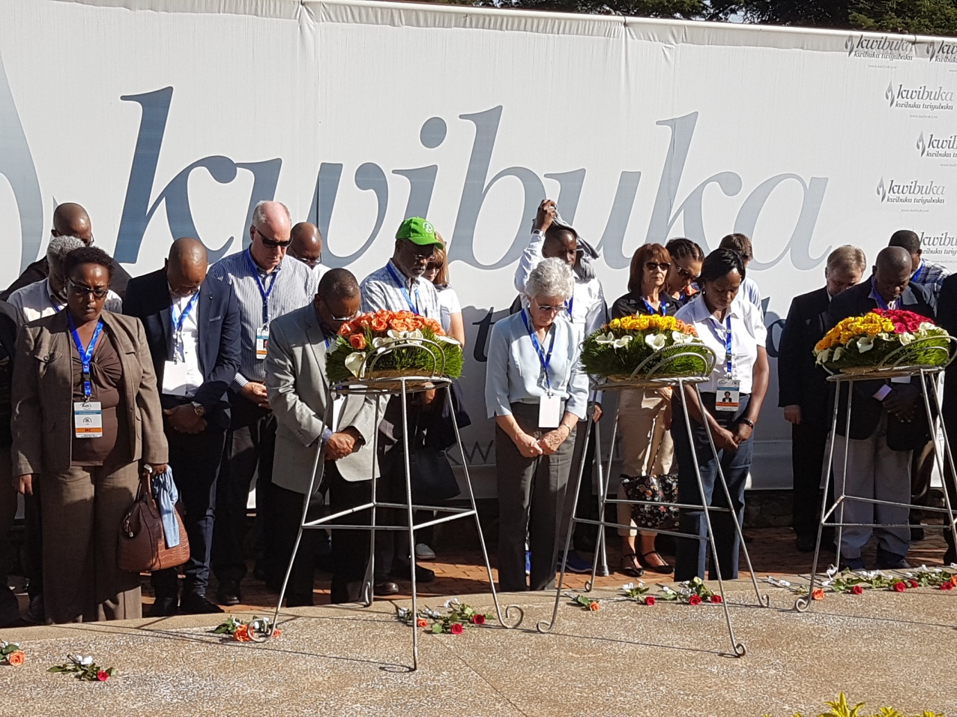
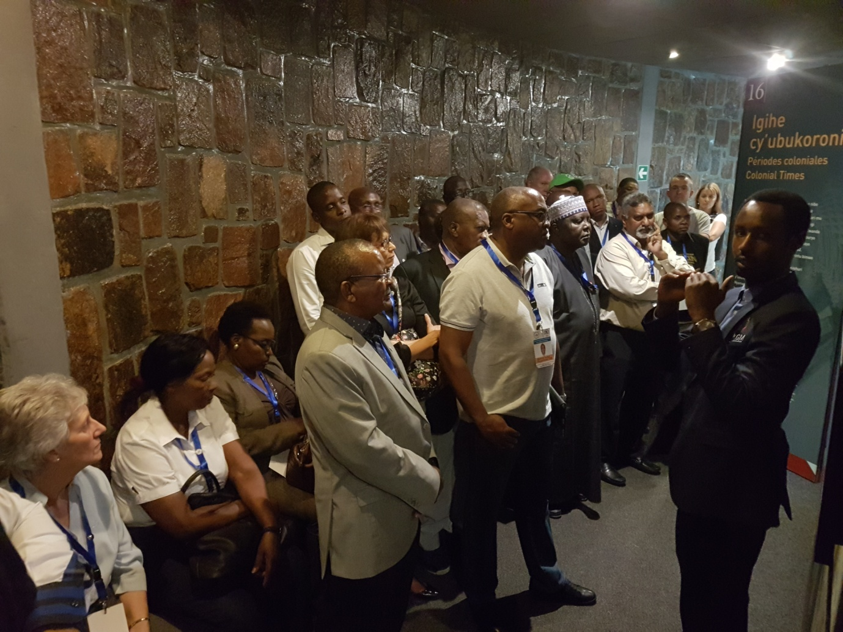
Ms LOUISE MARTIN ukuriye CGF yagiranye ibiganiro na Minisitiri wa siporo n’umuco Mme UWACU JULIENNE, anasura icyicaro cya Commonwealth Games Association - RWANDA kuri stade Amahoro i Remera
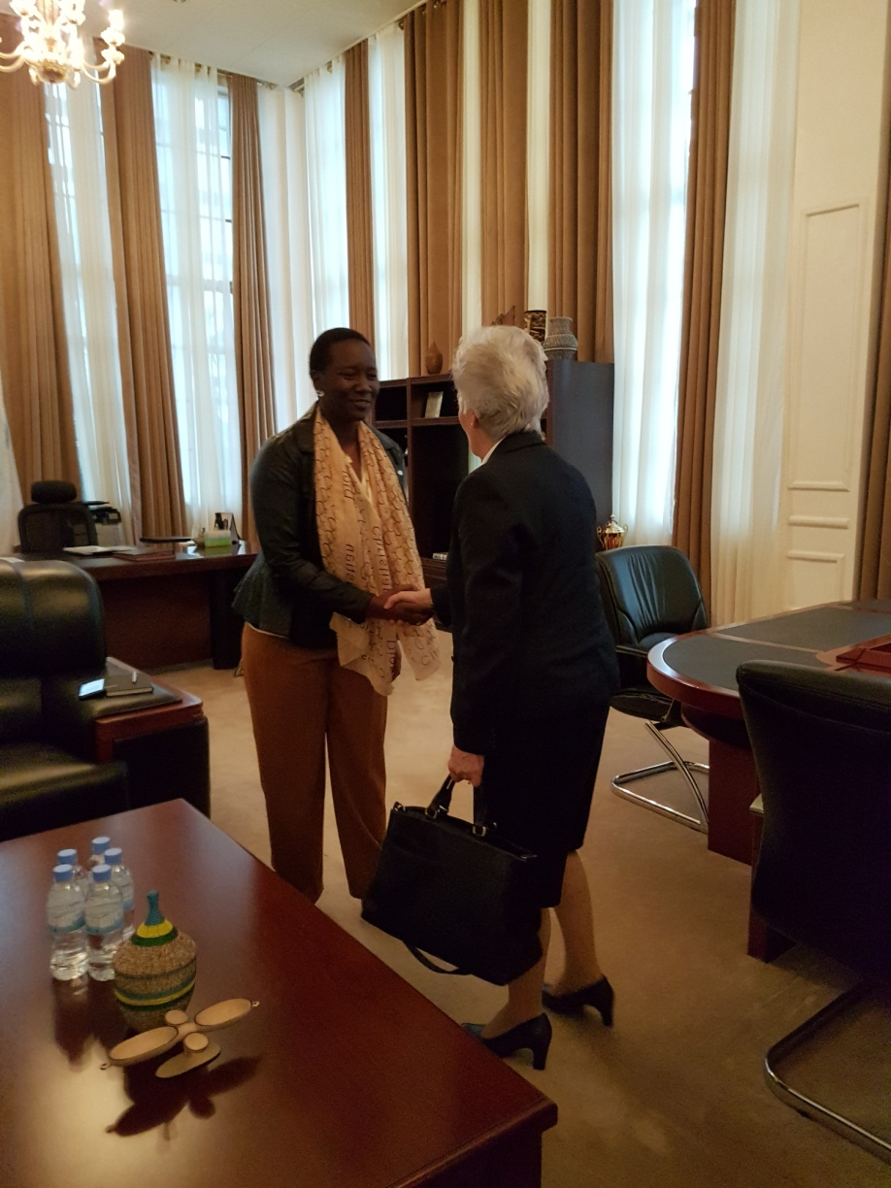

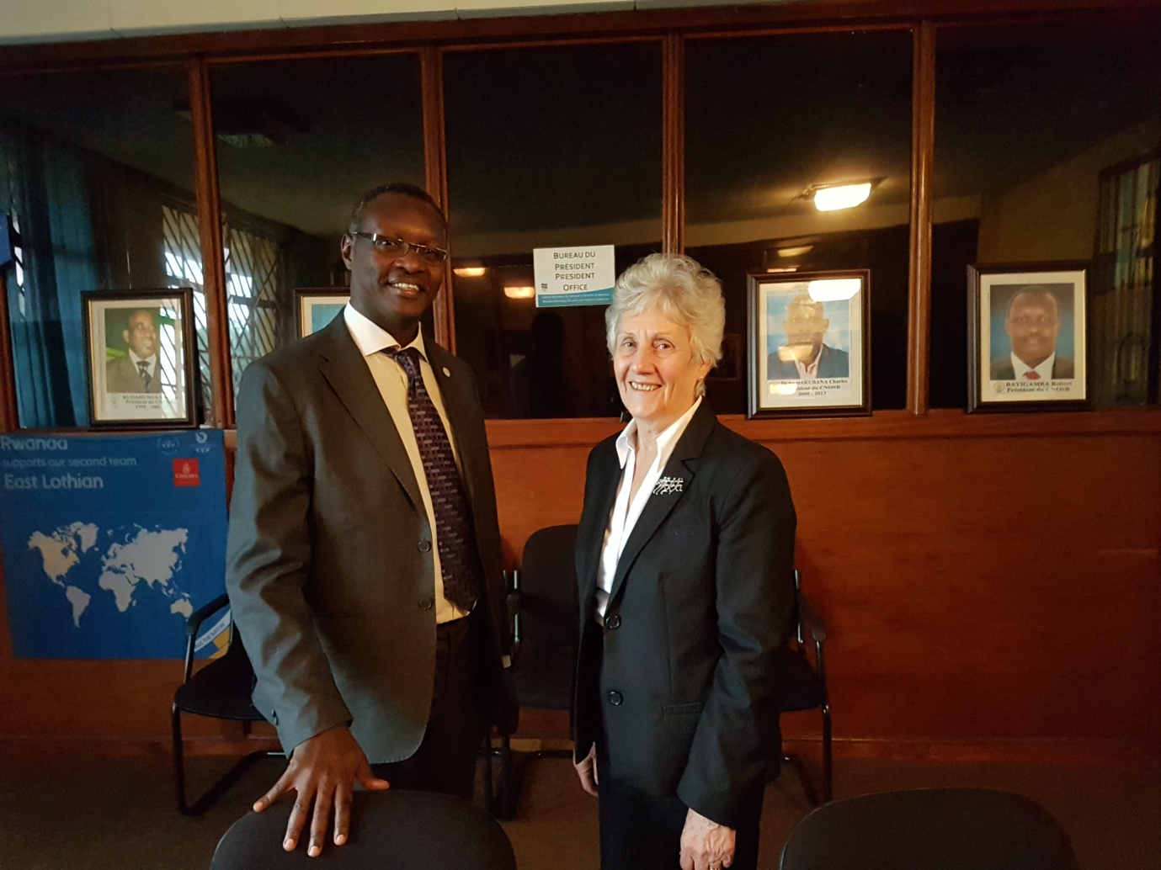

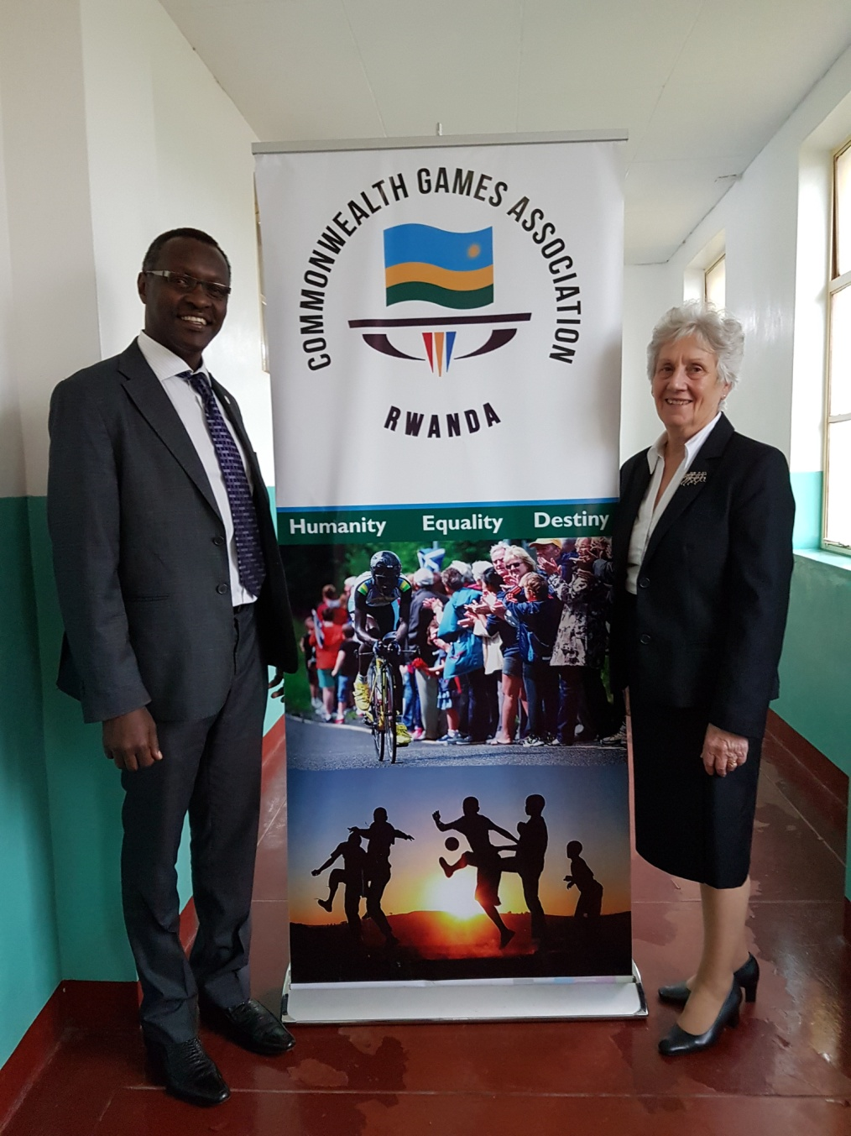

QUEEN’S BATON RELAY – RWANDA
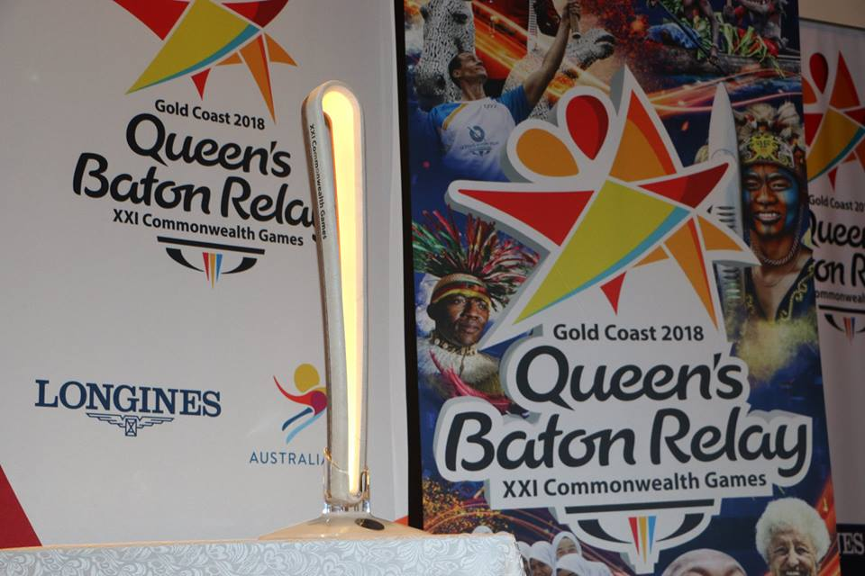
Muri gahunda yo kumenyekanisha imikino ya Commonwealth izabera Gold Coast muri Australia mu 2018, kuva kuwa 22 kugeza kuwa 25.03.2017 mu bice binyuranye by’u Rwanda hatambagijwe inkoni y’Umwamikazi (Queen’s baton relay).
Yaje iherekejwe na Ms Luise Martin, ukuriye Commonwealth Games Federation
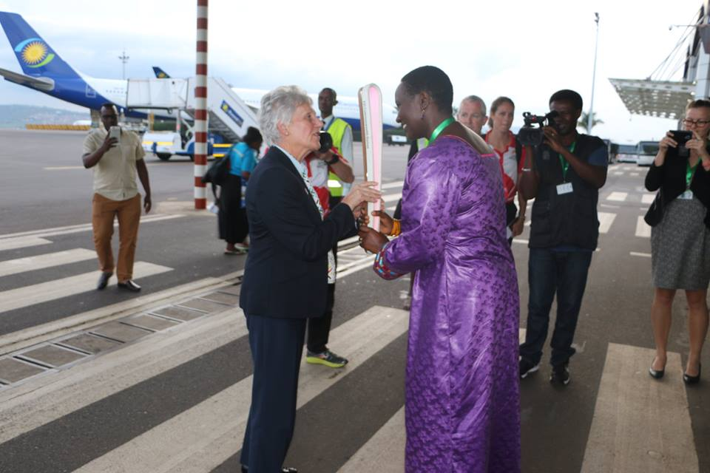
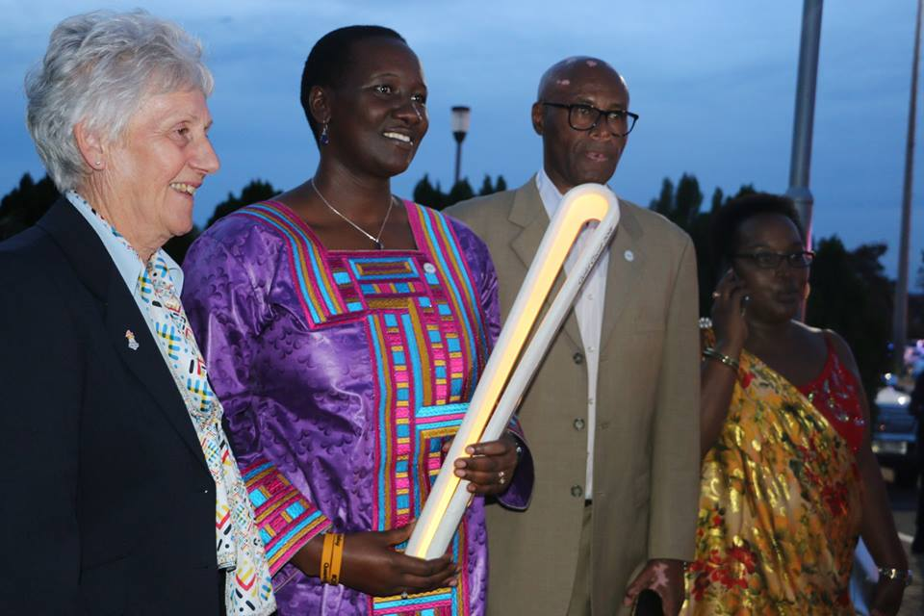

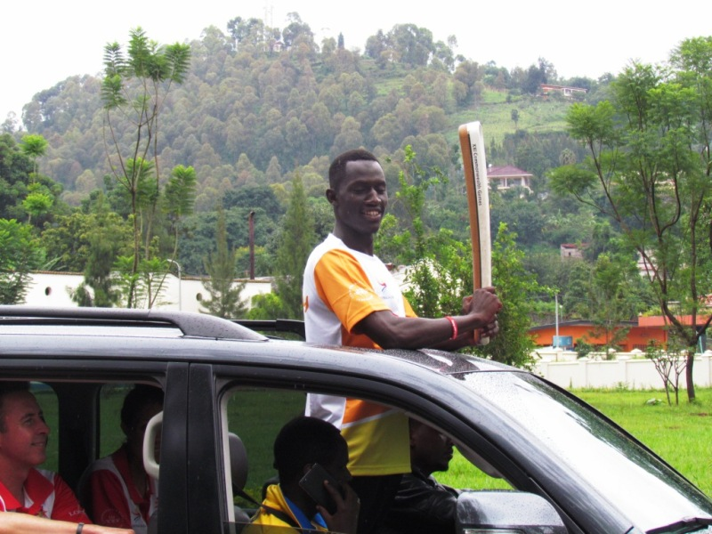
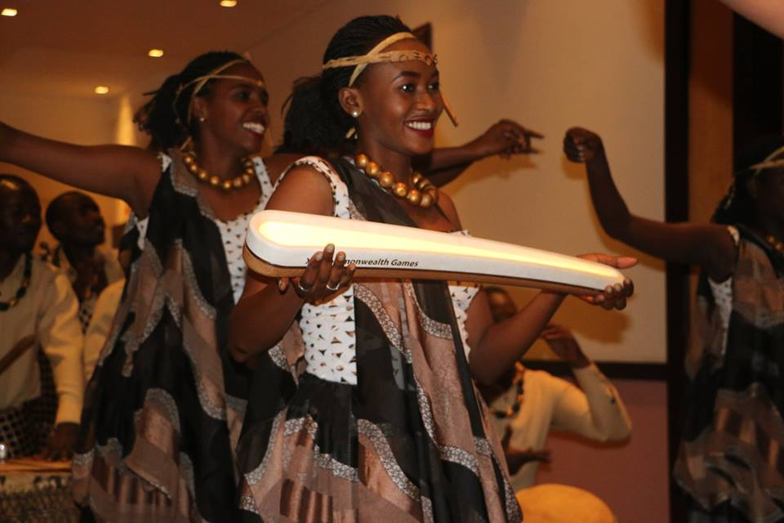
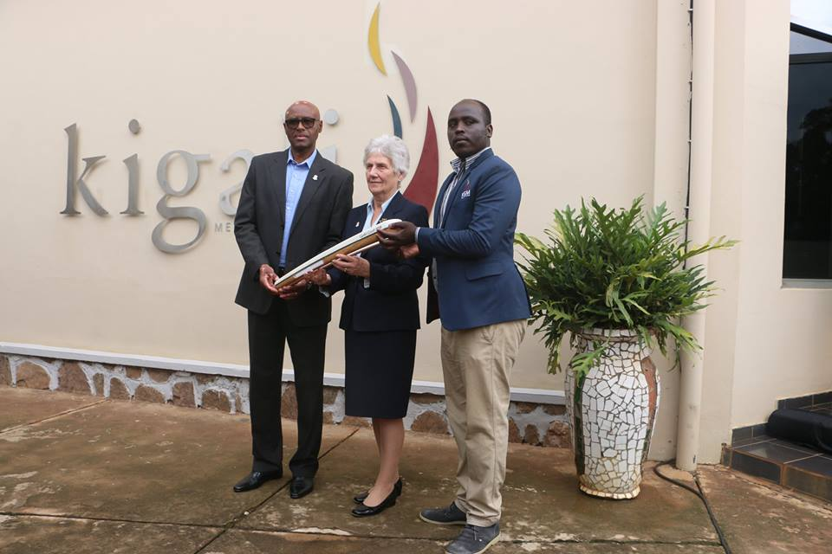
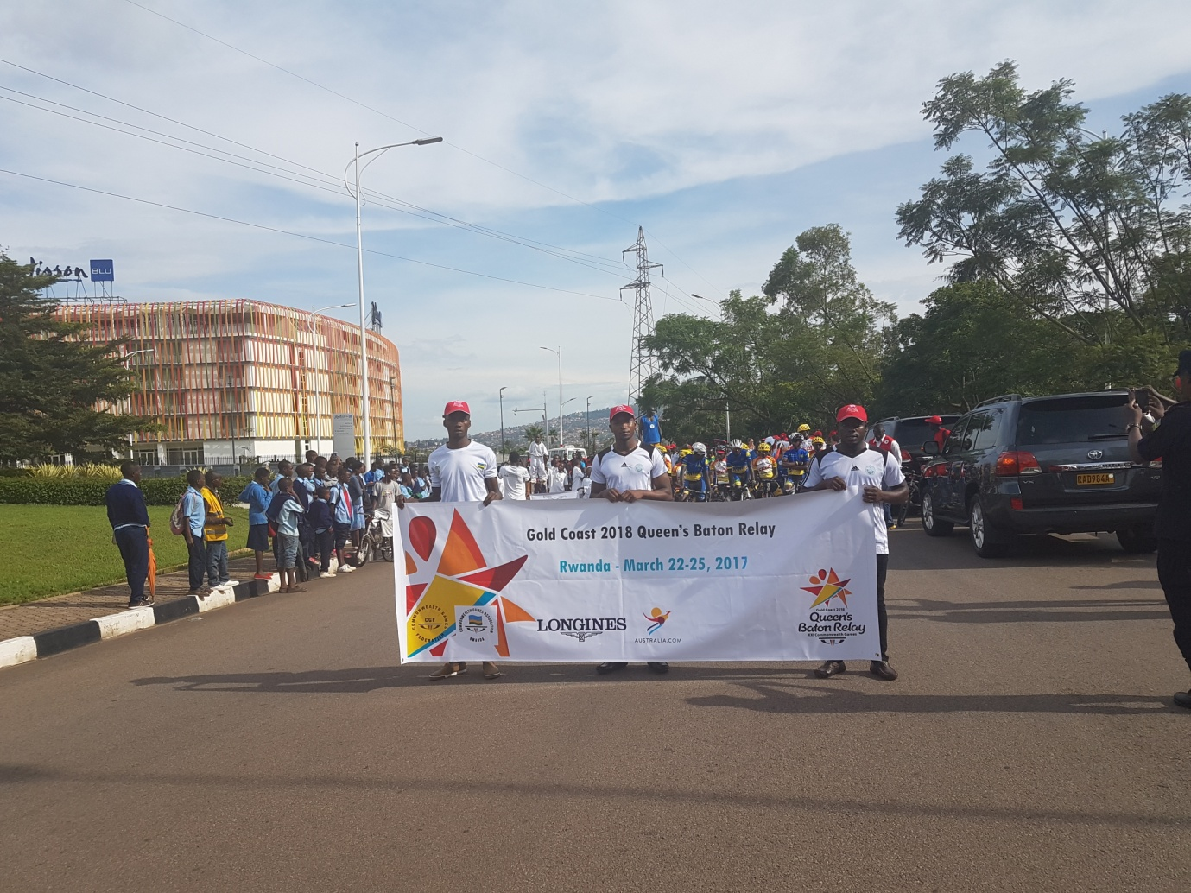
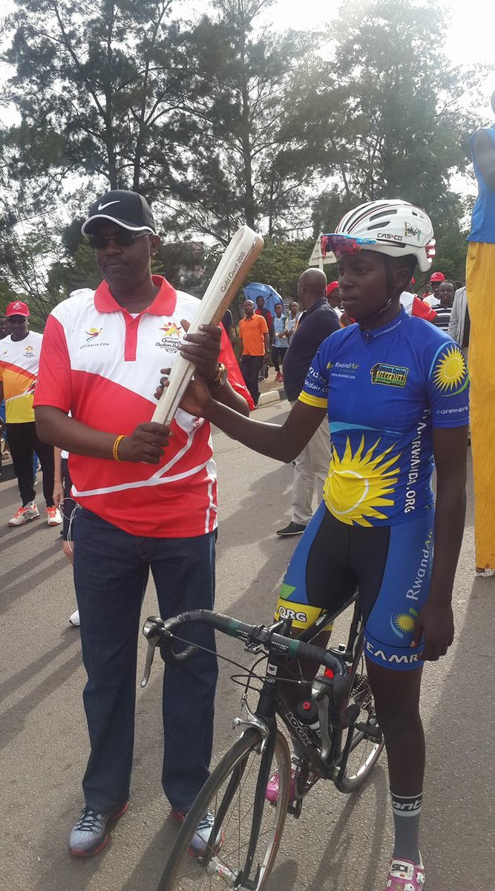

COMMONWEALTH DAY 2017
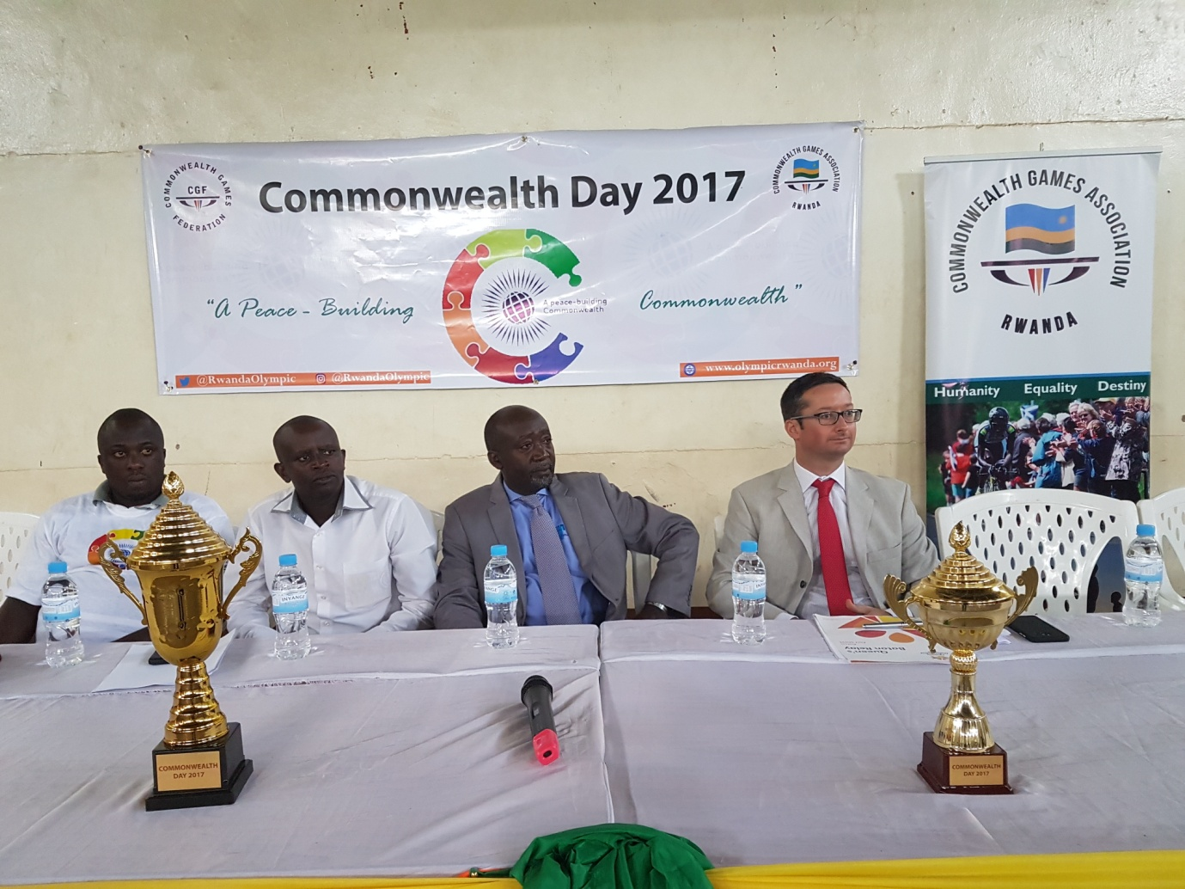
Mu ishuri rya Lycée de Kigali kuwa 27.03.2017 ku nshuro ya mbere mu Rwanda hizihijwe umunsi mpuzamahanga “Commonwealth Day” ahandi ku isi wizihijwe taliki 13.03.2017.

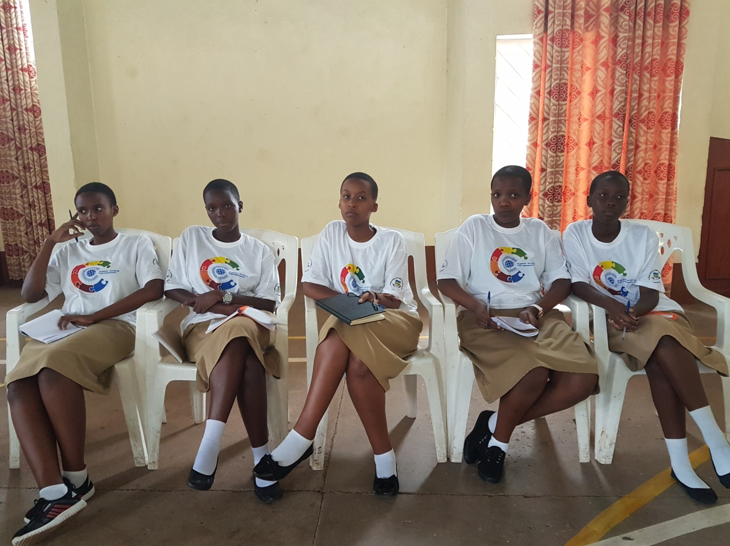
Ibikorwa by’uwo munsi byibanze ku biganiro-mpaka (debate) ku nsanganyamatsiko “ A peace - building Commonwealth”, umukino wo gusiganwa kwiruka na tag of war.
Byagizwemo uruhare n’abanyeshuri bibumbiye muri Commonwealth Club ebyiri zimaze gushingwa, iyo muri Lycée de Kigali n’iyo muri Lycée Notre Dame de Citeaux.

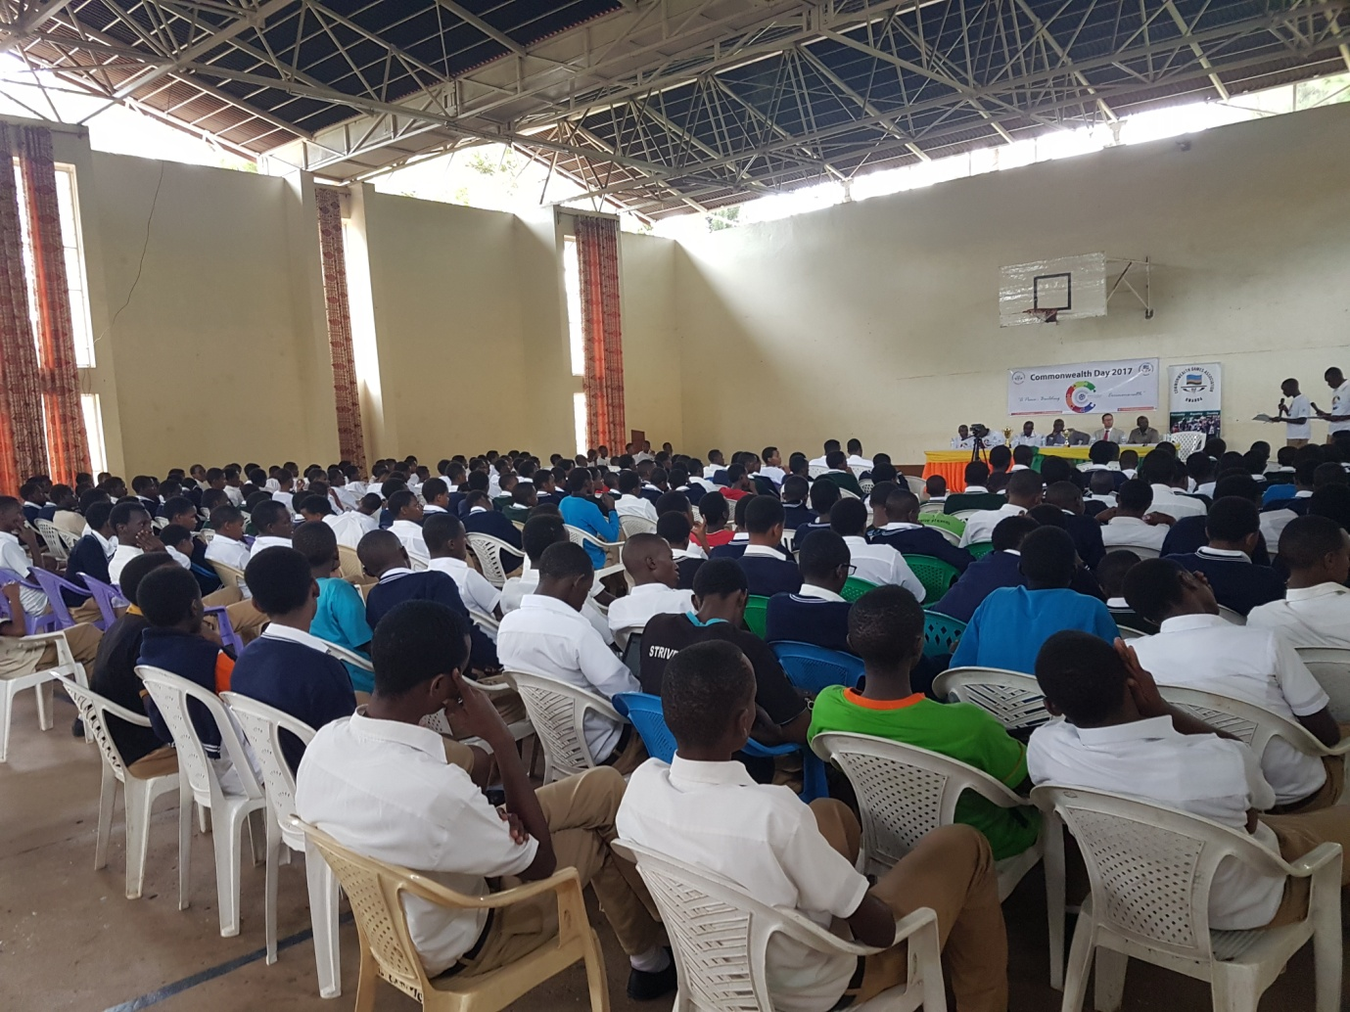
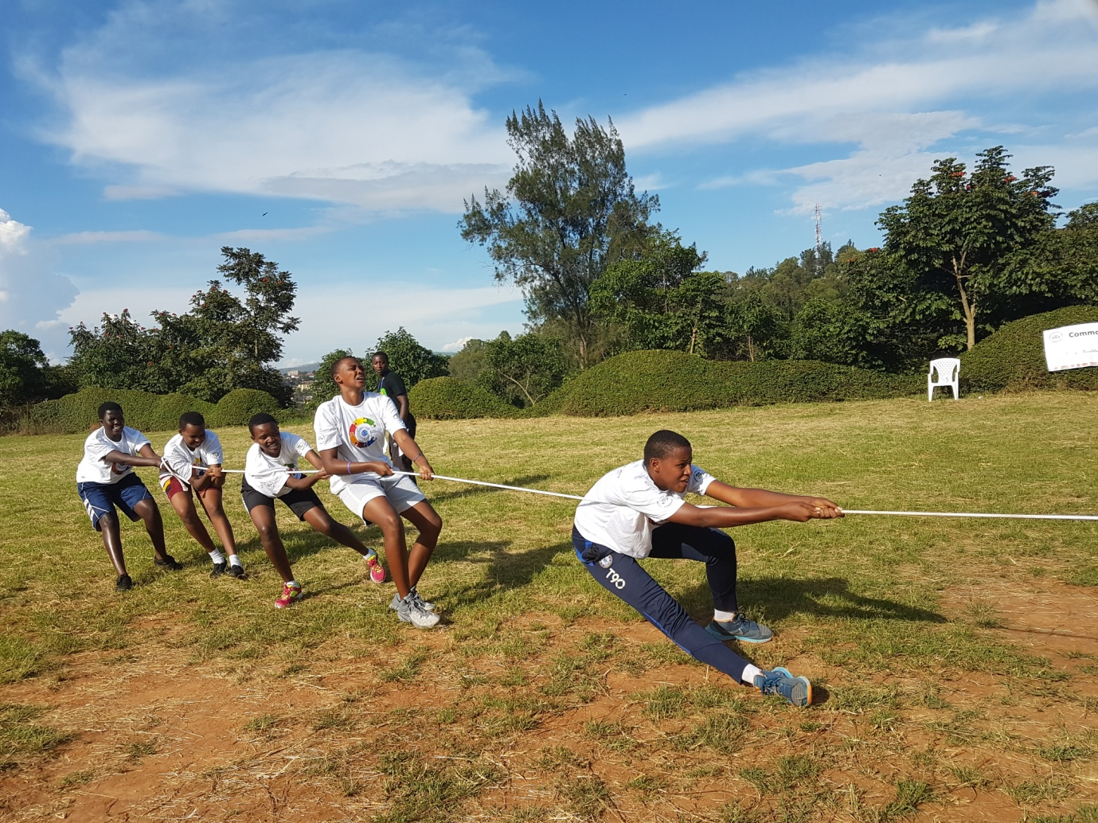
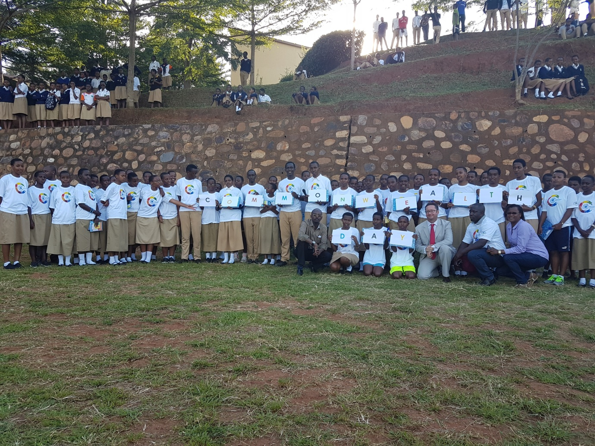

CIO – CNOSR – AKWOS
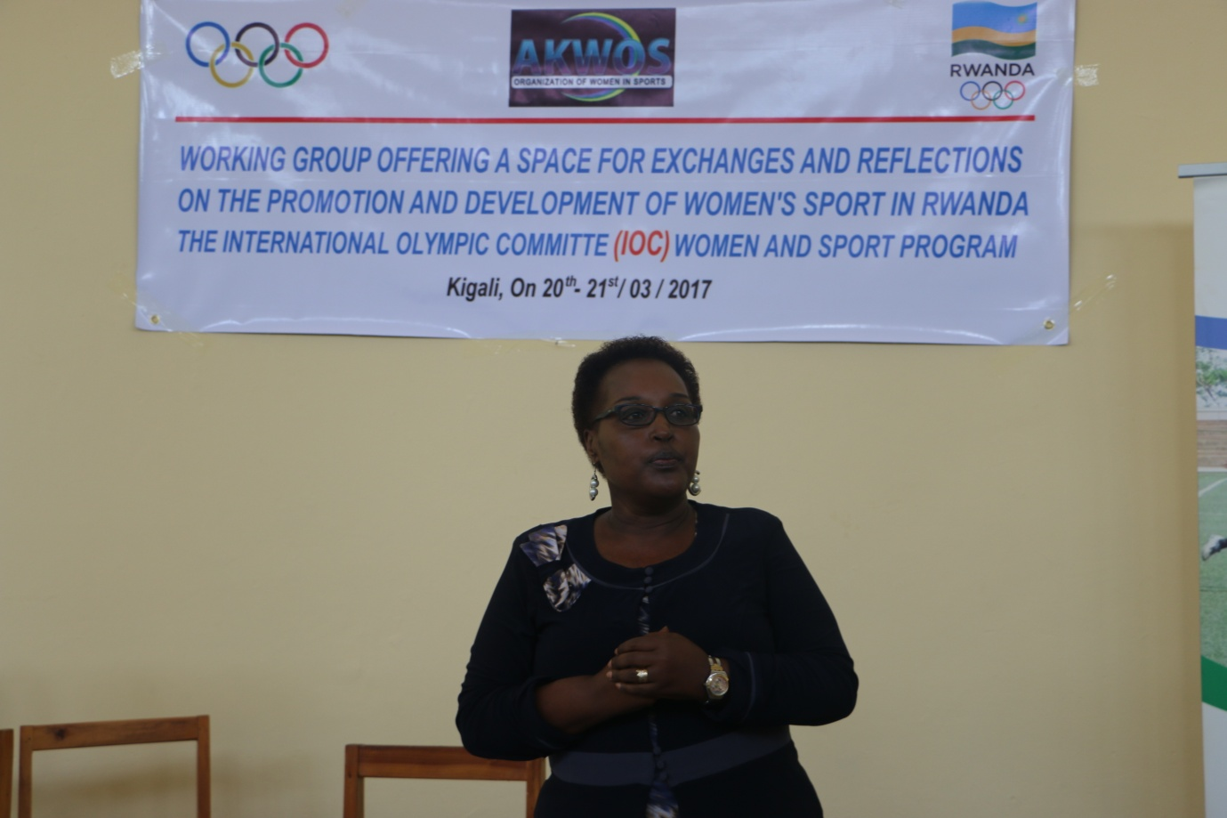
Nyuma y’aho mu mpera z’umwaka ushize wa 2016 Mme Felicité RWEMALIKA, kuri ubu Vice Présidente wa CNOSR, ahawe igihembo na Comité International Olympique cyitwa “IOC Women and Sports Award for Africa 2016”; CIO yamugeneye inkunga yo gukora umushinga wafasha abanyarwandakazi kwitabira ibikorwa bya siporo no kugira uruhare mu iterambere ry’igihugu binyuze muri siporo.
Uwo mushinga watangiriye ku mahugurwa yahawe abanyarwandakazi bari mu nzego za siporo, kuva kuwa 20.03.2017 kugeza kuwa 06.04.2017 yabereye mu ntara zose n’umujyi wa Kigali.

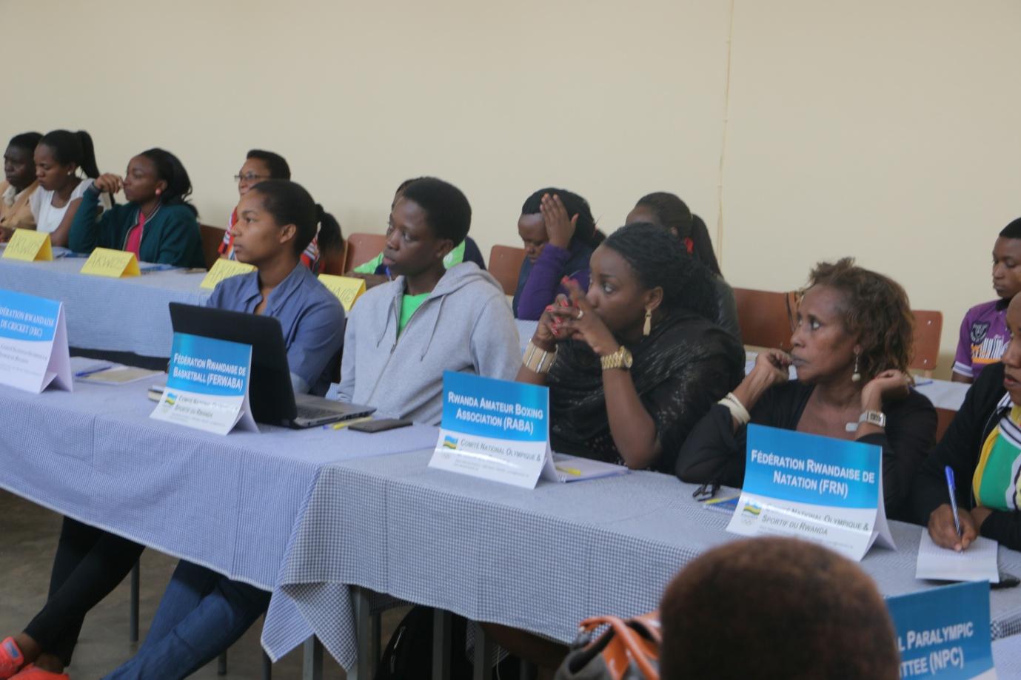
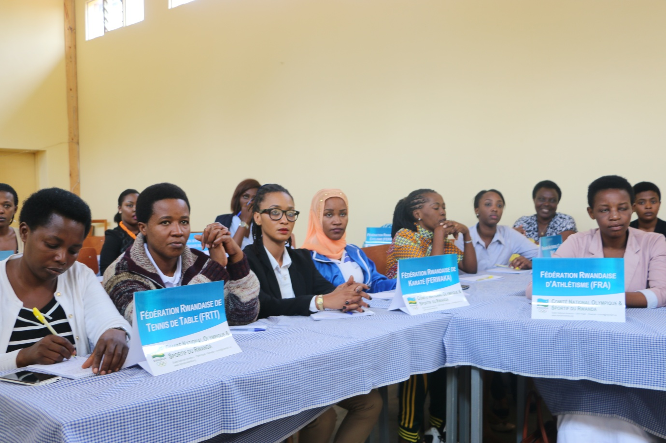

AMAHUGURWA Y’ABATOZA B’UMUKINO WA BOCCIA
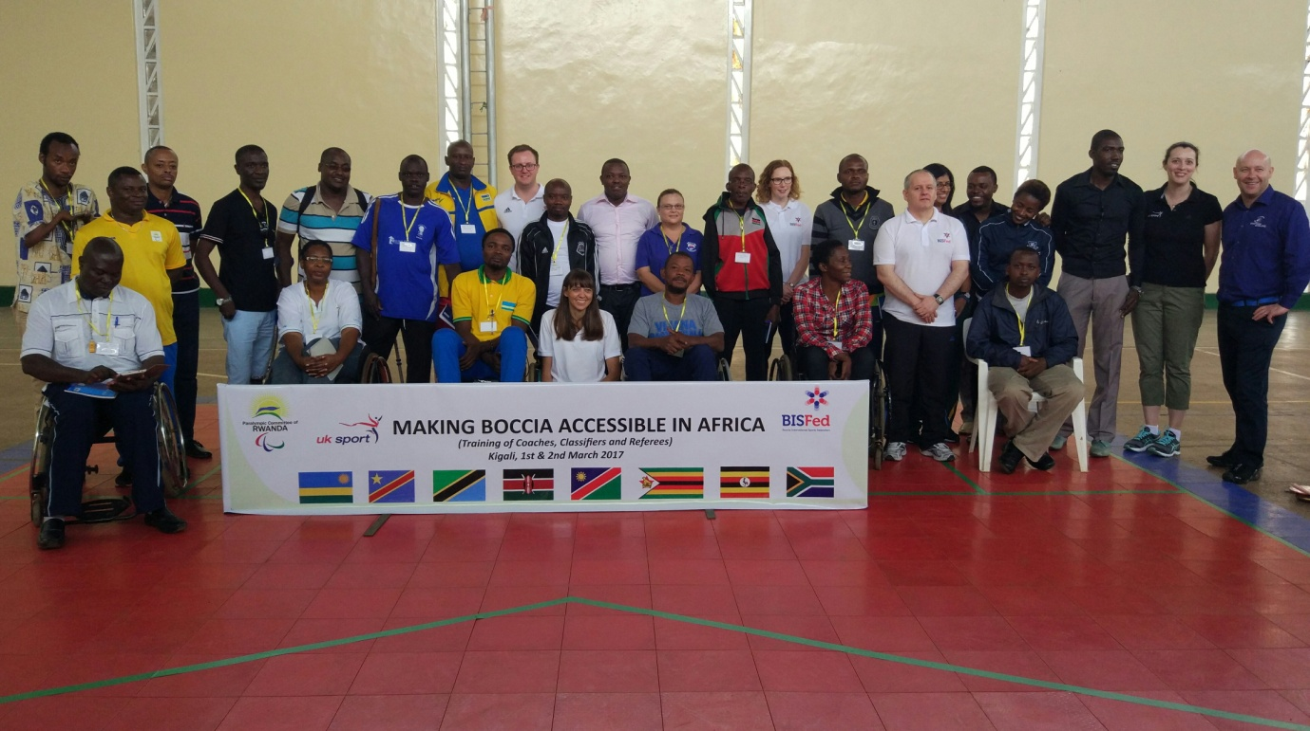
Amahugurwa yo rwego mpuzamahanga ku mukino wa boccia w’abafite ubumuga bwo mu mutwe, yabereye i Kigali kuwa 01 no kuwa 02.03.2017. Yarimo abaturutse mu bihugu 8 : R.D.CONGO, TANZANIE, KENYA, NAMIBIE, ZIMBABWE, UGANDA, AFRIQUE DU SUD, RWANDA.
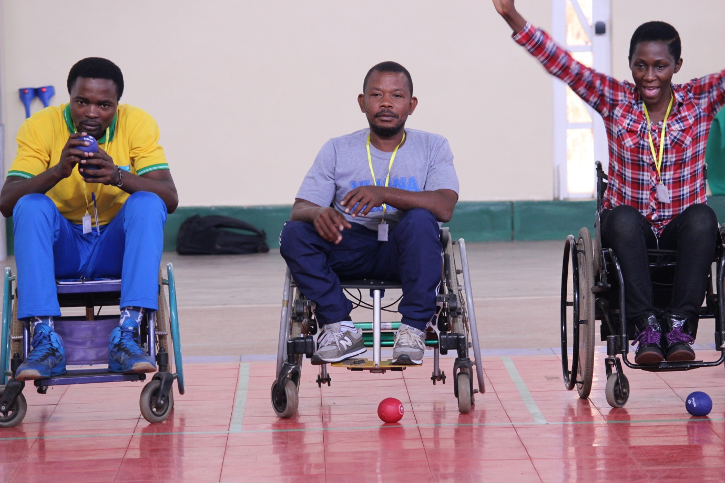
Ayo mahugurwa yatanzwe n’impuguke z’Abongereza zaturutse mu ishyirahamwe mpuzamahanga ry’umukino wa boccia (BISFED).

CYCLISME « LA TROPICALE AMISSA BONGO 2017 »
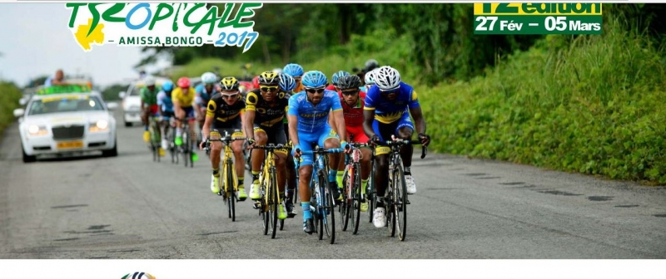
Irushanwa ngarukamwaka ryo gusiganwa ku magare « La Tropicale Amissa Bongo » ryabereye muri Gabon kuva taliki 27.02.2017 kugeza kuya 05.03.2017. Ryarimo amakipe 12, iy’u Rwanda ikaba yari igizwe n’abakinnyi 6 :
1.UWIZEYIMANA BONAVENTURE
2.KAREGEYA JEREMIE
3.UKINIWABO JEAN PAUL RENE
4.NIZEYIMANA ALEX
5.HAKIRUWIZEYE SAMUEL
6.NDUWAYO ERIC
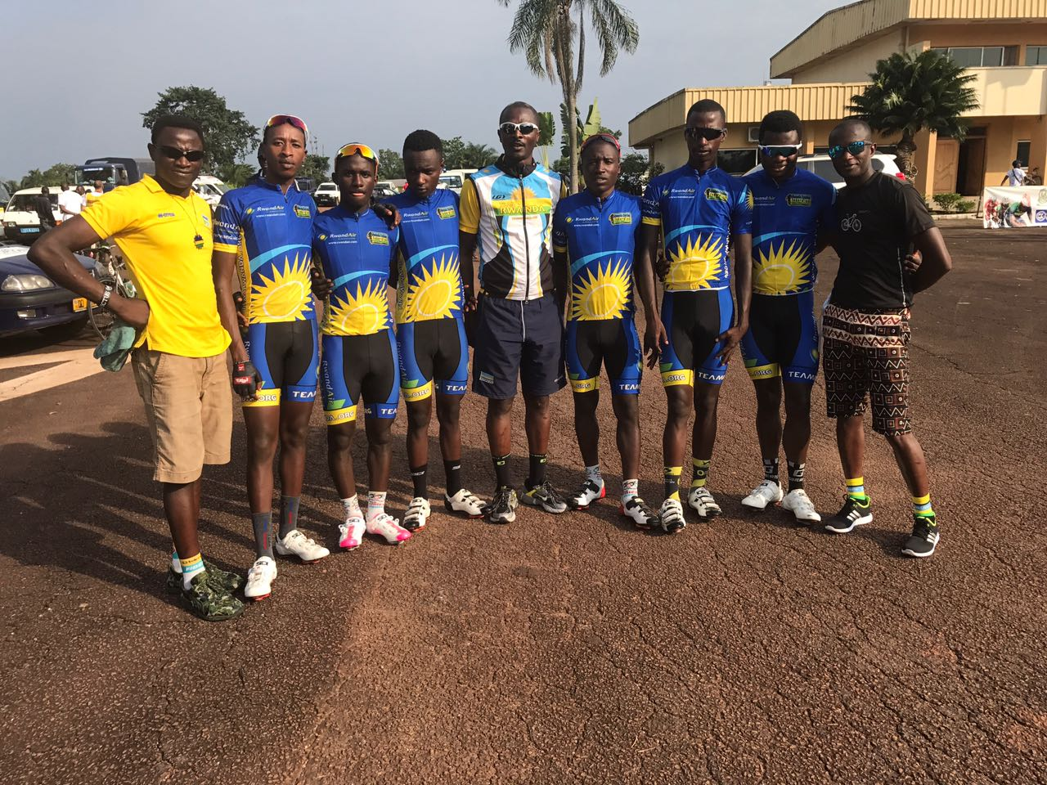

IMYANYA Y’ABAKINNYI KU RUTONDE RWA RUSANGE / GENERAL CLASSIFICATION
Uwa mbere yabaye GENE YOHANN ( DIRECT ENERGIE) 19H41’21’’
……………………………………………………………………………………………………………..
IMYANYA Y’ABAGIZE TEAM RWANDA
6.UWIZEYIMANA BONAVENTURE 19H41’38’’
27.UKINIWABO JEAN PAUL RENE 19H51’10’’
33.HAKIRUWIZEYE SAMUEL 19H51’39’’
40.KAREGEYA JEREMIE 19H54’05’’
48.NIZEYIMANA ALEX 20H09’15’’
54.NDUWAYO ERIC 20H15’18’’

UKO AMAKIPE YAKURIKIRANYE
Iyabaye iya mbere ni MAROC
TEAM RWANDA yafashe umwanya wa 7

CYCLISME : TOUR INTERNATIONAL DU CAMEROUN 2017
Irushanwa mpuzamahanga ryo gusiganwa ku magare “Tour international du Cameroun” ryabereye muri Cameroun kuva kuwa 10 kugeza kuwa 18.03.2017. Ikipe y’u Rwanda yari igizwe n’abakinnyi 6 :
1.NDAYISENGA VALENS
2.NSENGIMANA JEAN BOSCO
3.UWIZEYIMANA BONAVENTURE
4.TUYISHIME EPHREM
5.UKINIWABO RENE JEAN PAUL
6.UWIZEYIMANA JEAN CLAUDE
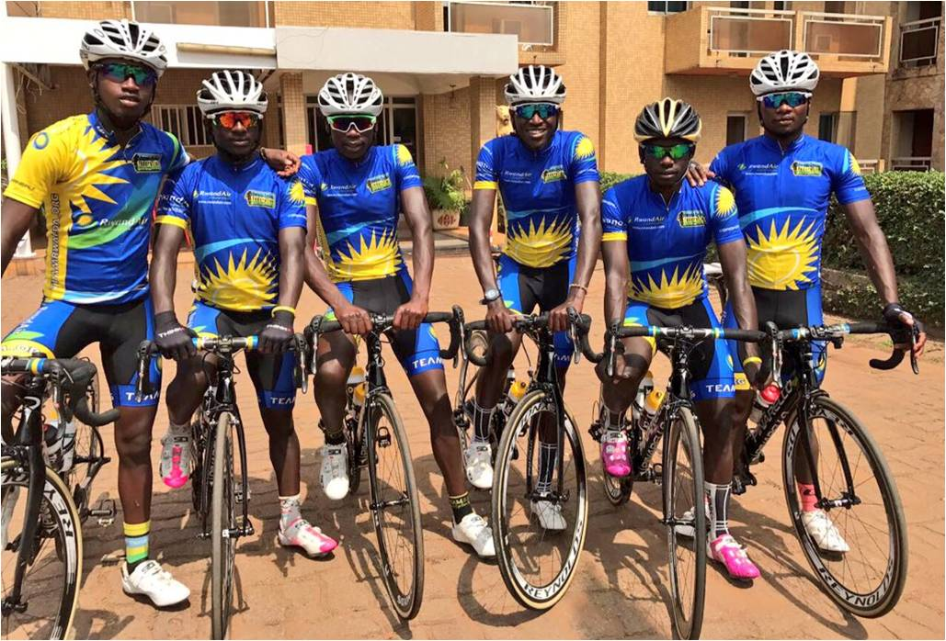
Ku gace (étape ) ya 7 BOUMNYEBEL - MBALMAYO (119 km), NSENGIMANA JEAN BOSCO yabaye uwa 2
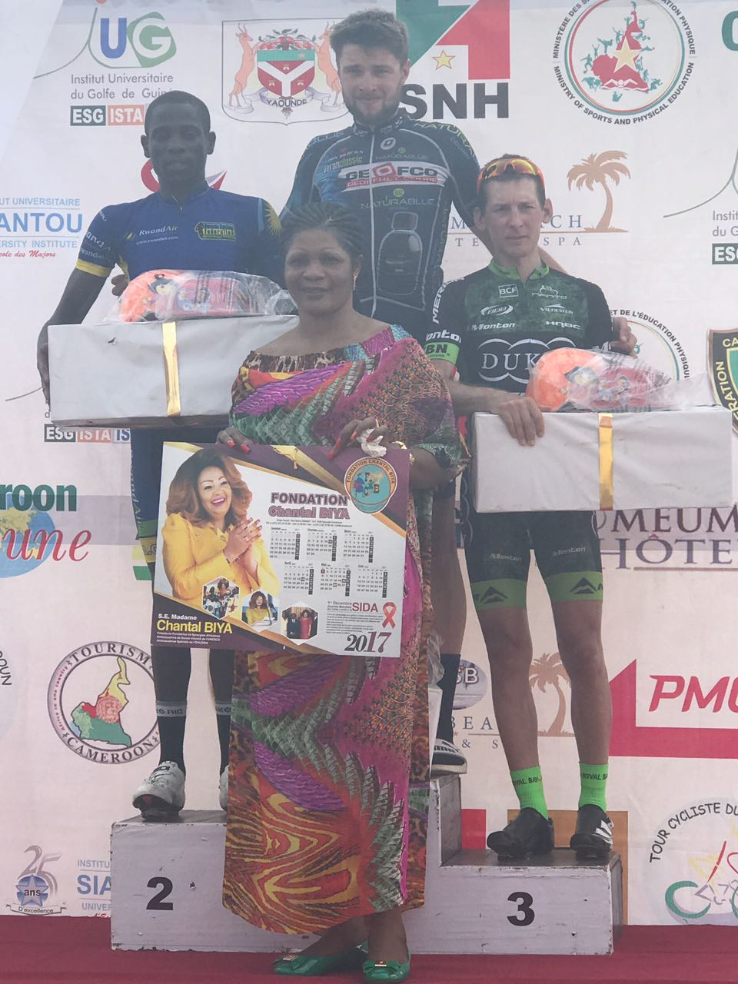NSENGIMANA JEAN BOSCO (2)
Irushanwa ryasojwe n’abakinnyi 52 bagenze 956 km, uwa mbere yabaye HOLLER NIKOGEMUS (BIKE AID) 24H04’44’’

IMYANYA Y’ABAGIZE TEAM RWANDA
10.NDAYISENGA VALENS : 24H04’44’’
11. UWIZEYE JEAN CLAUDE : 24H04’51’’
13. UWIZEYIMANA BONAVENTURE : 24H05’20’’
14.UKINIWABO JEAN PAUL RENE : 24H05’37’’
20. NSENGIMANA JEAN BOSCO : 24H11’43’’
23. TUYISHIMIRE EPHREM : 24H12’57’’

CYCLISME : IMYITOZO, AMAHUGURWA, CHAMPIONNAT D’AFRIQUE - VELODROME
HABIMANA JEAN ERIC na MUNYANEZA DIDIER kuva kuwa 10 kugeza kuwa 26.03.2017 bari mu kigo cya UCI cyo muri Afurika y’epfo mu myitozo y’umukino w’amagare ukinirwa kuri velodrome (Track / Piste), hamwe na championnat d’Afrique ya track izabera i Durban.
BYUKUSENGE NATHAN we yakurikiranye amahugurwa y’abatoza b’uyu mukino.
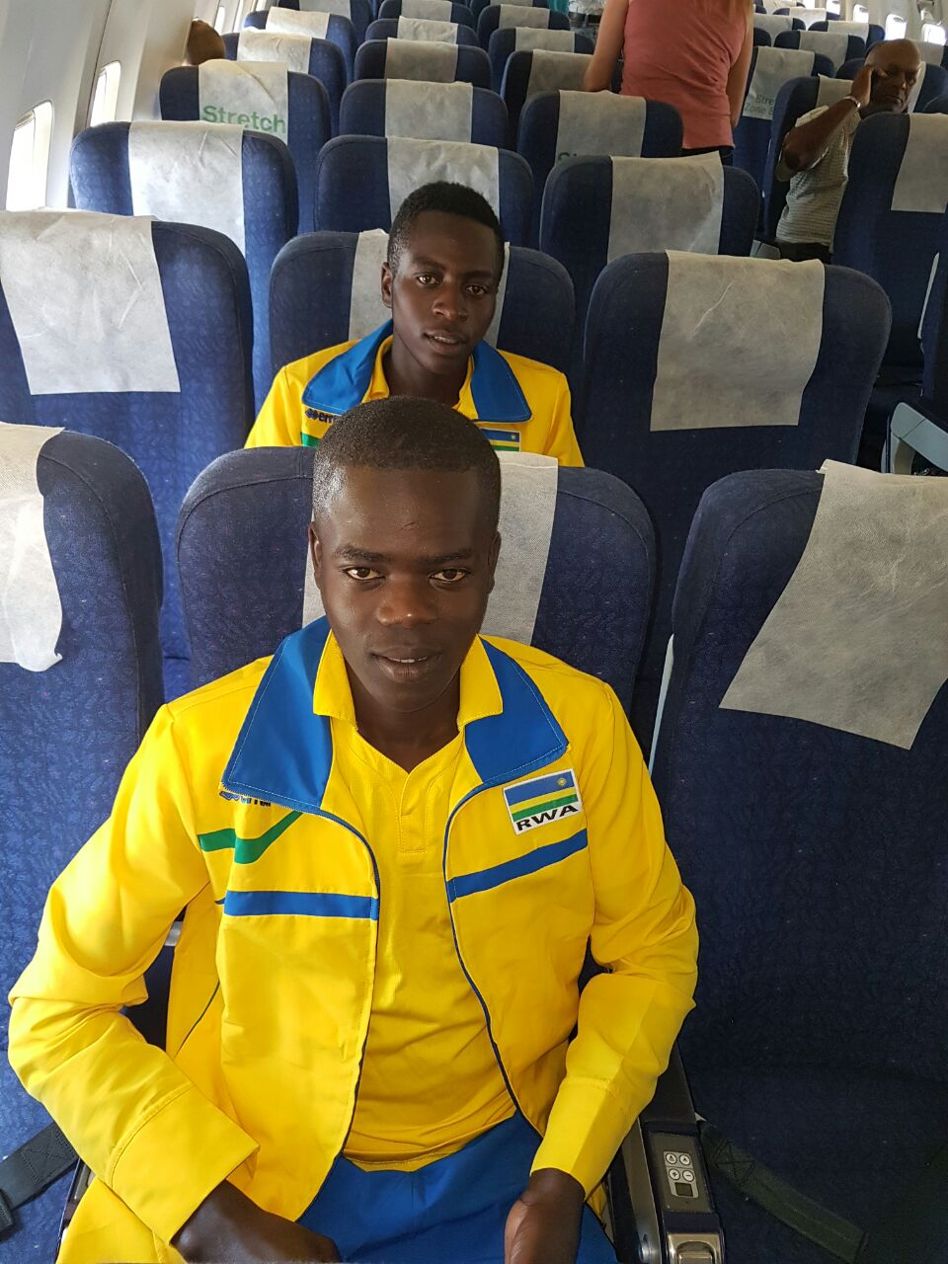

FIFA BEACH SOCCER REFEREEING AND COACHING COURSE
Mu mukino w’umupira w’amaguru i Rubavu kuva kuwa 06 kugeza kuwa 09.03.2017 habaye amahugurwa ku mupira w’amaguru ukinirwa ku musenyi, yahawe abantu 31 barimo abagore 18 n’abagabo 13. Ayo mahugurwa yateguwe ku bufatanye bwa FIFA, FERWAFA, AKWOS
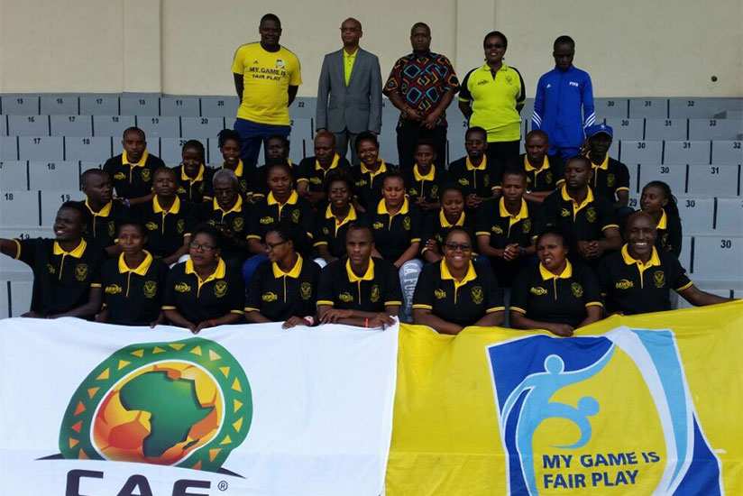

BASKETBALL : FIBA AFRICA ZONE V PRELIMINARIES OF AFROBASKET 2017
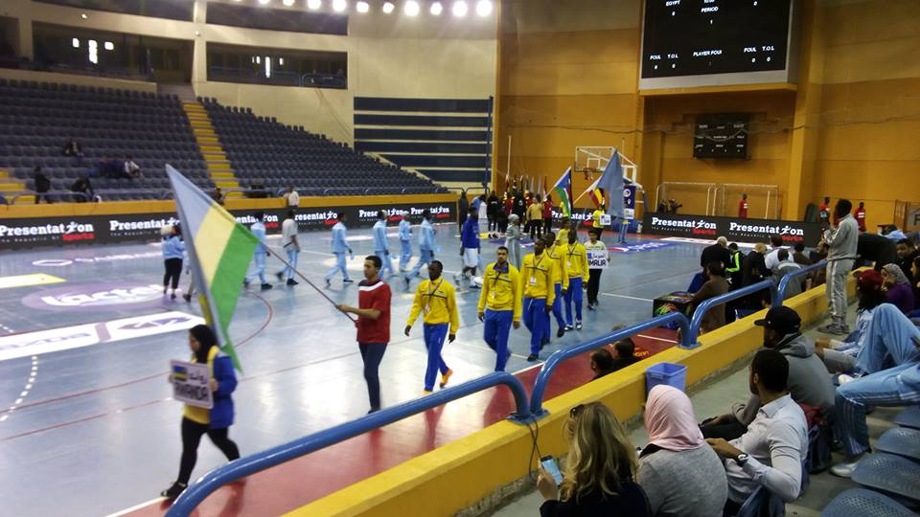
Ikipe y’igihugu y’abagabo ya basketball yari i Cairo mu irushanwa ry’akarere ka 5 ryahabereye kuva kuwa 12 kugeza kuwa 18.02.2017, mu majonjora yagombaga gutanga amakipe 2 ya mbere azahagararira akarere ka 5 mu mikino nyafurika « Afrobasket 2017 ».
Iryo rushanwa ryarimo amakipe 7 : EGYPTE, UGANDA, SOUDAN DU SUD, SOMALIE, KENYA, BURUNDI, RWANDA
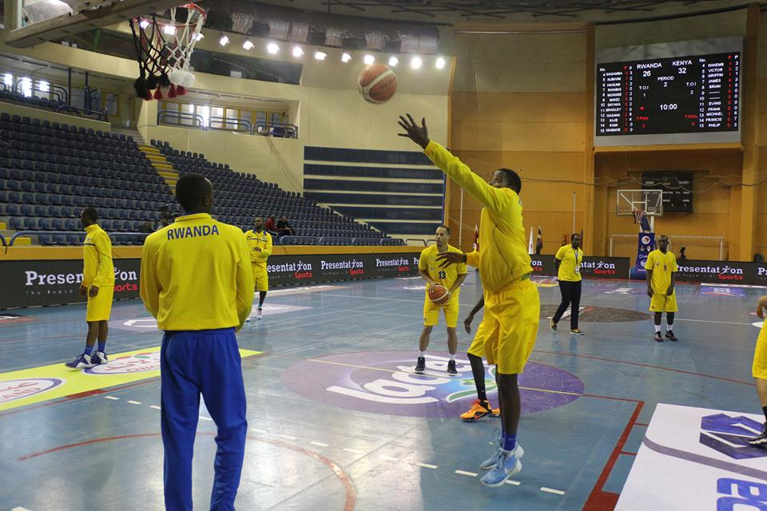

Mu mikino y’ijonjora amakipe yashyizwe mu matsinda abiri, u RWANDA mu itsinda rya mbere rwari hamwe na EGYPTE, KENYA, SOUDAN DU SUD.
IMIKINO Y’IKIPE Y’U RWANDA MU ITSINDA RYA MBERE
RWANDA 76 – 60 KENYA
RWANDA 71 – 83 EGYPTE
RWANDA 90 – 80 SOUDAN DU SUD

Umukino wa ½ cy’irangiza
RWANDA 64 – 77 UGANDA
Gukinira umwanya wa 3
RWANDA 89 – 75 BURUNDI
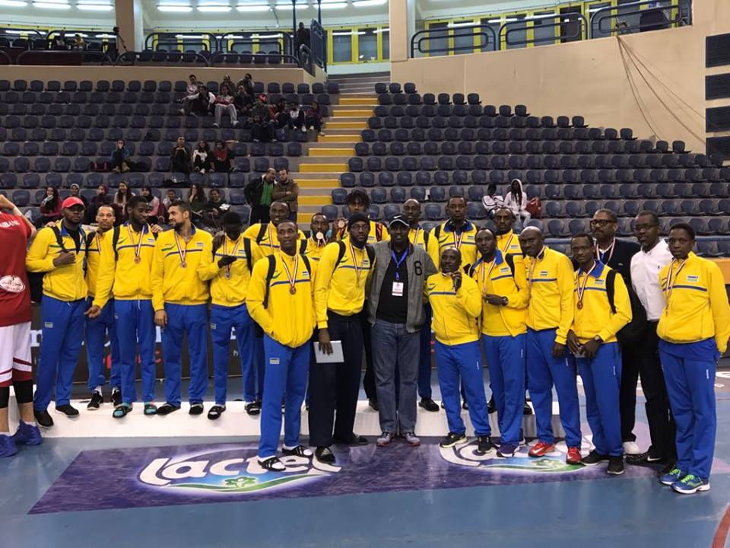
UKO AMAKIPE YASOJE AKURIKIRANA
1.EGYPTE
2.UGANDA
Zatsindiye kuzahagararira zone V muri Afrobasket
…………………………………..
3.RWANDA
4.BURUNDI
5.SOUDAN DU SUD
6.KENYA
7.SOMALIE

Nyuma y’amajonjora mu turere twose (zones) tw’Afurika, FIBA - AFRIQUE yemereye u Rwanda kuzakina Afrobasket 2017

FOOTBALL : CAF/ COUPE DE LA CONFEDERATION
Mu irushanwa ry’igikombe cy’ishyirahamwe ry’umupira w’amaguru muri Afurika ( Coupe de la Confédération) muri 1/16 cy’irangiza RAYON SPORTS yahuye na ONZE CREATEURS yo muri Mali.
Mu mukino ubanza wabereye muri Mali kuwa 11.03.2016, ONZE CREATEURS yatsinze RAYON SPORTS igitego 1 - 0
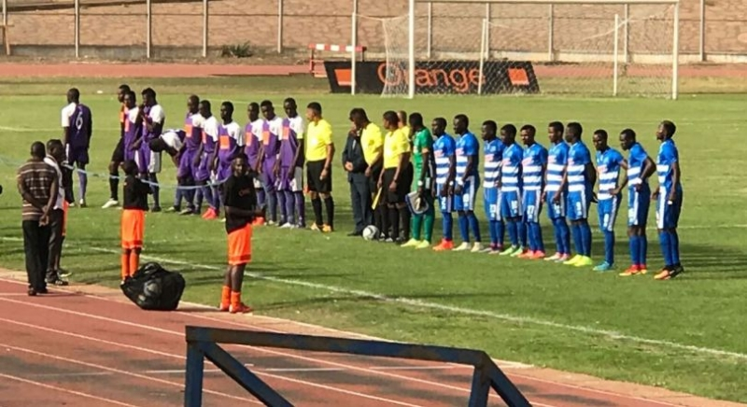
Umukino wo kwishyura wagombaga kubera i Kigali ntiwabaye kubera ko CAF yahagaritse Fédération Malienne de Football mu marushanwa, RAYON SPORTS ikomeza muri 1/8 cy’irangiza.

SPORT SCOLAIRE : AMASHURI KAGAME CUP 2017
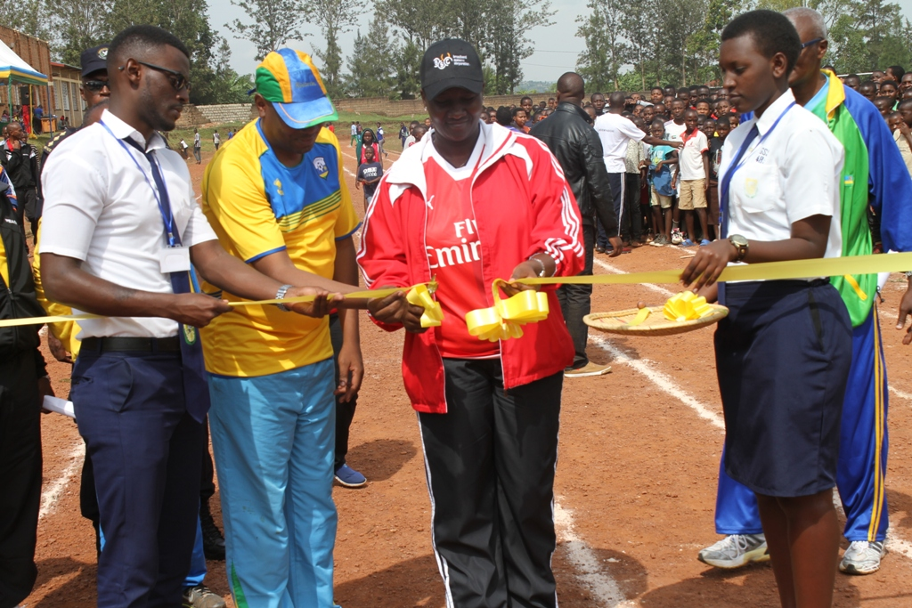
Muri Groupe Scolaire Saint Aloys i Rwamagana kuwa 12.03.2017 hatangirijwe ku mugaragaro amarushanwa « Amashuri Kagame Cup 2017», hanatahwa ibikorwa remezo by’imikino.
Amarushanwa aba mu mikino 6 : football, volleyball, basketball, handball, athletisme, sitball
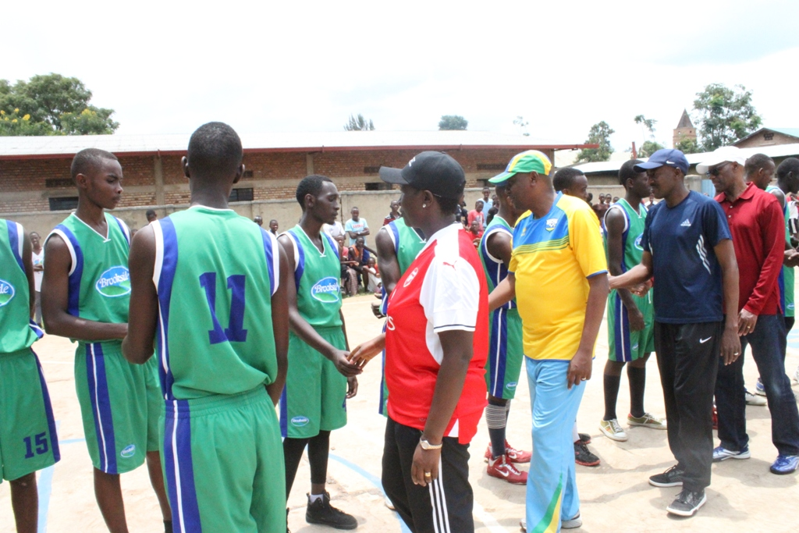
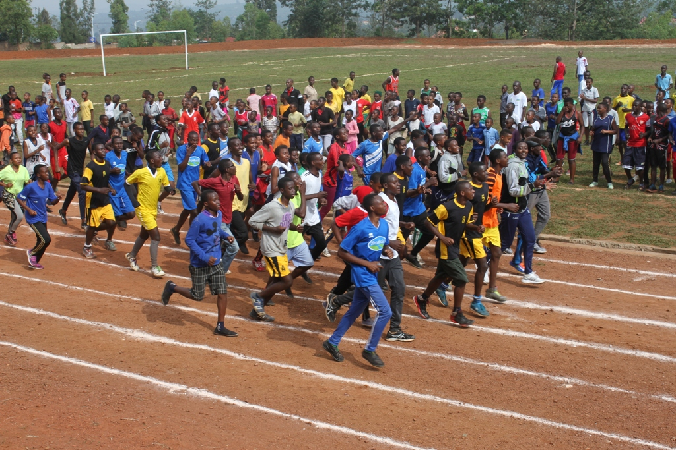

SPORT UNIVERSITAIRE : CROSS COUNTRY
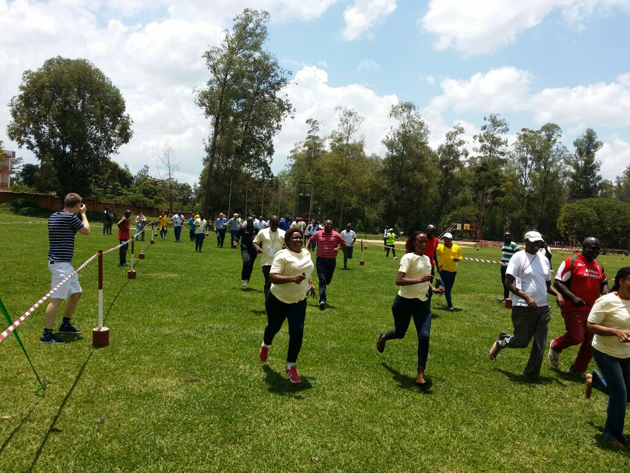
Irushanwa ry’imikino ngororamubiri ryo gusiganwa kwiruka mu misozi (cross country) ryahuje abanyeshuri bo muri kaminuza zo muri KENYA, UGANDA, AFRIQUE DU SUD, ZAMBIE, RWANDA; ryabereye i Kigali kuwa 18.03.2017
IMYANYA ITATU YA MBERE KU RUTONDE RWA ZA KAMINUZA
ABAGABO
1.TSHWANE INIVERSITY UNIVERSITY OF TECHNOLOGY « TUT » (AFRIQUE DUSUD) : umudari wa zahabu
2.KENYATTA UNIVERSITY ( KENYA) : umudari wa feza
3.MAKELELE UNIVERSITY (UGANDA) : umudari wa bronze

ABAGORE
1.KENYATTA UNIVERSITY (KENYA) : umudari wa zahabu
2.TSHWANE UNIVERSITY OF TECHNOLOGY : umudari wa feza
3.MAKELELE UNIVERSITY (UGANDA) : umudari wa bronze

IMYANYA ITATU YA MBERE KU RUTONDE RW’IBIHUGU
ABAGABO
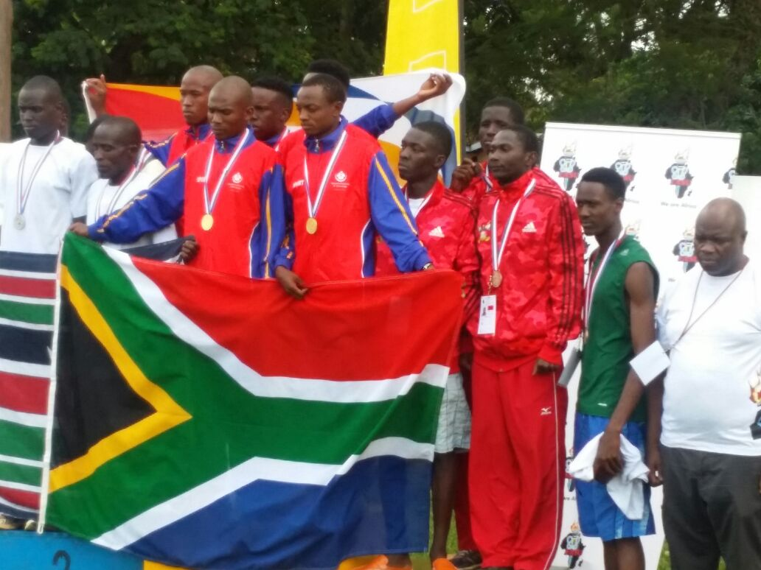
1.AFRIQUE DU SUD
2.KENYA
3.UGANDA

ABAGORE
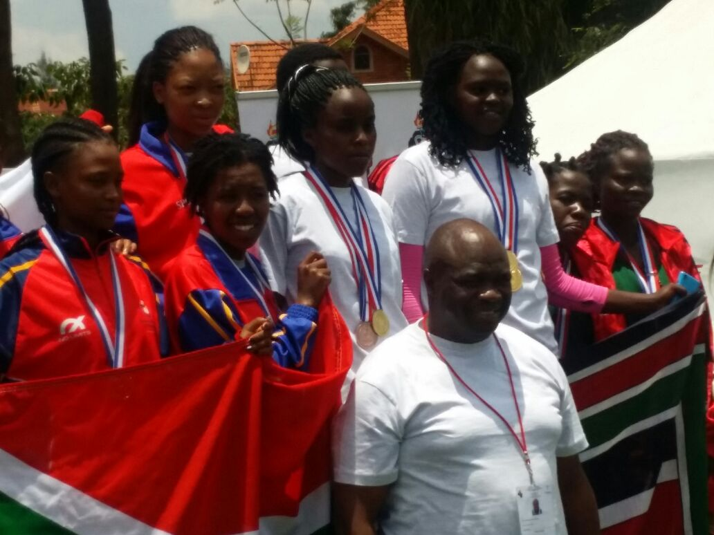
1.KENYA
2.AFRIQUE DU SUD
3.UGANDA

VOLLEYBALL : CHAMPIONNAT D’AFRIQUE DES CLUBS CHAMPIONS
Tunis 17 – 26.03.2017
Irushanwa ry’igikombe cy’Afurika cy’amakipe y’abagabo yabaye aya mbere mu bihugu iwayo ryabereye i Tunis muri Tuniziya kuva kuwa 17 kugeza kuwa 26.03.2017, ryahuje amakipe y’abagabo 17. U Rwanda rwahagarariwe na UNIK (University of Kibungo) yari mu itsinda C mu mikino y’ijonjora, hamwe na BORJ BOU ARIRIJ (ALGERIE), POLICE VI (BOTSWANA), DOUANES (BURKINA FASO), ASSARYA (LIBYE).

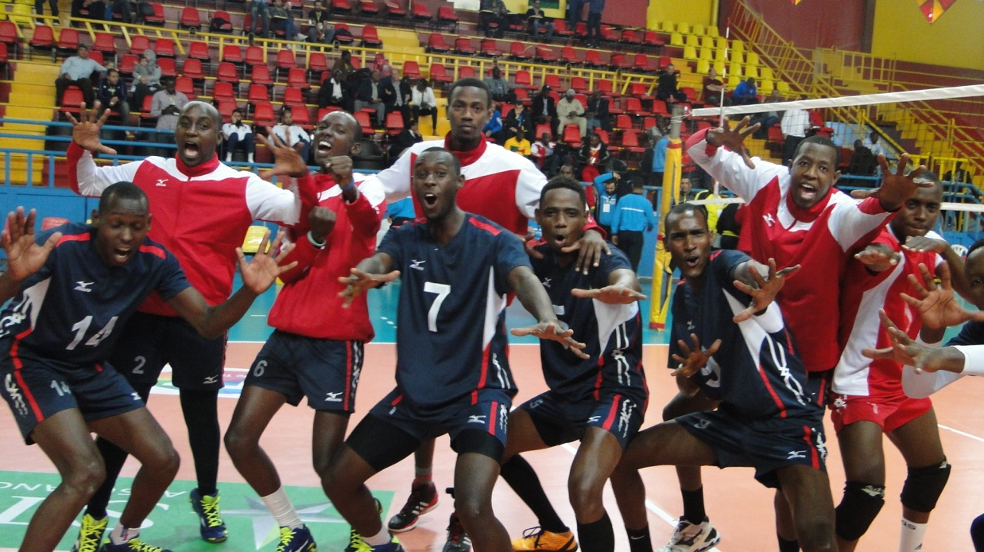
UNIVERSITY OF KIBUNGO
UKO IMIKINO YA UNIK YAGENZE
UNIK 2 – 3 ASSARYA (LIBYE)
UNIK 1 – 3 BORDJ BOU ARIRIJ (ALGERIE)
UNIK 3 – 0 POLICE VI (BOTSWANA)
UNIK 3 – 2 DOUANES (BURKINA FASO)
UNIK ntiyshoboye gukomeza muri ¼ cy’irangiza

GUKINIRA IMYAYA YA 9 – 16
UNIK 3 – 0 FINANCES (BENIN)

GUKINIRA IMYANYA YA 9 – 12
UNIK 0 – 3 AL AHLY BENGHAZI (LIBYE)

GUKINIRA IMYANYA YA 11 – 12
UNIK 3 – 0 ALNAHDA (SOUDAN)
UNIK yasoje ku mwanya wa 11 mu makipe 17, igikombe gitwarwa na AL AHLY (EGYPTE)

ATHLETISME : WORLD CROSS COUNTRY CHAMPIONSHIPS 2017
Mu irushanwa ry’isi ry’imikino ngororamubiri mu kwiruka mu misozi (cross country) ryabereye i Kampala muri Uganda kuwa 26.03.2017, u Rwanda rwahagarariwe n’abakinnyi 6 :
1.SUGIRA JAMES
2.MYASIRO JEAN MARIE VIANNEY
3.NIZEYIMANA ALEXIS
4.GAKURU DAVID
5.RUBAYITA SIRAGI
6.MANIRAFASHA PRIMIEN
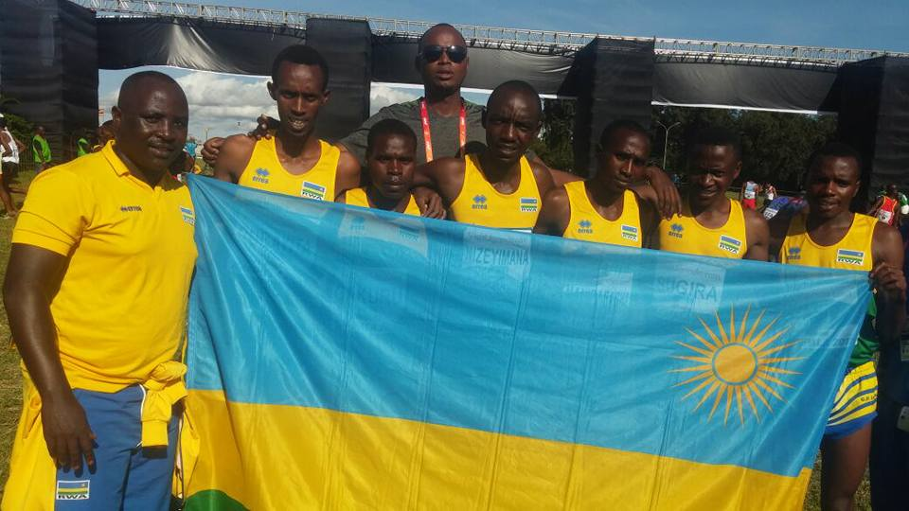
Abasoje isiganwa ni 132, umwanya wa mbere wafashwe na KAMWOROR GEOFFREY KIPSANG (KENYA) 28’24’’. Abakinnyi b’abanyarwanda bafashe imyanya ikurikira :
48.SUGIRA JAMES 30’54’’
54.NIZEYIMANA ALEXIS 31’11’’
57.MANIRAFASHA PRIMIEN 31’19’’
60.GAKURU DAVID 31’26’’
66.MYASIRO JEAN MARIE VIANNEY 31’36’’
106.RUBAYITA SIRAGI 33’54’’
Irushanwa ryarimo amakipe 18, u Rwanda rwafashe umwanya wa 10
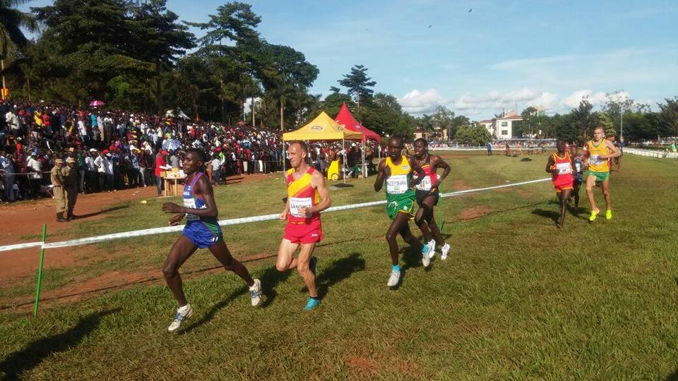

NPC : INTEKO RUSANGE
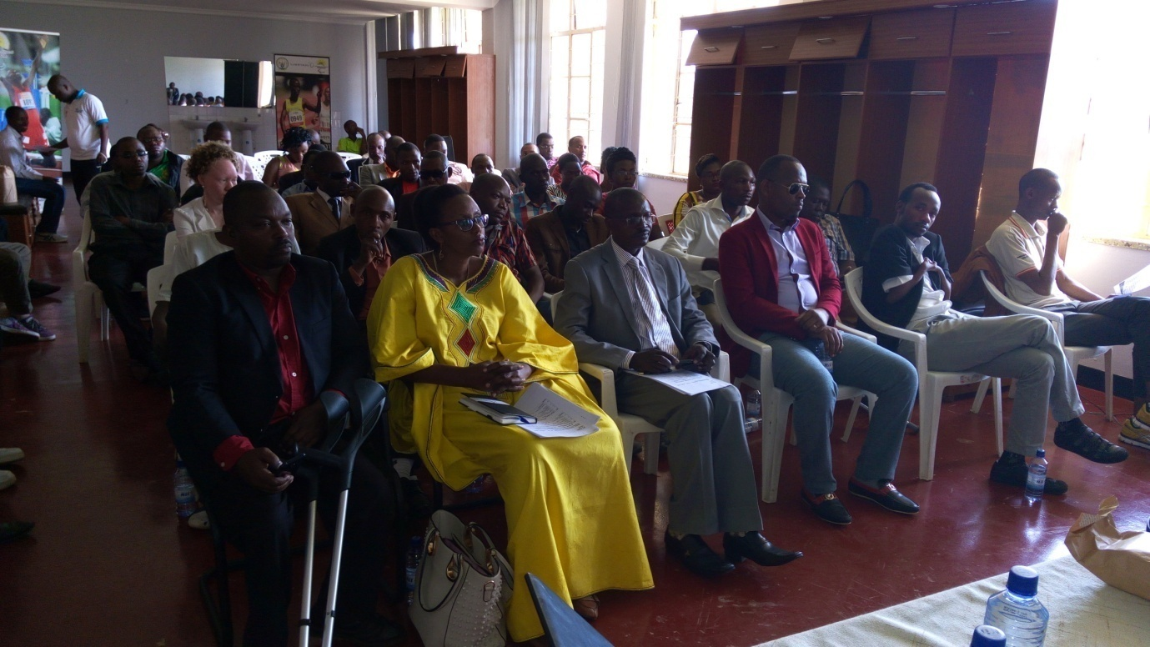
Inama y’inteko rusange ya National Paralympic Committee yateranye kuwa 26.03.2017 yabayemo amatora y’abayobozi bashya :
Perezida: Murema Jean Baptiste
Visi Perezida wa mbere: Iriza Dinah Marie Claire
Visi Perezida wakabiri : Safari William
Umunyamabanga Mukuru : Dr Mutangana Dieudonne
Umubitsi : Vuningabo Emile
Abajyanama : Sekarema Jean Paul, Mukarusine Claudine, Mukanyemazi, Bizimana J. Damascène
Abagize inama ngenzuzi : Nkurayija J. Pierre, Twizerimana David, Ingabire Marthe
Abagize akanam nkemurampaka : Ngendanumwe Augustin, Habimana Louis, Cyamenyerwa Solange
Uhagaraliye abakinnyi : Twagirayezu Callixte,
Uhagaraliye abagore : Mukobwankawe Liliane
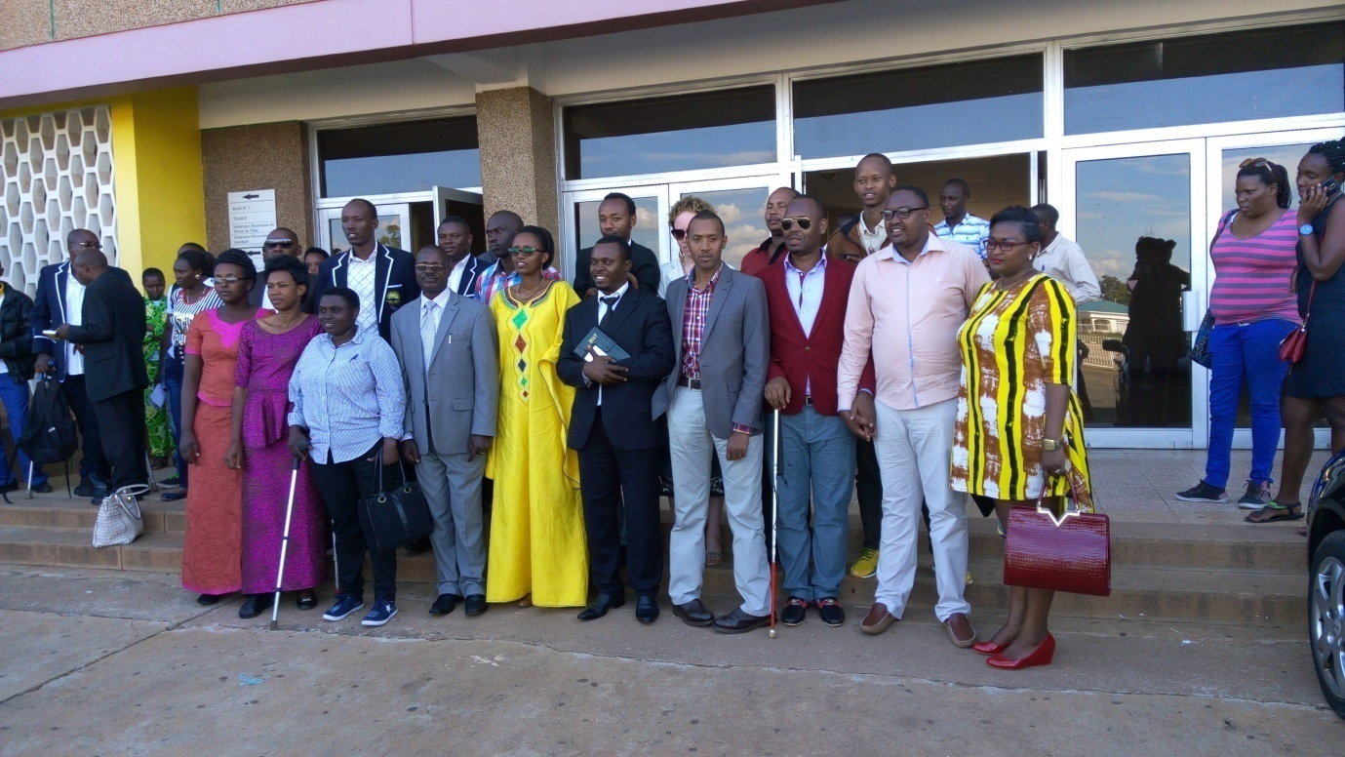

SPORT AUTOMOBILE : SLALOM 1st EDITION 2017
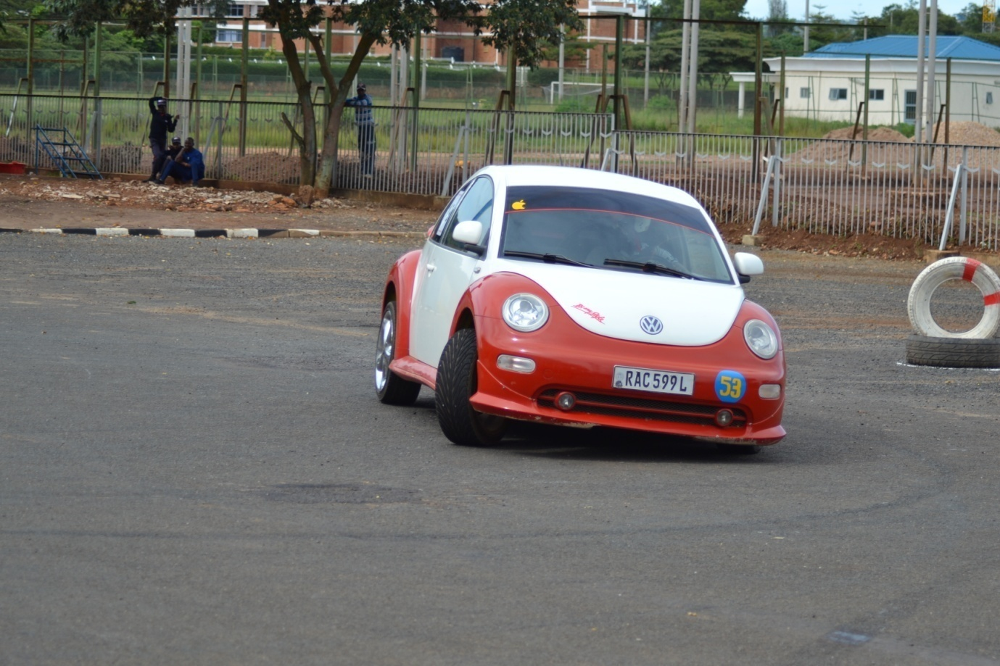
Irushanwa ryo gukata amakorosi hakoreshejwe imodoka zisanzwe « slalom » ryateguwe na Rwanda Automobile Club, kuwa 25.03.2017 ryabereye kuri stade Amahoro i Remera ryarimo abasiganwa 13
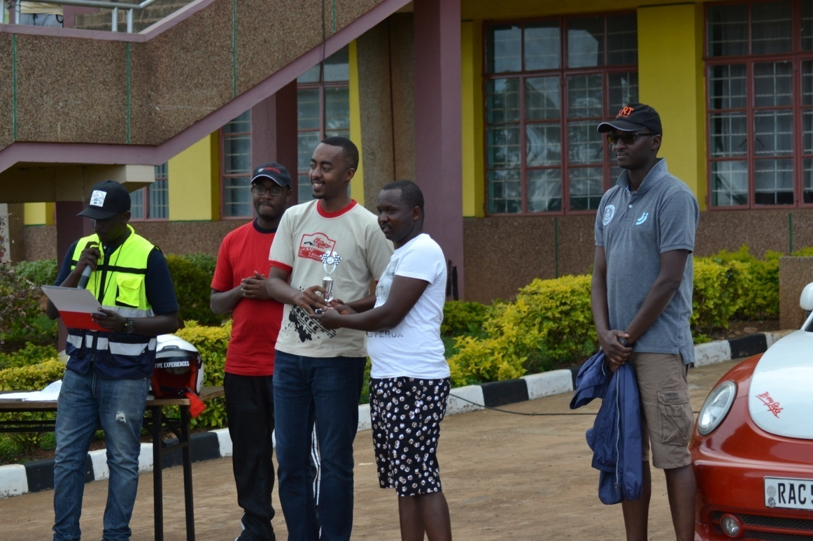
ABAFASHE IMYANYA ITATU YA MBERE
1.FURAHA SEKAMANA (TOYOTA COROLLA)
2.NSHIMIYIMANA ADOLPHE (VW)
3.MBABAZI OLIVIER (SUBARU IMPREZA)

TRIATHLON : 1st INTER CLUB TRIATHLON RACE 2017
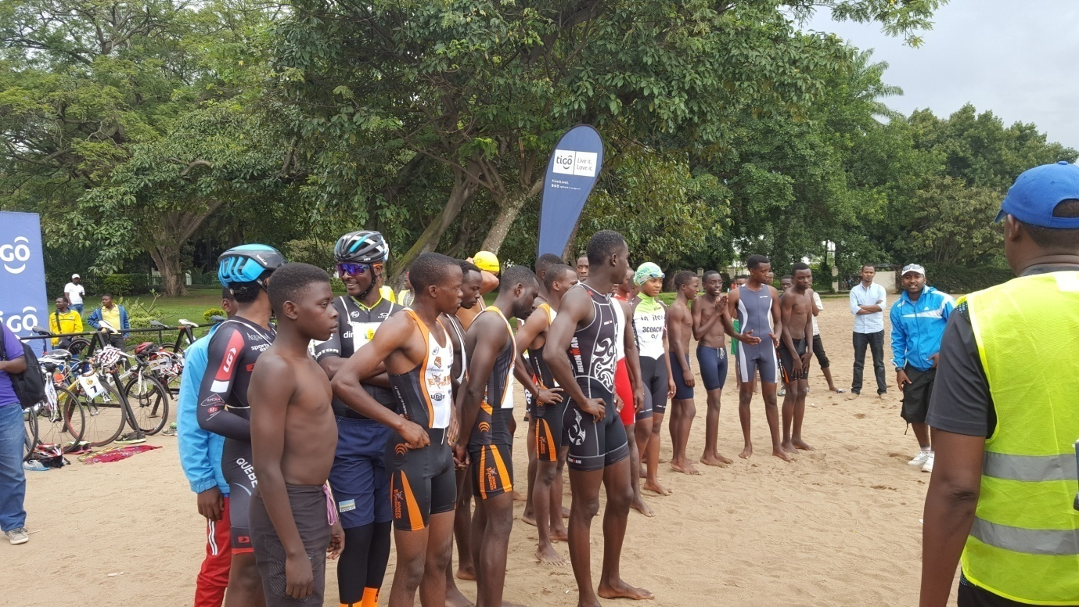
Irushanwa ryo gusiganwa mu mikino itatu icya rimwe (triathlon) ryabereye i Rubavu kuwa 25.03.2017, hakorwa : kwoga 750m, gusiganwa ku magare 20km, kwiruka 5km.
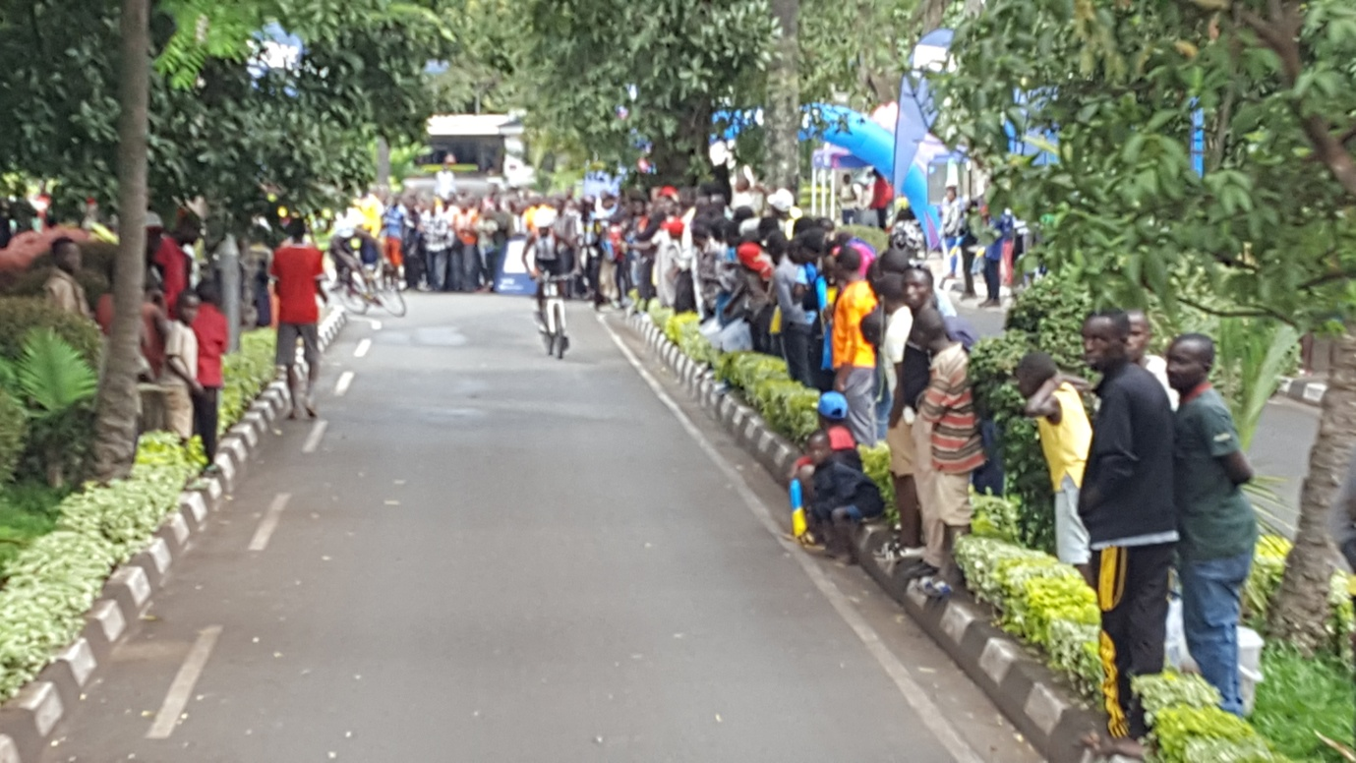
ABAFASHE IMYANYA YA MBERE
ABAGORE
1.UWINEZA HANINI 1h29’04’’
2.TUYISHIME ALICE 1h41’21’’
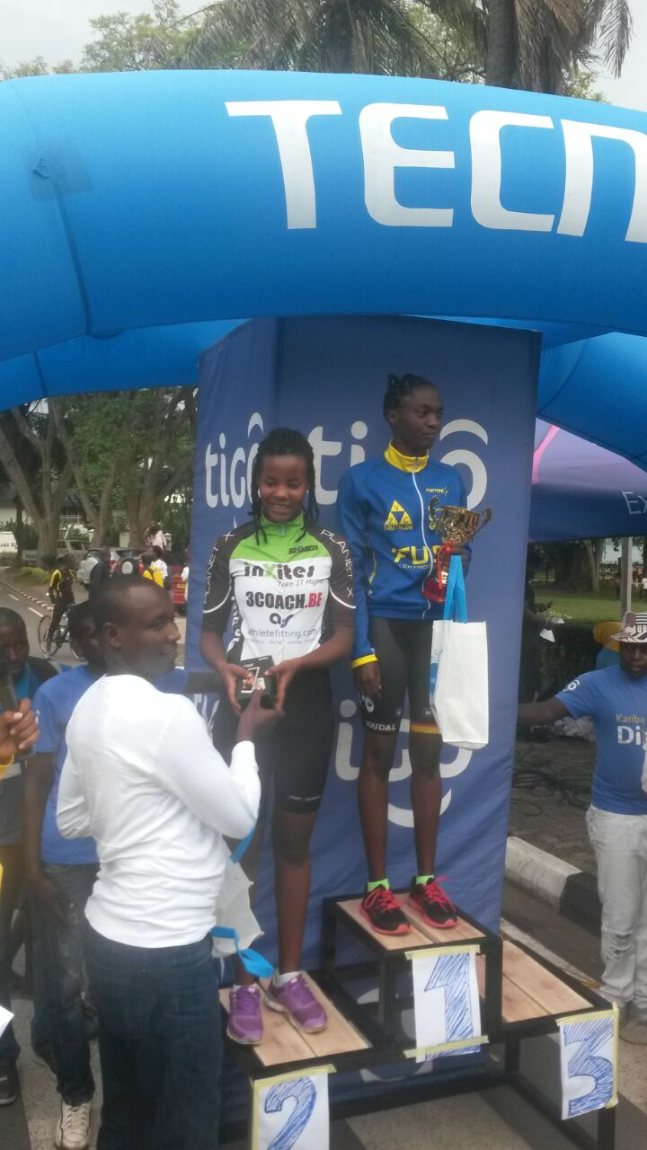

ABAGABO
1.IRADUKUNDA ISIAKA (BEBETO) 1h04’10’’
2.MANIRAGUHA FARADJI 1h08’
3.NIYONSENGA 1h09’14’’
