MUTARAMA 2017

ATHLETISME : NATIONAL CROSS COUNTRY / SENIOR
I Kampala muri Uganda kuwa 14.01.2017 habereye irushanwa mpuzamahanga ry’imikino ngororamubiri yo gusiganwa kwiruka ahareshya na kirometero 10, ryarimo abakinnyi 4 b’abanyarwanda :
1.SUGIRA JAMES
2.MANIRAFASHA PRIMIEN
3.MYASIRO JENA MARIE VIANNEY
4.NIZEYIMANA ALEXIS
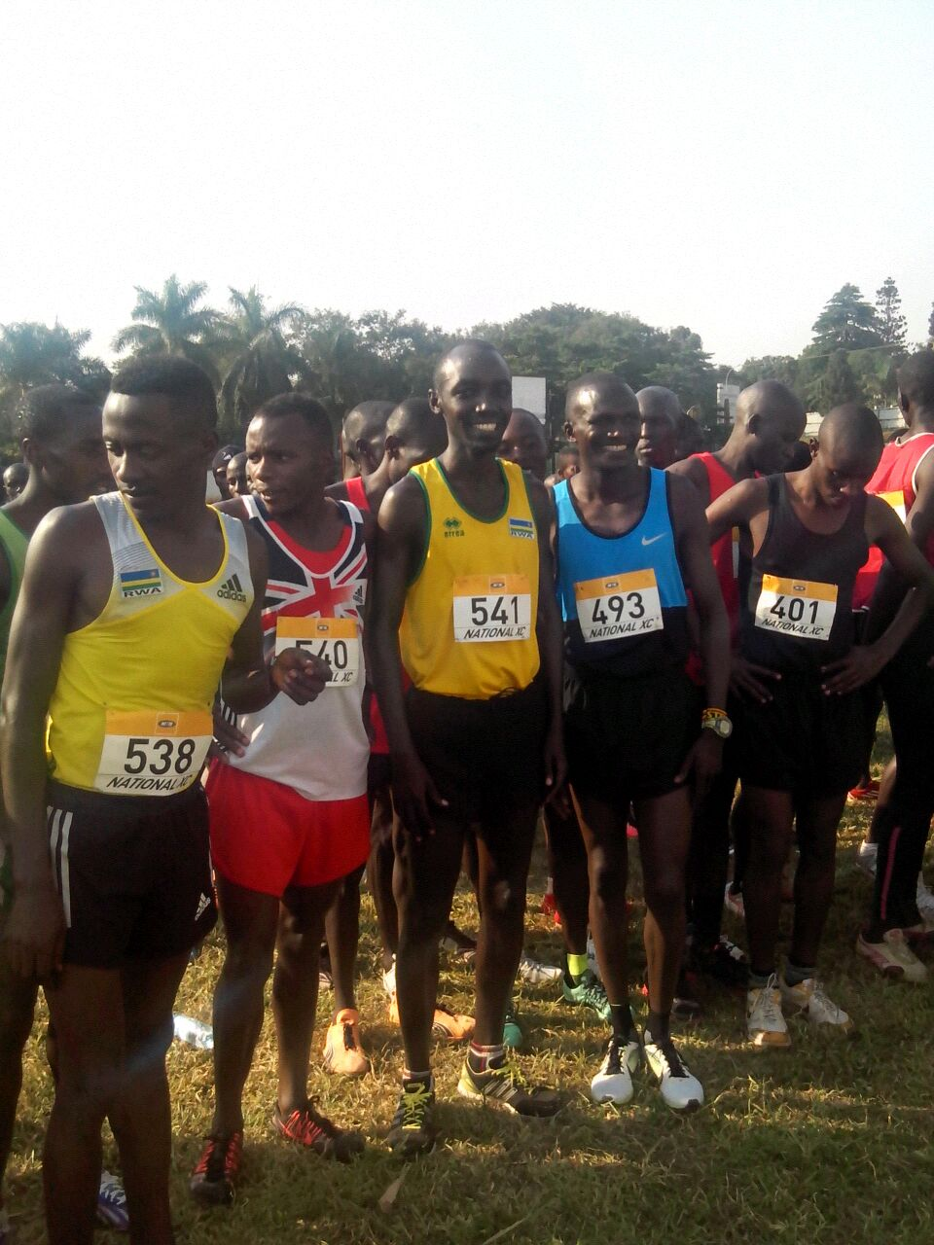

Uwa mbere yabaye JOSHUA KIPRUI CHEPTEGEI wo muri UGANDA wakoresheje 29 min 02 sec 29

IMYANYA ABAKINNYI B’ABANYARWANDA BAFASHE N’IBIHE BAKORESHEJE :
15.SUGIRA JAMES : 30min 37sec 30
21.MANIRAFASHA PRIMIEN : 30min 59sec 30
23.NIZEYIMANA ALEXIS : 31min 09sec 31
29.MYASIRO JEAN MARIE VIANNEY : 31min 26sec 31

BASKETBALL
Mu kiganiro n’abanyamakuru cyabaye kuwa 13.01.2017, Fédération Rwandaise de Basketball (FERWABA) yerekanye technical director JOSEPH RIGHT “JOBY”, n’abatoza bakuru b’amakipe y’igihugu ya basketball : MUTOKAMBALI MOISE umutoza mukuru w’ikipe y’abagabo na BAHIGE JACQUES umutoza mukuru w’ikipe y’abagore.
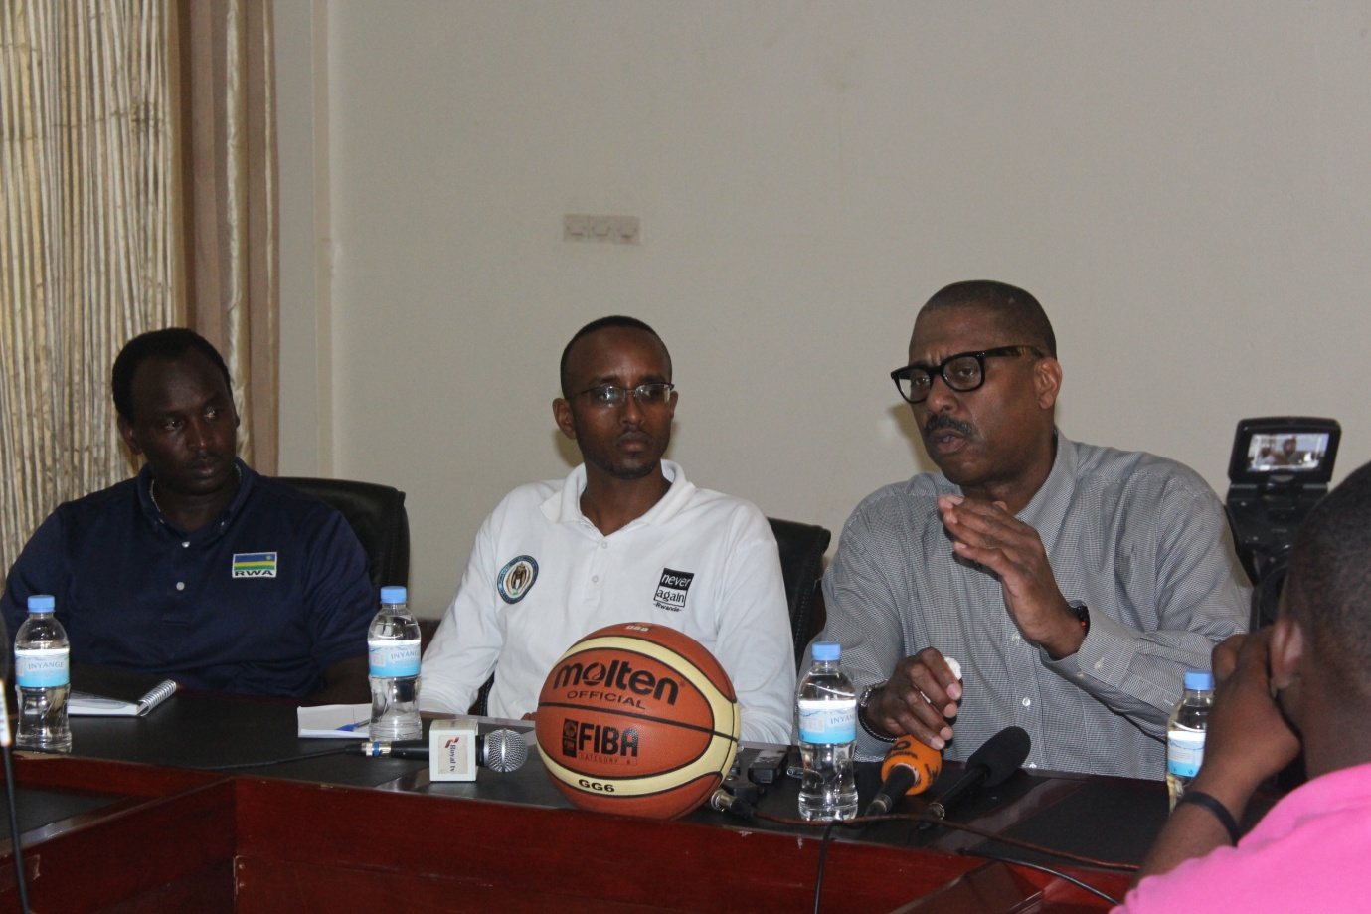
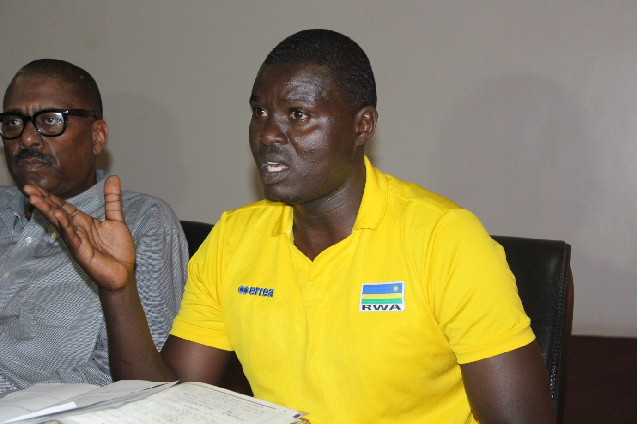

SPORTS POUR HANDICAPES : CHAMPIONNAT SITBALL 2017
Mu mukino w’abafite ubumuga wa sitball, kuwa 14.01.2017 hatangiye championnat y’amakipe y’abagabo n’ay’abagore, imikino yabereye mu ntara 4 na n’Umujyi wa Kigali.
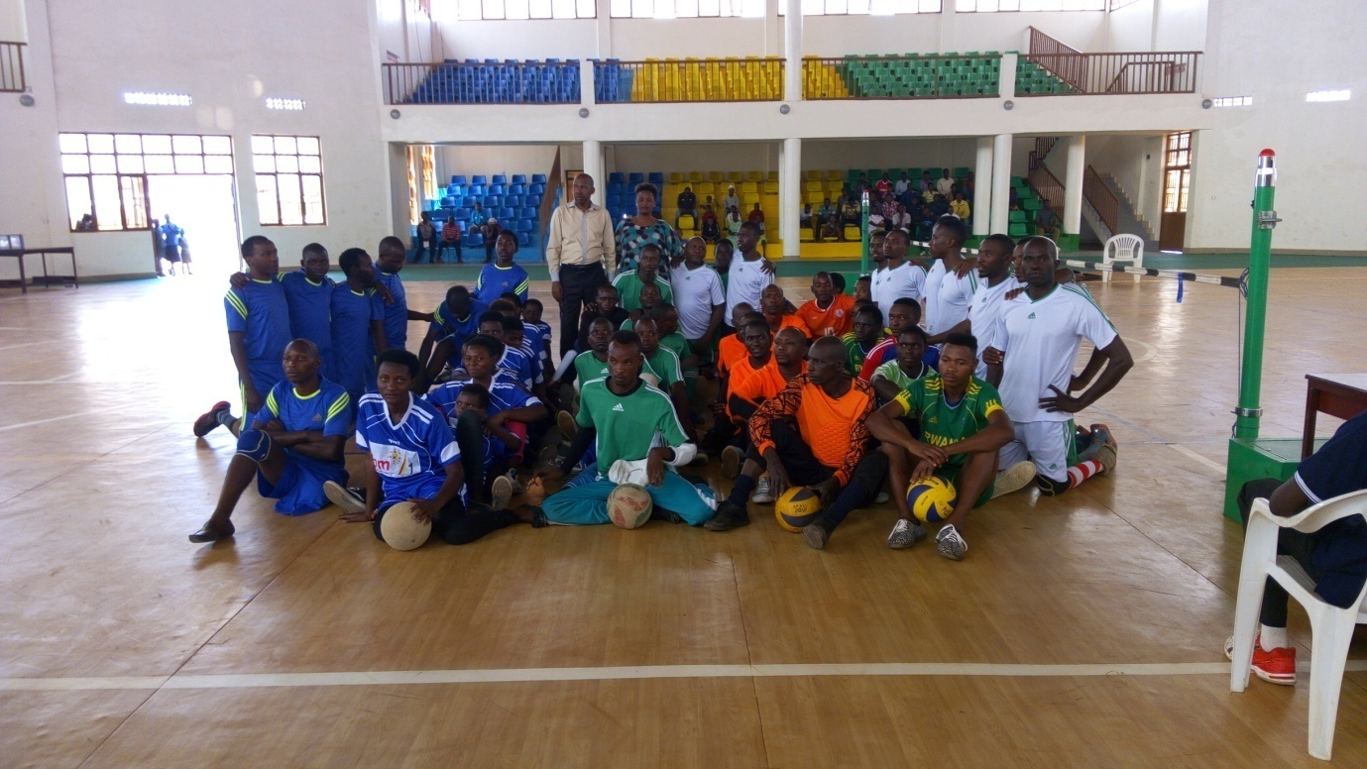

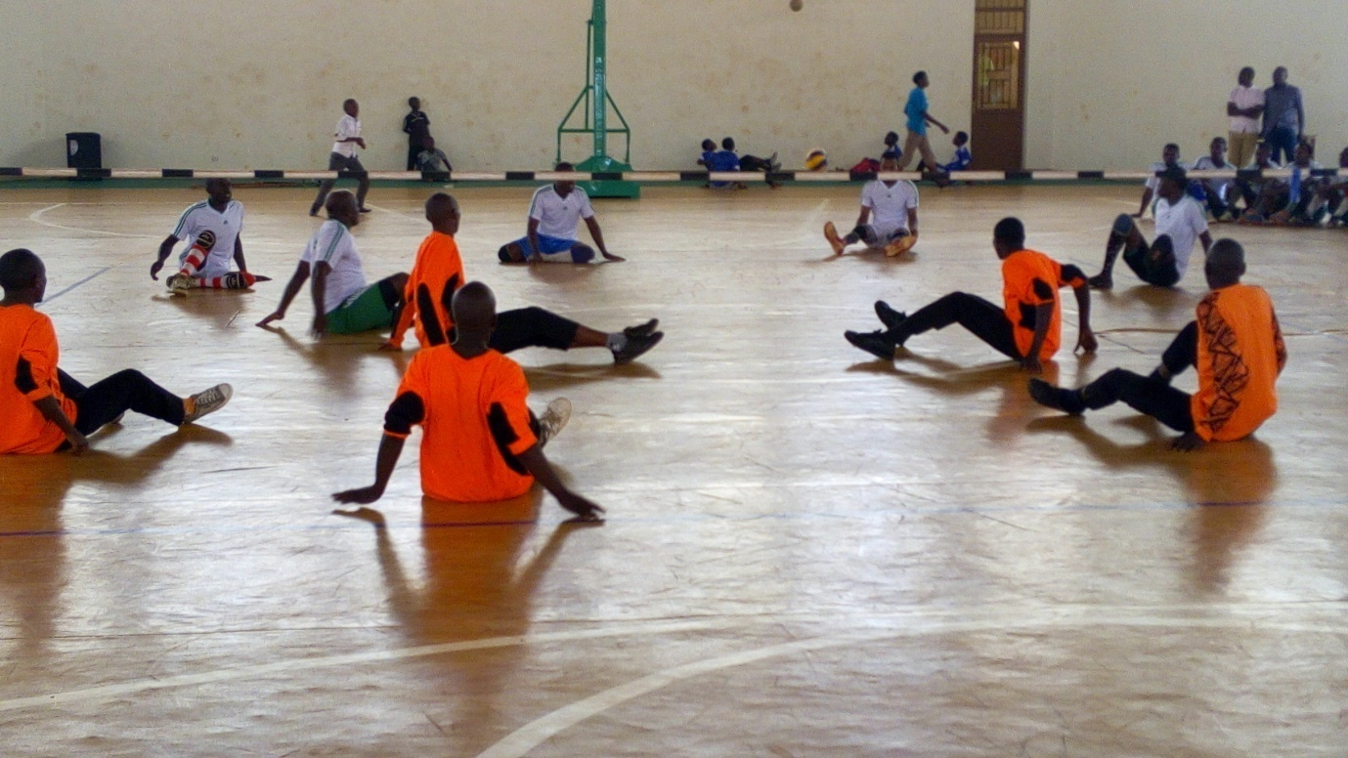

CYCLISME : RWANDA CYCLING CUP
Isiganwa Nemba - Kigali ryabaye kuwa 21.01.2017, niryo ryasoje irushanwa “Rwanda Cycling Cup 2016” ryarimo abakinnyi bari muri clubs zose zigize FERWACY
MU CYICIRO CY’ABAGABO
Uwa mbere yabaye GASORE HATEGEKA
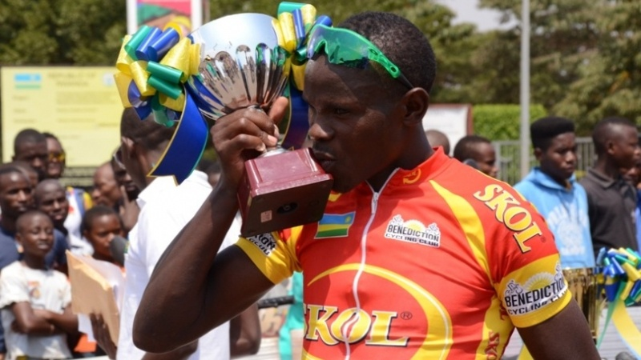
MU CYICIRO CY’ABAFITE MUNSI Y’IMYAKA 23
Uwa mbere yabaye UWIZEYE JEAN CLAUDE
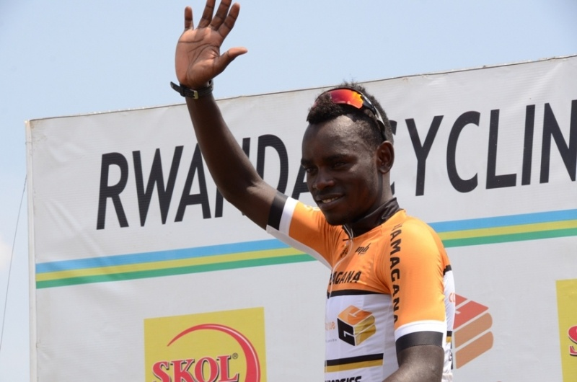
MU CYICIRO CY’ABAGORE
Uwa mbere yabaye INGABIRE BEATA
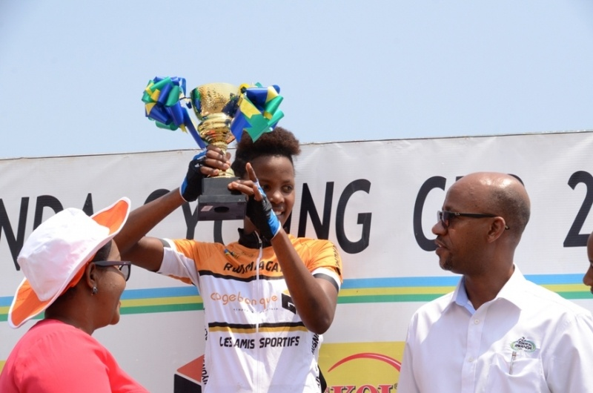
MU RWEGO RW’AMAKIPE
Iya mbere yabaye LES AMIS SPORTIFS y’ i Rwamagana
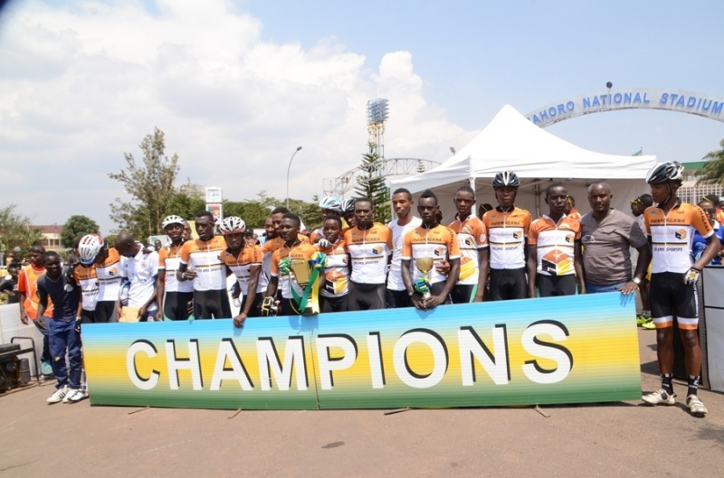

MINISPOC - NIC : ITORERO
Abayobozi ba Comité National Olympique et Sportif du Rwanda , amashyirahamwe y’imikino, bamwe mu bayobozi b’amakipe, bamwe mu banyamakuru b’imikino n’abandi bafatanyabikorwa ba MINISPOC basoje itorero ryabereye i Nkumba kuva kuwa 16 kugeza kuwa 29.01.2017.

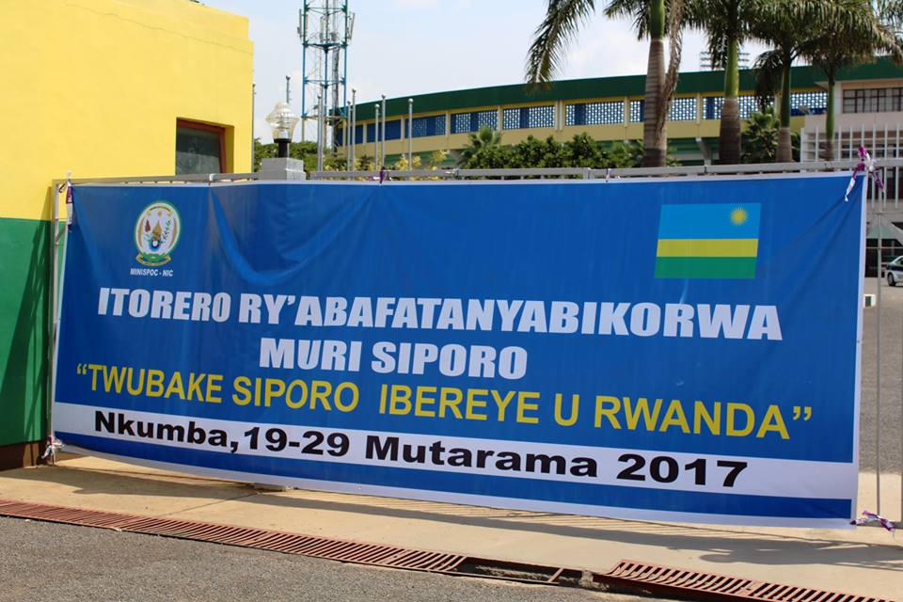

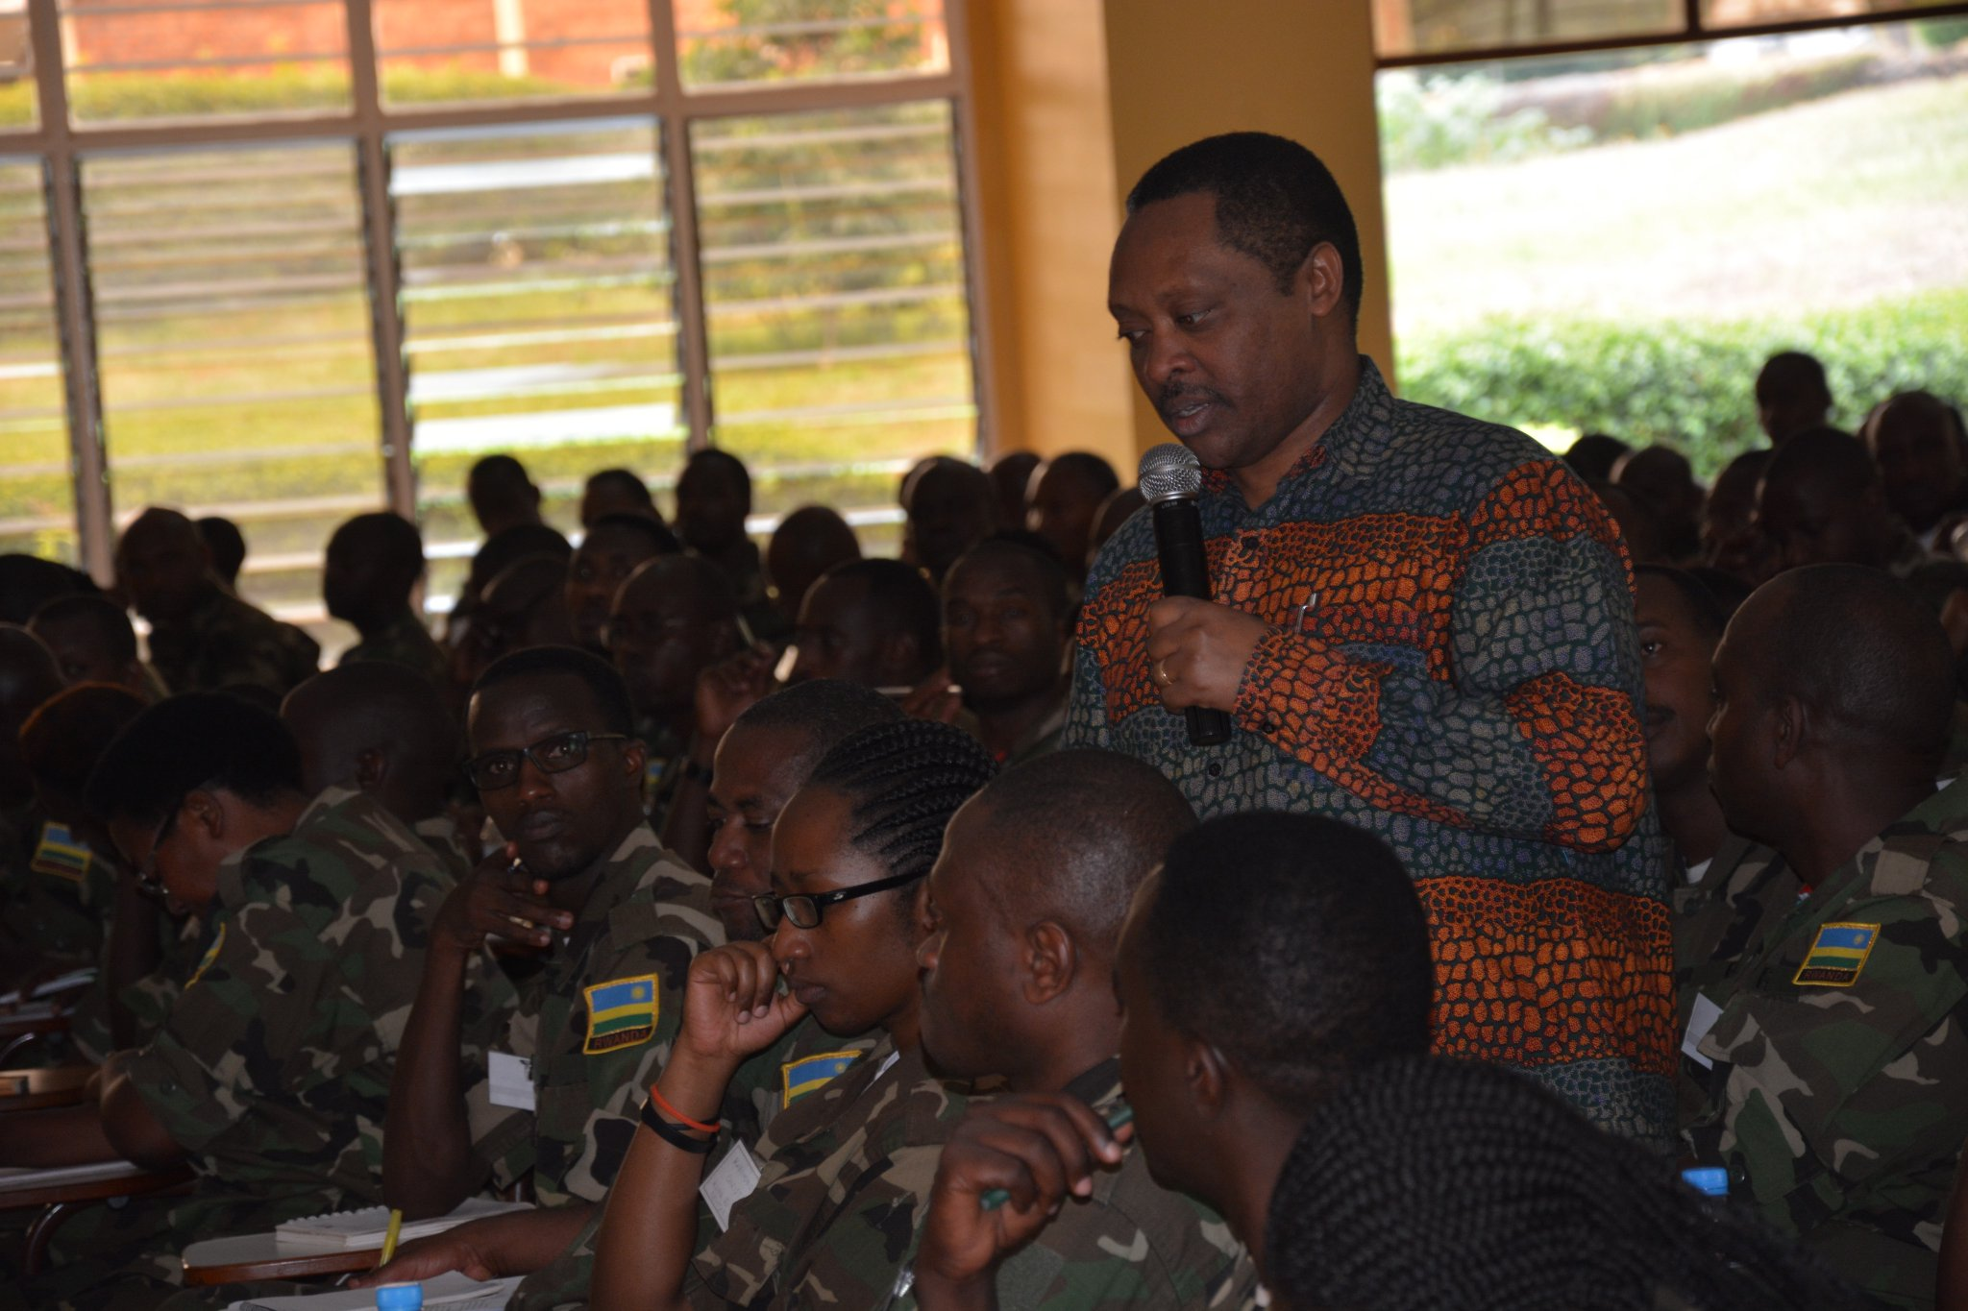

CNOSR - AFCNO : VOLONTAIRE 2017
Mlle GABRIELLE BECARD ni umukorerabushake (volontaire) muri CNOSR mu gihe cy’umwaka (2017), yaje ku bufatanye busanzwe hagati ya CNOSR na Association Francophone des Comités Nationaux Olympiques (AFCNO) .

