GICURASI 2017

ATHLETISME : 22 PLACENTIA HALF MARATHON
Abanyarwanda batatu, MUHITIRA FELICIEN, MANIRAFASHA PRIMIEN, MUKANDANGA CLEMENTINE bakinnye isiganwa mpuzamahanga ryo kwiruka 21 km (half marathon) ryabereye i Piacenza muri Italie kuwa 07.05.2017
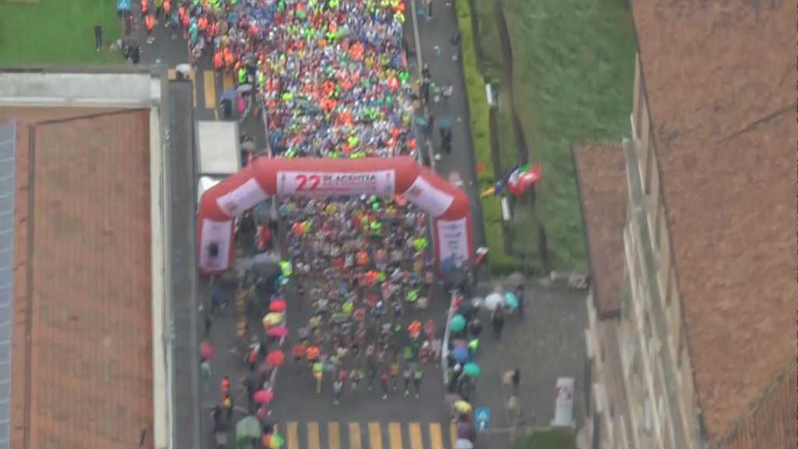
IMYANYA BAFASHE :
MUHITIRA FELICIEN : yabaye uwa mbere akoresheje 1h02’33’’
MANIRAFASHA PRIMIEN : yabaye uwa 4 akoresheje 1h04’07’’

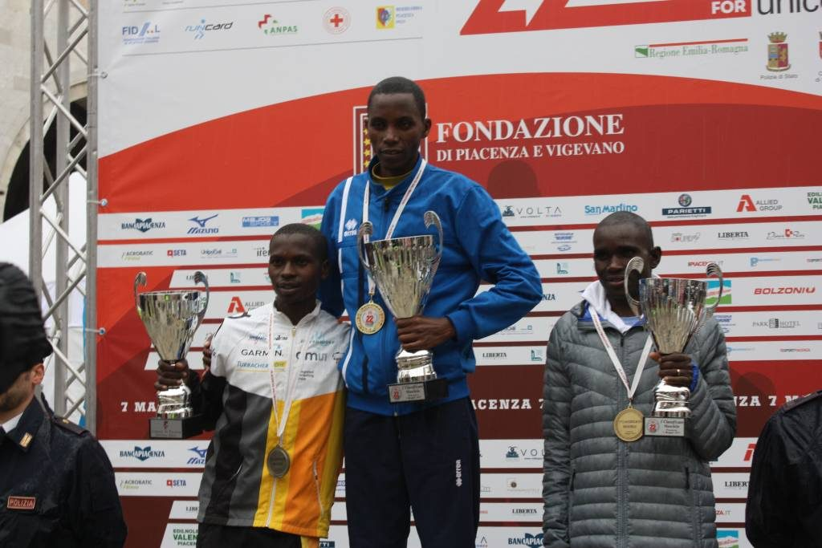MUHITIRA FELICIEN (uri hagati)

MUKANDANGA CLEMENTINE yabaye uwa 3 akoresheje 1h12’42’’
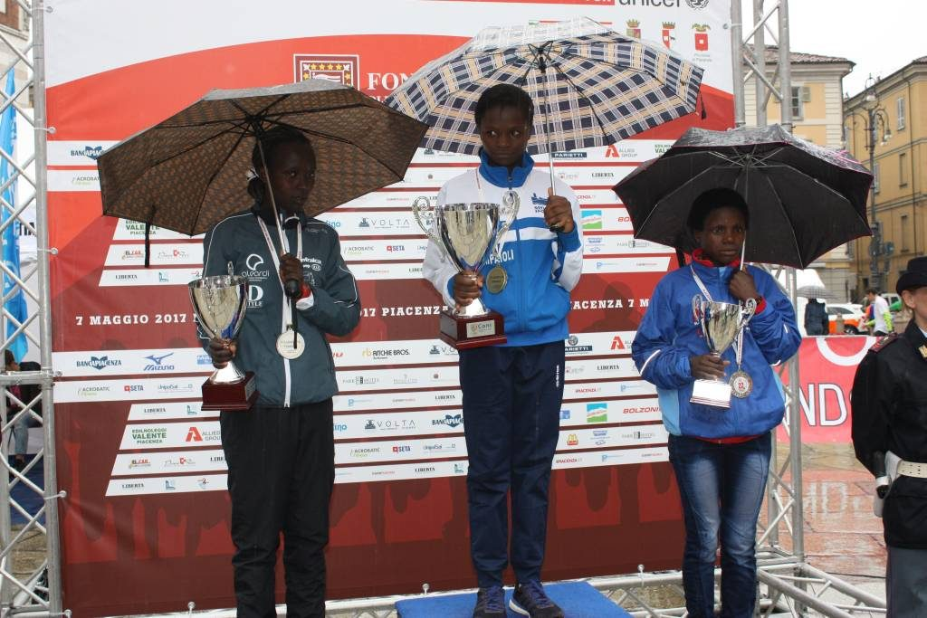MUKANDANGA CLEMENTINE (uwa mbere uturutse iburyo)
BASKETBALL : FIBA - FERWABA
Fédération Rwandaise de Basketball (FERWABA) kuwa 05.05.2017 yashyikirijwe na Fédération Internationale de Basketball (FIBA) icyemezo cy’ishimwe ryo kuba yarateje imbere umukino wa basketball mu bana b’abahungu mu myaka ya 2014 – 2017. Igikorwa cyo gushyikirizwa iki gihembo cyabereye muri Congrès ya FIBA yateraniye Hong Kong
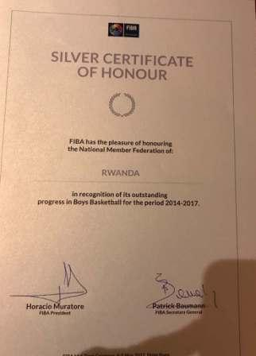

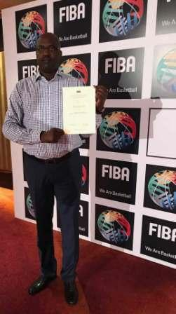
MUGWIZA DESIRE Président wa FERWABA
VOLLEYBALL : INTEKO RUSANGE IDASANZWE
Inama y’inteko rusange idasanzwe ya Fédération Rwandaise de Volleyball (FRVB) yateranye kuwa 06.05.2017, yabayemo amatora yo gusimbura abahoze muri komite nyobozi beguye. Abatowe n’imyanya batorewe:
1.KAREKEZI LEANDRE : Perezida
2.RUTERANA FERNAND : Visi Perezida wa kabiri
3.MUKAMURENZI PROVIDENCE : Umubitsi
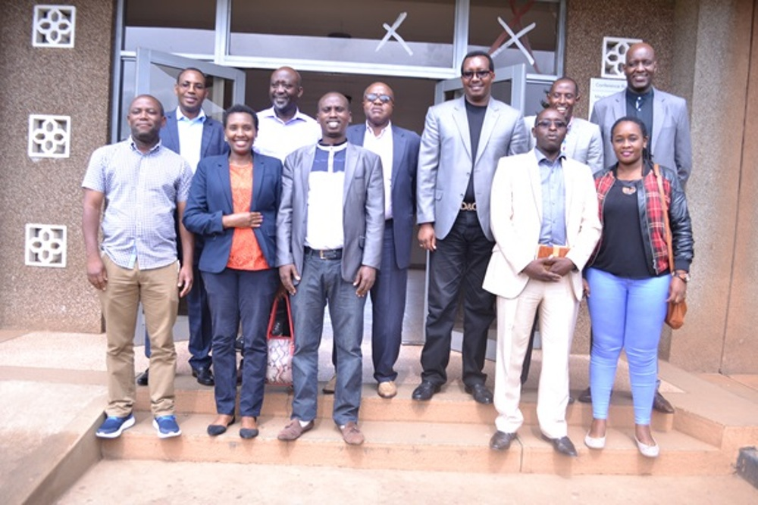

TAEKWONDO : ALLIANZ ATHLETE OF THE MONTH - APRIL 2017
Umunyarwanda NIRINGIYIMANA JEAN CLAUDE ukina taekwondo mu bafite ubumuga batarengeje 61kg yatorewe kuba umukinnyi mwiza ku isi w’ukwezi kwa 4.2017 muri uwo mukino.

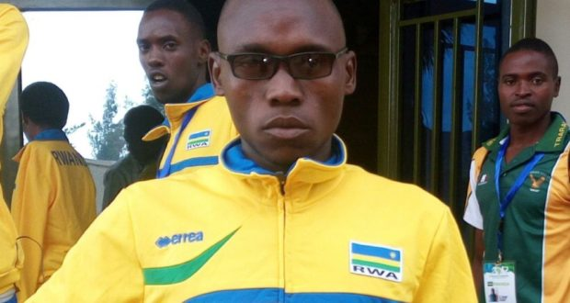NIRINGIYIMANA JEAN CLAUDE
Abikesha kuba yaratwaye umudari wa feza mu irushanwa ry’isi rya taekwondo “African Para Taekwondo Open” ryabereye mu Rwanda mu ntangiriro z’ukwezi kwa 4.2017; agahita ajya no ku mwanya wa 13 ku rutonde rw’isi.

FIFA CONGRESS
Mu nama y’inteko rusange ya Fédération Internationale de Football Association ( FIFA) yaterenaniye i Bahrein, umunyarwanda Honorable NGOGA MARTIN yashyizwe mu kanama ka FIFA gashinzwe ubugenzuzi n’imyitwarire. Asanzwe ari umudepite w’u Rwanda muri EALA

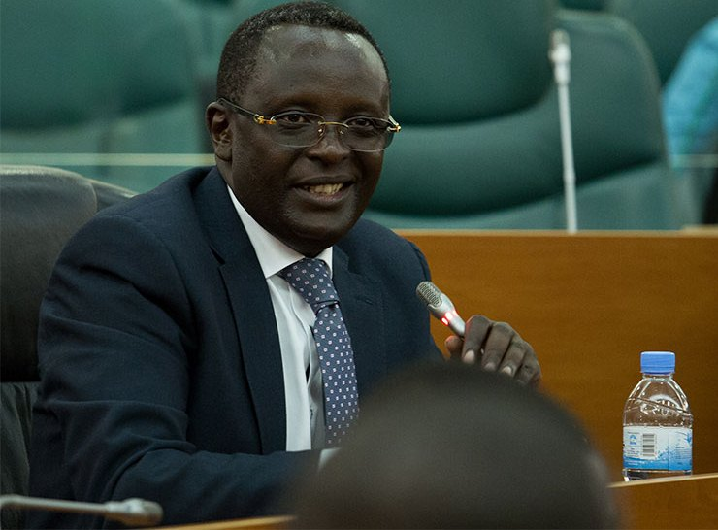Honorable NGOGA MARTIN
KUNG - FU WUSHU : INTEKO RUSANGE
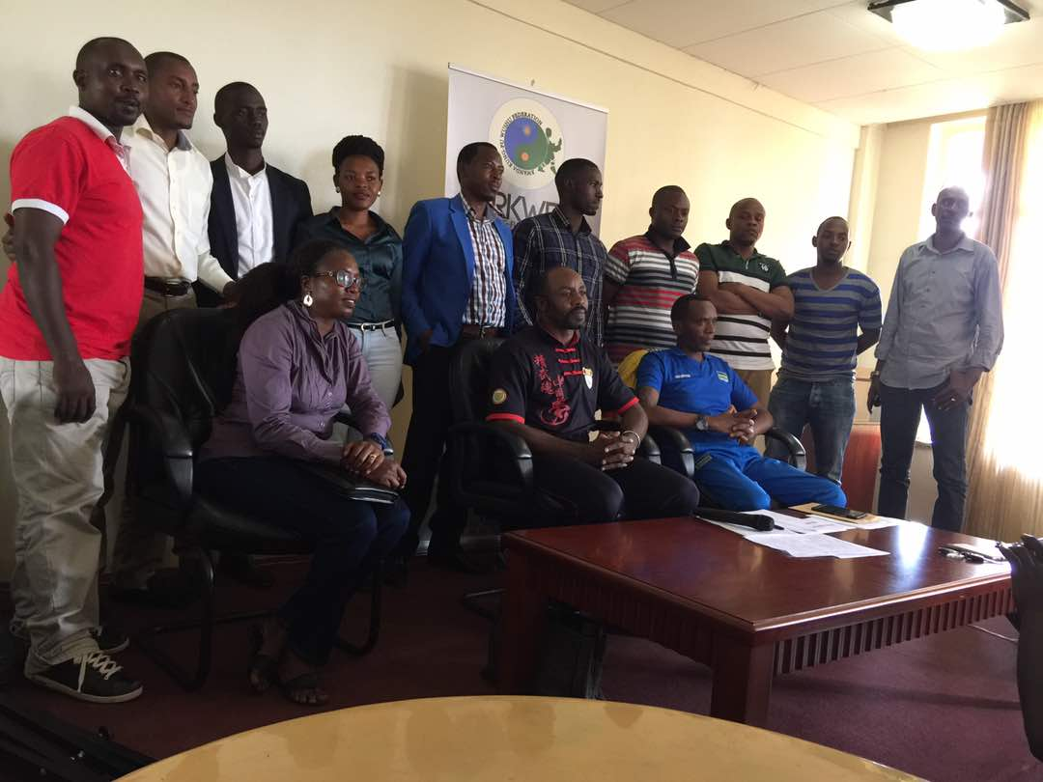
Kuwa 07.05.2017 hateranye inama y’inteko rusange ya Rwanda Kung - Fu Wushu Federation yabayemo amatora y’abayobozi bashya.

Perezida : UWIRAGIYE MARC
Visi Perezida : MAKUZA RICHARD
Umunyamabanga Mukuru : NSANZIMANA CLAUDE
Ushinzwe umutungo : DUSHIMIMANA PAULINE
Komite ngenzuzi : KALISA ERIC, RUKUNDO J.DAMASCENE
Komite nkemurampaka : HAKIZIMANA SHAFFY, KARENGERA ALPHONSE, HAVUGIMANA FRANCOIS
Ushinzwe tekinike : HAVUGIMANA EMMANUEL
Ushinzwe abasifuzi : IRYAMUKURU FESTUS
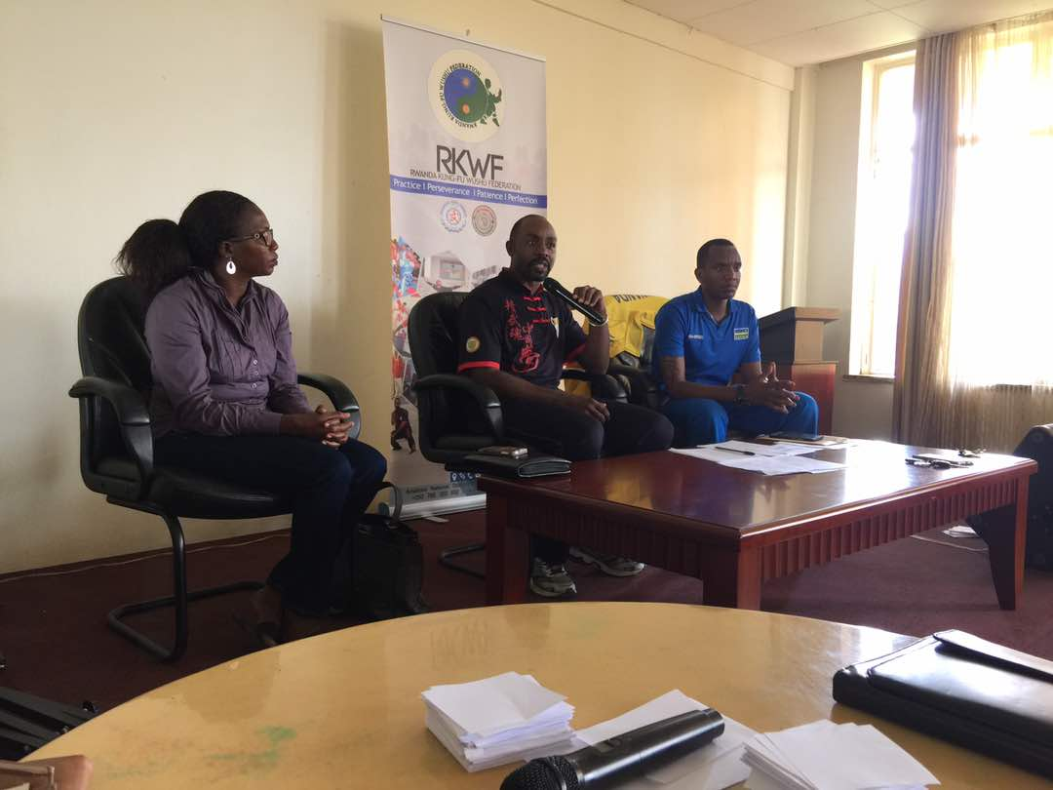
BEACH VOLLEYBALL AFRICAN NATIONS CUP
Ikipe y’igihugu y’abagore n’iy’abagabo kuva kuwa 12 kugeza kuwa 14.05.2017 zari mu irushanwa ry’igikombe cy’Afurika ryabereye i Maputo muri Mozambique riganisha ku mikino y’isi.

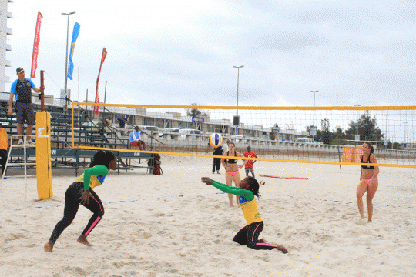
Ikipe y’abagore yari igizwe na MUTATSIMPUNDU DENYSE na NZAYISENGA CHARLOTTE
Ikipe y’abagabo yari igizwe na NDAMUKUNDA FLAVIEN na AKUMUNTU KAVALO PATRICK

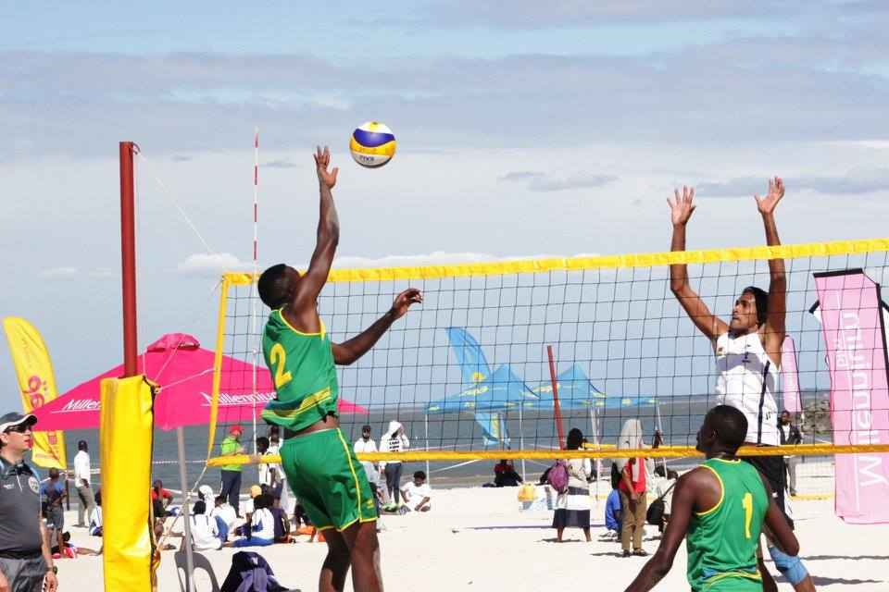
Ikipe y’u Rwanda y’abagore yegukanye umudari wa zahabu n’igikombe cy’Afurika nyuma yo gutsinda ku mukino wa nyuma ikipe ya Maroc seti 2 - 1, banatsindira kujya mu irushanwa ry’igikombe cy’isi i Vienne muri Autriche.
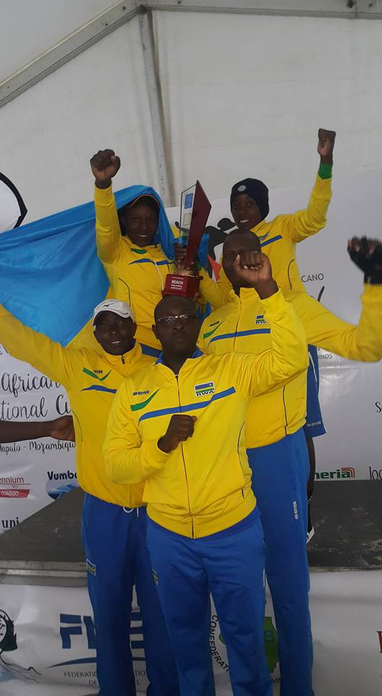
Ikipe y’abagabo yafashe umwanya wa 5, Maroc yegukana umudari wa zahabu n’igikombe mu makipe y’abagabo.

KIGALI INTERNATIONAL PEACE MARATHON 2017
Kuwa 21.05.2017 habaye irushanwa mpuzamahanga ryo gusiganwa kwiruka 21km (half marathon), 42km (full marathon), no kwiruka bitari irushanwa (run for peace).
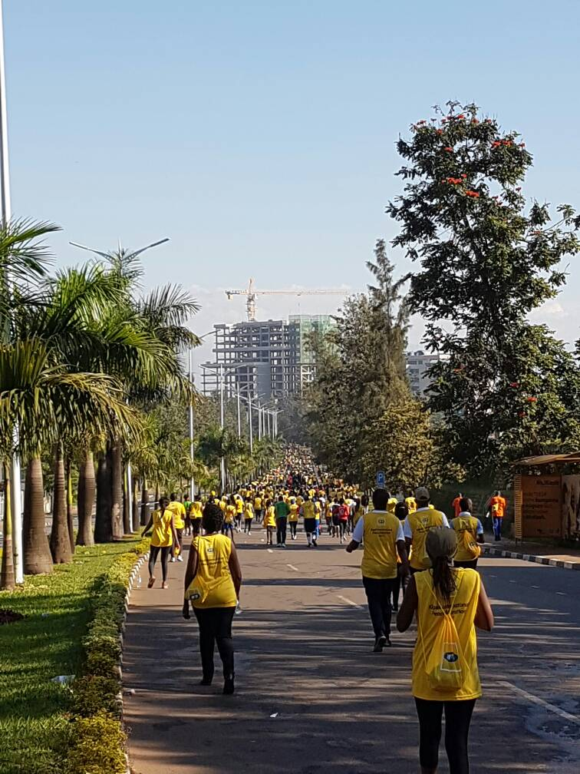
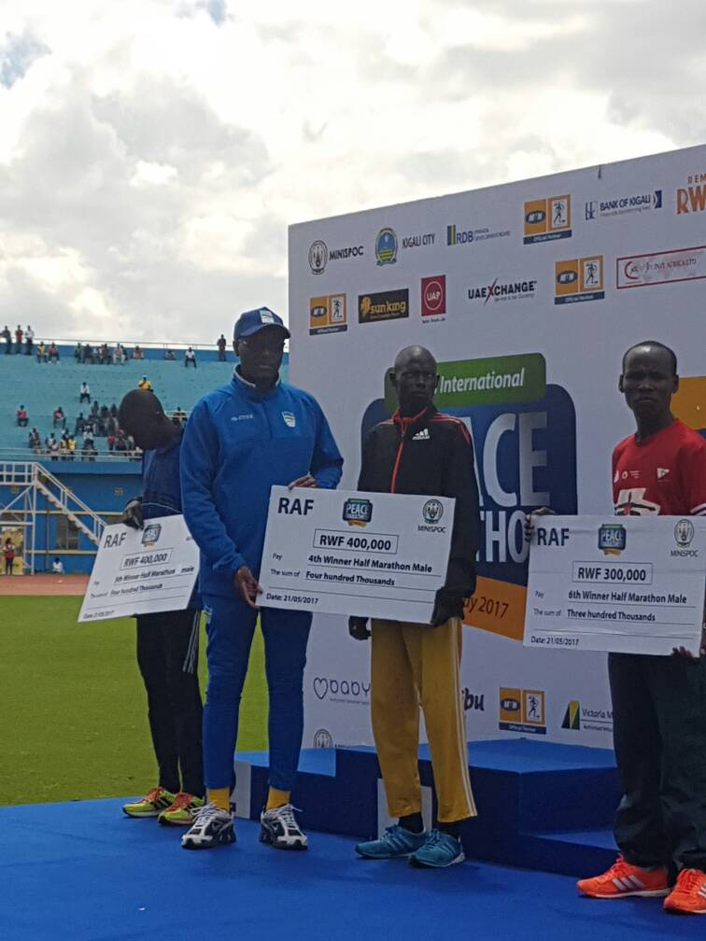

ABAFASHE IMYANYA ITATU YA MBERE
A.HALF MARATHON (21 km)
ABAGORE
1.NYIRARUKUNDO SALOME (RWANDA) 1h15’28’’
2.CHESANG SHEILA (KENYA) 1h20’24’’
3.MUKASAKINDI CLAUDETTE (RWANDA) 1h20’36’’
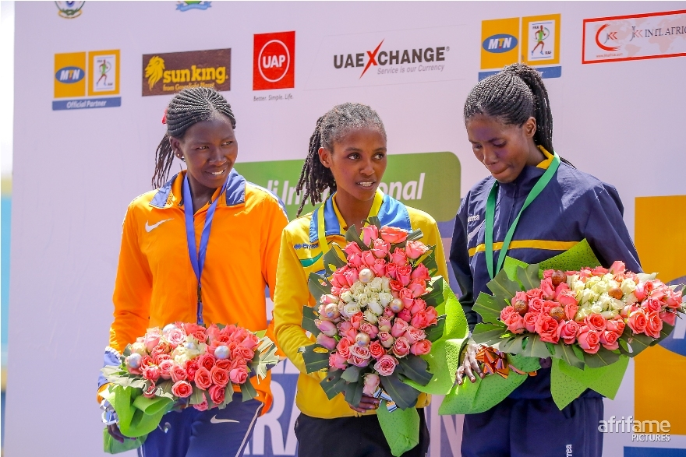
ABAGABO
1.KIPKOECH BARTILE KIPTOO (KENYA) 1h04’25’’
2.MUTAI EZEKIEL KIMELI (KENYA) 01h05’38’’
3.HAKIZIMANA JOHN (RWANDA) 01h05’48’’
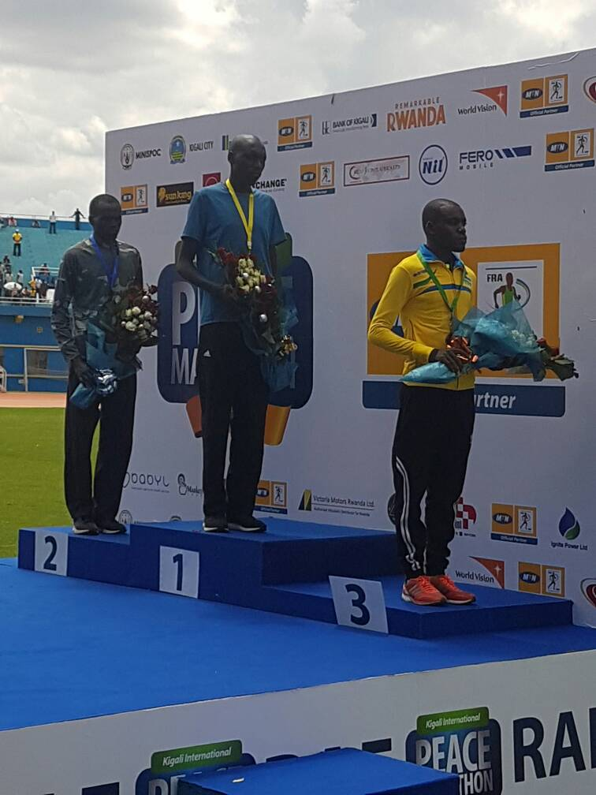
B.FULL MARATHON (42 km)
ABAGORE
1.RUTTO BEATRICE JEPKORIR (KENYA) 02h46’38’’
2.BUNDOTICH PAMELA CHEPKOECH (KENYA) 02h47’21’’
3.JEROP LEGAT SARAH (KENYA) 02h47’24’’
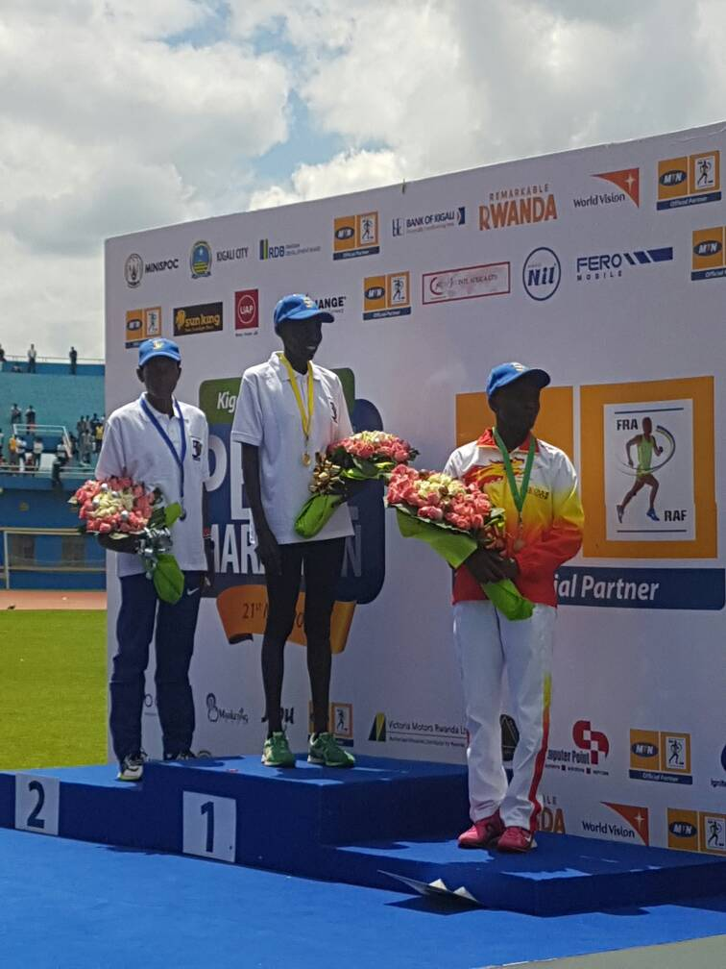
ABAGABO
1.CHUMBA GILBERT KIPLETING (KENYA) 02h19’49’’
2.KIYENG EDWIN KEMBOI (KENYA) 02h19’57’’
3.TALLAM JAMES (KENYA) 02h20’00’’
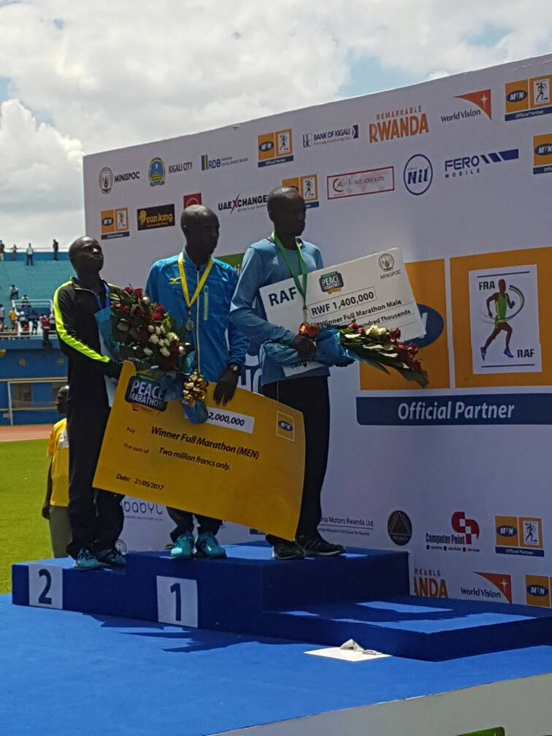
C.RUN FOR PEACE (7 km)
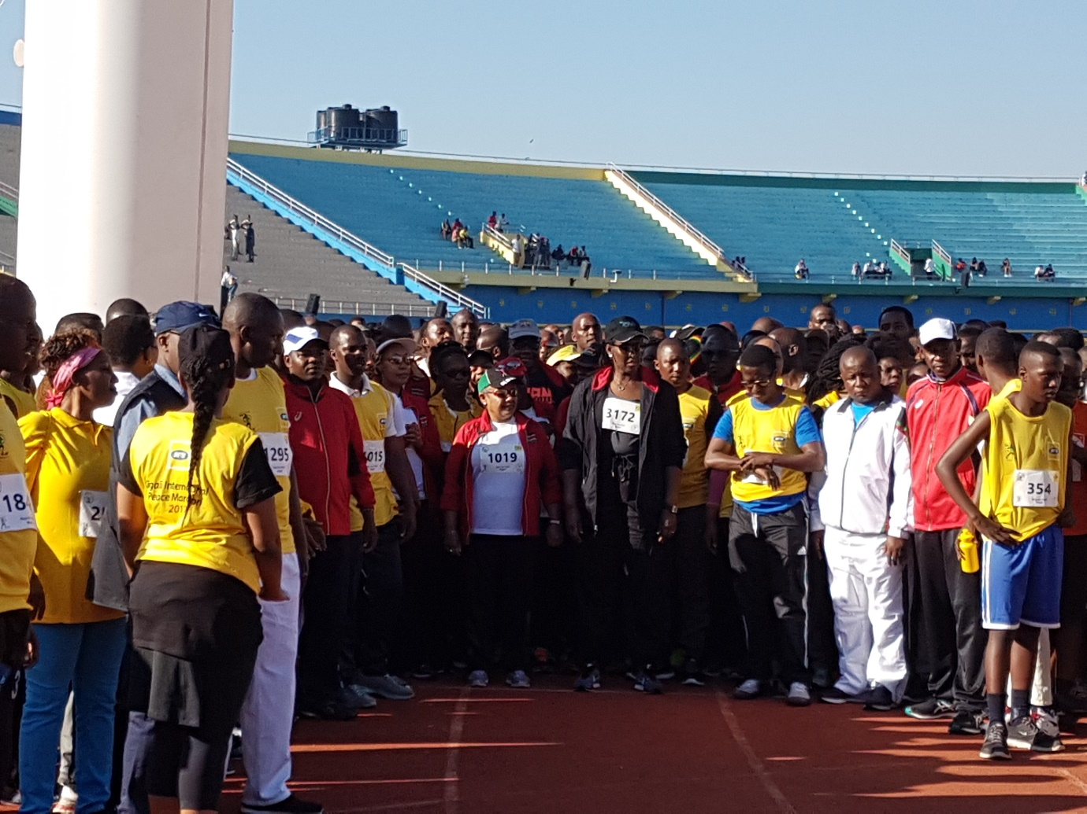
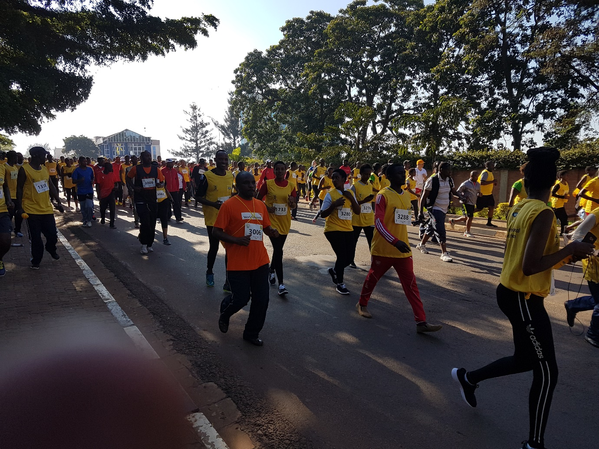
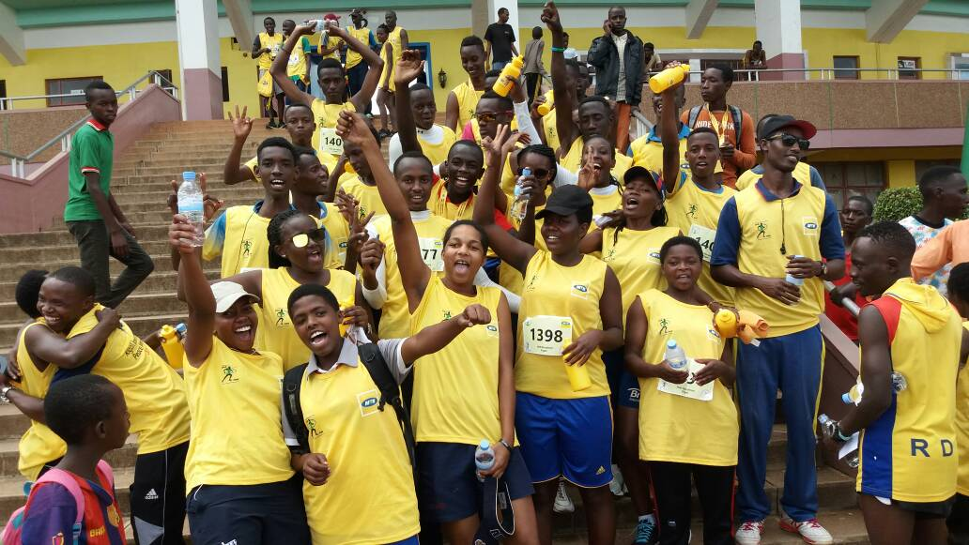
ATHLETISME : CHAMPIONNAT NATIONAL DANEMARK
MUHITIRA FELICIEN na MUKANDANGA CLEMENTINE bari mu irushanwa ryo kwiruka 10.000m mu kibuga, ryabereye muri Danemark kuwa 20.05.2017; bagamije gushaka minima za championnat du monde - Londres 2017.
MUHITIRA FELICIEN yabaye uwa mbere akoresheje 28’10’’
MUKANDANGA CLEMENTINE yabaye uwa kabiri akoresheje 32’30’’
Bombi ntabwo bashoboye kubona minima
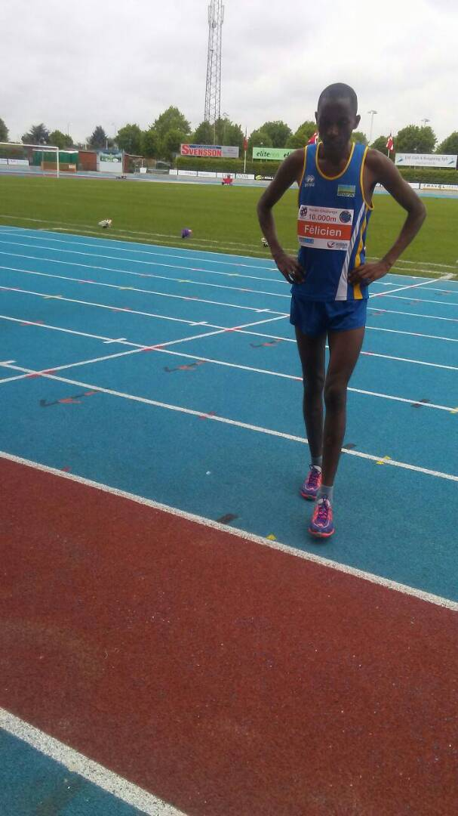
SPORT AUTOMOBILE : RALLYE DE L’EST 2017
Isiganwa mpuzamahanga ryarimo imodoka 9 : 6 zo mu Rwanda na 3 zo mu Burundi, ryabereye mu karere ka Bugesera kuwa 20.05.2017
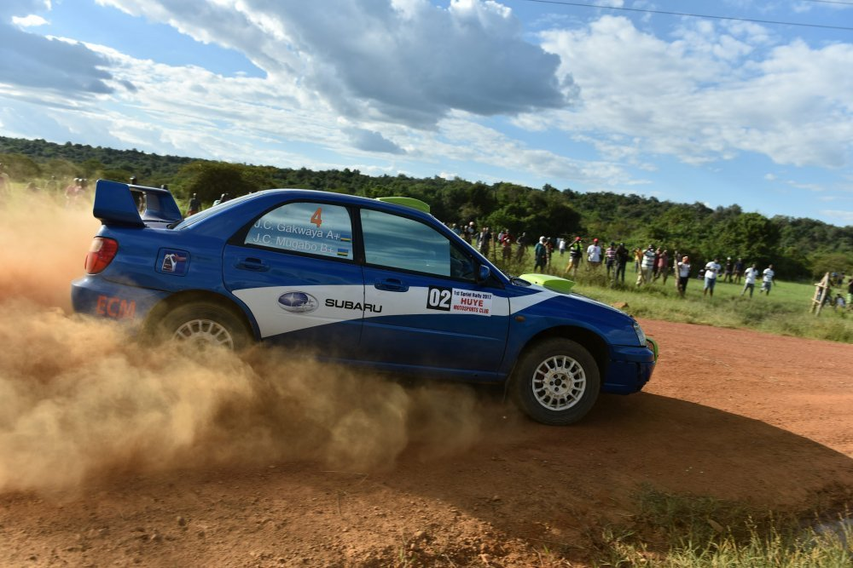
ABAFASHE IMYANYA ITATU YA MBERE
1.Gakwaya Claude na Mugabo Claude (Rwanda) bari mu modoka Subaru Impreza
2.Giesen Jean Jean na Maceri Diaz (Burundi) bari mu modoka Toyota Celica
3.Mutuga Janvier na Kayitankole Lionel (Rwanda) bari mu modoka Toyota Corolla
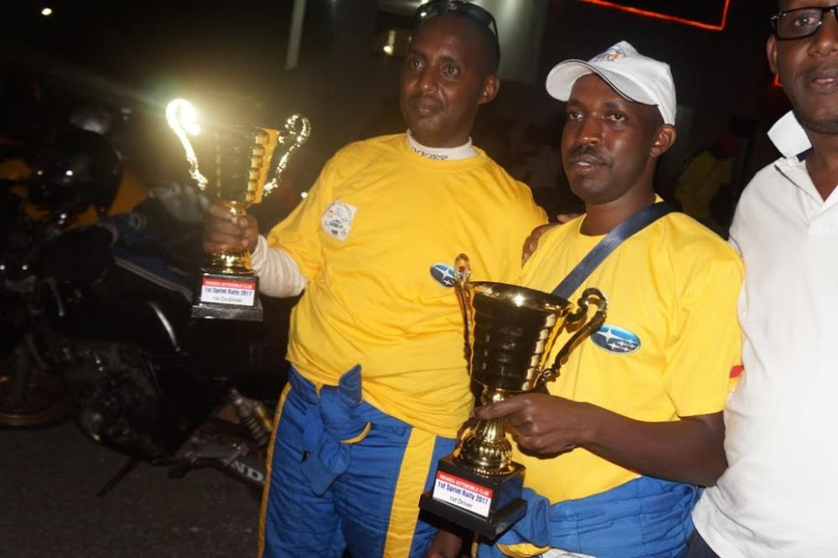

MEET THE PRESIDENT
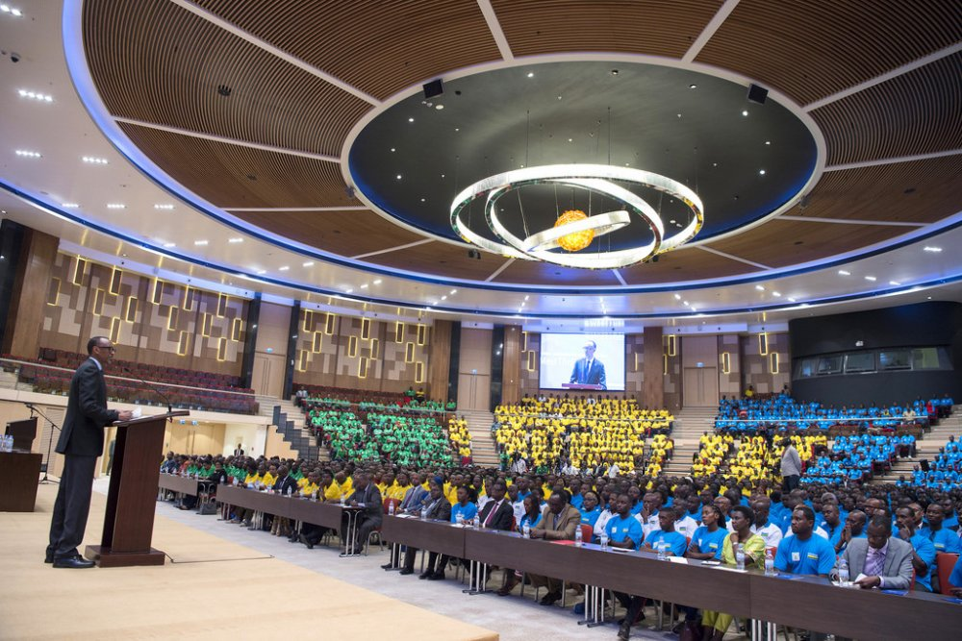
Abanyuze mu matorero akurikira :
ITORERO IMPARIRWAKUBARUSHA (abo muri siporo)
ITORERO IMPAMYABIGWI (abanyamakuru)
INDATABIGWI (abahanzi)
n’abandi bari mu mashyihamwe n’inzego z’imikino, iz’abahanzi n’iz’itangazamakuru; kuwa 27.05.2017 bahuye na Perezida wa Repubulika Paul KAGAME muri Kigali Convention Center.
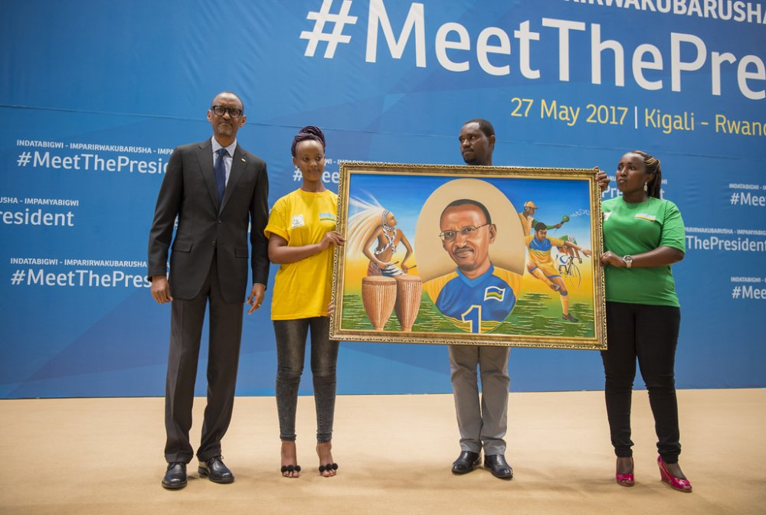
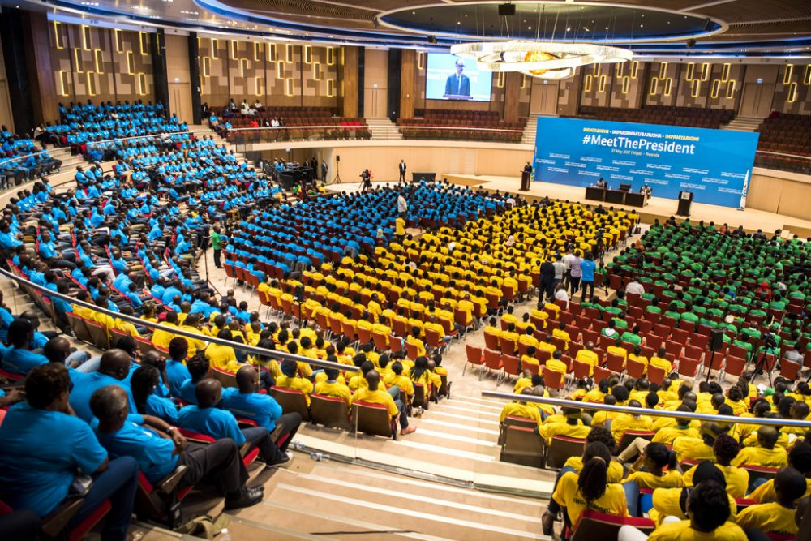
CNOSR : COURS D’ADMINISTRATION DU SPORT FRA, FRSS
Abari muri Fédération Rwandaise d’Athletisme no muri Fédération Rwandaise du Sport Scolaire, kuva taliki 24 kugeza kuya 26.05.2017 bahuriye i Kigali mu mahugurwa ku miyoborere ya siporo.
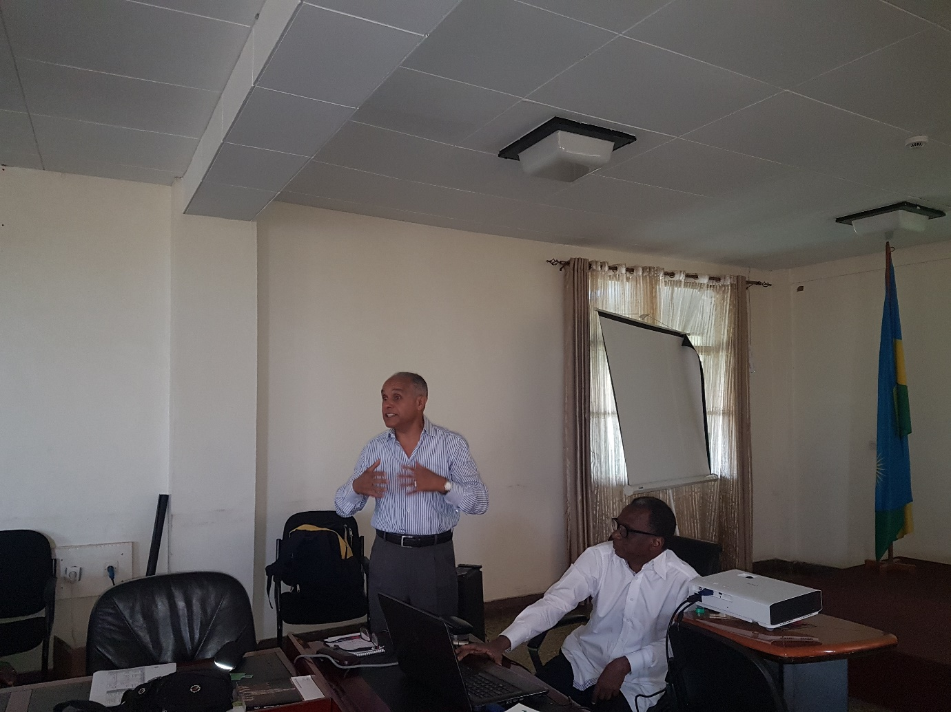
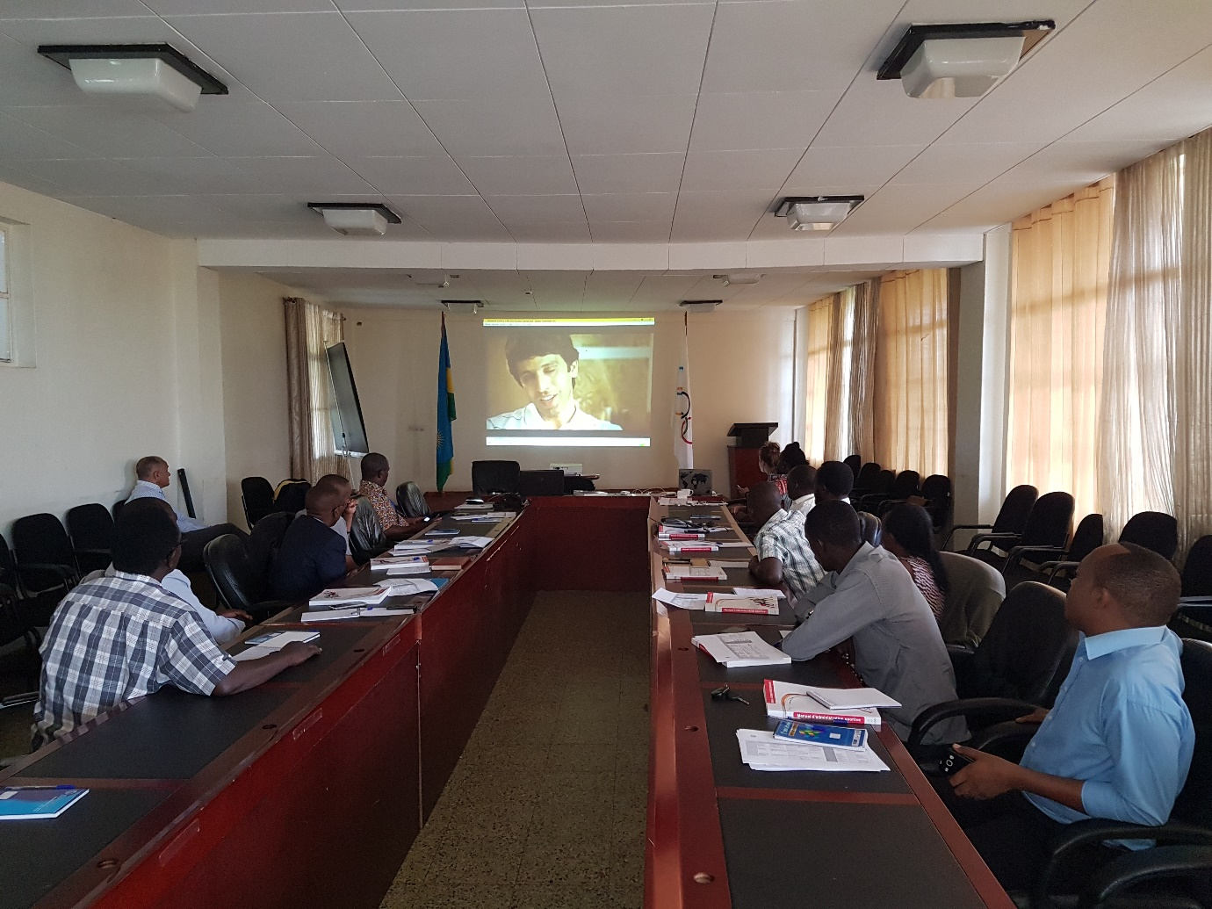
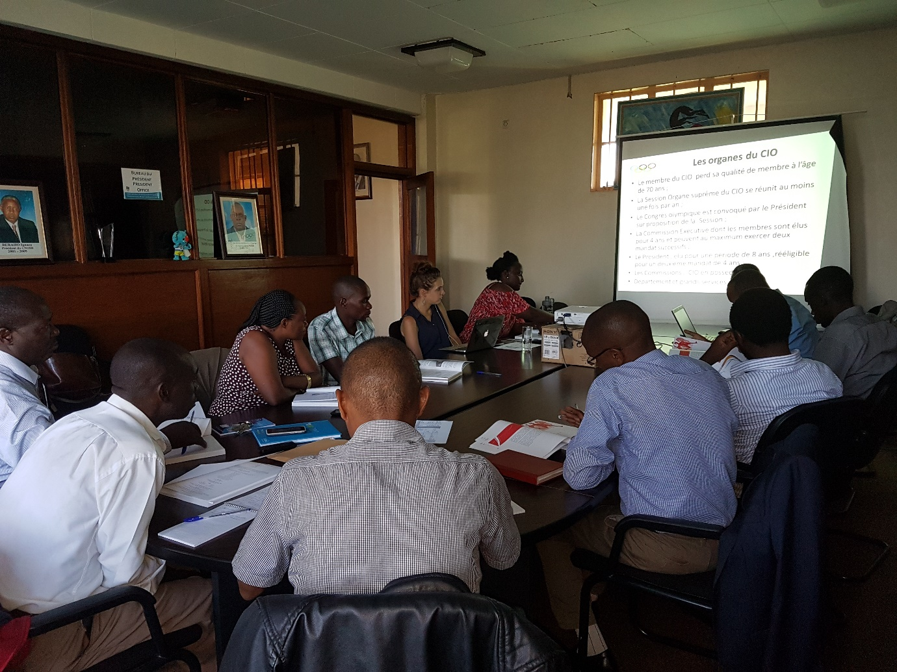
TAEKWONDO : AMBASSADOR’S CUP 2017
Irushanwa mpuzamahanga ryarimo abakinnyi bo mu bihugu 5 : UGANDA, RD CONGO, RWANDA, TANZANIE KENYA; ryabereye i Kampala kuwa 27 na 28.05.2017.
Ikipe y’u Rwanda yari igizwe n’abakinnyi 8, muri bo 7 batwaye imidari ya zahabu :
1.KAYITARE BENON
2.UKWIGIZE JEAN DE DIEU
3.NIZEYIMANA SAVIO
4.TWIZEYIMANA MOUSSA
5.MWEMEZI CEDRICK
6.NDACYAYISENGA ALINE
7.UWAYO CLARISSE
