SO - CNOSR - RTF: STAGE TECHNIQUE
Abatoza 24 ba taekwondo bahawe amahugurwa ya niveau I yayobowe na Master KIM HONGSEAK ukomoka muri COREE, yabereye I Kigali kuva kuwa 27.06.2016 kugeza kuwa 30.06.2016
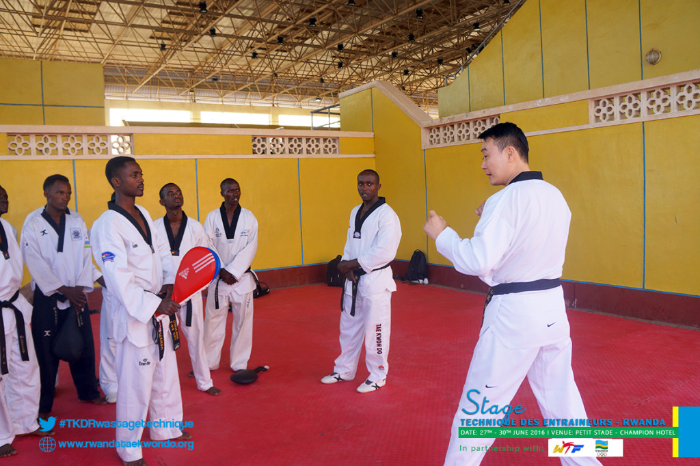
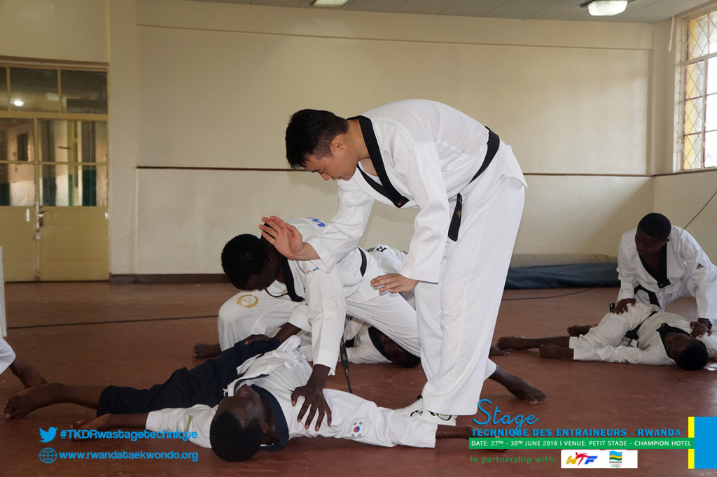
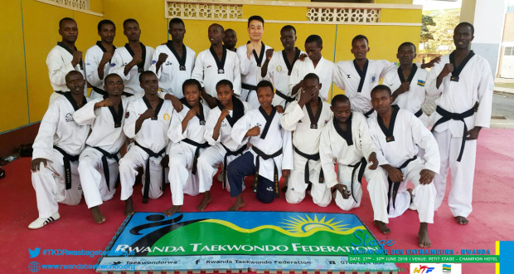
SPORTS POUR HANDICAPES: SITTING VOLLEYBALL: DUTCH TOURNAMENT
Kuwa 01 - 03.07.2016
Ikipe y’igihugu y’abagore yiteguraga Jeux Paralympiques - Rio 2016 yagiye mu irushanwa mpuzamahanga ryabereye mu Hollande kuva kuwa 01.07.2016 kugeza kuwa 03.07.2016
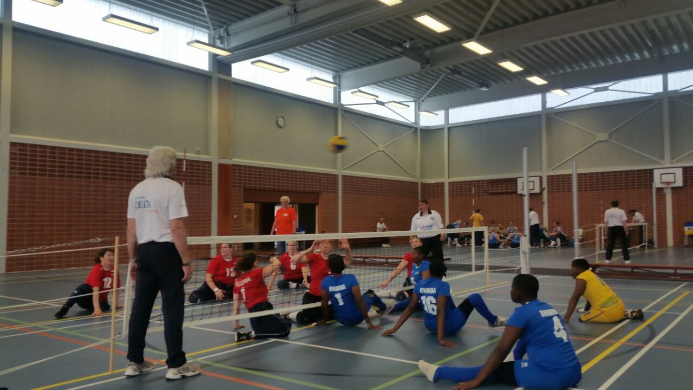
Uko imikino y’ikipe y’u Rwanda yagenze :
RWANDA 0 - 3 HOLLANDE
RWANDA 0 - 3 RUSSIE
RWANDA 0 - 3 UKRAINE
RWANDA 0 - 3 CHINE
RWANDA 0 - 3 USA

FOOTBALL: COUPE DE LA PAIX 2016
Kuwa 04.07.2016 habaye imikino ya nyuma y’irushanwa ngarukamwaka ry’igikombe cy’Amahoro
GUKINIRA UMWANYA WA 3
AS KIGALI 1 - 0 ESPOIR
UMUKINO WA NYUMA
RAYON SPORTS 1 - 0 APR
Igikombe cy’Amahoro cyatwawe na Rayon Sports
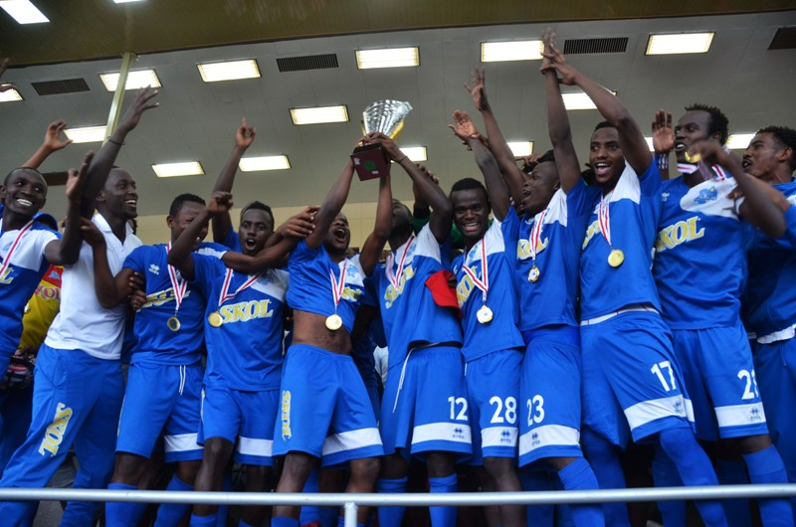RAYON SPORTS
BASKETBALL : PLAY - OFFS
Imikino ya nyuma ya play – offs yabaye kuwa 10.07.2016
UMUKINO WABAYE UWA NYUMA WO GUKINIRA UMWANYA WA 3
IPRC KIGALI 69 - 57 ESPOIR
UMUKINO WABAYE UWA NYUMA WO GUKINIRA IGIKOMBE
IPRC SOUTH 58 - 56 PATRIOTS
Umwanya wa gatatu wa play - offs watwawe na IPRC KIGALI, igikombe gitwarwa na IPRC SOUTH.
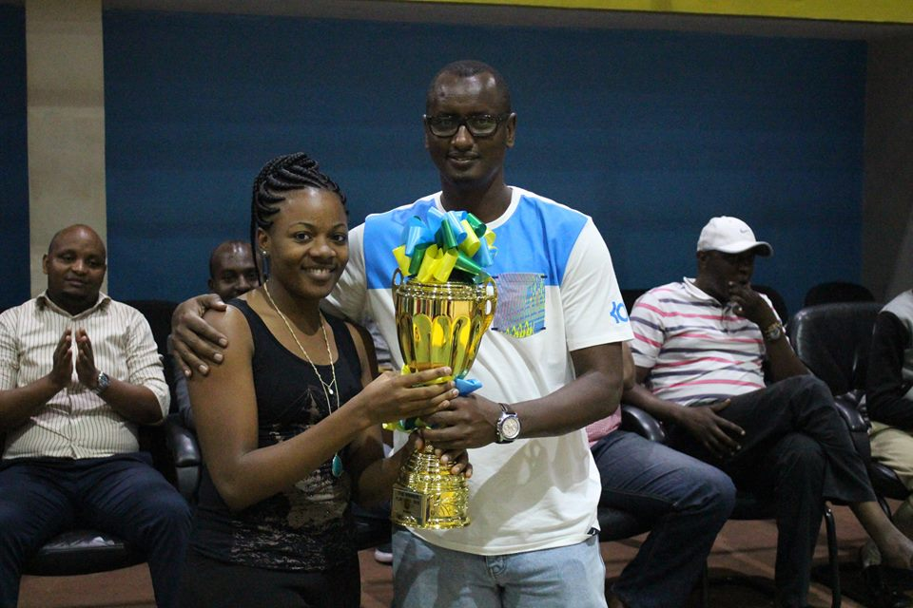UBUMWE yatwaye igikombe cya play-offs mu makipe y’abagore

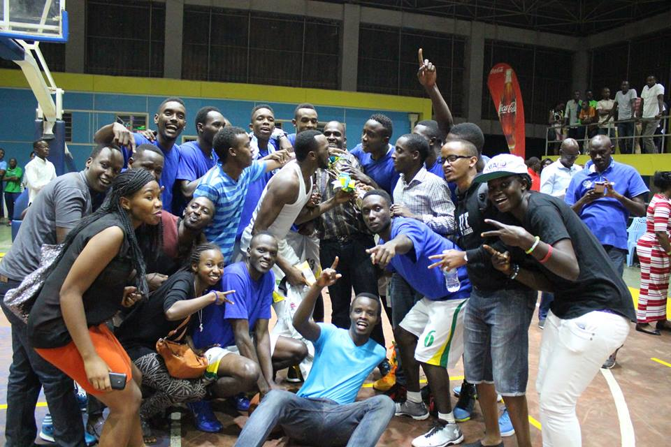
IPRC SOUTH yatwaye igikombe cya play-offs mu makipe y’abagabo

Hatanzwe n’ibikombe ku makipe yatwaye icya championnat “saison regulière’’
Mu makipe y’abagore cyatwawe na APR BBC.
Mu makipe y’abagabo cyatwawe na PATRIOTS

OLYMPAFRICA - CNOSR
REUNION DU RESEAU OLYMPAFRICA: NYANZA 15 - 17.07.2016
Centre Olympafrica y’i Nyanza yakiriye inama yahuje abayobozi ba centres OLYMPAFRICA bo mu bihugu 15: Mozambique, Uganda, Tanzanie, Malawi, Zambie, Ile Maurice, Lesotho, Seychelles, Burundi, Zimbabwe, Soudan, R.D.Congo, Somalie, Senegal, Rwanda; yabereye i Nyanza kuva kuwa 15.07.2016 kugeza kuwa 17.07.2016.
Imirimo y’iyo nama yasojwe n’umuyobozi w’akarere ka Nyanza Erasme Ntazinda.
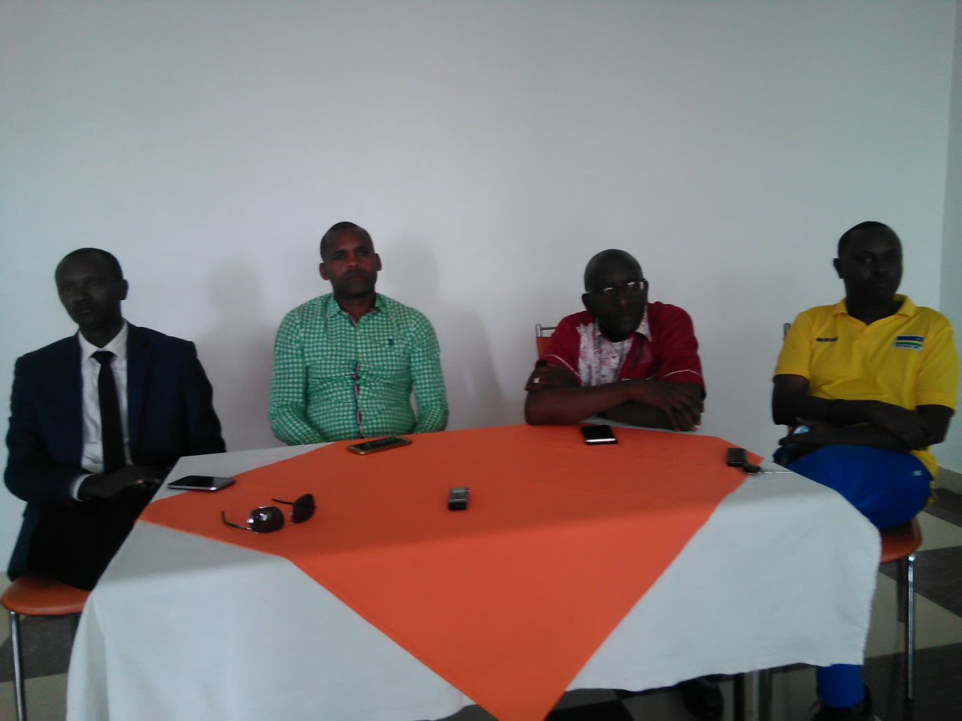
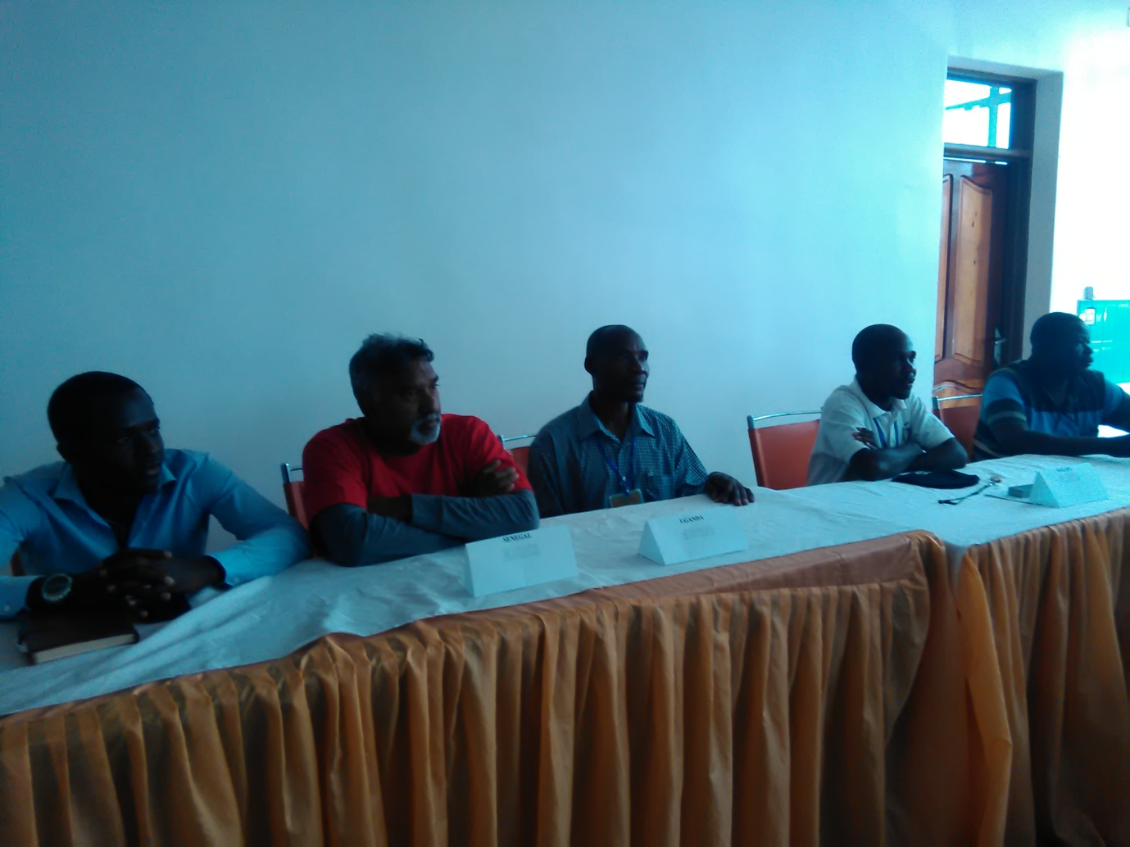
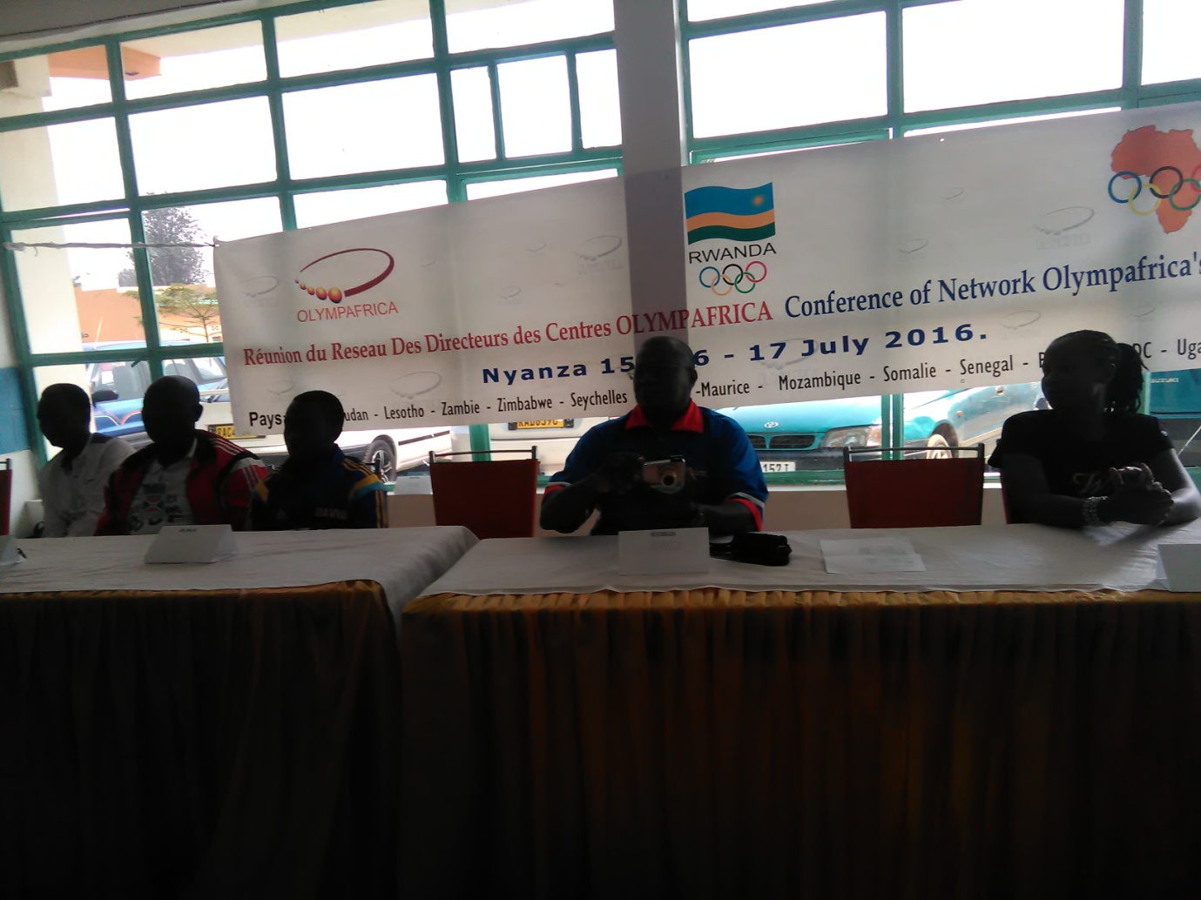
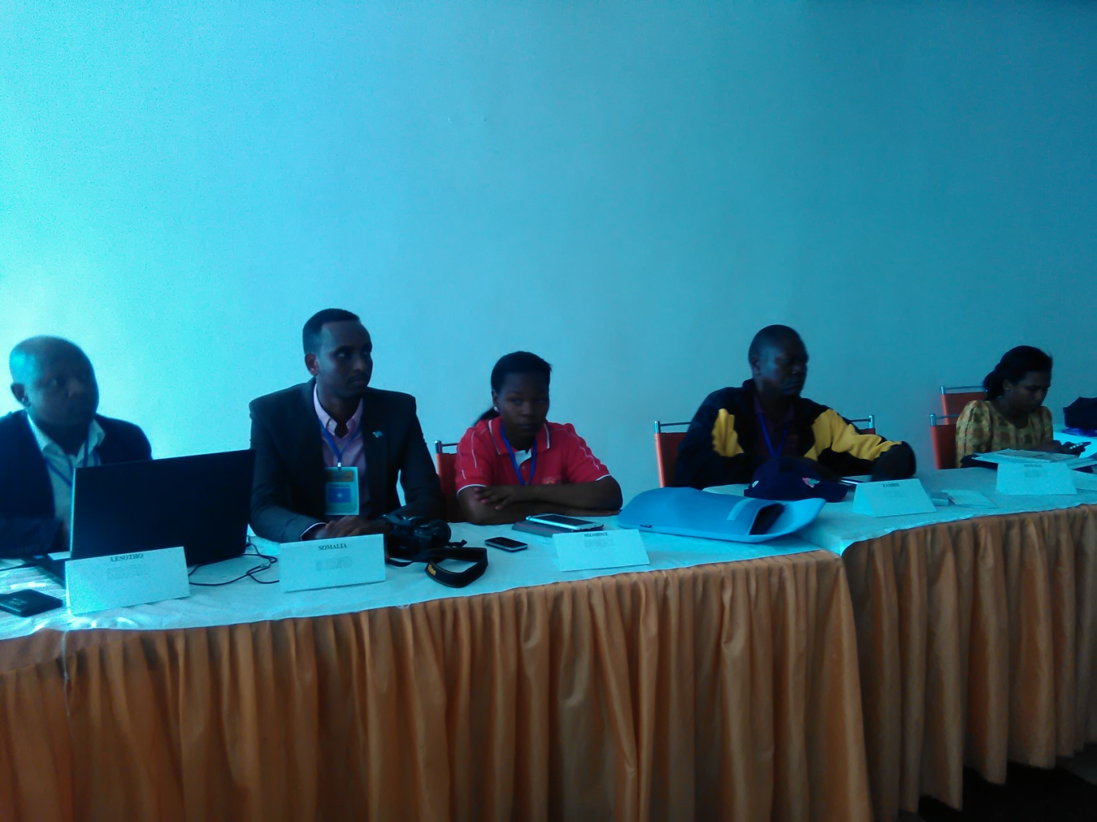
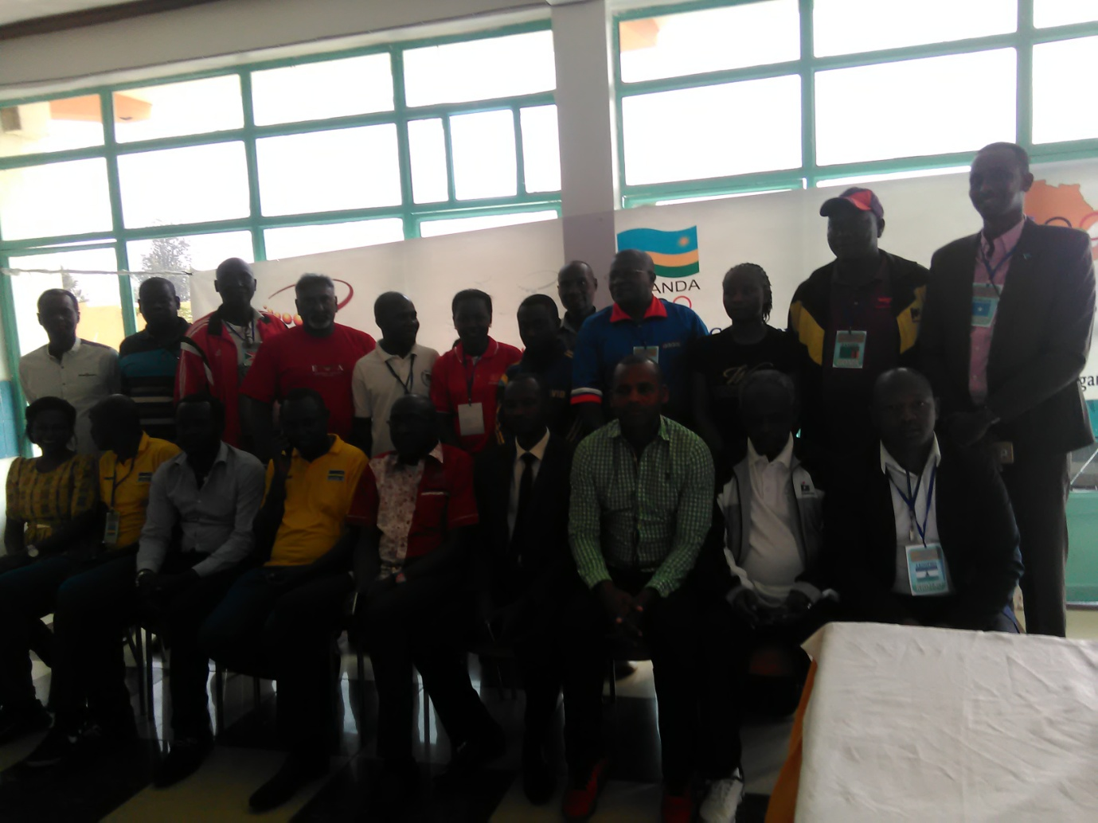
FUTBOLNET REGIONAL 2016: NYANZA 15 - 16.07.2016
Centre Olympafrica y’I Nyanza yakiriye n’irushanwa ry’umupira w’amaguru hagati y’amakipe y’abana batarengeje imyaka 15 “Futbolnet” yo mu bihugu 5: Uganda, Tanzanie, R.D.Congo, Burundi, Rwanda.
Habaye kandi n’irushanwa rya Futbolnet ry’amakipe y’abana batarengeje imyaka 15 hagati y’amashuri abanza ukwayo n’ayisumbuye ukwayo yo muri Nyanza
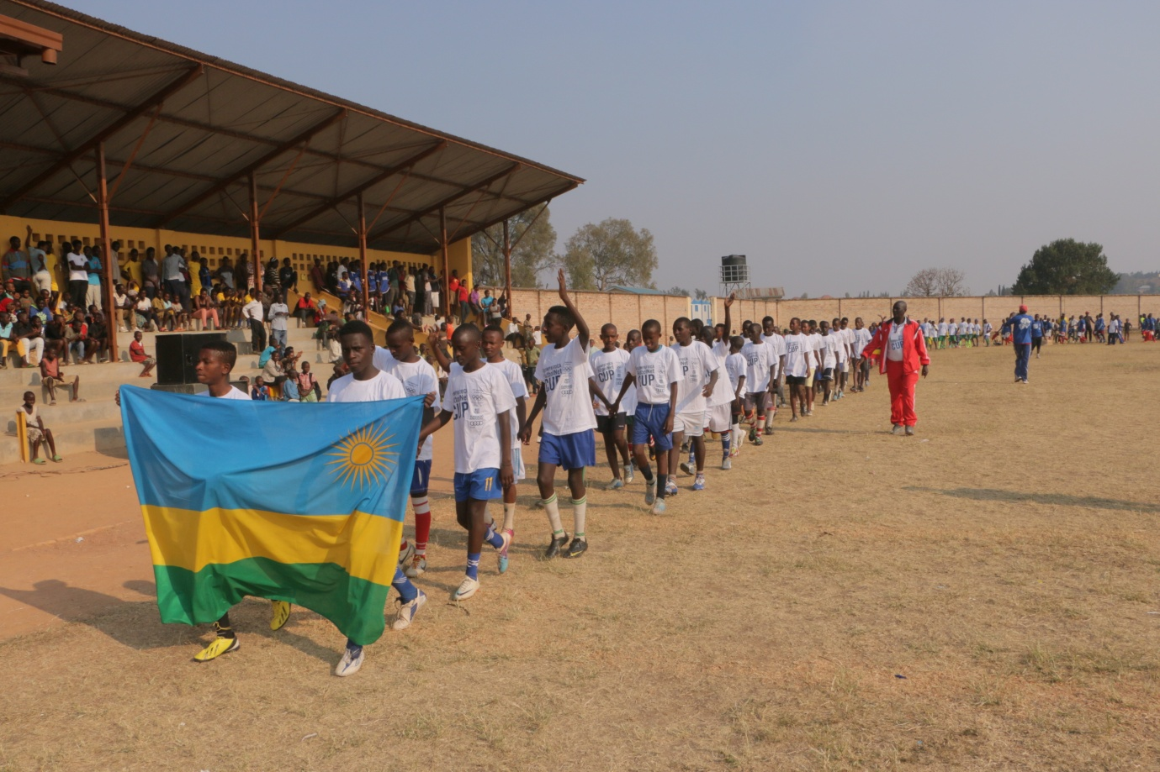
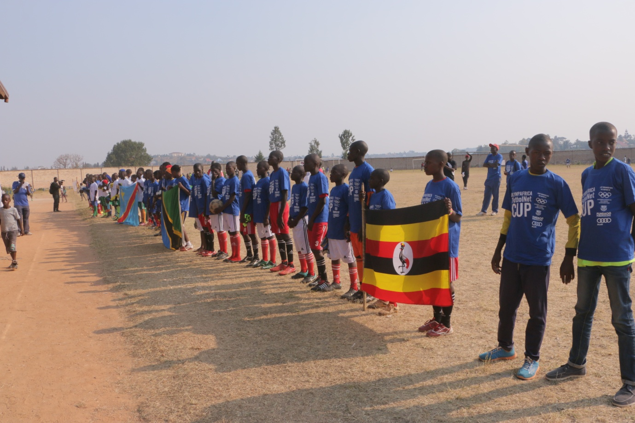
- Mu bafite imyaka 12 - 13 “benjamins” igikombe cyatwawe na Uganda,
- Mu bafite imyaka 14 - 15 “minimes” igikombe cyatwawe n’ikipe y’u Rwanda
- Igihembo cya “fair-play cyahawe Tanzanie
- Trophée des valeurs ihabwa Burundi.
- Mu cyiciro cy’amashuri abanza yo muri Nyanza, igikombe cyatwawe na E.P. Kibaga
- Mu cyiciro cy’amashuri yisumbuye gitwarwa na ESPANYA.
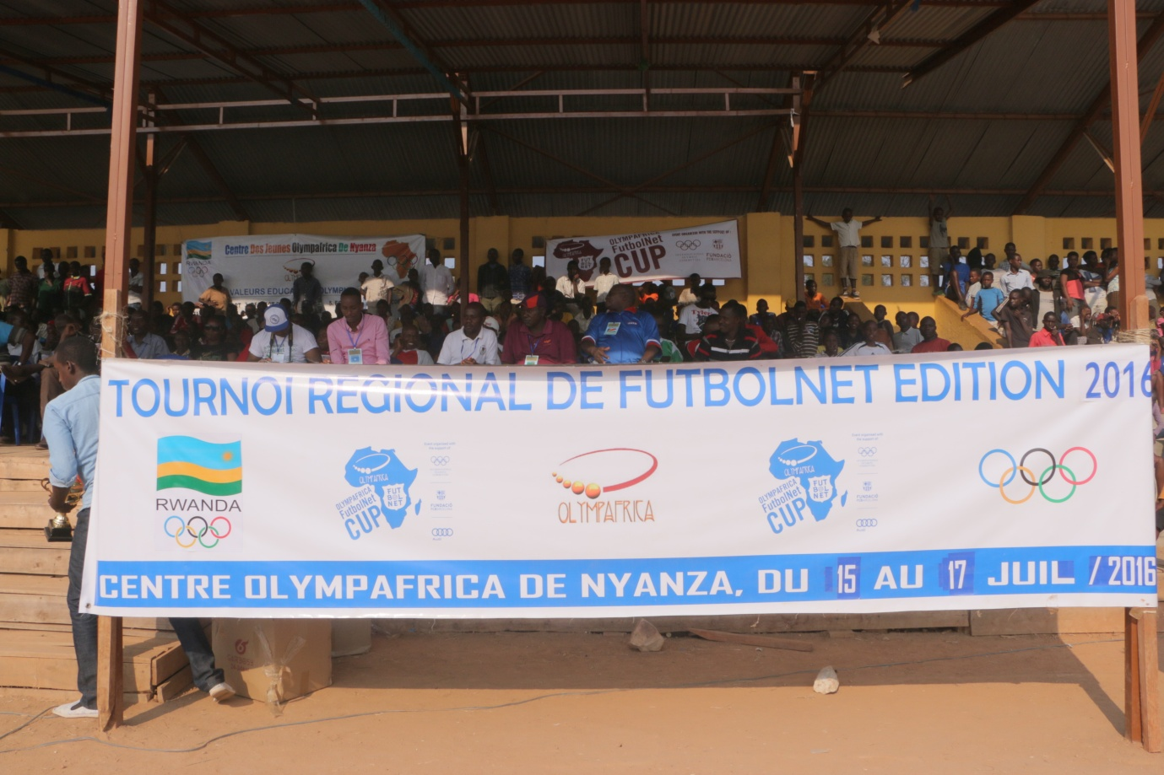
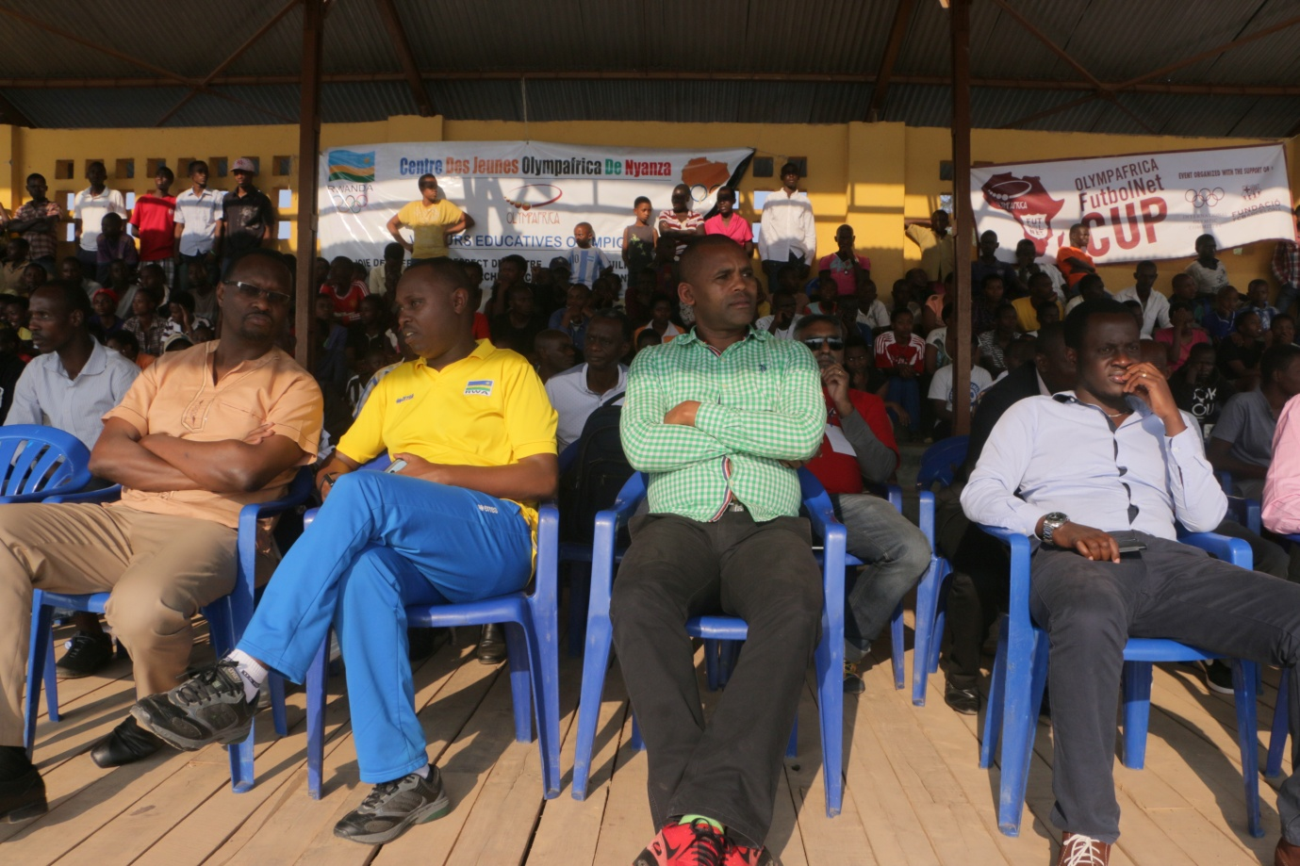
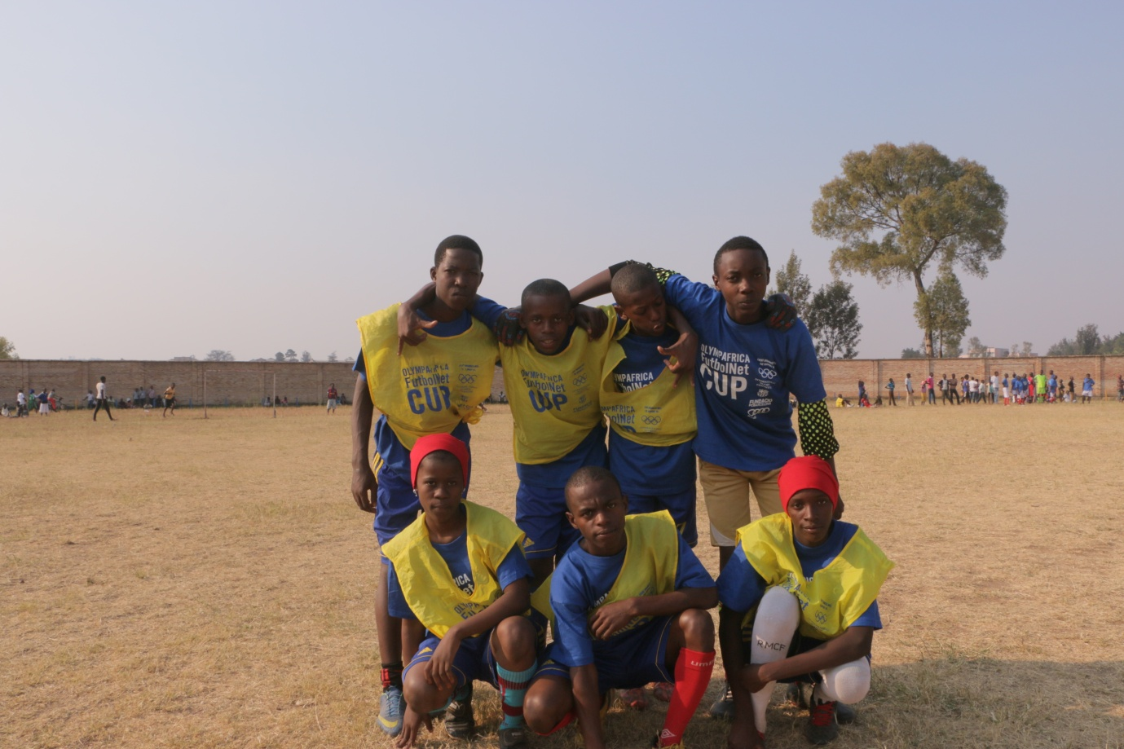
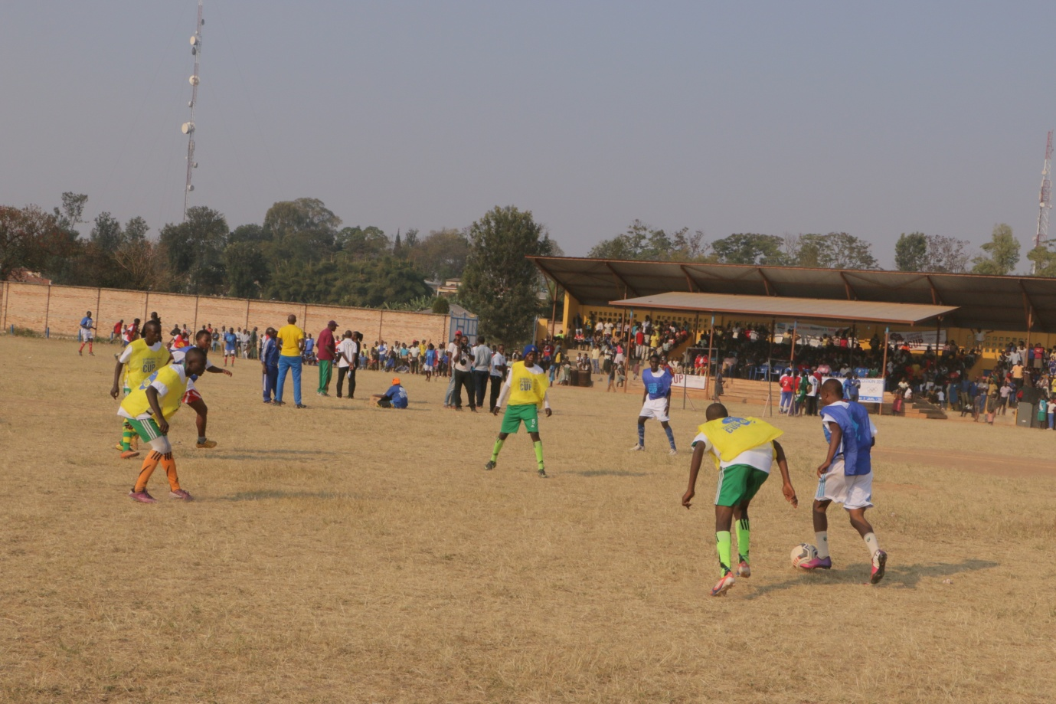
SPORTS POUR HANDICAPES: BERLIN OPEN GRAND PRIX 2016
Abakinnyi 2 bari mu irushanwa ngororamubiri ry’abafite ubumuga ryabereye i Berlin mu Budage kuwa 16.07.2016 no kuwa 17.07.2016,batsindiye imidari 3.

- MUVUNYI HERMAS
- Muri 1.500 m /T46 yabaye uwa mbere akoresheje iminota 4 n’amasegonda 14 ahabwa umudari wa zahabu
- Muri 400 m / T46 yabaye uwa 2 akoresheje amasegonda 50 n’iby’ijana 97 ahabwa umudari wa feza
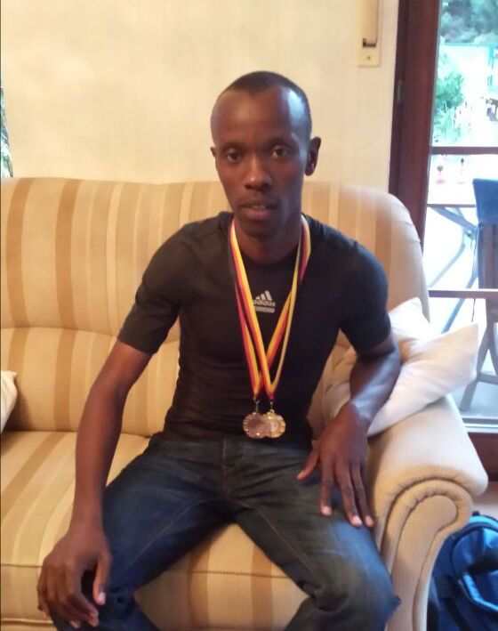
MUVUNYI HERMAS
- NDAYISENGA JEAN CLAUDE: muri 400 m / T46 & 47 yabaye uwa 2 ahabwa umudari wa bronze
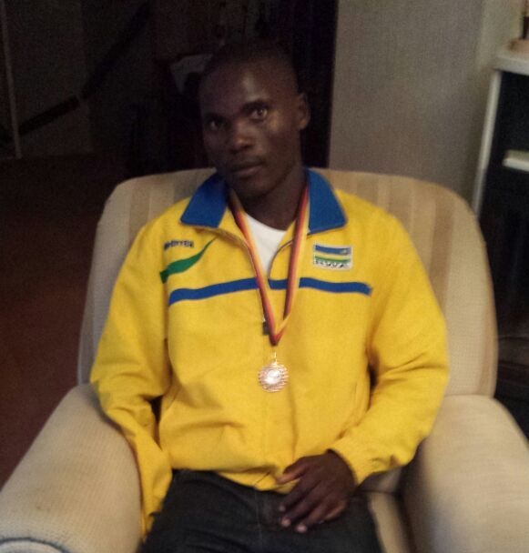
NDAYISENGA JEAN CLAUDE
MINISPOC - SPECIAL OLYMPICS RWANDA
MINISPOC n’umuryango wita ku mikino y’abafite ubumuga bwo mu mutwe “Special Olympics Rwanda” kuwa 16.07.2016 bagiranye amasezerano y’ubufatanye azamara imyaka 3.
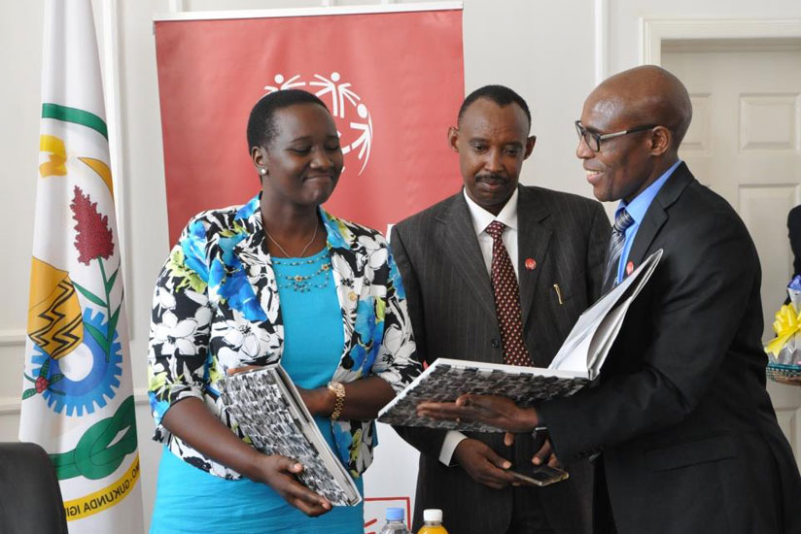
FOOTBALL: CHAMPIONNAT NATIONAL D1
Championnat y’umupira w’amaguru mu cyiciro cya mbere yasojwe kuwa 17.07.2016
UKO AMAKIPE YAKURIKIRANYE
1.APR : amanota 67
2.RAYON SPORTS : 61
3.MUKURA : 60
4.AS KIGALI : 56
5.POLICE : 53
6.KIYOVU : 46
7.BUGESERA : 37
8.SUNRISE : 35
9.GICUMBI : 34
10.MARINES : 33
11.ESPOIR : 33
12.ETINCELLES : 32
13.AMAGAJU : 30
14.MUSANZE : 29
15.RWAMAGANA : 25
16.AS MUHANGA : 22

Igikombe cyatwawe APR FC, amakipe abiri ya nyuma RWAMAGANA (15) na AS MUHANGA (16) zimanuka mu cyiciro cya 2.
Abakinnyi USENGIMANA DANY (POLICE) na HAKIZIMANA MUHADJIRI (MUKURA) nibo batsinze ibitego byinshi, buri wese afite 16.
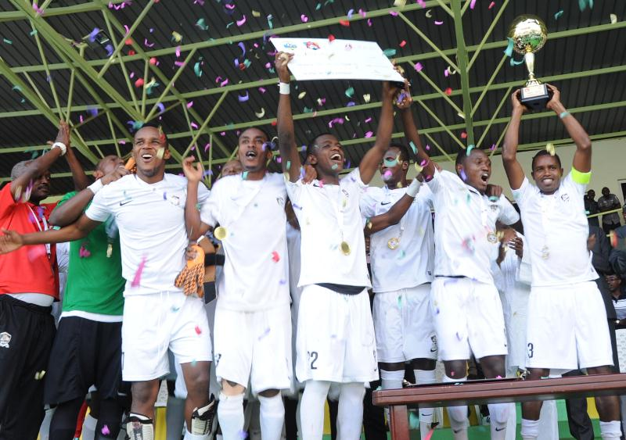
ATHLETISME : 2016 IAAF WORLD U20 CHAMPIONSHIPS
Abakinnyi 5 bahagarariye u Rwanda muri irushanwa ry’imkino ngororamubiri ryo kwiruka ryabereye i BYDGOSZCZ muri POLOGNE kuva kuwa 19.07.2016 kugeza kuwa 24.07.2016.
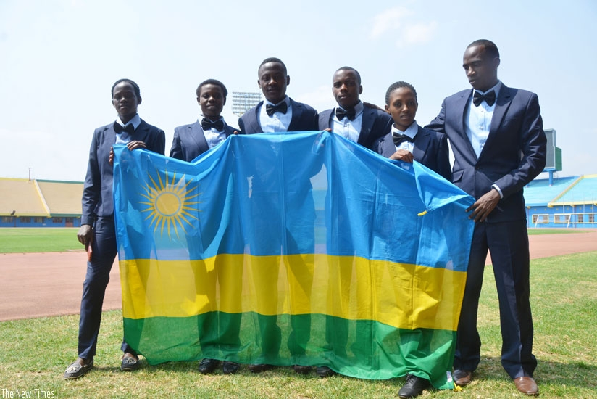
Uturutse ibumoso: ILIBAGIZA HONORINE, NISHIMWE BEATA, SUGIRA JAMES, MYASIRO JMV, NYIRARUKUNDO SALOME, KANYABUGOYI ANICET (umutoza)

MYASIRO JEAN MARIE VIANNEY muri 10.000 m yabaye uwa 11 mu basiganwa 34, akoresheje 29’26’’16. Yakuyeho umuhigo wa 29’35’’41 kuva mu 2004 wari ufitwe na Valence Bivahagumye.
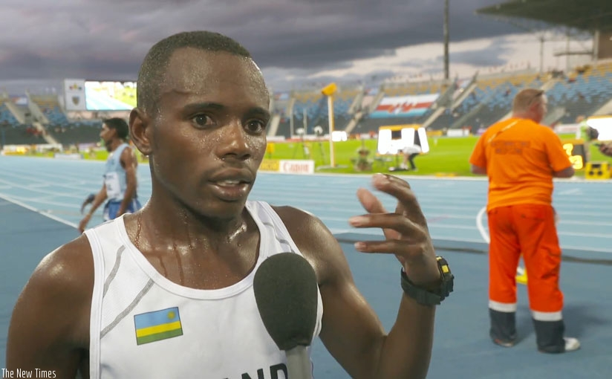MYASIRO JMV
ILIBAGIZA HONORINE muri 800 m yagarukije mu ijonjora aho mu itsinda (heat) yarimo yabaye uwa 6 akoresheje 2’12’’30. Bane ba mbere nibo bakomeje muri ½ cy’irangiza.
SUGIRA JAMES muri 1.500 m nawe yagarukiye mu ijonjora, mu itsinda (heat) yarimo yabaye yabaye uwa 9 akoresheje 03’51’’32. Batatu ba mbere nibo bagiye muri ½ cy’irangiza.
NISHIMWE BEATA muri 1.500 m yabaye uwa 6 akoresheje 4’12’’13
NYIRARUKUNDO SALOME muri 5.000 m yabaye uwa 13 akoresheje 15’57’’68, abasiganwa bari 18.

BASKETBALL : 2016 FIBA AFRICA U18 CHAMPIONSIP
I Kigali kuva kuwa 22.07.2016 kugeza kuwa 31.07.2016 habereye irushanwa ry’igikombe cy’Afrika cy’amakipe y’abahungu batarengeje imyaka 18 ryahuje amakipe y’ibihugu 11 yashyizwe mu matsinda abiri y’imikino y’ijonjora:
Itsinda A : RWANDA, GABON, ALGERIE, MALI, COTE D’IVOIRE (ZIMBABWE ntiyaje)
Itsinda B : EGYPTE, TUNISIE, BENIN, ANGOLA, RDC, UGANDA.
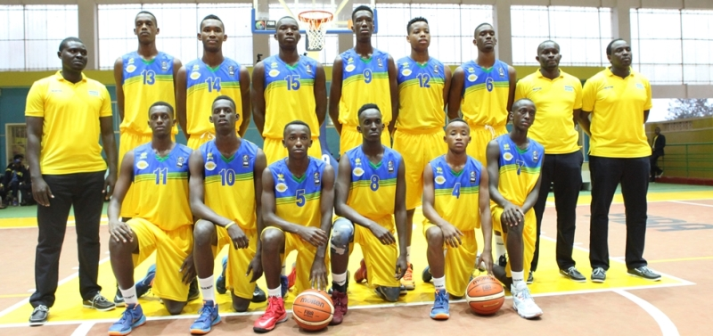RWANDA

UKO IMIKINO YO GUSOZA YAGENZE :
Gukinira umwanya wa 5 - 6
RWANDA 77 - 73 RDC
Gukinira umwanya wa 3 - 4
MALI 59 - 52 TUNISIE
Gukinira igikombe
ANGOLA 86 - 82 EGYPTE
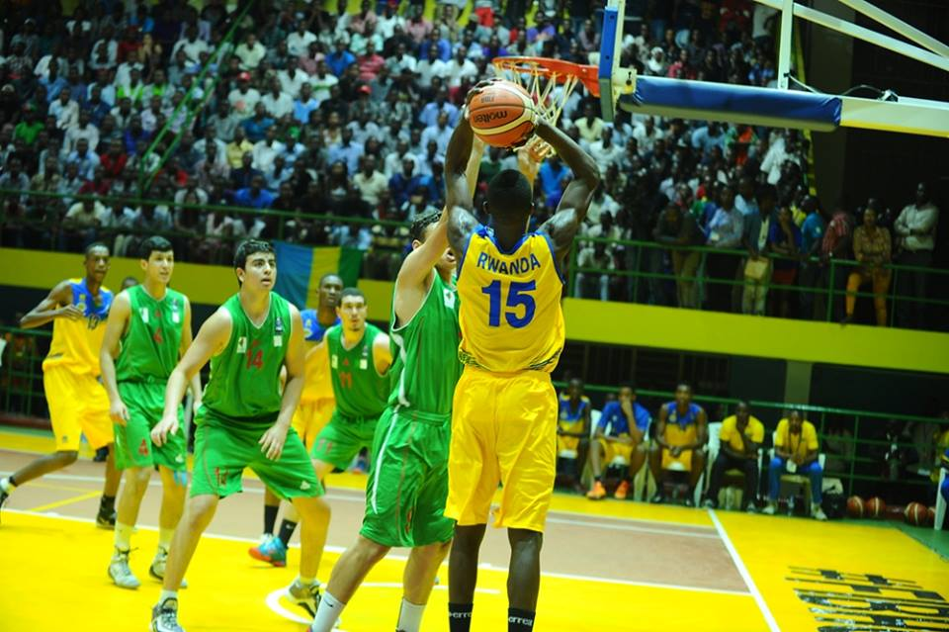
Uko amakipe 11 yakurikiranye:
1.ANGOLA 7.ALGERIE
2.EGYPTE 8.COTE D’IVOIRE
3. MALI 9.UGANDA
4. TUNISIE 10.GABON
5.RWANDA 11.BENIN
6.RDC.
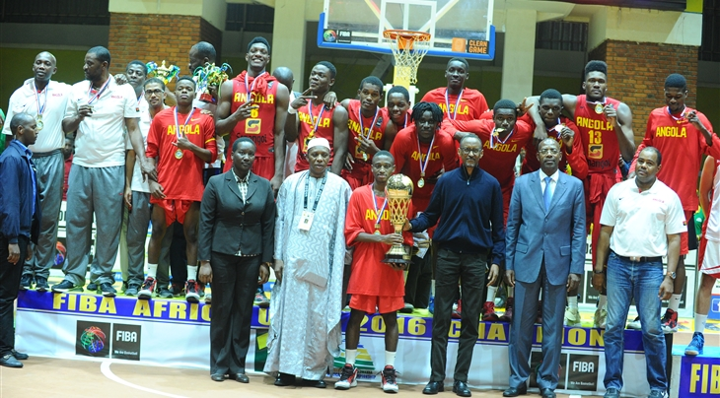
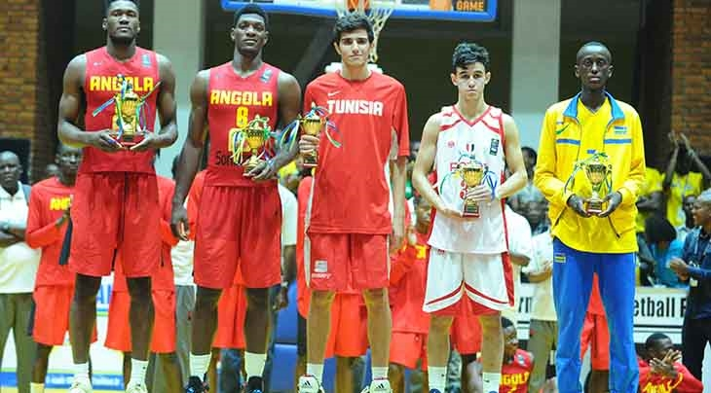Abakinnyi 5 beza b’irushanwa barimo GASANA SANO (RWANDA) “meilleur meneur”

SPORTS POUR HANDICAPES: SITBALL: CHAMPIONNAT NATIONAL 2016
Imikino isoza championnat 2016 kuwa 23.07.2016 yahurije i Kigali amakipe 20: ay’abagabo 10 n’iy’abagore 10
UKO AMAKIPE Y’ABAGORE YAKURIKIRANYE
IMYANYA 5 Y’AMAKIPE YA MBERE
1.INTWALI : amanota 12
2.GICUMBI : 10
3.HVP GATAGARA : 8
4.BUGESERA : 6
5.MUSANZE : 4
IMYANYA 5 Y’AMAKIPE ASIGAYE
6.RUBAVU : 10
7.NGOMA : 8
8.NYARUGENGE : 8
9.NYABIHU : 8
10.RUHANGO : 6
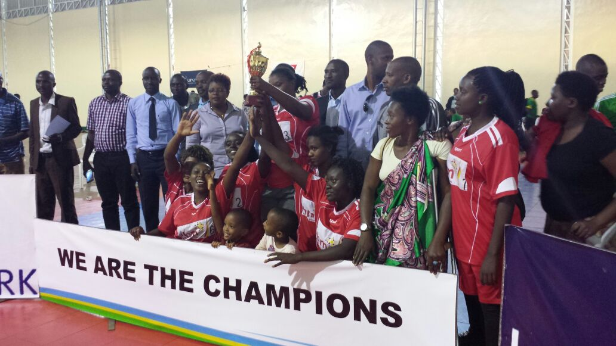
UKO AMAKIPE Y’ABAGABO YAKURIKIRANYE
1.GISAGARA : amanota 12
2.INTWALI : 8
3.RUTSIRO : 8
4.MUSANZE : 8
5.KARONGI : 4
IMYANYA 5 Y’AMAKIPE ASIGAYE
6.GICUMBI : 12
7.HUYE : 10
8.KIREHE : 8
9.KAYONZA : 6
10.KICUKIRO : 4
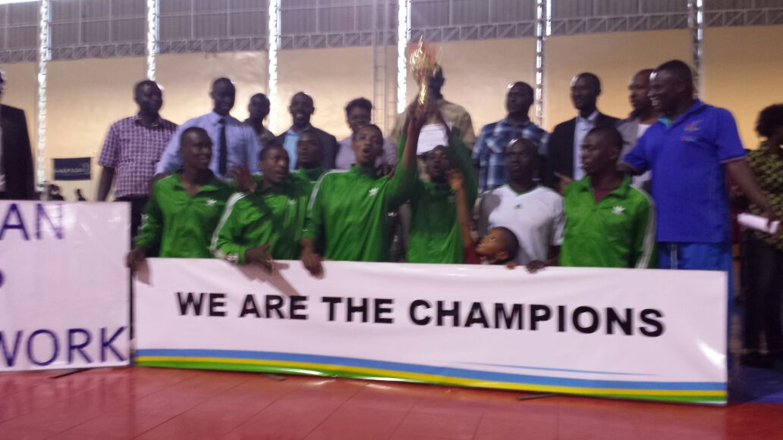

SPORT SCOLAIRE: FINALES SPORTS COLLECTIFS
Kuwa 23.07.2016 hasojwe irushanwa ry’amakipe y’ibigo by’amashuri
FOOTBALL
AMAKIPE Y’ABAKOBWA
Umukino wa nyuma : GS REMERA RUKOMA 1 ( 4 pen.5) 1 ES MUTUNDA
AMAKIPE Y’ABAHUNGU
Umukino wa nyuma : COLLEGE DE GISENYI 0 - 1 HANIKA TSS
VOLLEYBALL
AMAKIPE Y’ABAKOBWA
Iya mbere yabaye GS ST ALOYS RWAMAGANA
AMAKIPE Y’ABAHUNGU
Iya mbere yabaye
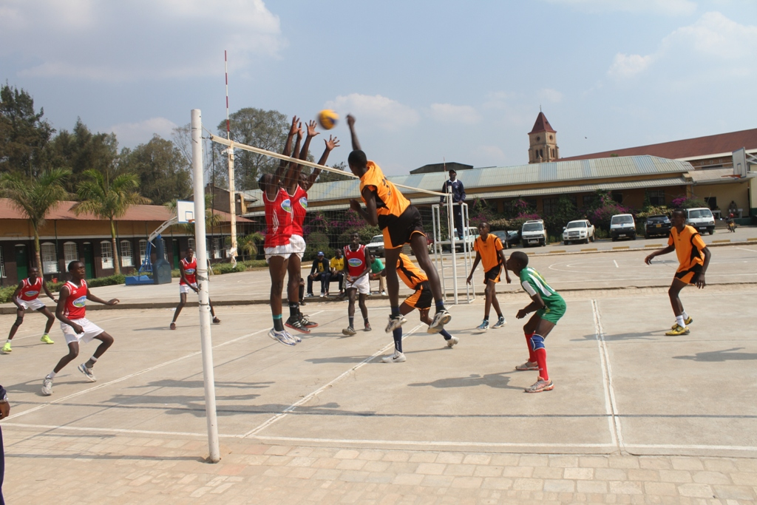
BASKETBALL
AMAKIPE Y’ABAKOBWA
Iya mbere yabaye COLLEGE DE GISENYI
AMAKIPE Y’ABAHUNGU
Iya mbere yabaye PS BAPTISTE
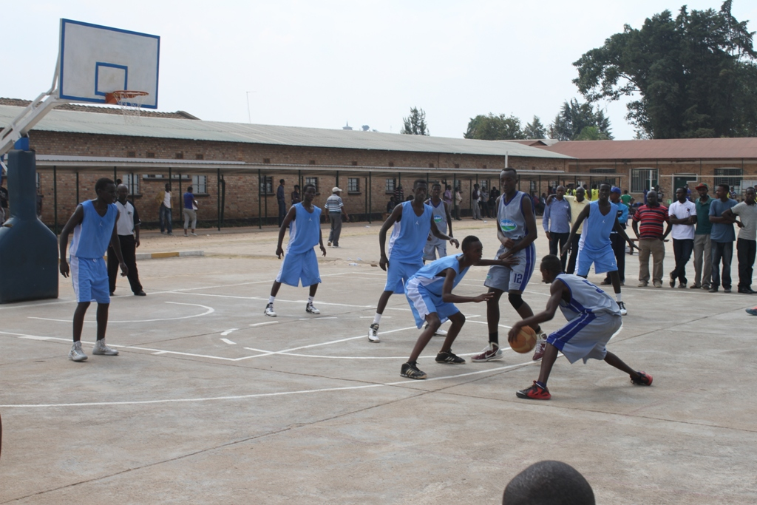
HANDBALL
AMAKIPE Y’ABAKOBWA
Iya mbere yabaye HANIKA TSS
AMAKIPE Y’ABAHUNGU
Iya mbere yabaye ESEKI
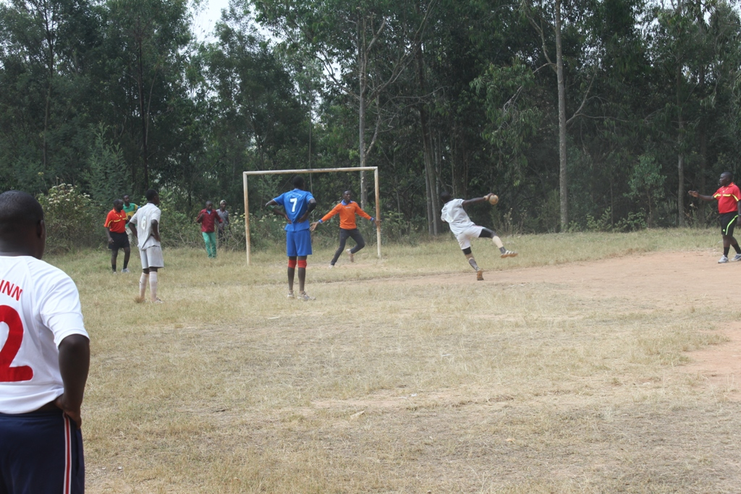
NETBALL
Iya mbere yabaye GS GAHINI
RUGBY
Iya mbere yabaye ET MUKINGI

JEUX OLYMPIQUES & PARALYMPIQUES - RIO 2016
Minisitiri wa siporo n’umuco Mme UWACU Julienne kuwa 27.07.2016 yahaye impanuro anashyikiriza ibendera ry’igihugu abahagarariyeu u Rwanda mu mikino olempike na paralempike yabereye i Rio muri Bresil
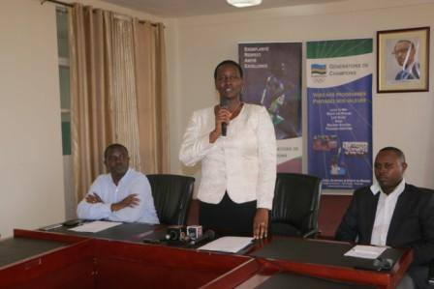
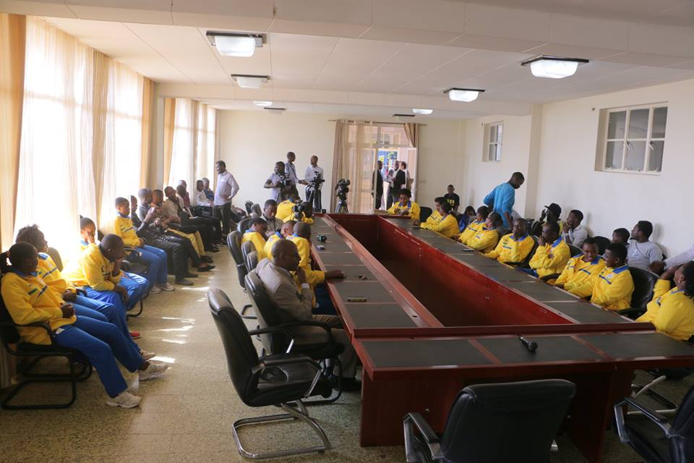

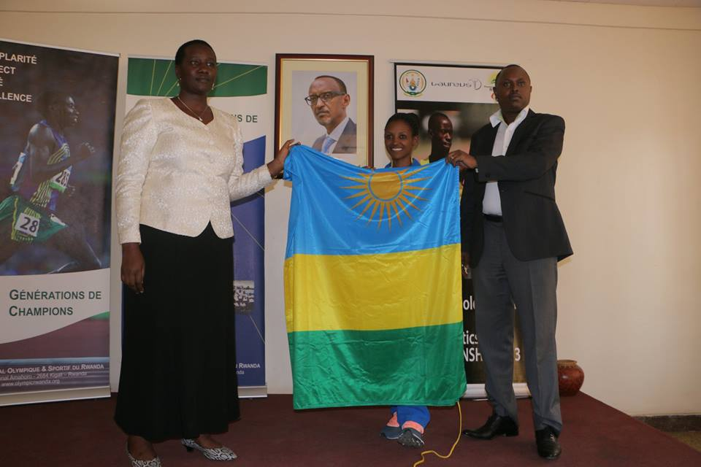
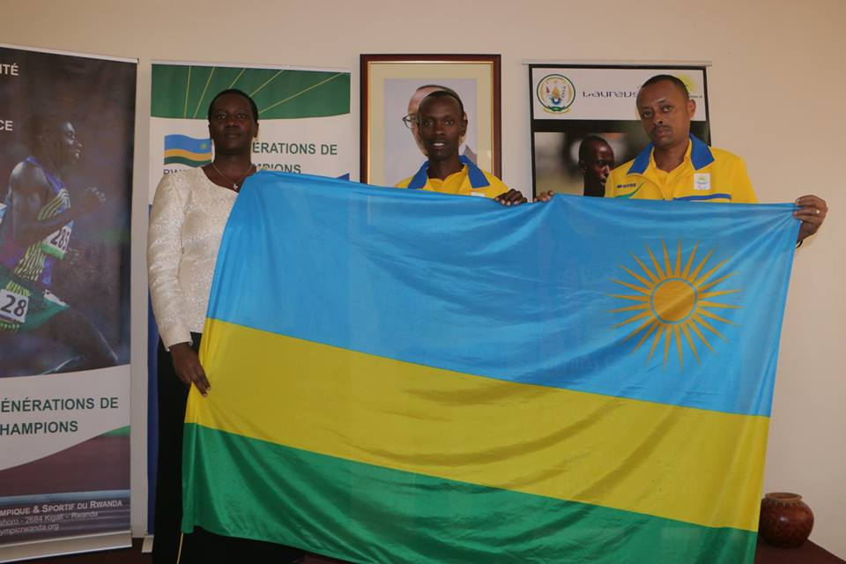

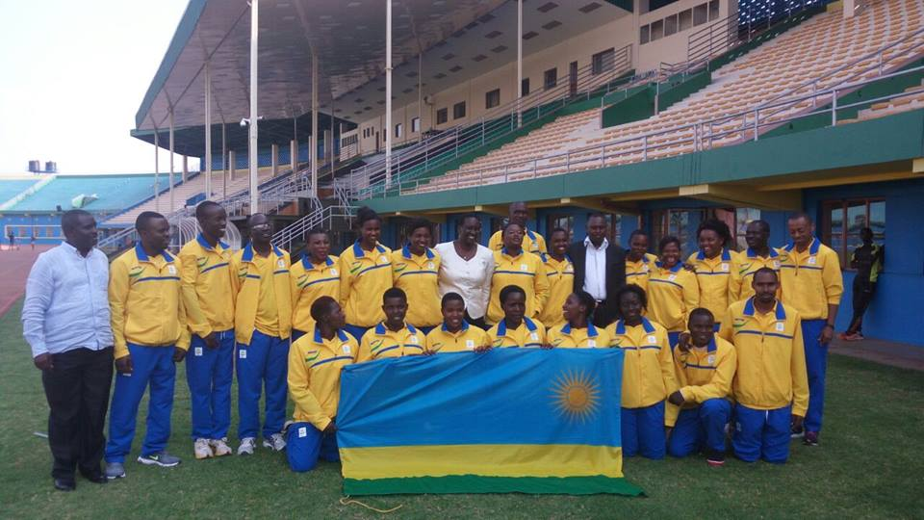
WELCOME CEREMONY
Abagize ikipe y’u Rwanda “TEAM RWANDA” yagiye mu mikino olempike kuwa 01.08.2016 yahawe ikaze muri Village Olympique i Rio
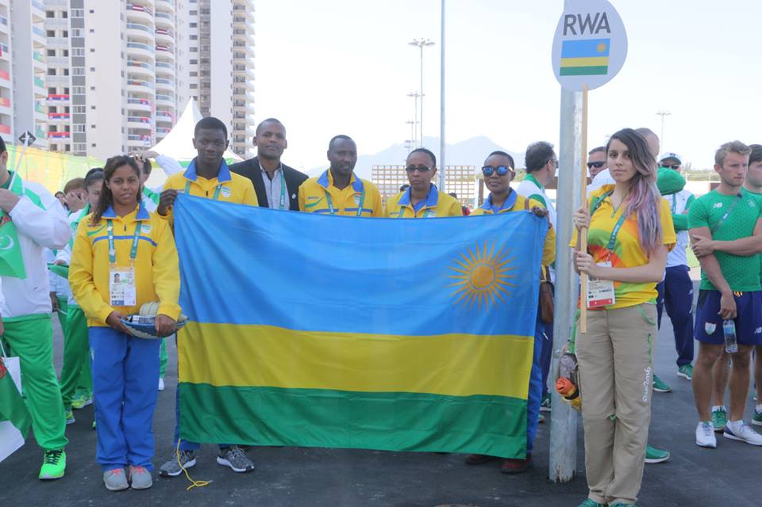
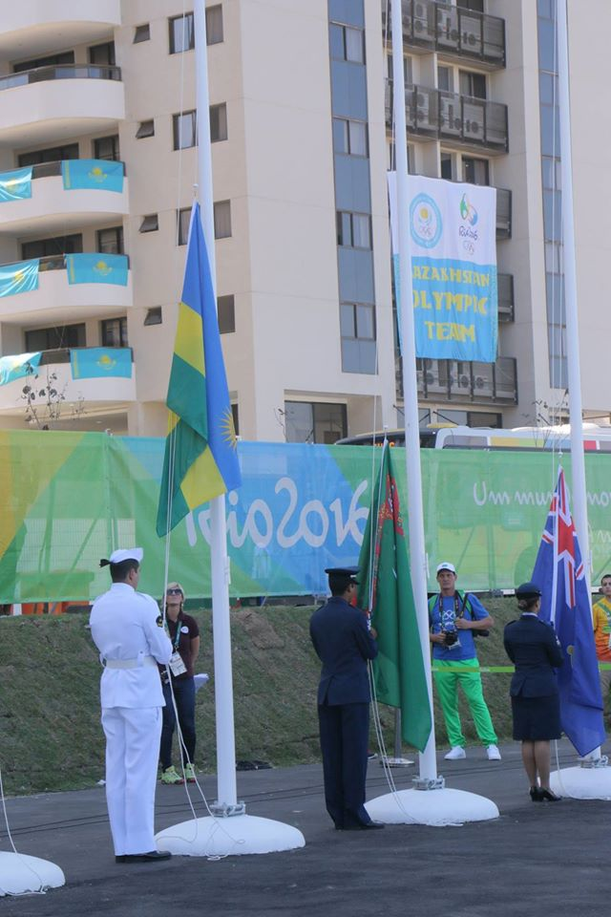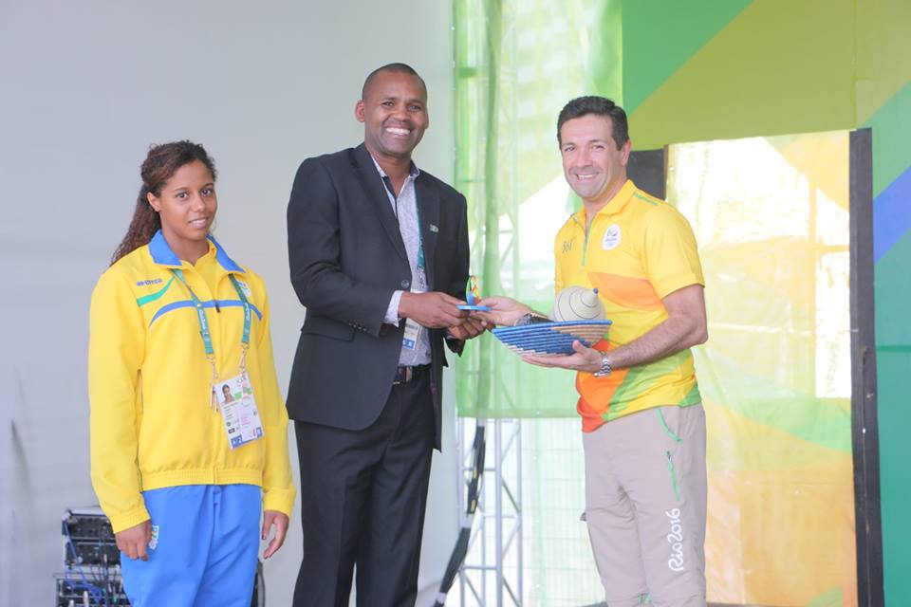
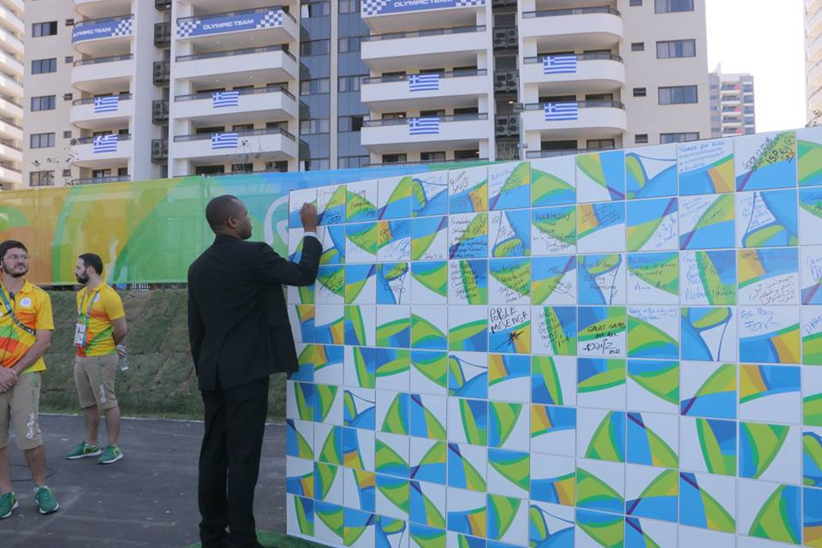
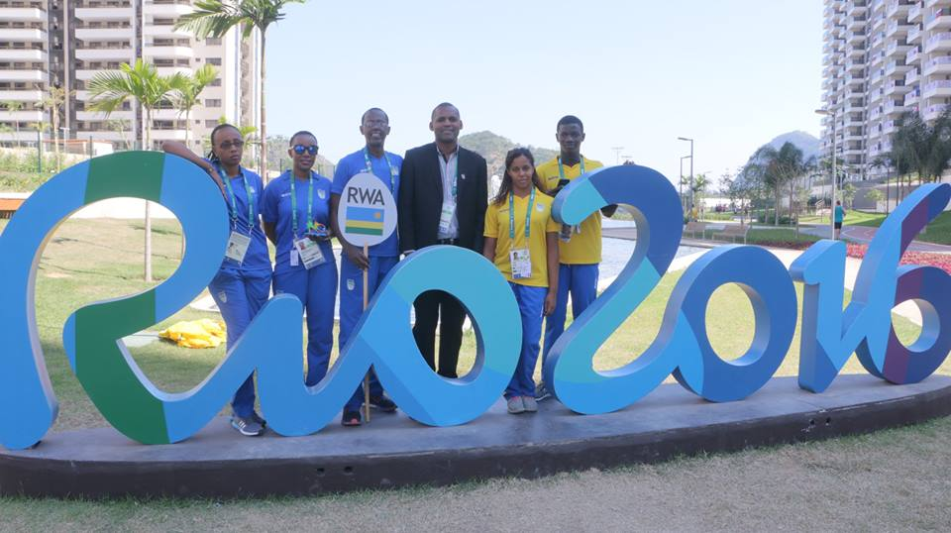
OPENING CEREMONY
I Rio muri Bresil kuwa 05.08.2016 habaye imihango yo gutangiza ku mugaragaro “Opening ceremony” imikino olempike yahabereye kuva kuwa 05.08.2016 kugeza kuwa 21.08.2016.
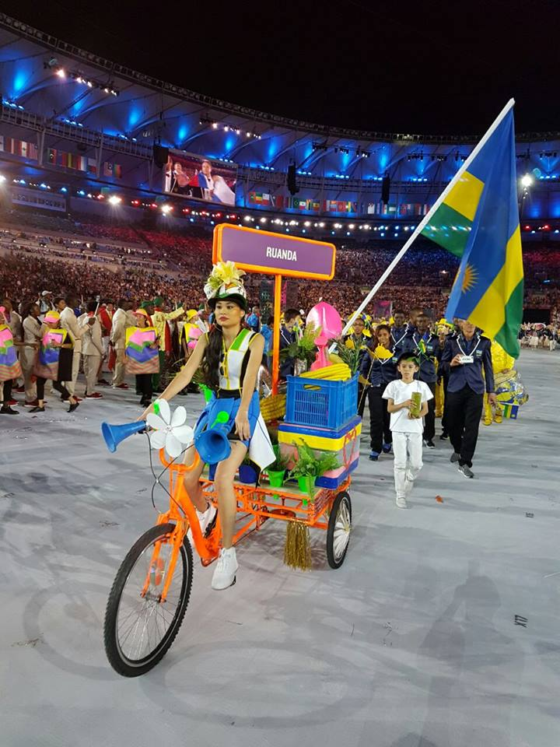

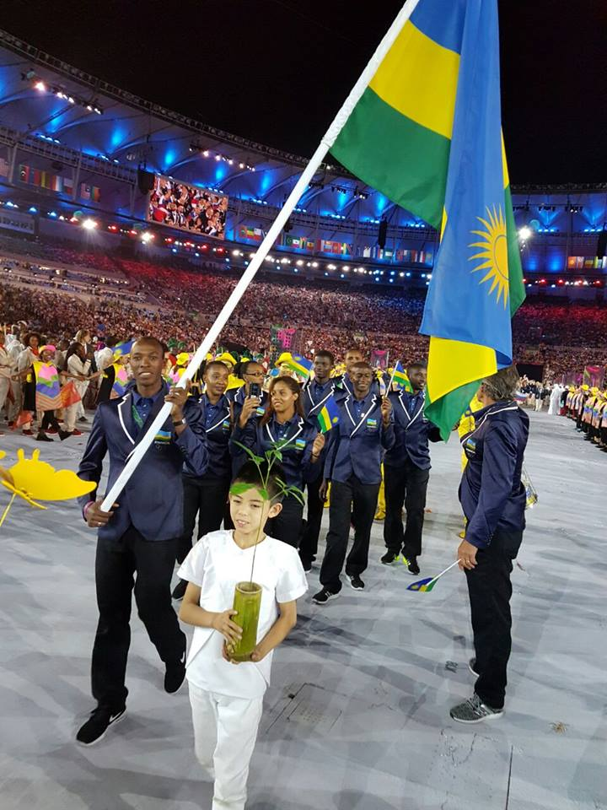
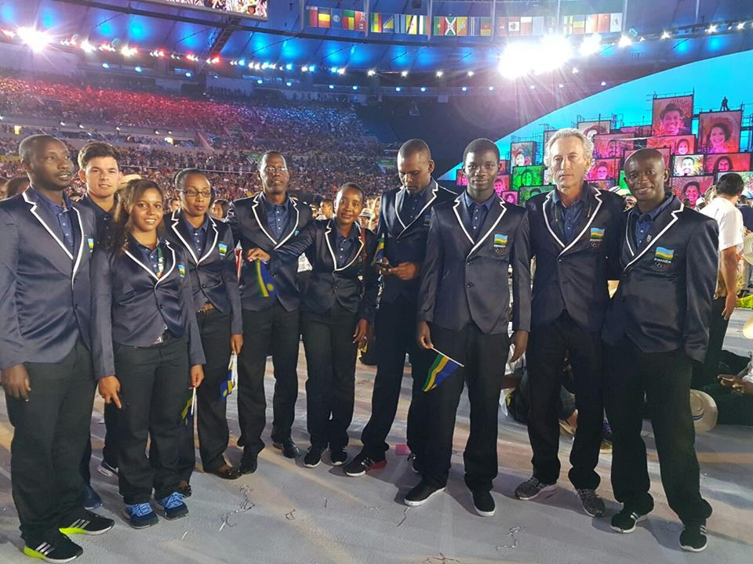
UKO TEAM RWANDA YITWAYE MU MARUSHANWA

CYCLISME: ROAD RACE
Kuwa 06.08.2016 NIYONSHUTI ADRIEN ntiyashoboye kurangiza isiganwa rya 237 km, kuko yabanje kugira ikibazo cy’igare, nyuma yo guhabwa irindi akora impanuka yatumye adakomeza; amaze kugenda km zisaga 50.
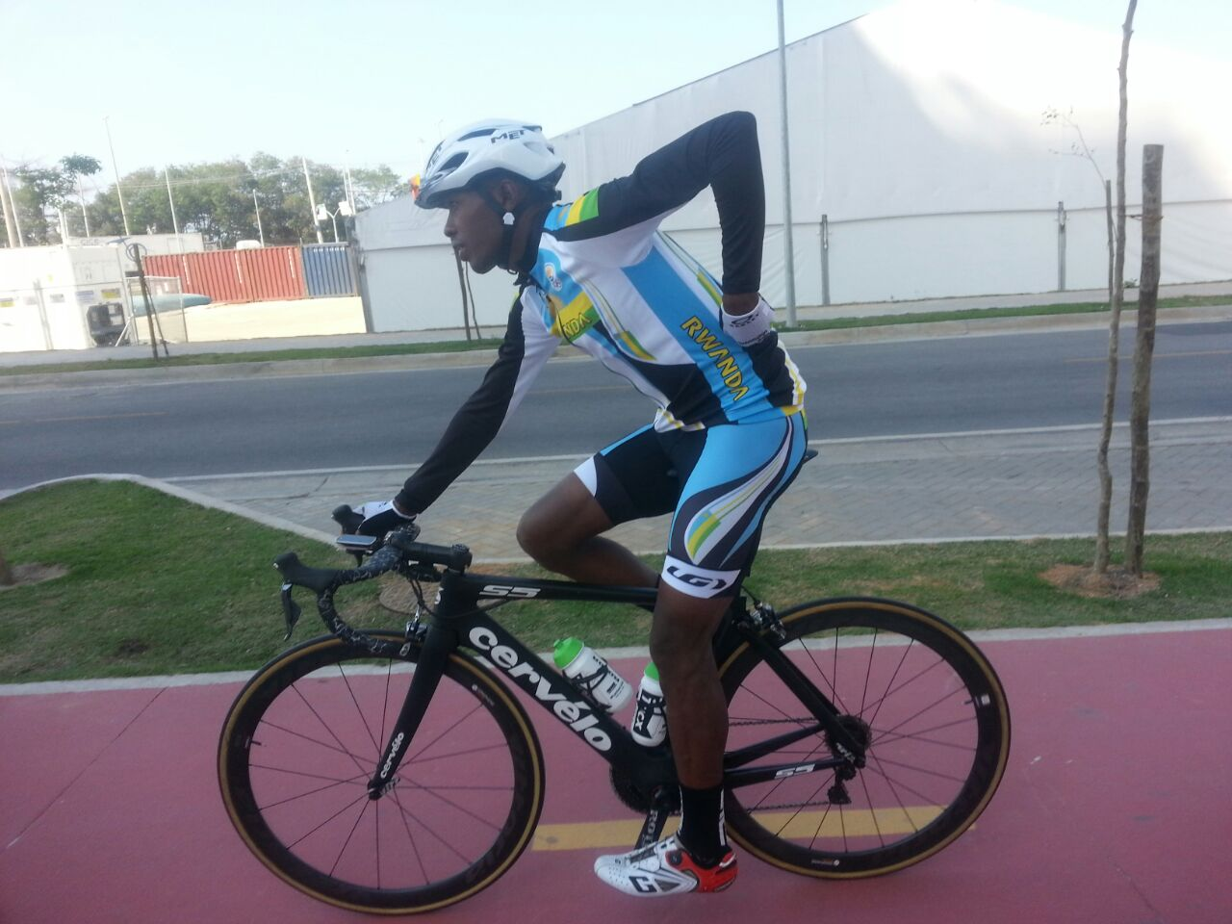NIYONSHUTI ADRIEN
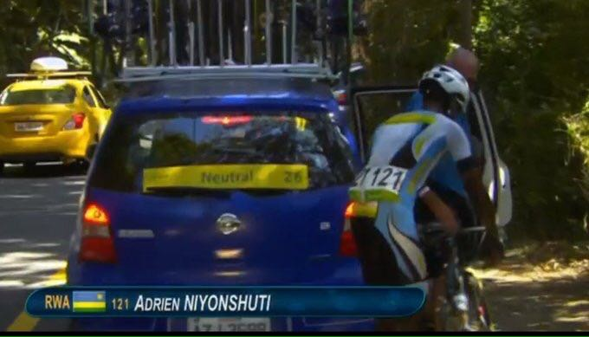NIYONSHUTI YAGIZE IKIBAZO CY’IGARE AHABWA IRINDI
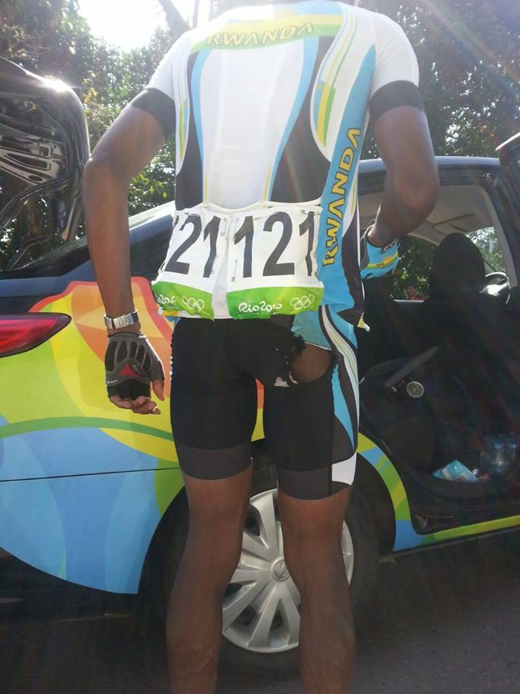NIYONSHUTI YAKOZE IMPANUKA AVA MU IRUSHANWA
NATATION 100m BATTERFLY
UMURUNGI JOHANNA kuwa 06.08.2016 mu gusiganwa kwoga ahareshya na 100 m batterfly, mu itsinda ry’amajonjora (heat / serie) yarimo ry’abakinnyi 5 yabaye uwa 4 akoresheje 1’11’’92; akaba atarashoboye gukomeza mu cyiciro cyisumbuye. Yagabanyijeho amasegonda 2 ku bihe yari asanganywe bya 1’13’14.
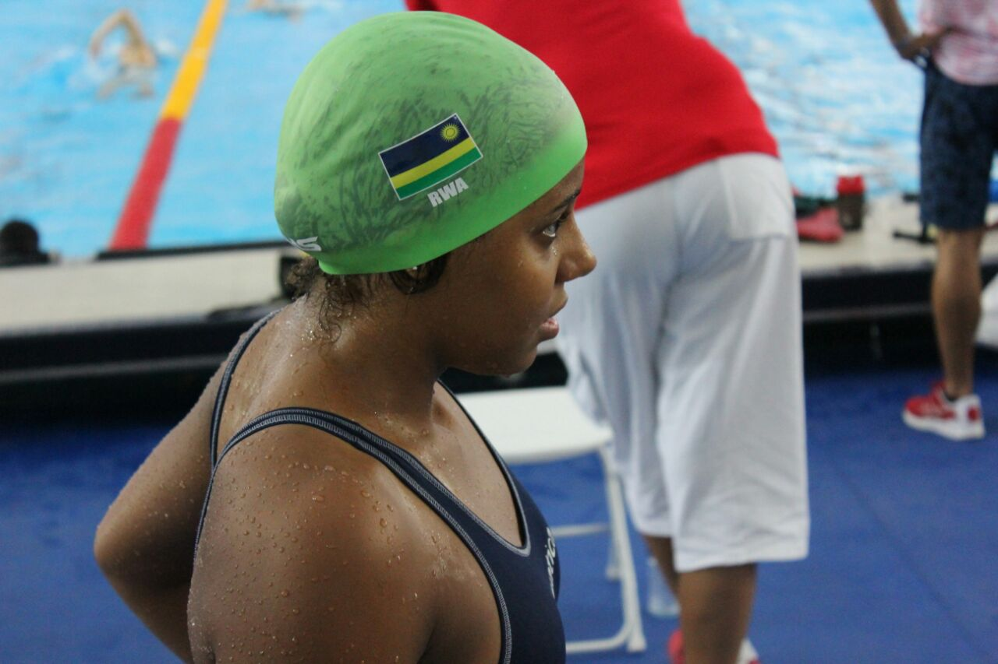UMURUNGI JOHANNA
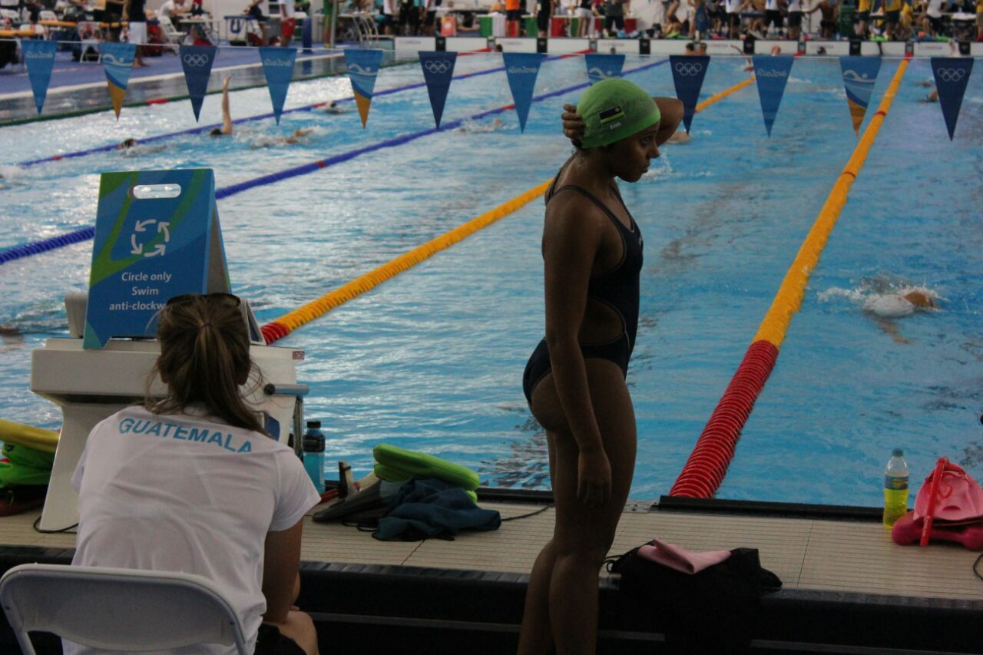

NATATION 50m FREESTYLE
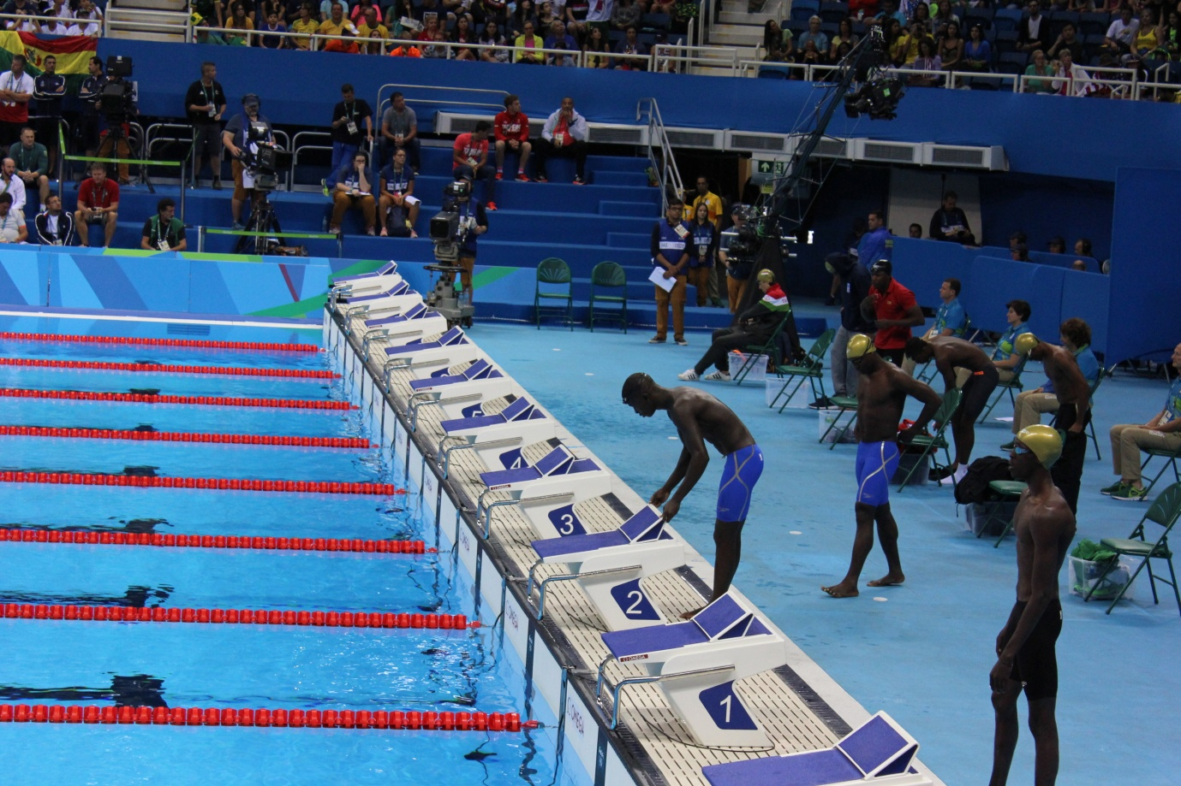
IMANIRAGUHA ELOI mu irushanwa ry’umukino wo kwoga ahareshya na 50m freestyle kuwa kane 11.08.2016 yakoresheje amasegonda 26 n’iby’ijana 43 (26’’43); aba uwa mu 8 mu bakinnyi 8 bari hamwe mu itsinda (heat / série) rya 4 bityo ntiyashobora kurenga amajonjora.
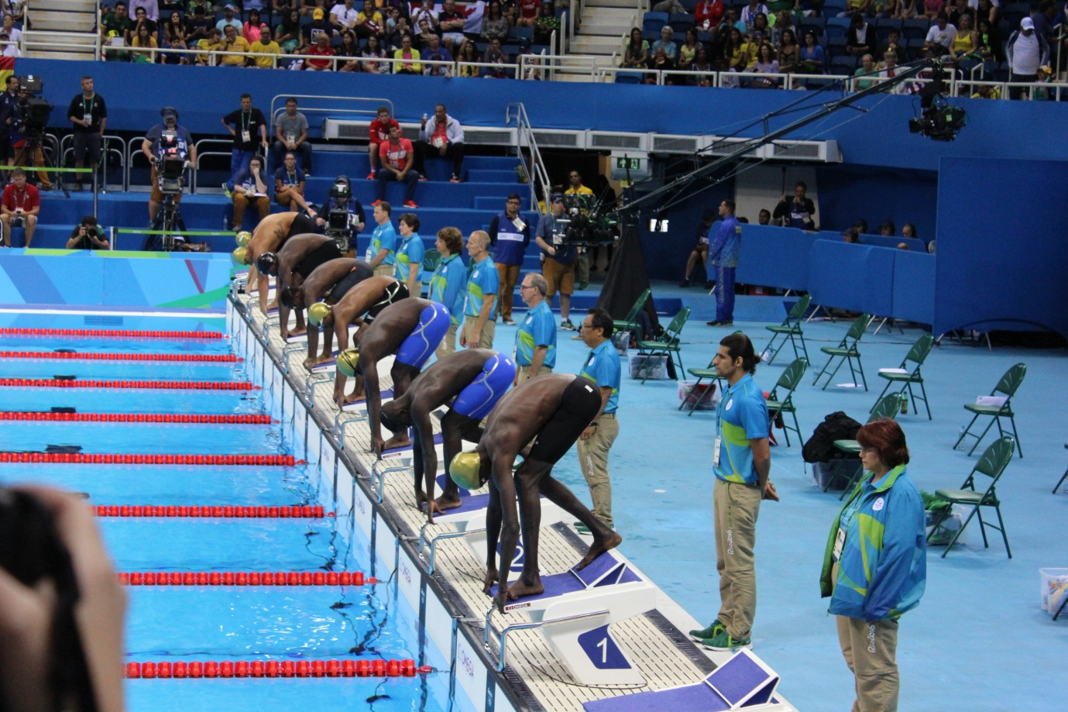
KWIRUKA 10.000m/ ABAGORE
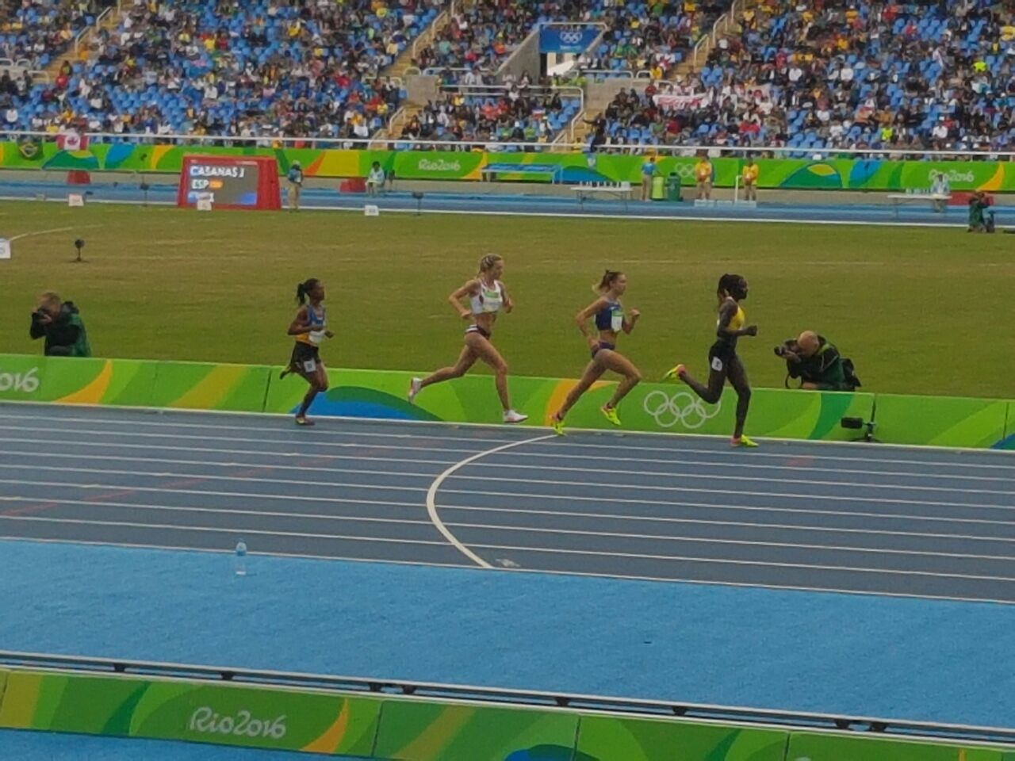
NYIRARUKUNDO SALLOME kuwa 12.08.2016 yakoze isiganwa mu kwiruka 10.000m asoza ku mwanya wa 27 mu basiganwa batangiye ari 37 hasoza 35. Yazirukanse mu minota 32, amasegonda 07 n’iby’ijana 80 (32’07’’80) akaba yarasubiye inyuma ku bihe byiza yari afite by’iminota 31 amasegonda 45 n’iby’ijana 82 (31’45’’82).
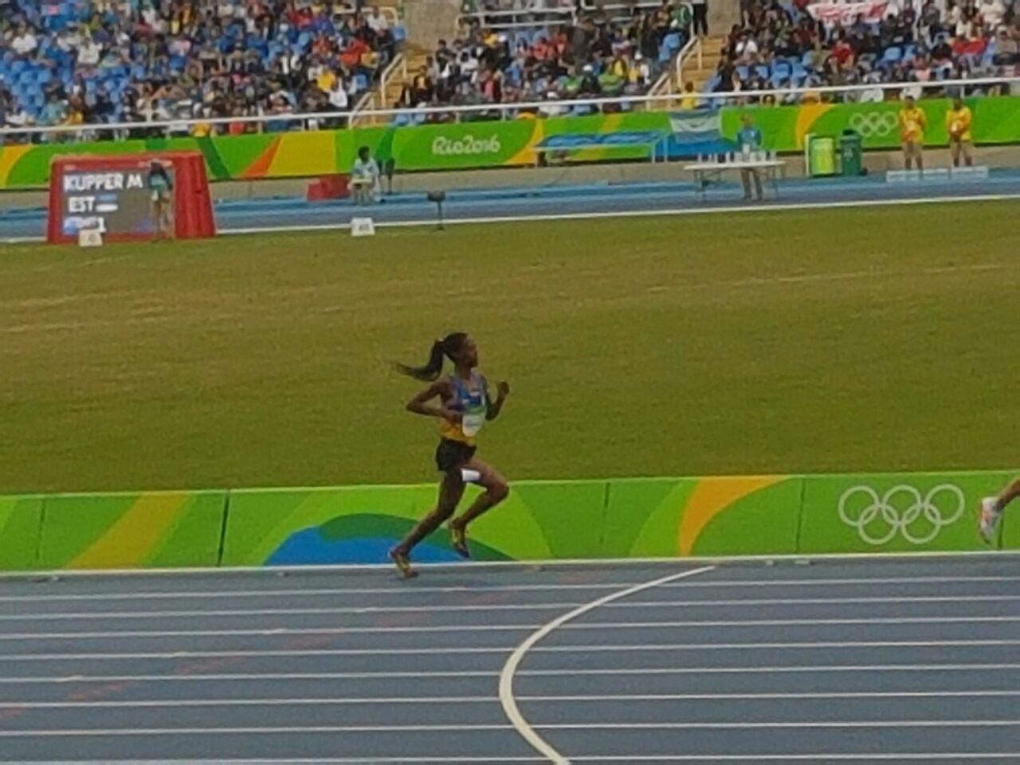
MARATHON / ABAGORE
Mu isiganwa rya marathon (42km) ryabaye kuwa 14.08.2016, MUKASAKINDI CLAUDETTE yabaye uwa 126 akoresheje 3h05’57’’ mu bakinnyi 133 basoje isiganwa ryari ryatangiwe na 157.
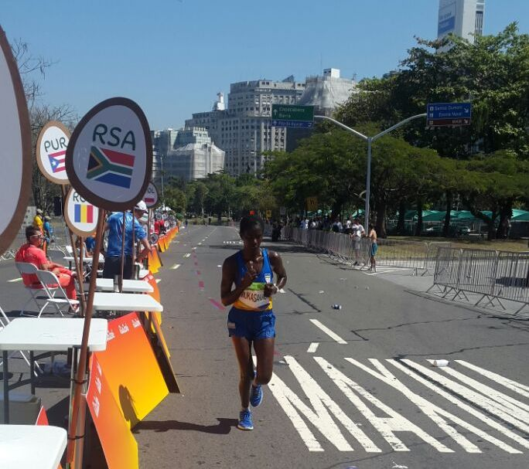
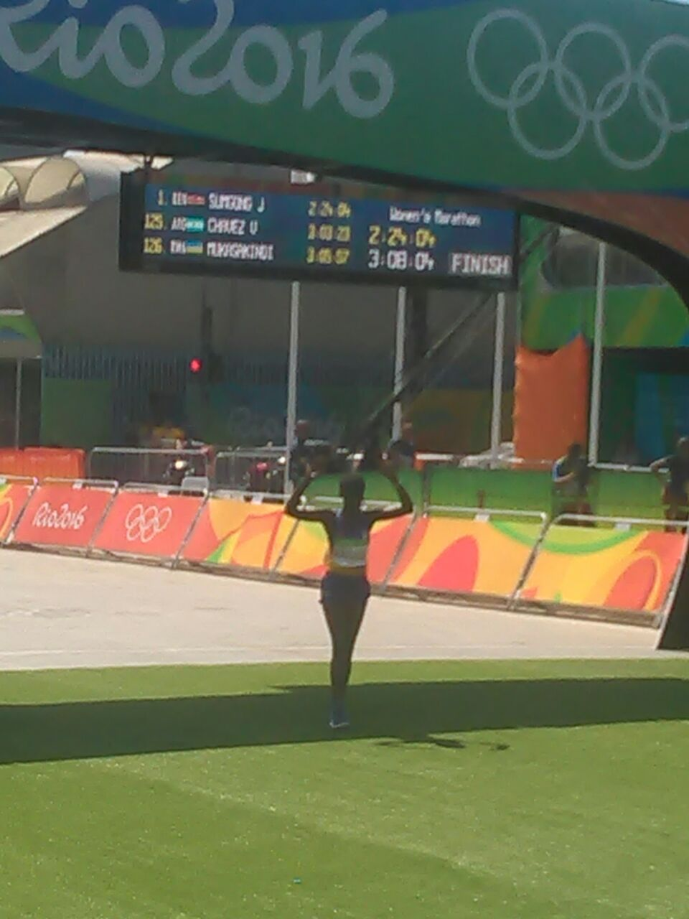
MARATHON / ABAGABO
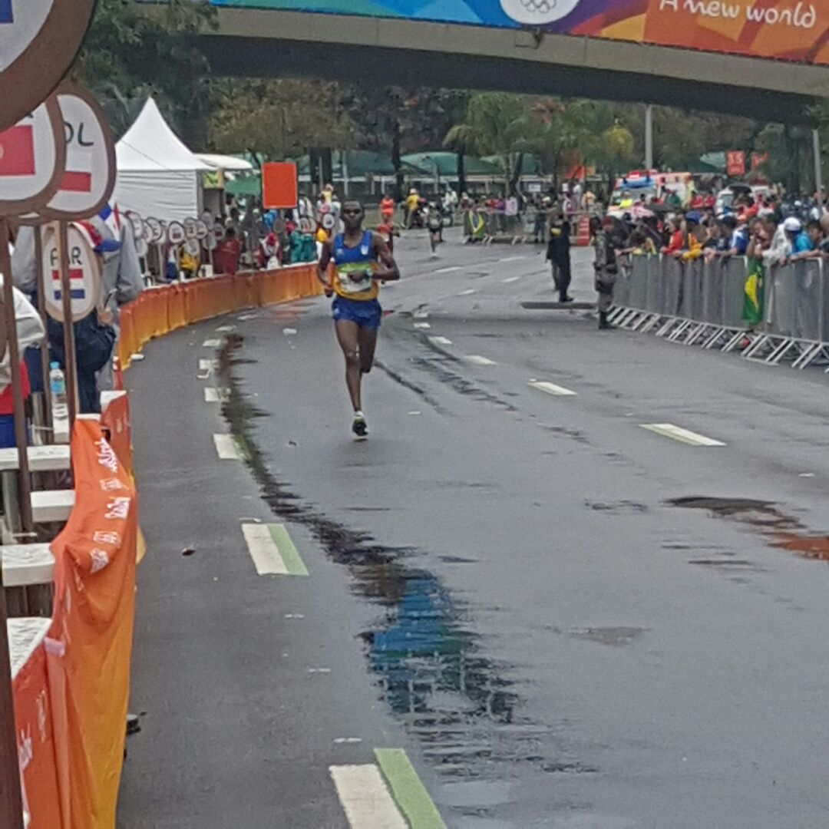
Mu isiganwa ryo kwiruka marathon (42 km) kuwa 21.08.2016 UWIRAGIYE AMBROISE yabaye uwa 99 akoresheje 2h25’57’’. Isiganwa ryari ryatangiwe n’abakinnyi 155 hasoza 140
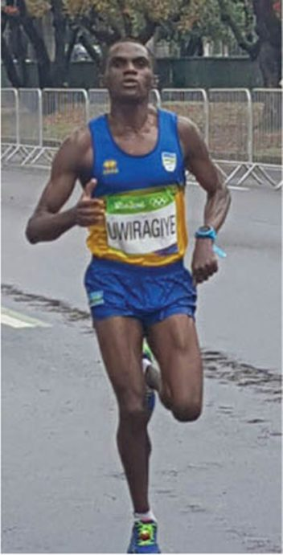
UWIRAGIYE AMBROISE

MOUNTAIN BIKE
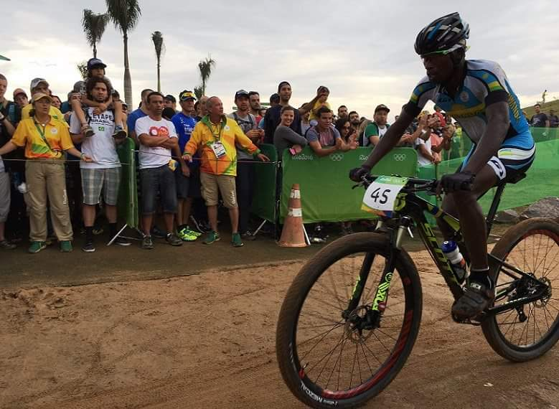
BYUKUSENGE NATHAN

Isiganwa ku magare mu misozi kuwa 21.08.2016 ryakorewe ahareshya na 4.850m (hafi 5 km) ariko bakahazenguruka(laps) inshuro 7, abari imbere uwo bashyikiriye mu nzira akavamo.
BYUKUSENGE NATHAN ntiyashoboye gusoza irushanwa kuko yavuyemo asigaje kuzenguruka inshuro 3 kuri 7 z’isiganwa. Isiganwe ryatangiwe n’abakinnyi 49 hasoza 34.

  - 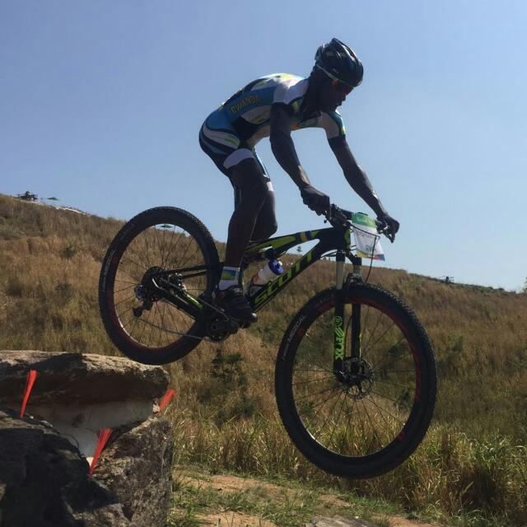

VOLLEYBALL : PLAY - OFFS & CHAMPIONNAT
Kuwa 31.07.2016 harangiye imikino ya play - offs hanasozwa championnat y’icyiciro cya mbere
UKO AMAKIPE YASOJE CHAMPIONNAT & PLAY - OFFS AKURIKIRANA
1.INATEK : amanota 59
2.APR : 54
3.KIREHE : 52
4.IPRC SOUTH : 33
5.LYCEE DE NYANZA : 22
6.RAYON SPORTS : 20
7.KVC : 14
8.UMUBANO BLUE TIGERS : 3

UKO AMAKIPE 4 YA MBERE YASOJE PLAY OFFS & CHAMPIONNAT 2016 AKURIKIRANA
1.RWANDA REVENUE AUTHORITY : amanota 53
2.APR : 43
3.G.S.ST ALOYS : 38
4.RUHANGO : 24
RWANDA REVENUE AUTHORITY yegukanye igikombe cya championnat 2016

VOLLEYBALL : KAVC MEMORIAL TOURNAMENT 2016
Irushanwa mpuzamahanga ngarukamwaka kuwa 06.07.2016 no kuwa 07.08.2016 ryabereye i Kampala muri Uganda ryarimo amakipe yo muri UGANDA, KENYA, RWANDA. Amakipe 3 yo mu Rwanda yari muri iryo rushanwa : RWANDA REVENUE AUTHORITY, INATEK, KIGALI YOUTH.
Mu makipe y’abagabo INATEK (RWANDA) yatwaye igikombe itsinze SKY (UGANDA) ku mukino wa nyuma sets 3 - 2.
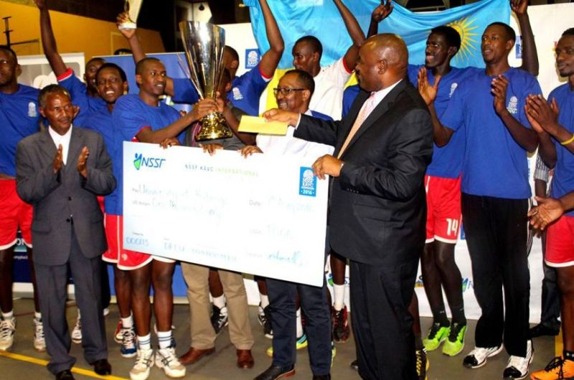INATEK VC
Mu makipe y’abagore ASPIRE (KENYA) yatsinze RRA( RWANDA) 3 - 0
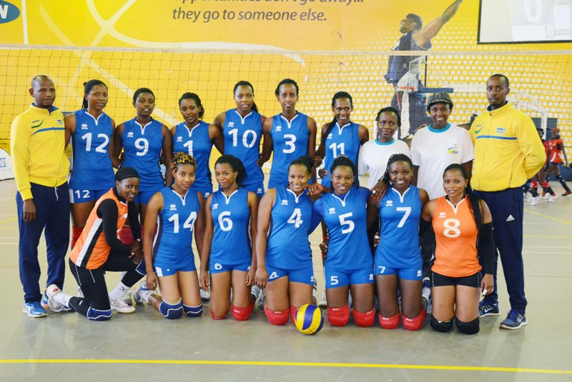RRA VC

SPORTS POUR HANDICAPES : SITTING VOLLEYBALL
Kuwa gatandatu 06.08.2016 habaye imikino yasoje championnat 2016
UKO AMAKIPE Y’ABAGABO YAKURIKIRANYE
1.INTWALI ; amanota 27
2.GISAGARA : 24
3.MUSANZE : 21
4.GICUMBI : 15
5.RUBAVU : 15
6.KICUKIRO : 9
7.BURERA : 9
8.GAKENKE : 6
9.HUYE : 3
10.NYAGATARE : 3
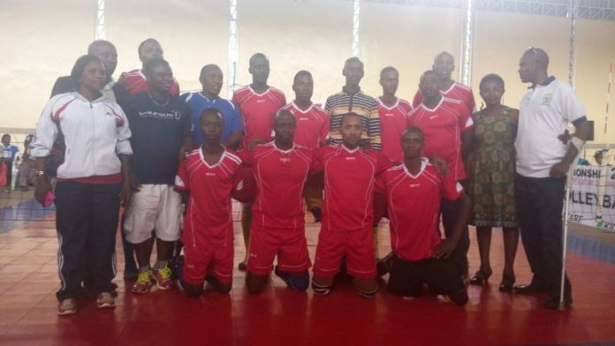INTWALI
UKO AMAKIPE Y’ABAGORE AKURIKIRANA
1.INTWALI : amanota 21+ 13 sets
2.GICUMBI : 21 + 12
3.MUSANZE : 15 + 6
4.NYARUGENGE : 15 + 3
5.RUBAVU : 15 + 1
6.GAKENKE : 9
7.RUHANGO : 3 - 7
8.BUGESERA : 3 - 10
9.NYANZA : 0
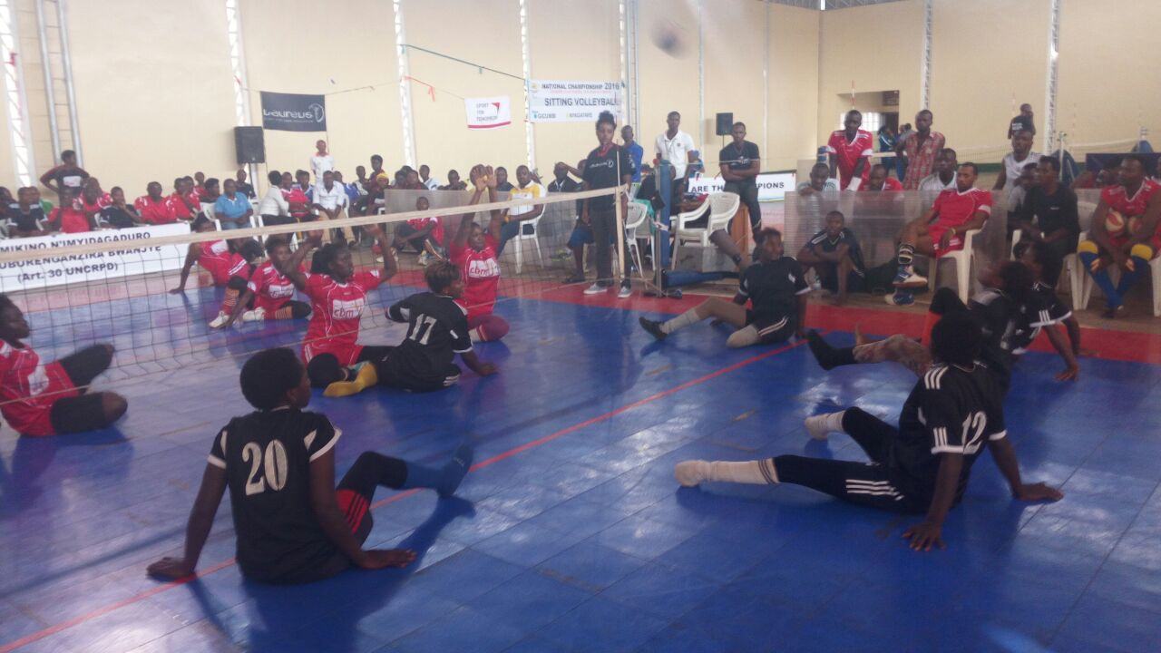
FOOTBALL : CHAMPIONNAT D2
Umikino wa nyuma wasoje championnat y’umupira w’amaguru mu cyiciro cya kabiri wabaye kuwa 07.08.2016.
PEPINIERE 2 (4 pen 3 ) 2 KIREHE
PEPINIERE yatwaye igikombe yazamutse muri D1 hamwe na KIREHE
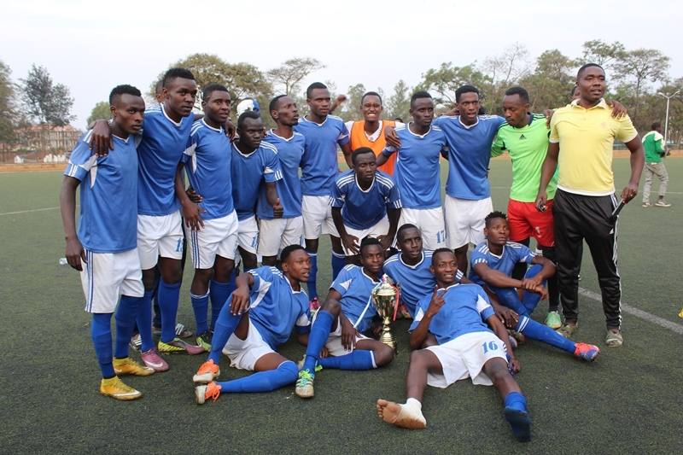PEPINIERE FC

SPORT AUTOMOBILE : RWANDA MOUNTAIN GORILLA RALLY 2016
Isiganwa mpuzamahanga ry’imodoka ryabaye kuva kuwa 12.08.2016 kugeza kuwa 14.08.2016 ryarimo imdodoka 23 zaturutse mu bihugu 5 : UGANDA, ZAMBIE, BURUNDI, KENYA, RWANDA, hasoza 13.
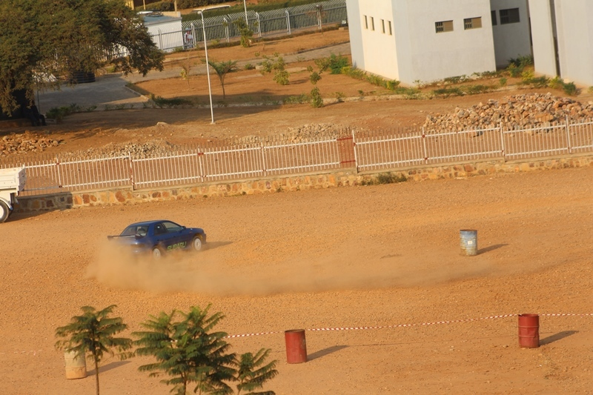
Mu myanya 3 ya mbere:
1.BUKERA VALERY & NITAL KHETIA (BURUNDI), imodoka Subaru Impreza
2.MUNA SINGH & JASMEEN SINGH (BURUNDI), imodoka Subaru Impreza
3.HASSAN ALWI & MUSA NSUBUGA (UGANDA), imodoka Subaru Impreza
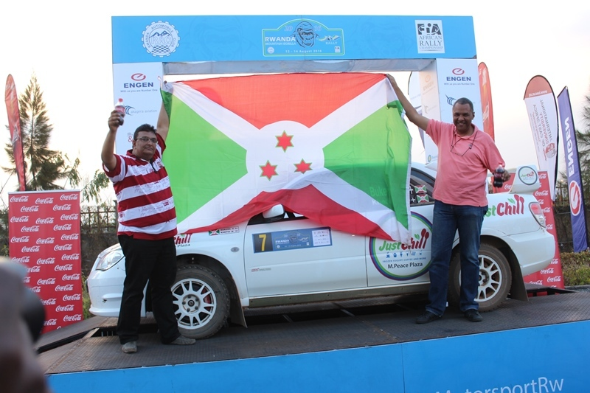BUKERA VALERY & KETIA NITAL
Abanyarwanda baje hafi ni ku mwanya wa 4: GAKWAYA JEAN CLAUDE & MUGABO CLAUDE, imodoka Subaru Impreza
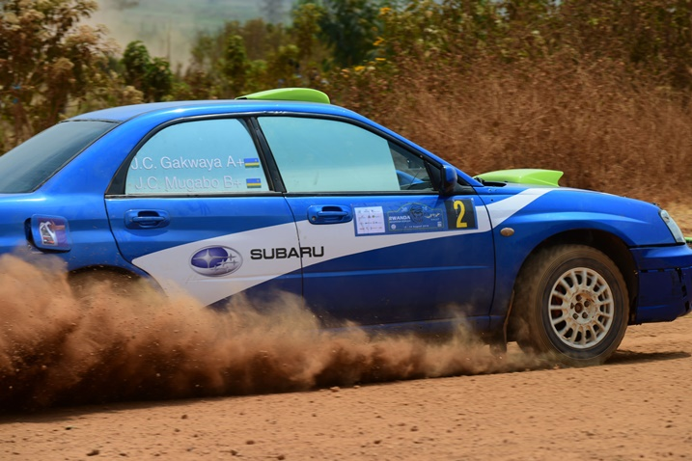
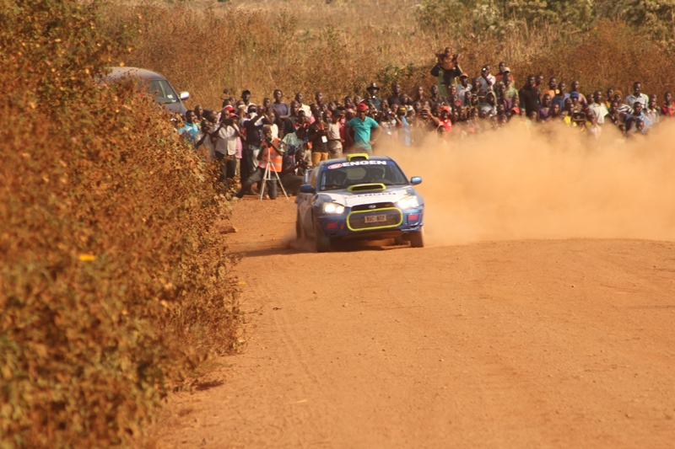
FOOTBALL : AMAVUBI SENIOR
Uwari umutoza w’ikipe y’igihugu AMAVUBI y’abakuru, JONATHAN MCKISTRY, kuwa 18.08.2016 yasezerewe kuri iyo mirimo
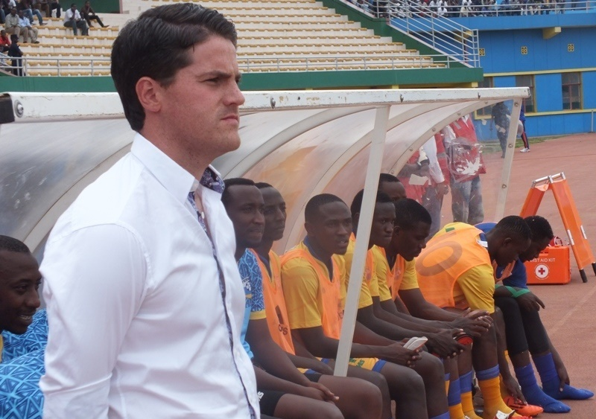

VOLLEYBALL : CARRE D’AS 2016
Irushanwa risoza umwaka w’imikino muri volleyball kuwa 20.08.2016 no kuwa 21.08.2016 ryahuje amakipe yafashe imyanya 4 ya mbere muri championnat 2016.
Amakipe y’abagabo : UNIK (ex INATEK), IPRC SOUTH, APR, KIREHE
Ku mukino wa nyuma : UNIK 3 - 2 APR
Igikombe cya championnat n’icya Carré d’As byatwawe na UNIK
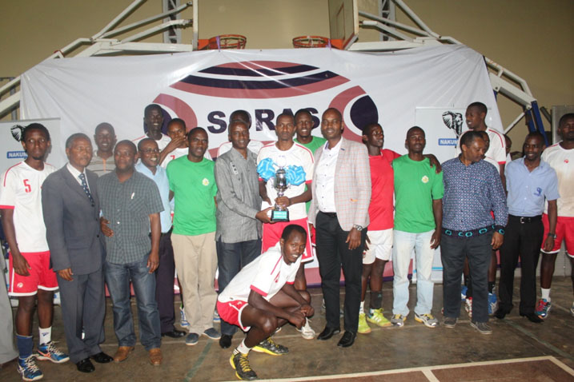UNIK VC
Amakipe y’abagore : RWANDA REVENUE AUTHORITY, RUHANGO, APR, G.S.ST ALOYS RWAMAGANA
Ku mukino wa nyuma : RRA 3 - 2 APR
Igikpmbe cya championnat n’icya Carré d’ As byatwawe na RRA
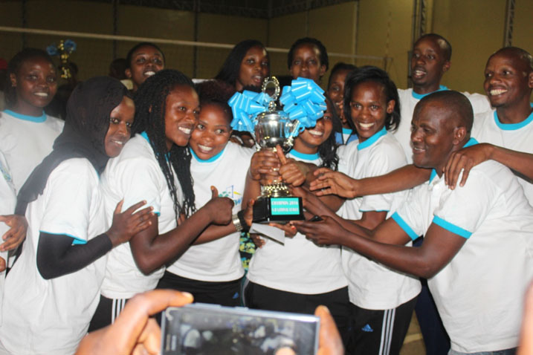RWANDA REVENUE AUTHORITY
BASKETBALL : “GIANTS OF AFRICA CAMP 2016”
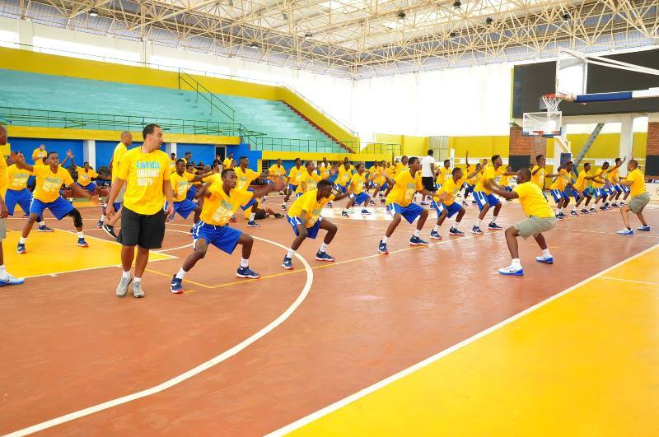
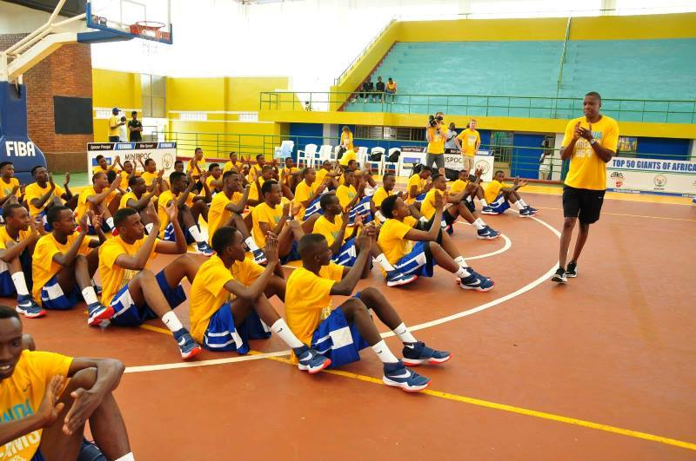
Umushinga ugamije gutoza no gukundisha abana bo muri Afrika umukino wa basketball ukuriwe na MASAI UJIRI umuyobozi w’ikipe Toronto Raptors ikina muri NBA, kuva kuwa 23.08.2016 kugeza kuwa 25.08.2016 yakoreye gahunda ngarukamwaka y’umwiherero w’abana 50 i Kigali kuri stade Amahoro no kuri club Rafiki i Nyamirambo.
Kuri club Rafiki hubatswe hanatahwa ikibuga cyavuguruwe ku nkunga ya Giants of Africa.
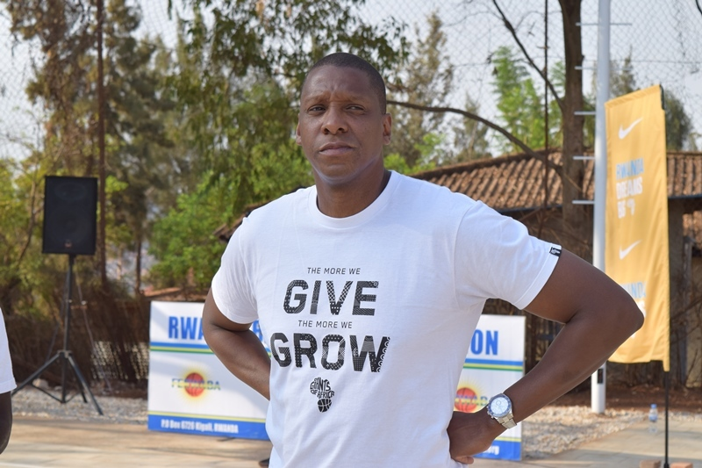MASAI UJIRI
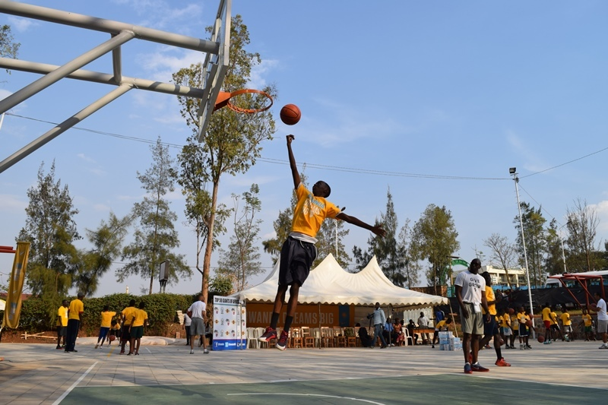
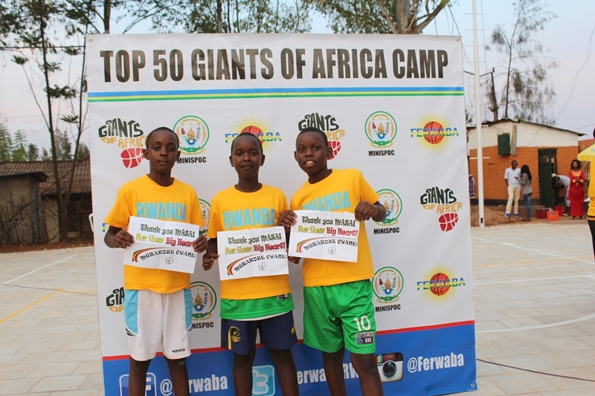

HANDBALL : U18 ZONE 4, 5, 6, TOURNAMENT
Irushanwa ryabereye i Yaoundé muri Cameroun kuva kuwa 25.08.2016 kugeza kuwa 29.08.2016, ryahuje amakipe y’abahungu batarengeje imyaka 18 y’ibihugu bibiri: CAMEROUN, RWANDA
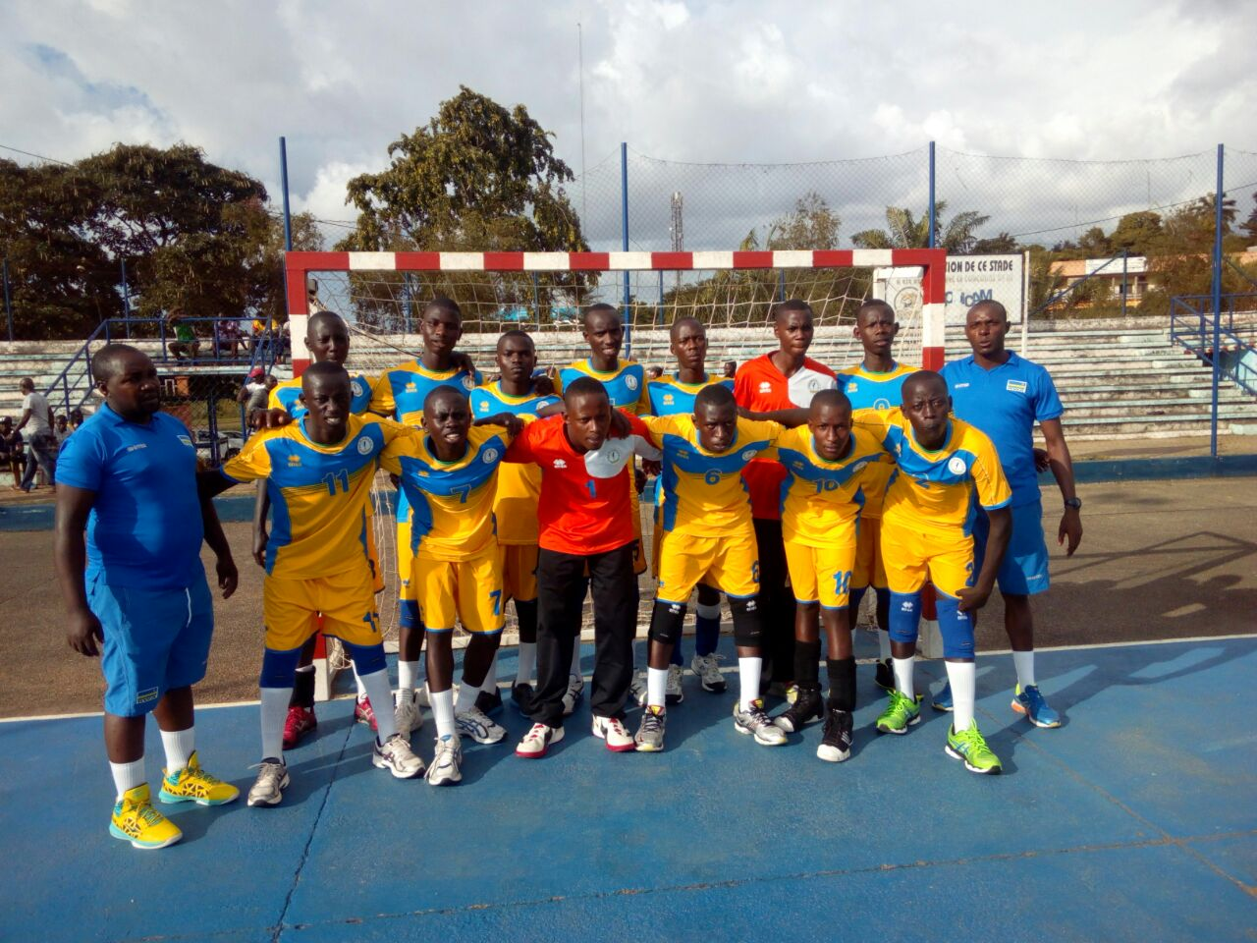
RWANDA 9 - 38 CAMEROUN
CAMEROUN 37 - 17 RWANDA
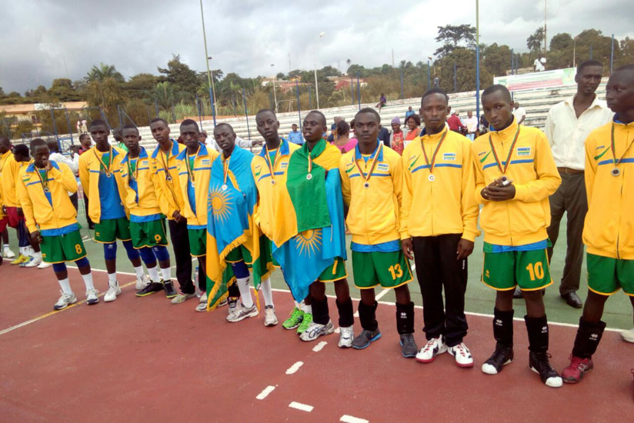
FIFA’s LIVE YOUR GOALS GRASSROOTS FESTIVAL 2016
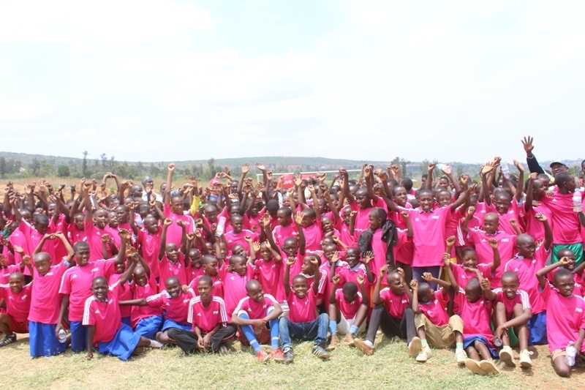
Mu bice bitandukanye by’igihugu kuva mu kwezi kwa 08.2016 habaye gahunda yo gutoza umupira w’amaguru abana b’abakobwa bafite kuva ku mwaka 6 kugeza kuri 12.

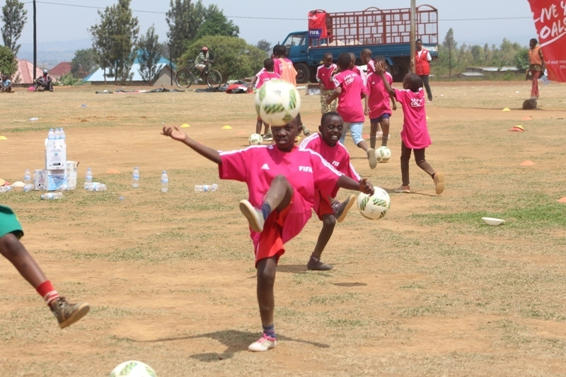
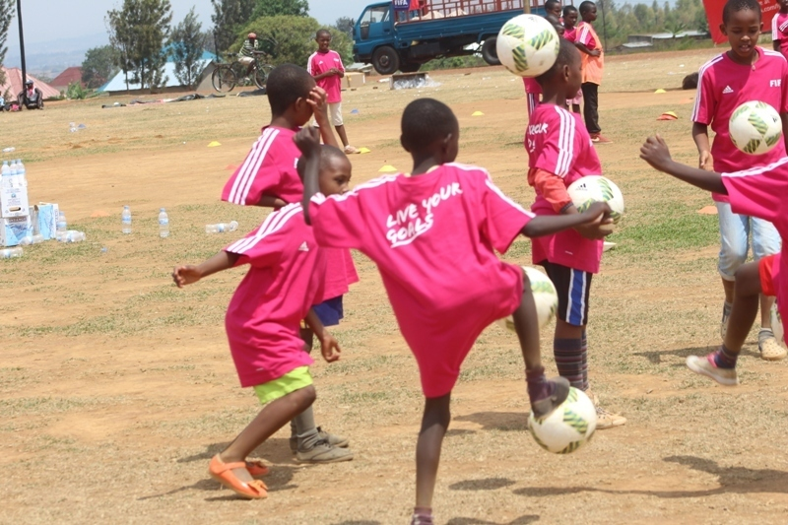

JEUX PARALYMPIQUES RIO 2016 : 07 - 18.09.2016
I Rio muri Bresil kuva kuwa 07.09.2016 kugeza kuwa 18.09.2016 habaye imikino paralempike
WELCOME CEREMONY
Kuwa 02.09.2016 abahagarariye u Rwanda mu mikino paralempike bahawe ikaze muri village olempike
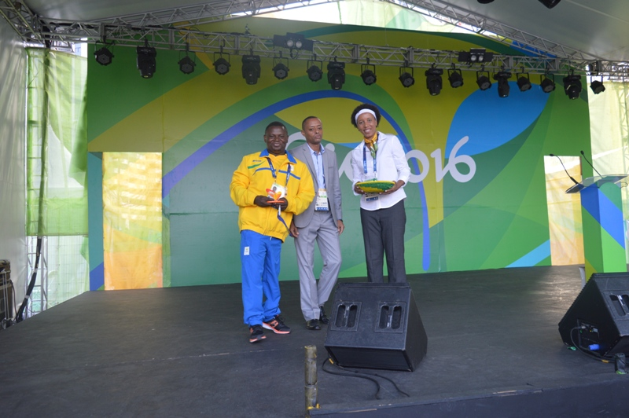
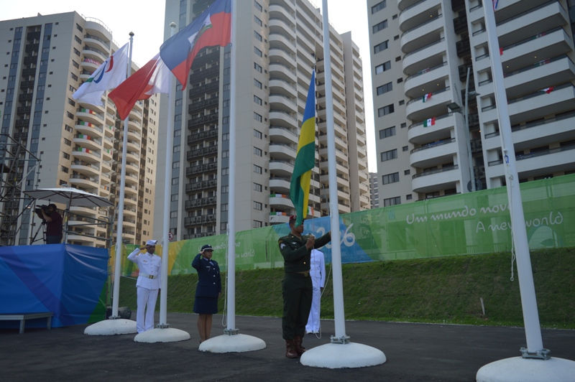
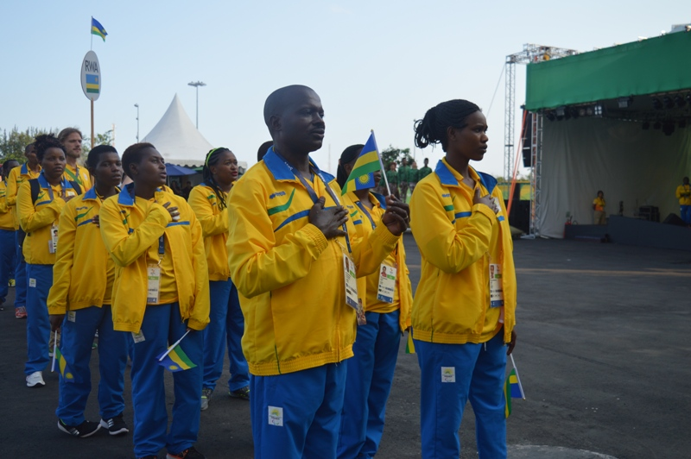
OPENING CEREMONY
Imihango yo gutangiza ku mugaragaro imikino paralempike kuwa 07.09.2016 yabereye i Rio
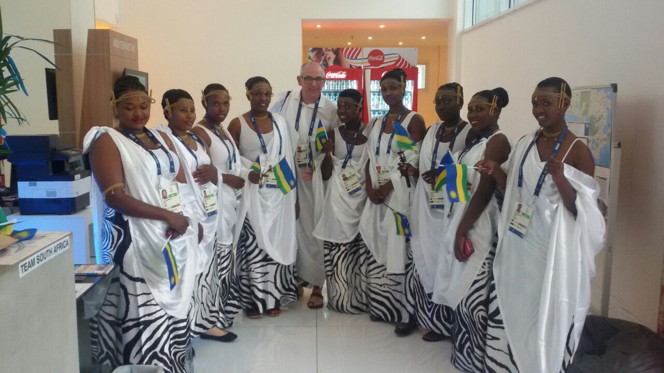
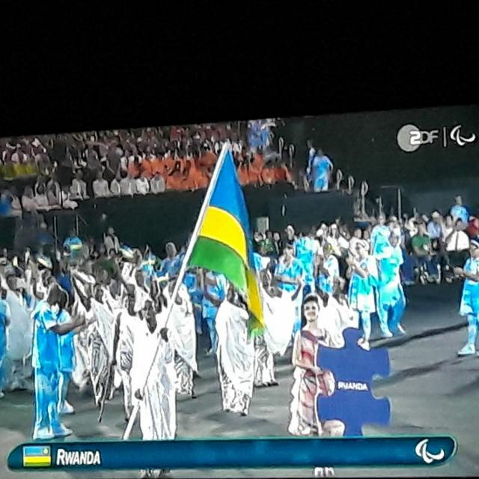
SITTING VOLLEYBALL
IMIKINO Y’IJONJORA MU MATSINDA
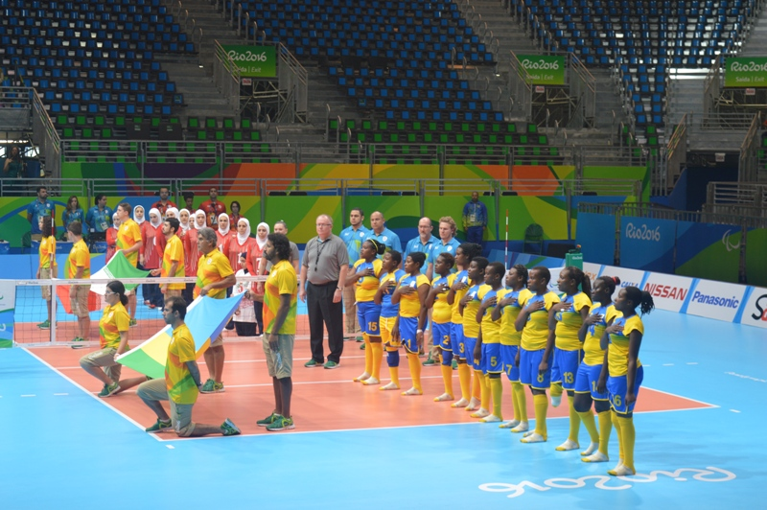
Kuwa 10.09.2016
RWANDA 0 - 3 CHINE
Kuwa mbere 12.09.2016
RWANDA 0 - 3 IRAN
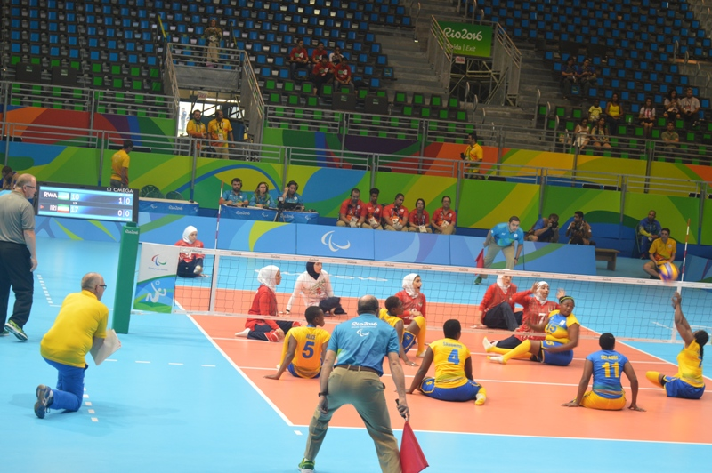
Kuwa 14.09.2016
RWANDA 0 - 3 USA
Kuwa kane 15.09.2016

GUKINIRA UMWANYA WA 7 & 8
RWANDA 0 - 3 CANADA
Ikipe y’u Rwanda yasoje ku mwanya wa 8

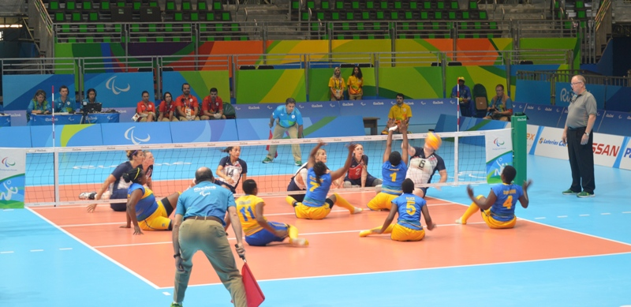

ATHLETISME :

MUVUNYI HERMAS
Mu gusiganwa kwiruka 1.500m MUVUNYI HERMAS kuwa 16.09.2016 yabaye uwa 5 akoresheje 4’05’’19.
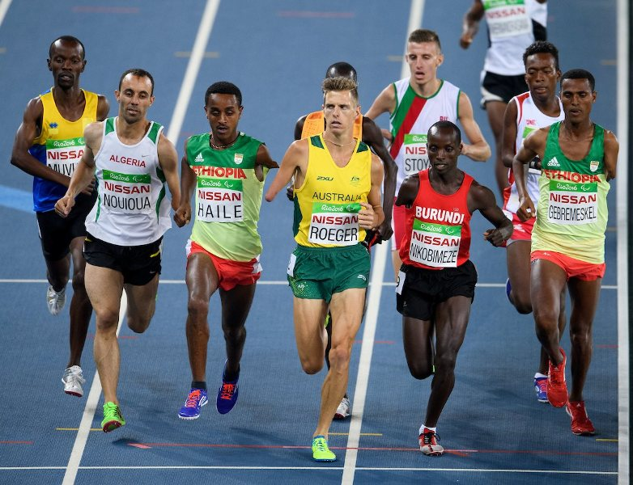
Mu gusiganwa kwiruka 400m, kuwa gatandatu 17.09.2016 MUVUNYI HERMAS yarahanwe arasezererwa kubera ikosa yakoze mu isiganwa.

FOOTBALL : ELIMINATOIRES CAN GABON 2017
Mu mikino y’ijonjora mu matsinda y’irushanwa ry’igikombe cy’Afurika Gabon 2017, u RWANDA rwari mu itsinda H. Umukino wasoje amajonjora wabereye muri Ghana kuwa gatandatu 03.09.2016
GHANA 1 - 1 RWANDA
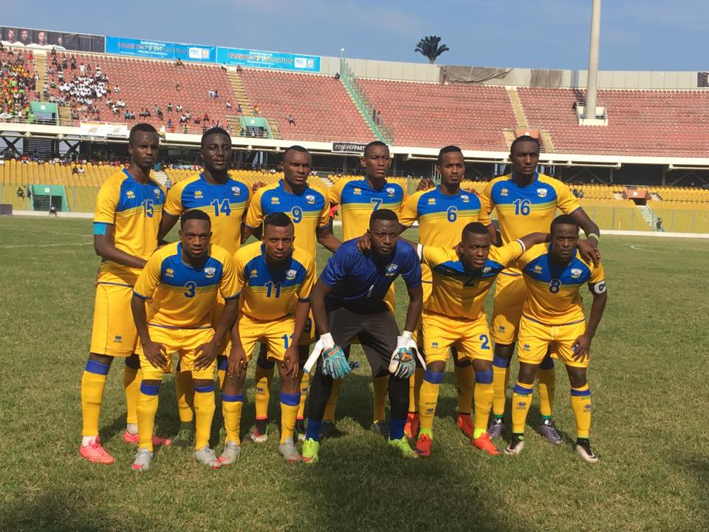
Uko amakipe yakurikiranye nyuma y’ijonjora mu itsinda H:
1.GHANA : amanota 13/ 18 yatsindiye gukina CAN 2016
Izindi kipe zo muri iri tsinda zarasezerewe
2.MOZAMBIQUE : 7
3.RWANDA : 6
4.ILE MAURICE : 6

HANDBALL : 12è CHAMPIONNAT D’AFRIQUE DES NATIONS CADETS MASCULINS
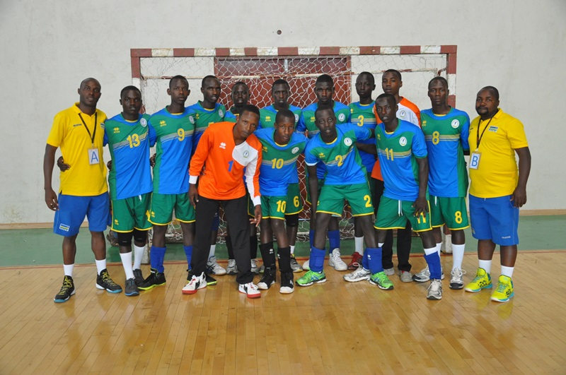
Irushanwa ryabereye i Bamako muri Mali kuva kuwa 02.09.2016 kugeza kuwa 09.09.2016 ryarimo amakipe 8 yashyizwe mu matsinda 2:
Itsinda B ririmo RWANDA, EGYPTE, TUNISIE, RD CONGO
Itsinda A ririmo ALGERIE, MAROC, GUINEE, MALI
IMIKINO Y’IKIPE Y’U RWANDA
RWANDA 15 - 45 RD CONGO
RWANDA 12 - 56 EGYPTE
RWANDA 7 - 40 TUNISIE

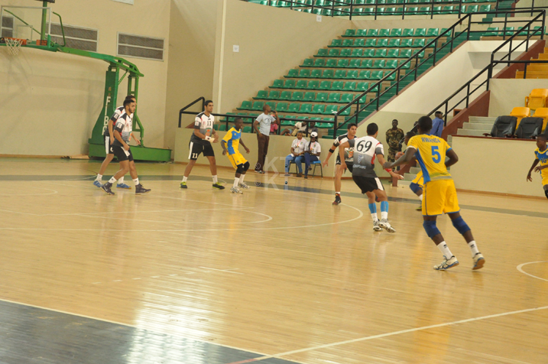
MURI ¼ CY’IRANGIZA
RWANDA 10 - 45 ALGERIE
GUKINIRA IMYANYA 5 - 6
RWANDA 21 - 29 MAROC
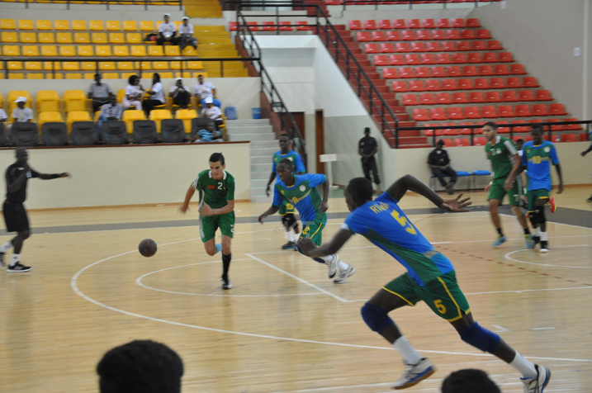
GUKINIRA IMYANYA 7 - 8
RWANDA 30 - 29 MALI
U RWANDA rwafashe umwanya wa 7 mu makipe 8

SPORT SCOLAIRE : 15th EDITION OF FEASSA
Imikino yahuje amakipe y’ibigo by’amashuri yisumbuye byo mu bihugu bihuriye muri East African Community: Kenya, Rwanda, Uganda,Tanzania, Burundi. Irushanwa ryabereye Eldoret muri Kenya kuva kuwa 27.08.2016 kugeza kuwa 03.09.2016
U Rwanda rwahagarariwe mu mikino 10 : football, tennis, netball, rugby, volleyball, handball, basketball, tennis de table, athletisme, natation.
AMAKIPE Y’AMASHURI YO MU RWANDA YAGEZE KURE :
BASKETBALL ABAHUNGU
UMUKINO WA NYUMA
APE RUGUNGA (RWANDA) 86 - 72 ETG NYAKABIGA (BURUNDI)
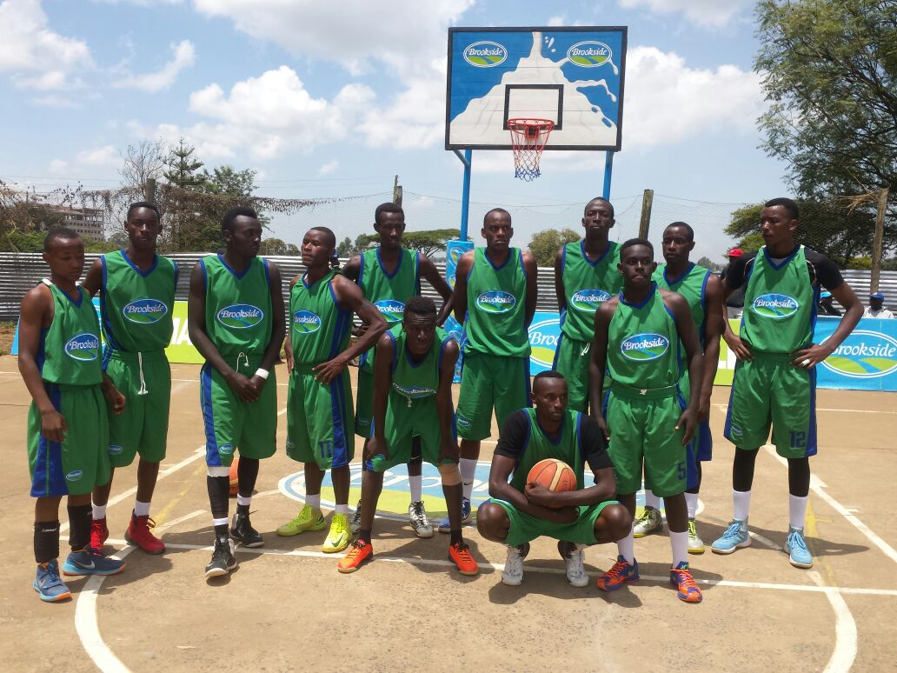APE RUGUNGA
VOLLEYBALL ABAHUNGU
UMUKINO WA NYUMA
APAPEN (RWANDA) 0 - 3 MALAVA (KENYA)
VOLLEYBALL ABAKOBWA
GUKINIRA UMWANYA WA 3
COLLEGE INDANGABUREZI (RWANDA) 2 - 3 LUBULU (KENYA)
FOOTBALL ABAKOBWA
UMUKINO WA NYUMA
REMERA RUKOMA (RWANDA) 1 (5 pen. 4) 1 ST JOHN’S KOLOLENI (KENYA)

VOLLEYBALL : 2016 BOY’S U19 AFRICAN NATIONS VOLLEYBALL CHAMPIONSHIP
Kelibia / Tunisie 08 - 10.09.2016
Irushanwa ryahuje amakipe y’ibihugu 4: TUNISIE, MAROC, RWANDA, EGYPTE, ryabereye i Kelibia muri Tunisie kuva kuwa 08.10.2016 kugeza kuwa 10.09.2016.
IMIKINO Y’IKIPE Y’U RWANDA
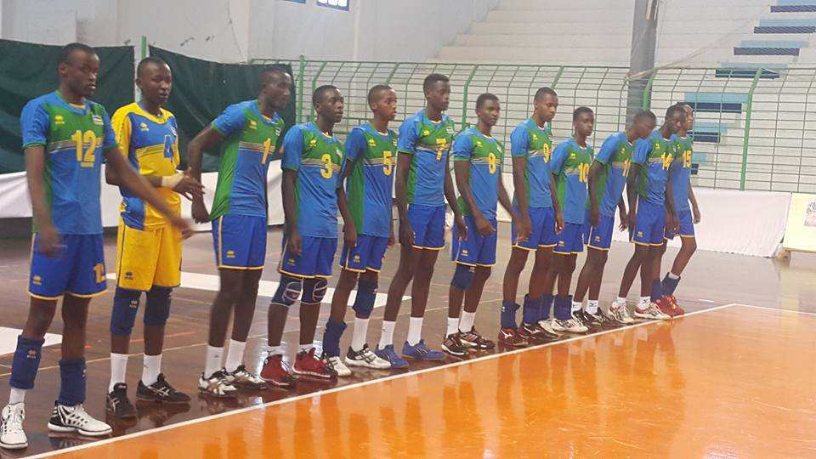
RWANDA 1 - 3 TUNISIE
RWANDA 1 - 3 EGYPTE
RWANDA 0 - 3 MAROC
UKO AMAKIPE YASOJE AKURIKIRANA
1.TUNISIE
2.EGYPTE
3.MAROC
4.RWANDA

FOOTBALL : 2016 CECAFA WOMEN CHAMPIONSHIP
Irushanwa ryahuje amakipe y’ibihugu y’abagore ryabereye i Jinja muri Uganda kuva kuwa 11.09.2016 kugeza kuwa 20.09.2016.
Ikipe y’u RWANDA yari mu itsinda B ry’imikino y’ijonjora hamwe na TANZANIE, ETHIOPIE.
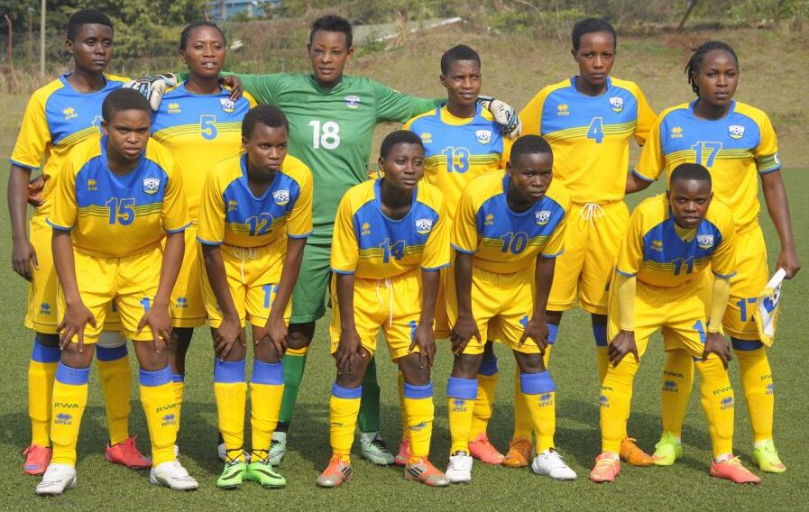
IMIKINO Y’IKIPE Y’U RWANDA
RWANDA 2 - 3 TANZANIE
RWANDA 2 - 3 ETHIOPIE
Ikipe y’u Rwanda yasezerewe itarenze ijonjora mu itsinda yarimo

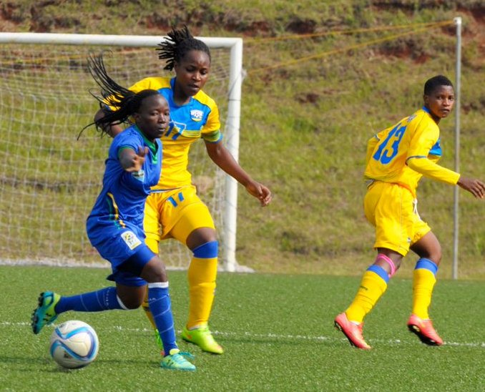

TAEKWONDO : AMBASSADOR’S CUP 4th EDITION
Stade Amahoro 10 - 11.09.2016
Irushanwa mpuzamahanga ryarimo amakipe 22 yo mu bihugu 4 : UGANDA, KENYA, R.D.CONGO, RWANDA; ryabereye i Kigali kuri stade Amahoro kuwa 10.09.2016 no kuwa 11.09.2016.
MU MAKIPE
ABAGABO : Igikombe cyatwawe na DREAM CLUB - GATENGA (RWANDA)
ABAGORE : Igikombe cyatwawe na G.S.STE MARIE REINE - MUHANGA (RWANDA)
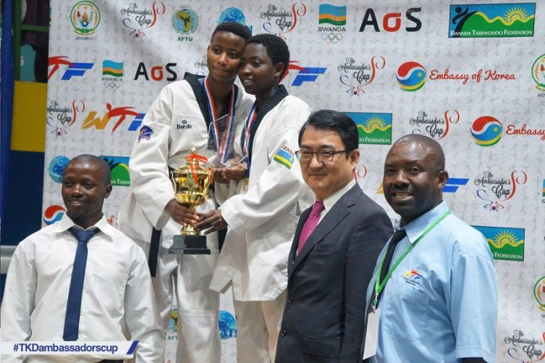
ABAKINNYI KU GITI CYABO
BEST MALE SENIOR : VINCENT DOCK (KENYA)
BEST FEMALE SENIOR : NDACYAYISENGA ALINE (RWANDA)
BEST MALE JUNIOR : SIBOMANA ATHANASE (RWANDA)
BEST FEMALE JUNIOR : AMINA (UGANDA)

TENNIS : RWANDA OPEN 2016
Kigali / Stade Amahoro 16 - 25.09.2016
Irushanwa mpuzamahanga ryarimo abakinnyi bo mu bihugu 6 : KENYA, UGANDA, TANZANIE, BURUNDI, R.D.CONGO, RWANDA, ryabereye i Kigali kuri sated Amahoro kuva kuwa 16.09.2016 kugeza kuwa 25.09.2016.
Ryakinwe mu byiciro binyuranye: abagabo, abagore, professionnels, amateurs, 16 and under.
ABATSINZE IRUSHANWA :
PROFESSIONNELS
SIMPLE / ABAGAB0
INDONDO DENIS (RDC) 2 - 0 MUGABE DUNCAN (UG)
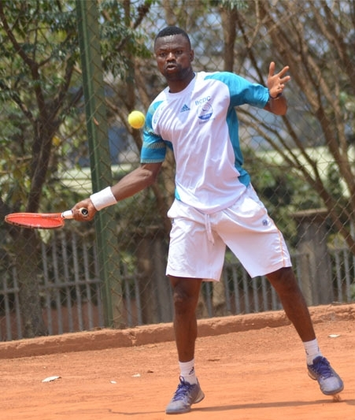
INDONDO DENIS

SIMPLE / ABAGORE
ONYA NANCY (RDC) 2 - 1 CHANGAWA SHUFA ( KEN)
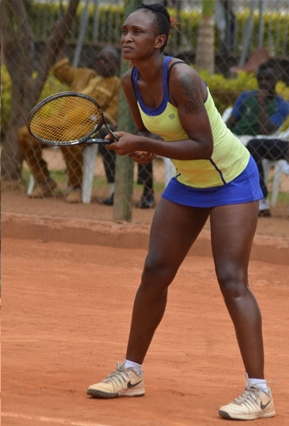
ONYA NANCY
DOUBLE / ABAGABO
INDONDO DENIS & NKULUFA SARMA (RDC) 2 - 0 HAVUGIMANA OLIVIER & HABIYAMBERE DIEUDONNE (RWANDA)
DOUBLE / ABAGORE
ONYA NANCY (RDC) & CHANGAWA SHUFA (KENYA) 2 - 0 INGABIRE MEGANE & UMUMARARUNGU GISELE (RWANDA)

AMATEURS
SIMPLE / ABAGABO
KANINGU CHRISTIAN (RWANDA)
DOUBLE / ABAGABO
BAHATI THEONESTE & KAREKEZI JEAN (RWANDA)

16 AND UNDER
ABAHUNGU
CYIZA JOSEPH (RWANDA)
ABAKOBWA
UWAMWEZI JASMINE (RWANDA)
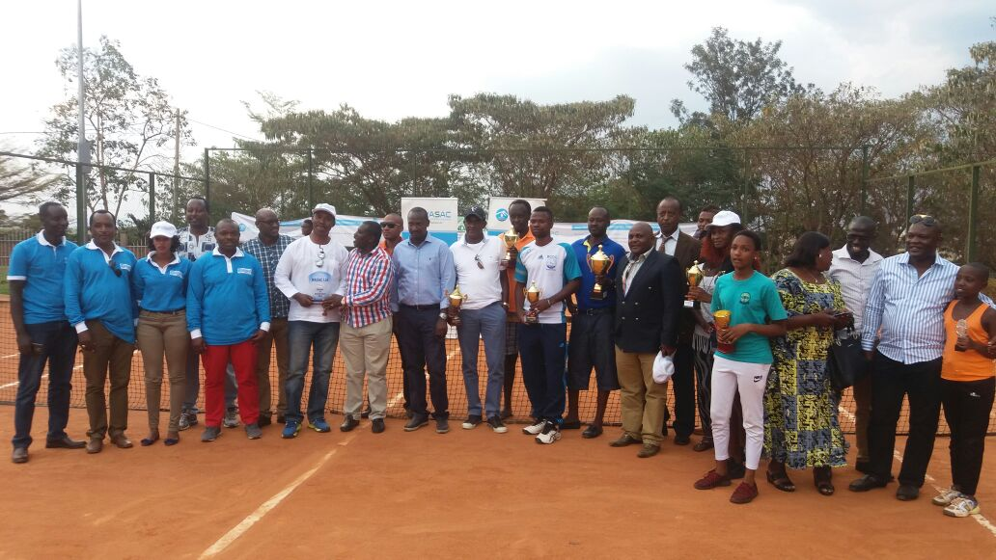
CNOSR - EAST LOTHIAN COUNCIL DELEGATION:
Kuwa 27.09.2016 - 02.10.2016
Intumwa za East Lothian Council yo muri Scotland zigizwe n’impuguke muri rugby, swimming, athletics, beach volleyball zagiriye uruzinduko rw’akazi mu Rwanda.
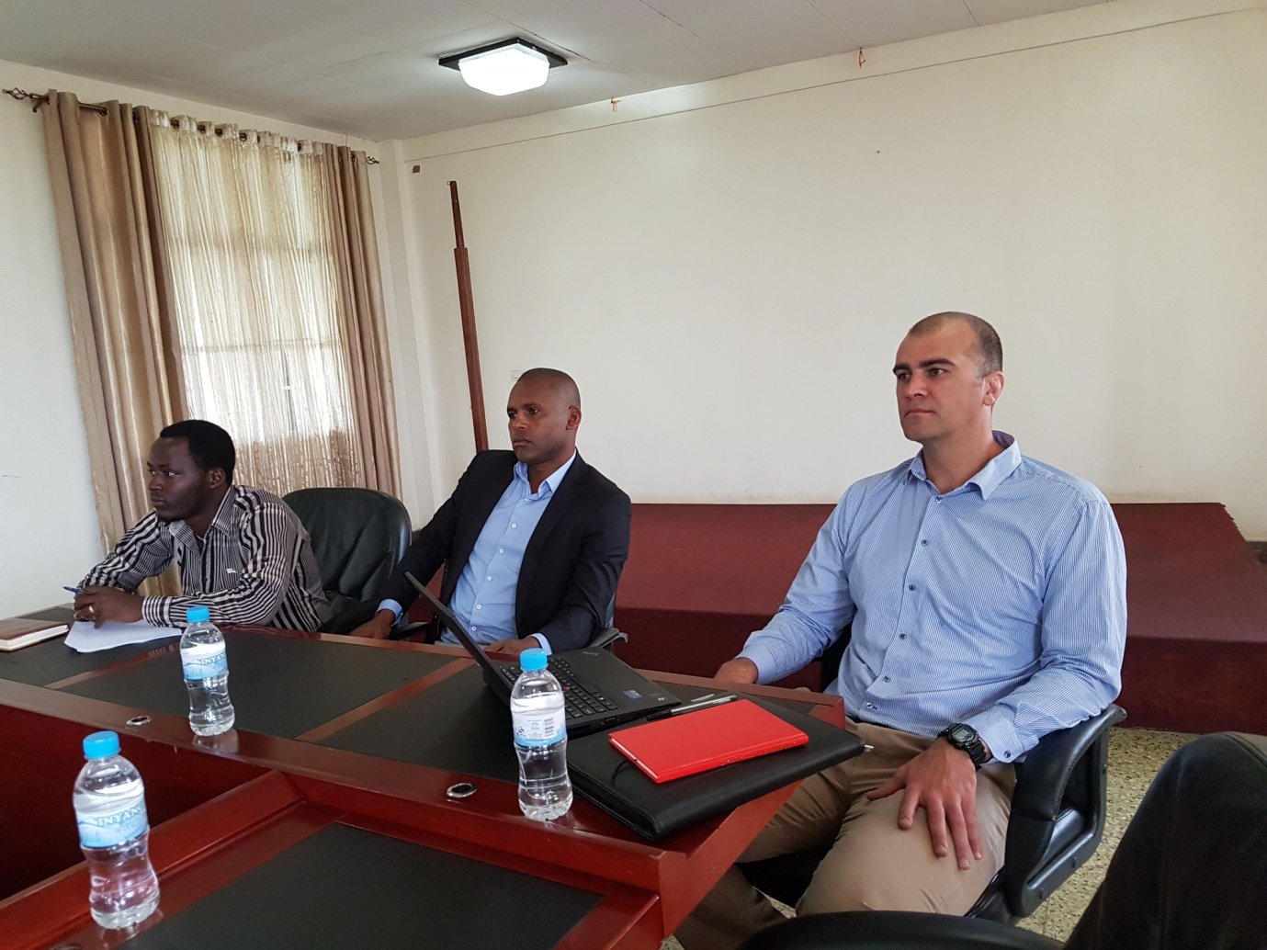
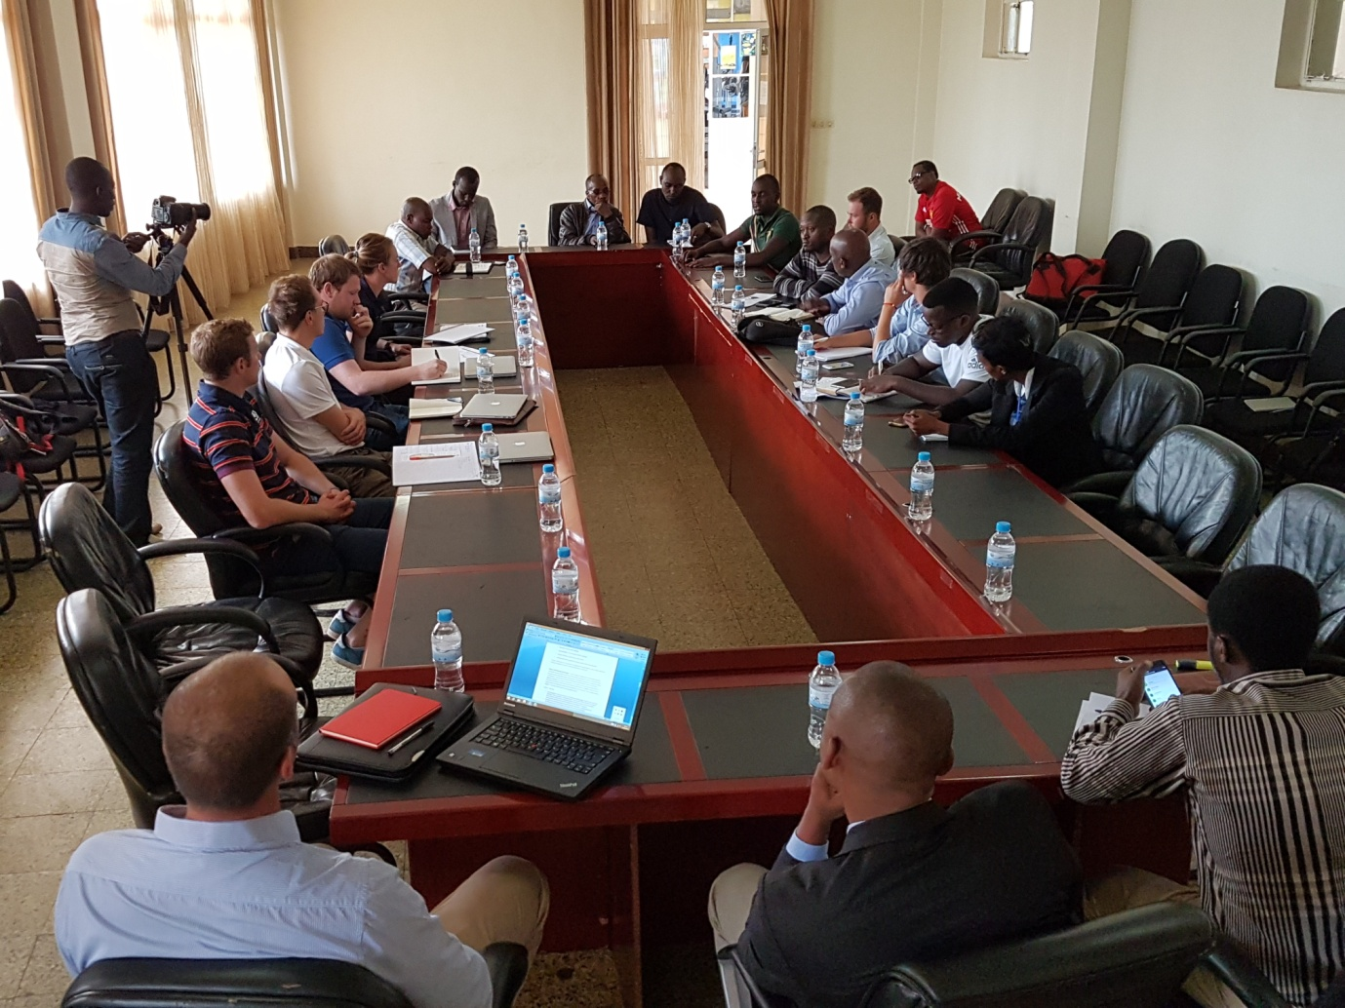
Bagiranye ibiganiro n’abayobozi ba CNOSR n’ab’amashyirahamwe y’imikino banatanga amahugurwa n’imyitozo ku bakinnyi mu cyerekezo cya Commonwealth Games - Gold Coast 2018 na Durban 2022.

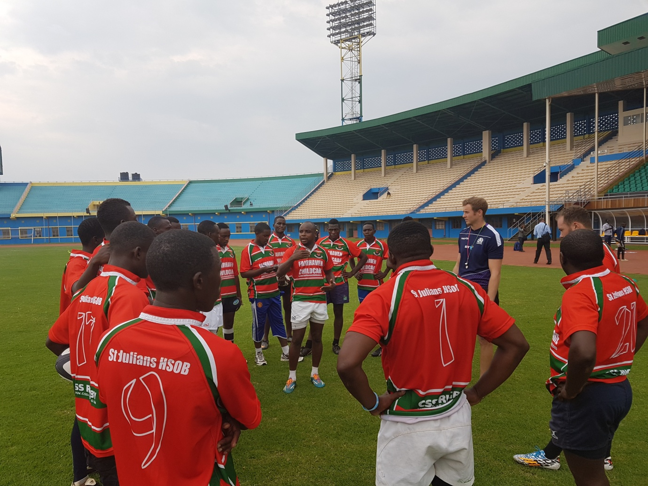
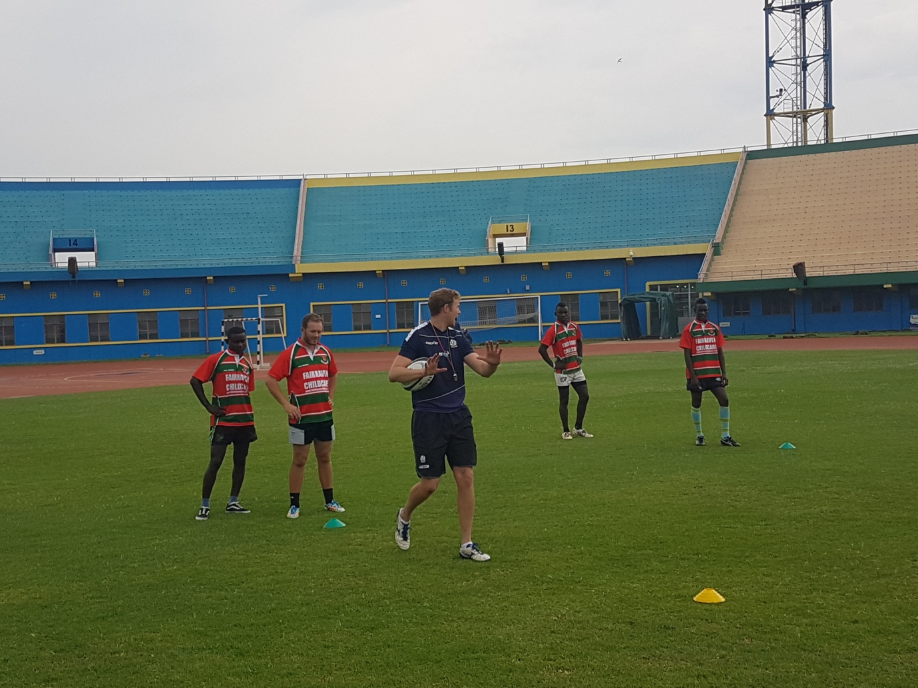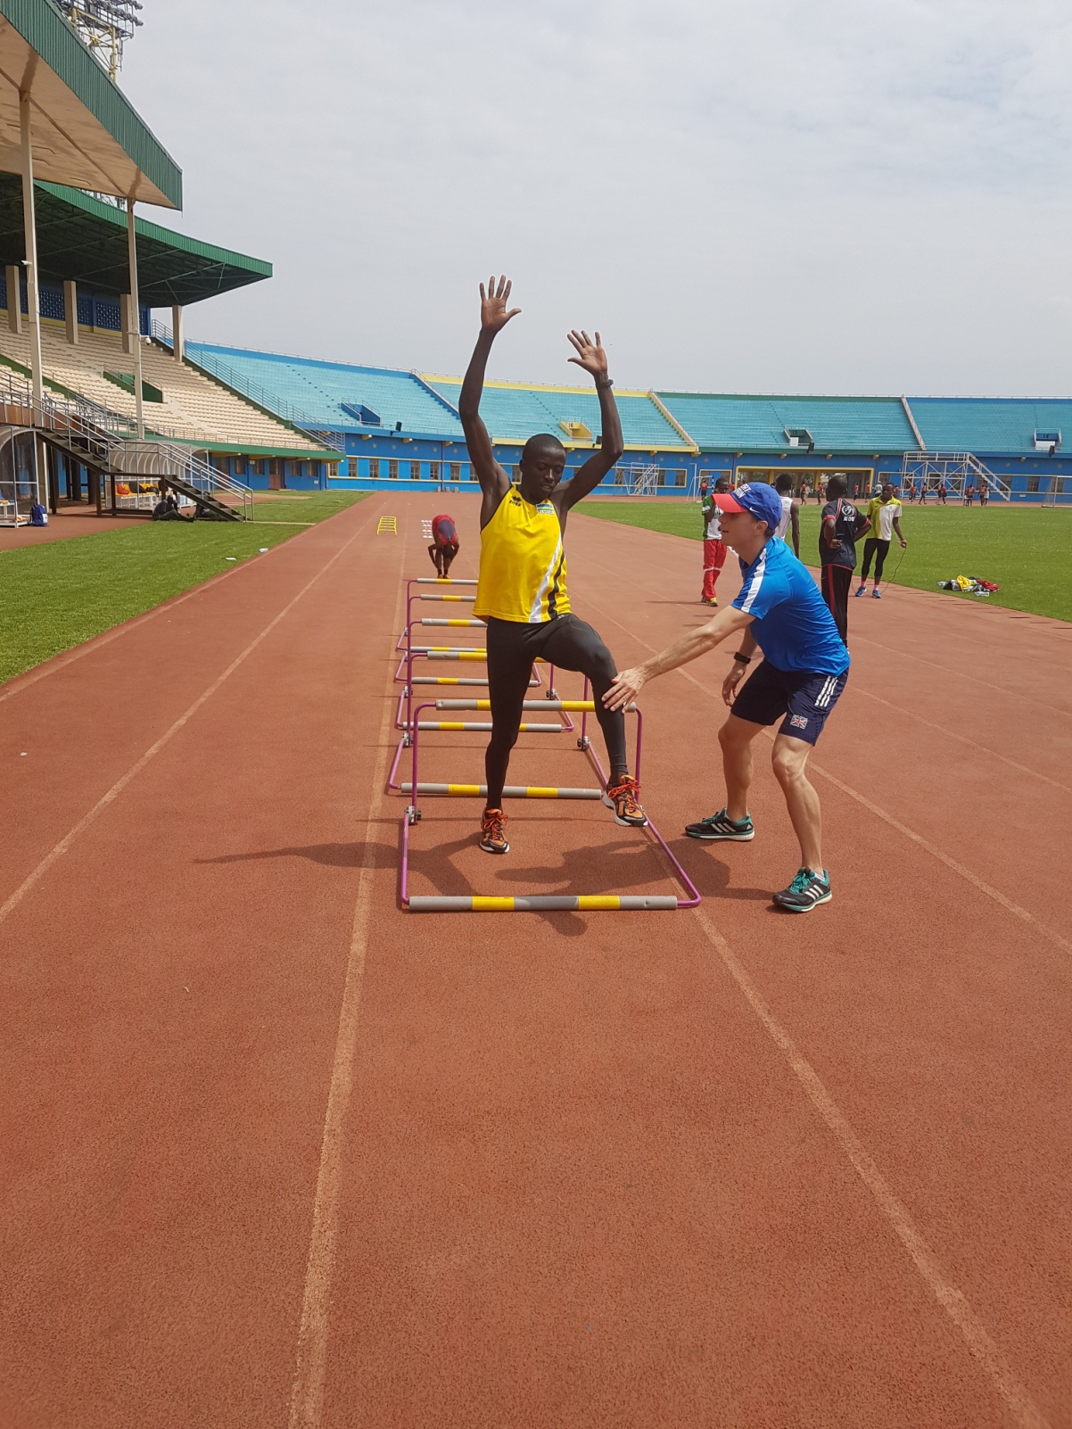

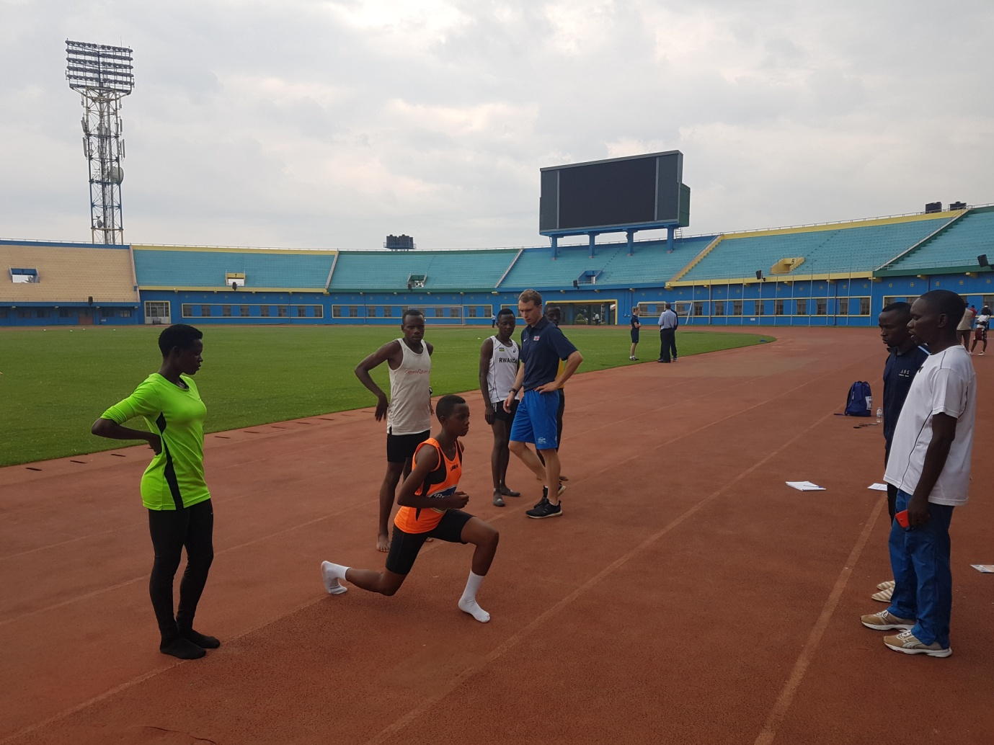
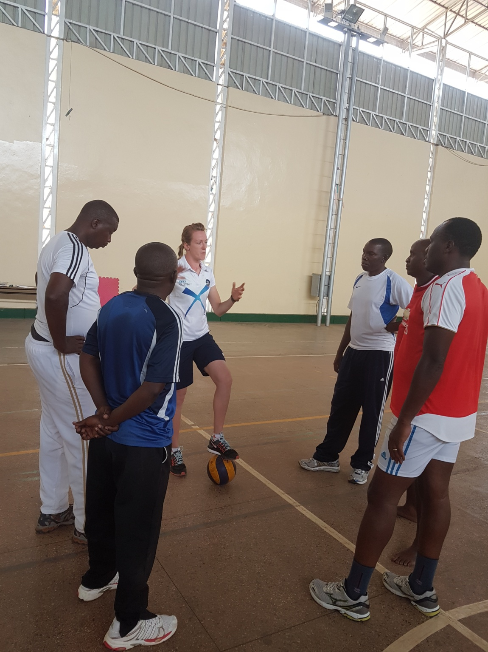

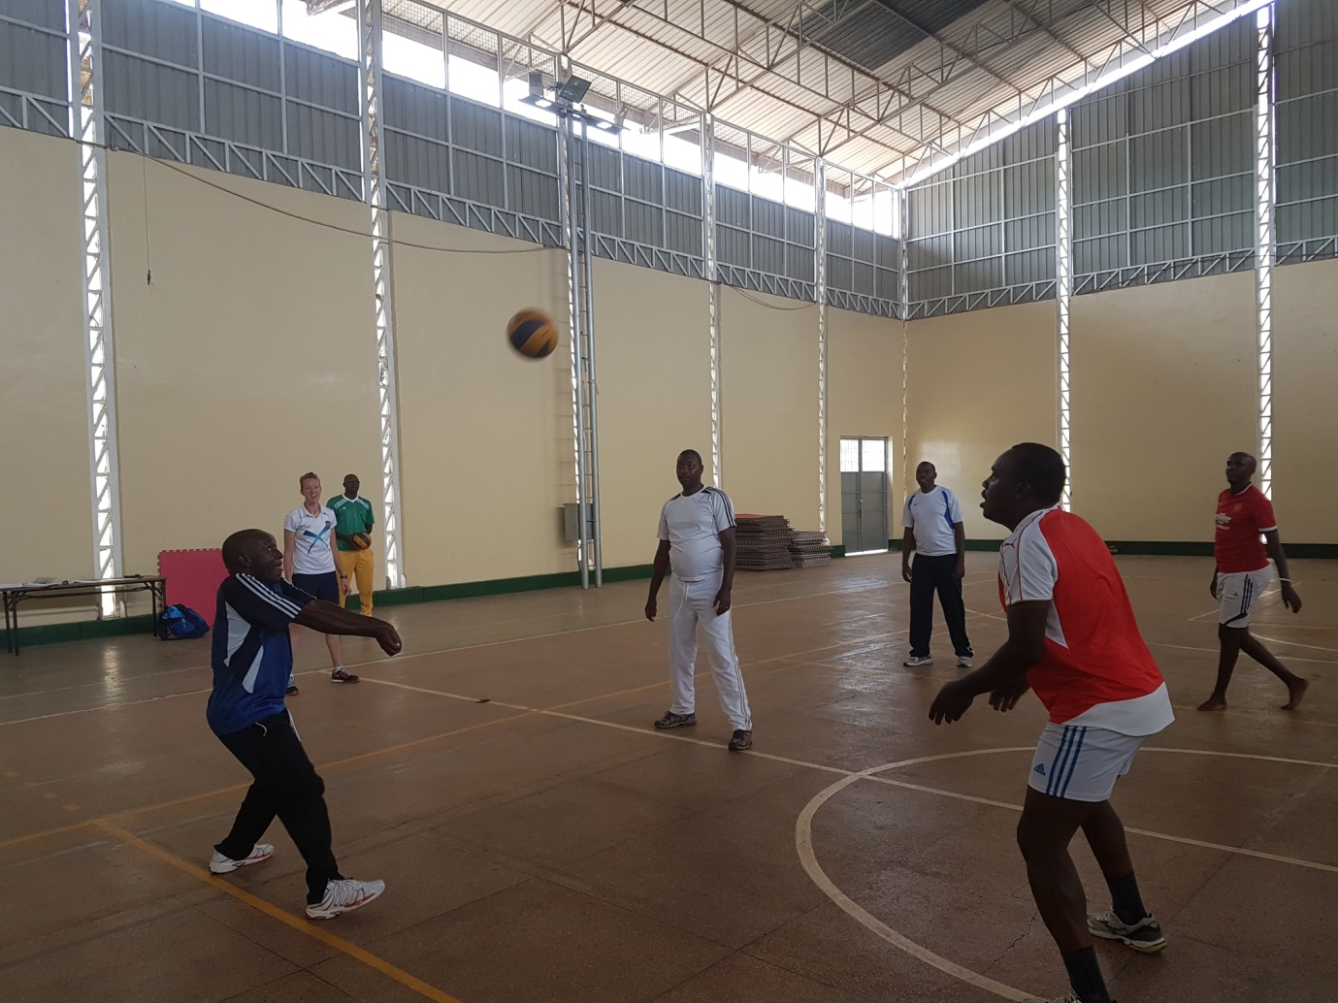
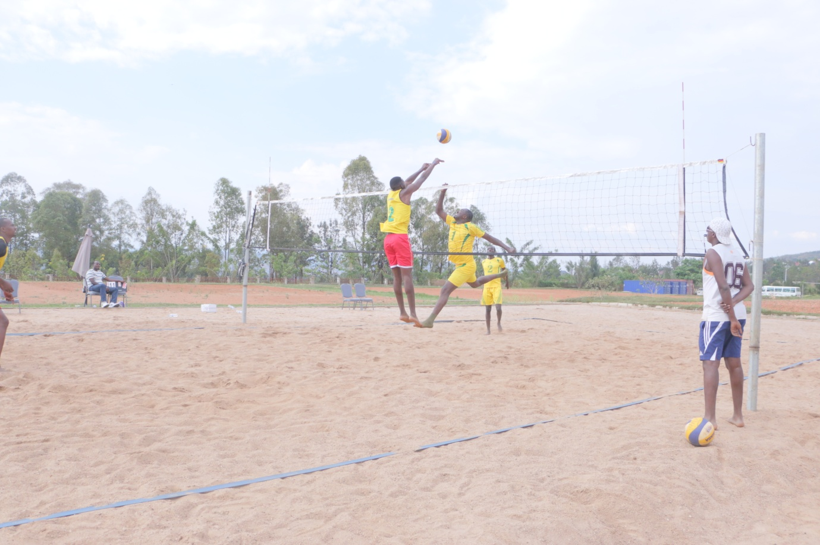
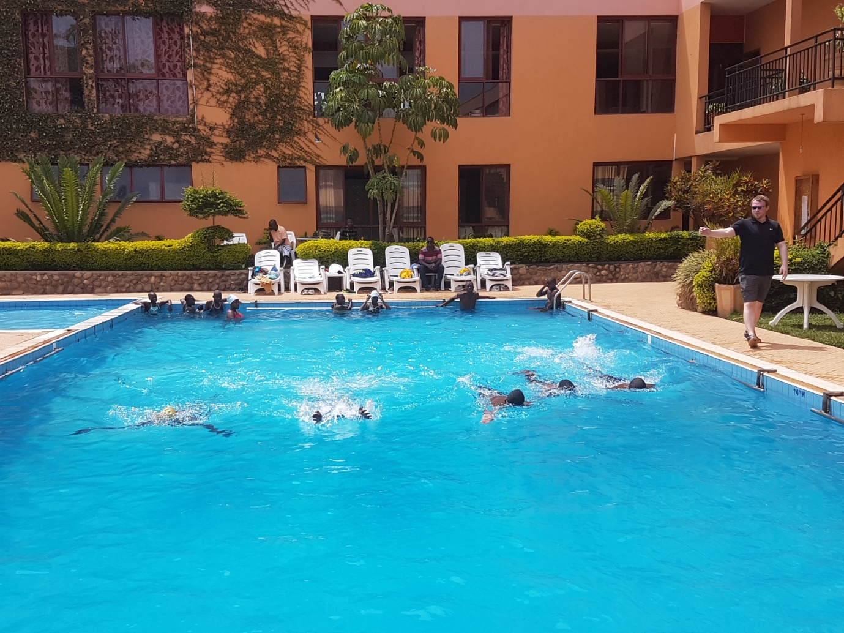
CYCLISME : TOUR DE LA RECONCILIATION 2016
TEAM RWANDA yari igizwe n’abakinnyi 6 yagiye mu irushanwa mpuzamahanga ryo gusiganwa ku magare ryabereye muri Cote d’Ivoire kuva kuwa 24.09.2016 kugeza kuwa 30.09.2016
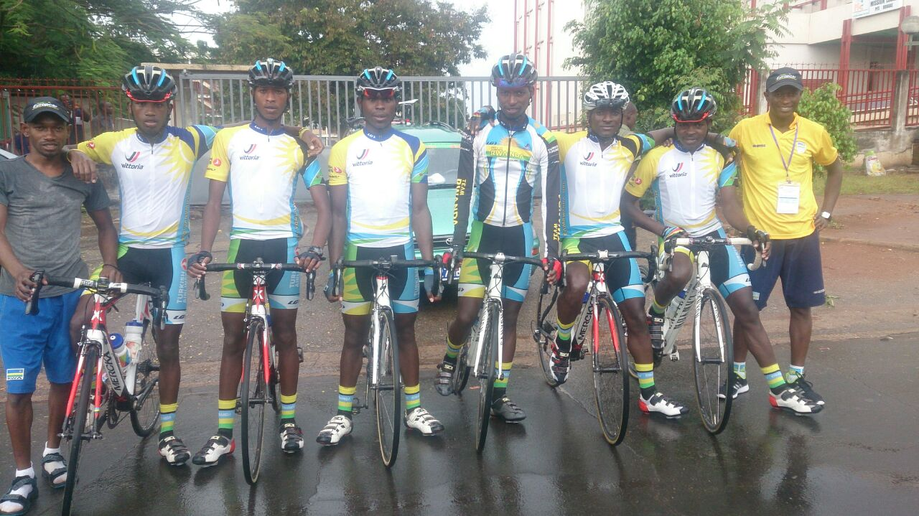
Imyanya abakinnyi ba Team Rwanda bafashe ku rutonde rusange (General classification):
10.RUHUMURIZA ABRAHAM
11.GASORE HATEGEKA
15.BIZIYAREMYE JOSEPH
18.KAREGEYA JEREMIE
19.TUYISHIMIRE EPREM
27.NDUWAYO ERIC

