MATA 2017

TAEKWONDO : 2nd AFRICAN PARA TAEKWONDO OPEN
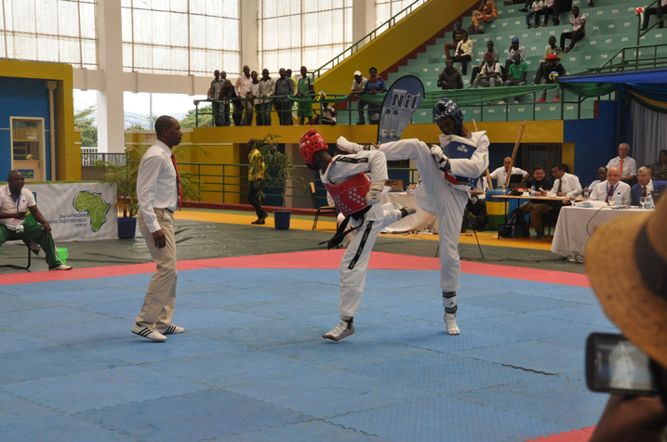
I Kigali ku i taliki ya 01 n’iya 02.04.2017 habereye irushanwa mpuzamahanga ry’abakinnyi bafite ubumuga baturutse mu bihugu 15 :
BURUNDI, ETHIOPIE, GHANA, LESOTHO, COMORES, MAROC, USA, KENYA, FRANCE, ALLEMAGNE, ESPAGNE, SERBIE, UZBEKISTAN, SERBIE, RWANDA.
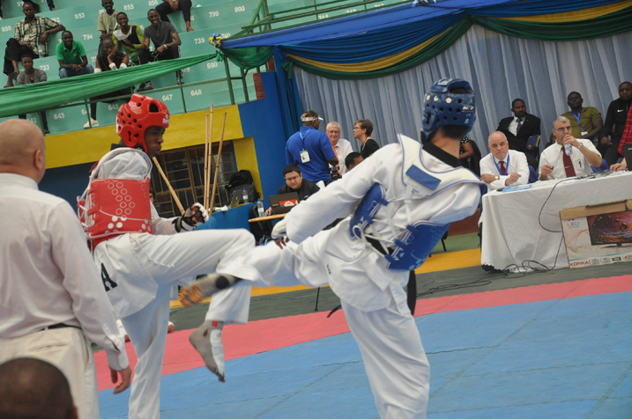
ABANYARWANDA BATWAYE IMIDARI MU BYICIRO BIKURIKIRA
K44 MALE UNDER 61 kg
NIRINGIYIMANA JEAN CLAUDE : feza /argent / silver
K44 FEMALE UNDER 58 kg
RUKUNDO CONSOLEE : feza / argent / silver
K42 MALE UNDER 61 kg
BIZUMUREMYI JEAN MARIE VIANNEY : feza/argent / silver
MANIRAKIZA JEAN PIERRE : bronze
K41 MALE UNDER 61 kg
NIKWIGIZE JEAN DE LA CROIX : zahabu/ or / gold
K42 FEMALE UNDER 58 kg
RUKUNDO CONSOLEE : zahabu /or / gold
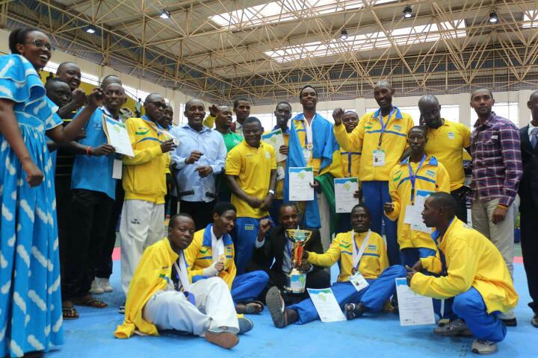
UKO IBIHUGU BYAKURIKIRANYE MU MYANYA ITATU YA MBERE
ABAGORE
1.MAROC
2.RWADA
3.SERBIE

ABAGABO
1.ESPAGNE
2.RWANDA
3.FRANCE
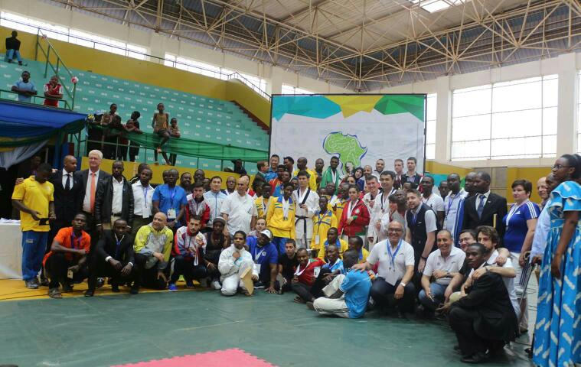

UKO IBIHUGU BYAKURIKIRANYE MURI RUSANGE MU MYANYA ITATU YA MBERE
1.RWANDA
2.ESPAGNE
3.UZBEKISTAN

ATHLETISME : SEMI - MARATHON INTERNATIONAL DE BERKANE
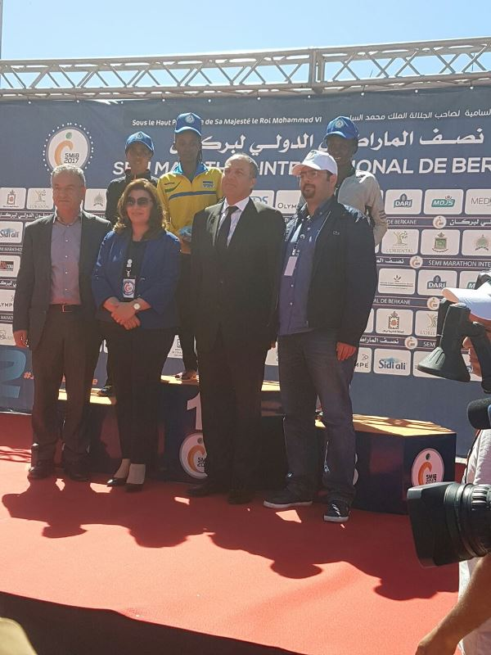
NYIRARUKUNDO SALOME yatwaye umudari wa zahabu mu irushanwa mpuzamahanga ryo gusiganwa kwiruka 21 km « Semi - marathon international de Berkane », kuwa 02.04.2017 ryabereye muri Maroc. Yakoresheje isaha 1 iminota 11 amasegonda 30.
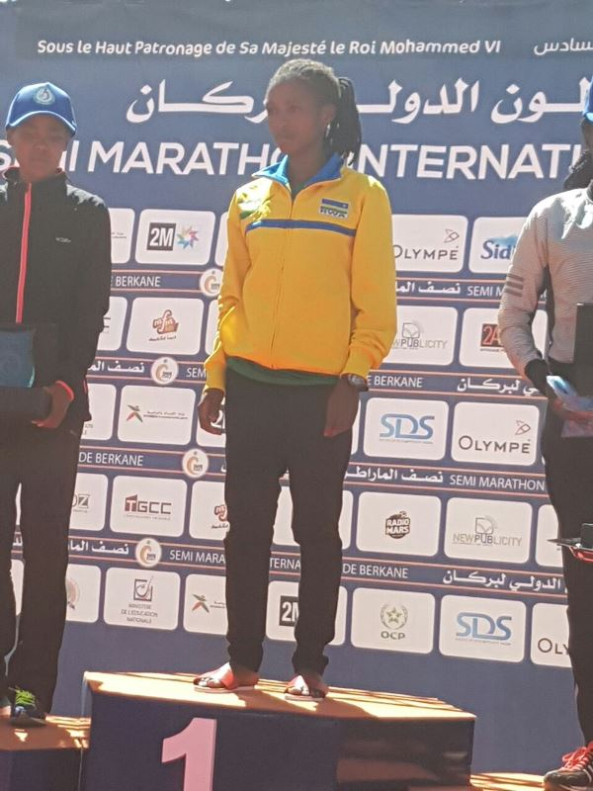
UKO BAKURIKIRANYE MU MYANYA ITATU YA MBERE
1.NYIRARUKUNDO SALOME (RWANDA) 1h11’30’’
2.GUDETA BEKELECH (ETHIOPIE) 1h11’53’’
3.JEPKEMOI GLADYS (KENYA) 1h12’31’’

KARATE : URUPFU RWA SENSEI SAYINZOGA JEAN
SAYINZOGA JEAN, Sensei 6è Dan wamenyekanye cyane mu mukino wa karate, yagize uruhare rukomeye mu iterambere ryawo mu Rwanda no mu bihugu byo mu burasirazuba bw’Afrika.
Yabaye umuyobozi wa commission d’études et évaluation muri CNOSR
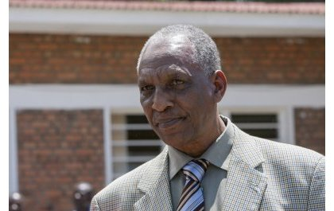

VOLLEYBALL : CHAMPIONNAT D’AFRIQUE DES CLUBS CHAMPIONS DAMES
Mu irushanwa ry’Afurika ry’amakipe y’abagore yabaye mu ya mbere mu bihugu byayo ryahuje amakipe 17 y’abagore, ryabereye i Monastir muri Tunisie kuva taliki 06 kugeza kuya 16.04.2017; u Rwanda rwahagarariwe na APR VC
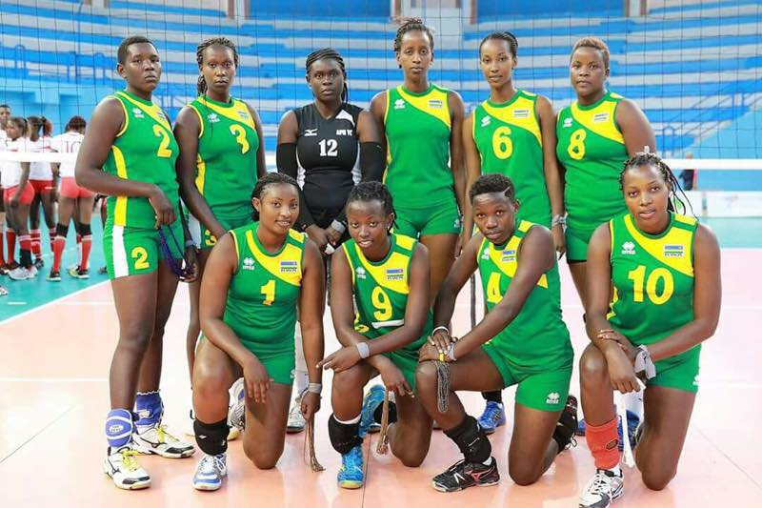
APR yasoje ku mwanya wa 10
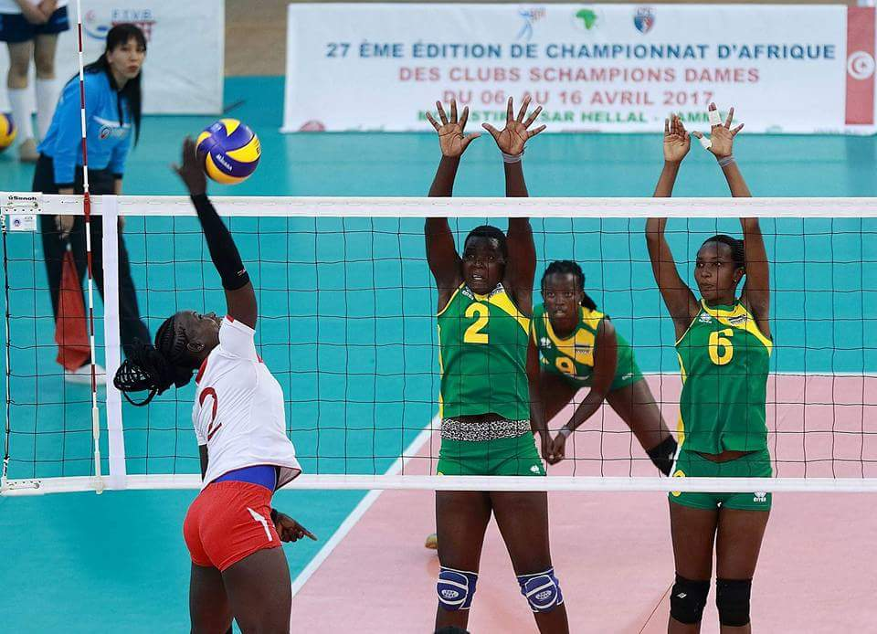
Igikombe cyatwawe na CARTHAGE yo muri Tunisie ku mukino wa nyuma yatsinze SHAMS yo muri Egypte sets 3 kuri 2.

UKO AMAKIPE YAKURIKIRANYE
1.CARTHAGE (TUNISIE)
2.SHAMS (EGYPTE)
3.PRISONS (KENYA)
4.AL AHLY (EGYPTE)
5.PIPELINE (KENYA)
6.GSP (ALGERIE)
7.SFAXIEN (TUNISIE)
8.INJS (CAMEROUN)
9.MARSA (TUNISIE)
10.APR (RWANDA)
11.NDEJJE (UGANDA)
12.FAP (CAMEROUN)
13.ARSU (SEYCHELLES)
14.ASEC (COTE D’IVOIRE)
15.BEJAIA (ALGERIE)
16.BAFIA (CAMEROUN)
17.UNIVERSITY OF ZIMBABWE

BEACH VOLLEYBALL : AFRICAN NATIONS CUP 2017 QUALIFIERS
Irushanwa ry’akarere ka 5 k’Afurika “ZONE V BEACH VOLLEYBALL CHAMPIONSHIP - SENIOR” ryarimo amakipe yo mu bihugu 4 : RWANDA,KENYA, UGANDA, SOUDAN; ryabereye Entebbe muri Uganda ku italiki 14 n’iya 15.04.2017

U Rwanda rwahagarariwe n’amakipe 2 :
Abagore : NZAYISENGA CHARLOTTE na MUTATSIMPUNDU DENYSE

Abagabo : NDAMUKUNDA FLAVIEN na AKUMUNTU KAVALO PATRICK

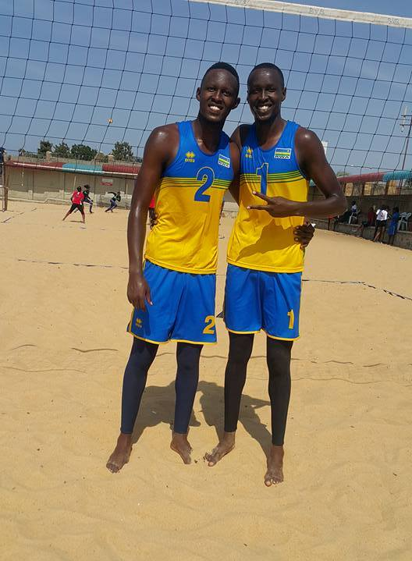

IMIKINO Y’AMAKIPE Y’U RWANDA
ABAGORE
RWANDA 2 – 0 UGANDA ( 21 – 16, 21 – 11)
RWANDA 2 – 0 KENYA (21 – 11, 21 – 14)
RWANDA 2 – 0 UGANDA (21 – 8, 21 -7)

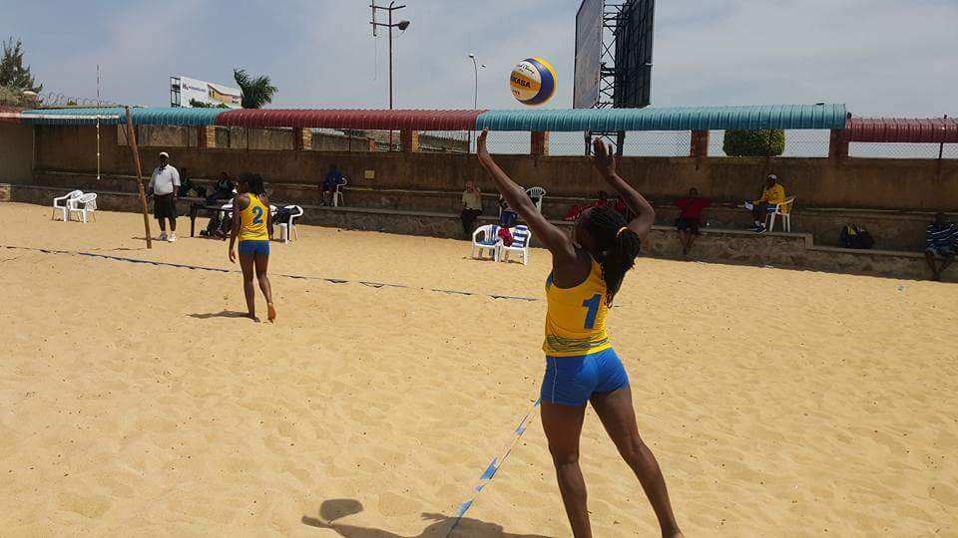
UKO AMAKIPE YAKURIKIRANYE
1.RWANDA : umudari wa zahabu
2.UGANDA : umudari wa feza
3.KENYA : umudari wa bronze
4.SOUDAN
RWANDA na UGANDA zatsindiye kuzajya mu irushanwa ry’Afurika “African Cup of Nations” i Maputo muri Mozambique.

ABAGABO
RWANDA 2 – 0 UGANDA ( 21 – 6, 21 – 15)
RWANDA 2 – 0 SOUDAN (21 – 14, 21 – 12)
RWANDA 0 – 2 KENYA ( 17 – 21, 24 -26)
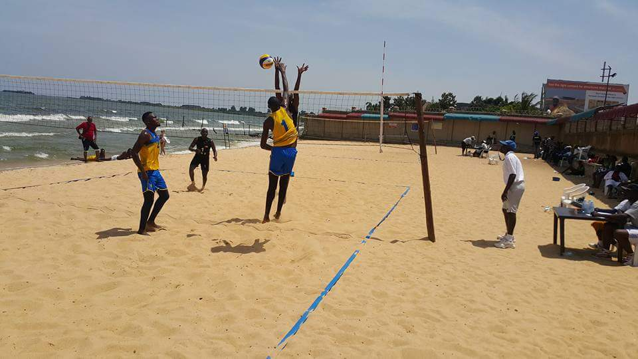
UKO AMAKIPE YAKURIKIRANYE
1.KENYA : umudari wa zahabu
2.RWANDA : umudari wa feza
3.UGANDA : umudari wa bronze
4.SOUDAN

KENYA n’u RWANDA zatsindiye kujya muri African Cup of Nations i Maputo muri Mozambique.

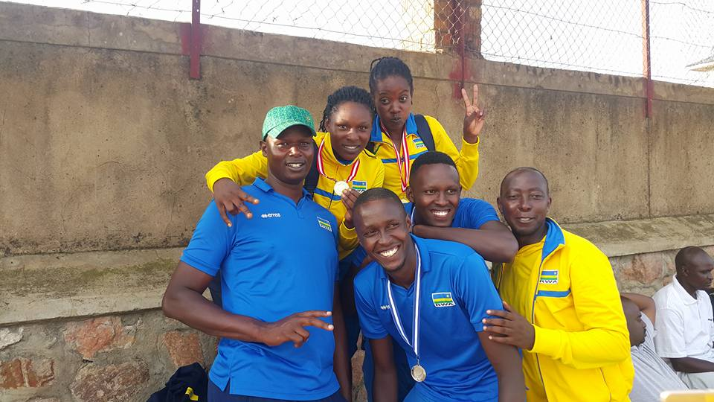
ATHLETISME : MANGYONGDAE MARATHON 2017
Irushanwa mpuzamahanga ryo gusiganwa kwiruka 42km ryarimo abanyarwanda 2 :
RUVUBI JEAN BAPTISTE na KAYIRANGA THEONESTE, ryabereye i Mangyongdae muri Koreya ya Ruguru taliki 08.04.2017
Uwa mbere yabaye PAK CHOL (Corée du Nord) akoresheje amasaha 2 iminota 14 amasegonda 55.

Uko abanyarwanda bitwaye :
11.KAYIRANGA THEONESTE 2h22’54’’
RUVUBI JEAN BAPTISTE ntiyashoboye gusoza isiganwa
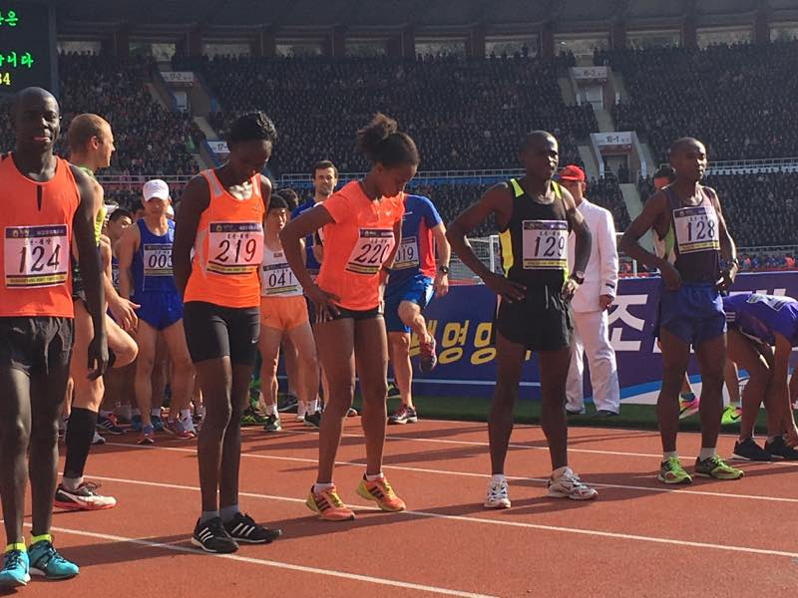RUVUBI J.B. (129), KAYIRANGA TH. (128)
CIO/IOC - RWEMARIKA F.: SPORT AND ACTIVE SOCIETY COMMISSION
Mme Rwemarika Félicité Visi Perezidante wa Komite Olempike y’u Rwanda yagiriwe icyizere cyo kujya muri “Sport and Active Society Commission / Commission Sport et Société Active” ya Komite Olempike Mpuzamahanga (CIO/OIC), umwanya yashyizwemo na Perezida wa IOC/CIO, Thomas BACH; binamuhesha ububasha bwo kuba mu bagize Inteko Rusange ya CIO/IOC.
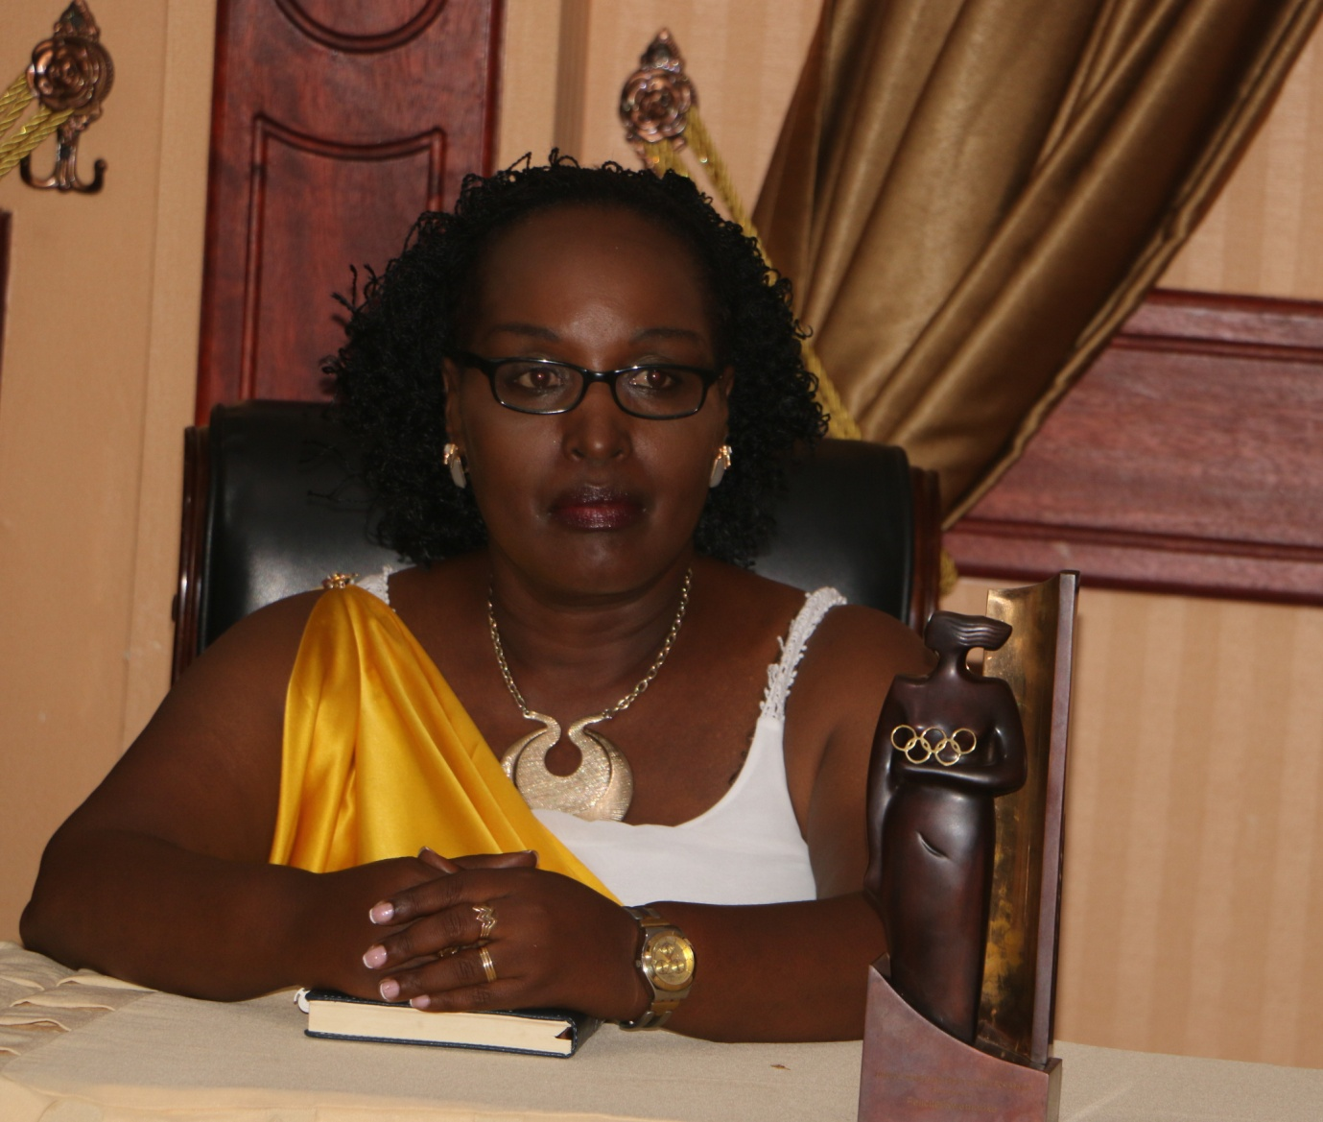
CYCLISME : TOUR OF ERITREA 2017
Irushanwa mpuzamahanga ryabaye kuva ku italiki 18 kugeza kuya 23.04.2017, u Rwanda rwahagarariwemo n’ikipe yari igizwe na :
1.UWIZEYIMANA BONAVENTURE
2.NSENGIMANA JEAN BOSCO
3.UWIZEYE JEAN CLAUDE
4.UKINIWABO RENE JEAN PAUL
5.NDUWAYO ERIC
6.MUNYANEZA DIDIER
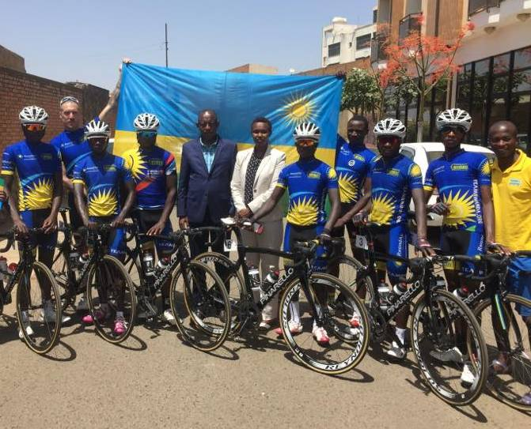
UKO ABASIGANWA BATATU BA MBERE BAKURIKIRANYE KU RUTONDE RUSANGE / CLASSEMENT GENERAL
- SOLOMON ZEMENFES (ERYTHREE) : 16H44’52’’
- UWIZEYE JEAN CLAUDE (RWANDA) : + 38’’
- TSEGAY AMANUEL (ERYTHREE) : + 40’’
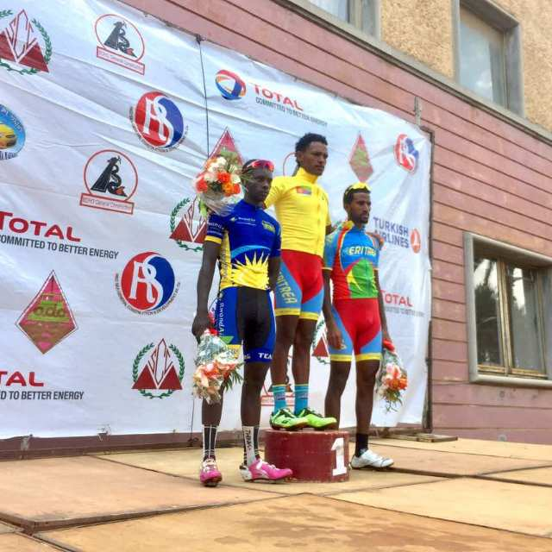
ABANDI BAGIZE TEAM RWANDA BASHOBOYE GUSOZA ISIGANWA
23. NSENGIMANA JEAN BOSCO : + 25’59’’
30. UWIZEYIMANA BONAVENTURE : + 1H34’35’

FOOTBALL : CAF / COUPE DE LA CONFEDERATION
Mu mukino wo kwishyura w’ijonjora rya kabiri wabereye i Kigali ku italiki ya 22.04.2017 RAYON SPORTS yanganyije 0 - 0 na RIVERS UNITED yo muri Nigeria.
Mu mukino ubanza RIVERS UNITED yari yatsindiye RAYON SPORTS ibitego 2 - 0 muri Nigeria; bituma RAYON SPORTS isezererwa.
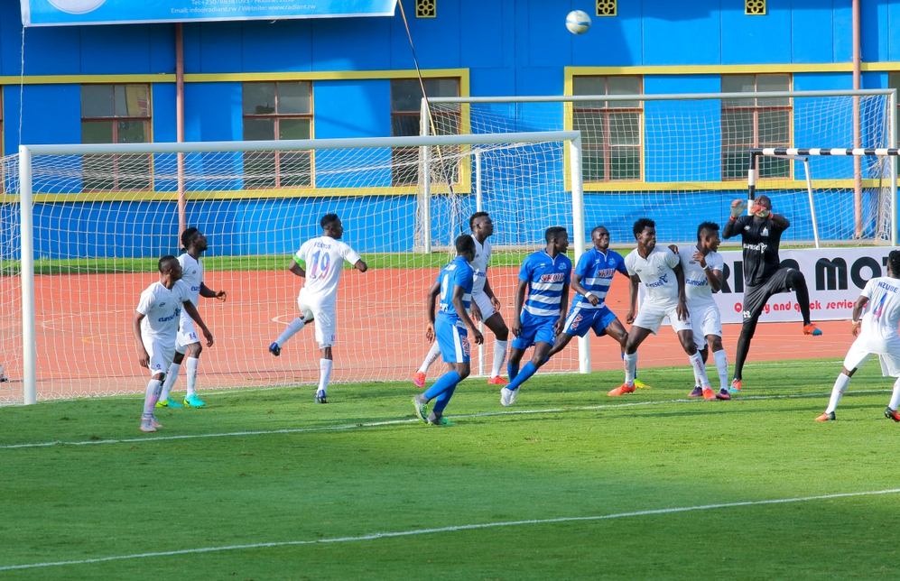

CRICKET : INTEKO RUSANGE
Taliki 23.04.2017 hateranye inama y’inteko rusange ya Rwanda Cricket Association (RCA) yabayemo amatora y’abagize komite nyobozi nshya wa RCA. Abatowe :
Perezida : BALABA EDDIE
Visi Perezida : BYIRINGIRO EMMANUEL
Umunyamabanga Mukuru : MAINA MARY
Ushinzwe umutungo : SRINATH VARDHINEN
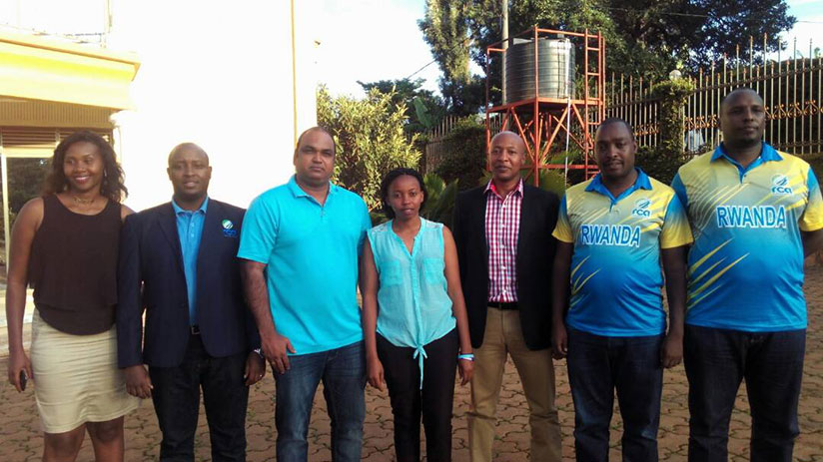

ATHLETISME : CAMPIONATO ITALIANO 10KM IN PISTA / FASE REGIONALE STRACARRA 2017
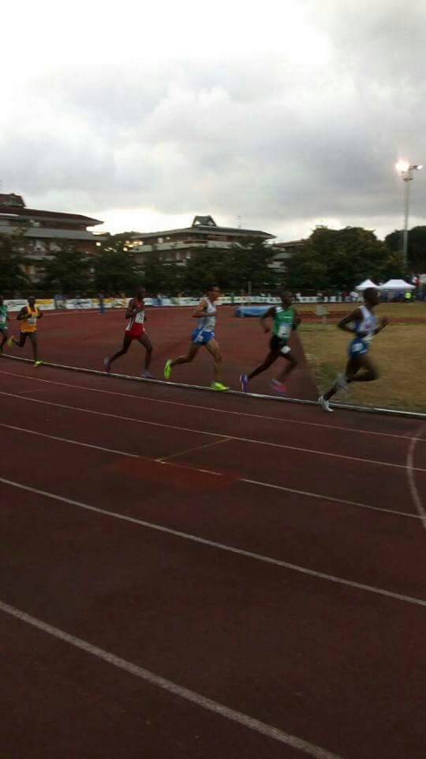
Umunyarwanda MUHITIRA FELICIEN “Magare”yabaye uwa kabiri ahabwa umudari wa feza mu irushanwa mpuzamahanga ryabereye muri Italie kuwa 23.04.2017.

Uko bakurikiranye mu myanya 3 ya mbere :
1.IRABARUTA OLIVIER (BURUNDI ) 26’ 03’’
2.MUHITIRA FELICIEN (RWANDA) 28’ 12’’
3.TIONJIK BITOK (KENYA) 28’ 36’’
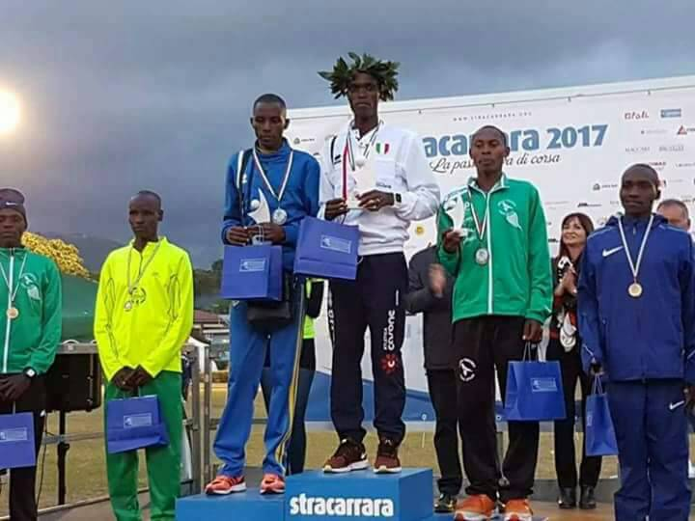MUHITIRA FELICIEN (uwa 3 uturutse ibumoso)
RUGBY : AFRICA RUGBY GROUP 1C SOUTH TOURNAMENT
Irushanwa mpuzamahanga ryarimo amakipe y’abagabo y’ibihugu 3 : ZAMBIA, MAURITIUS, RWANDA, ryabereye i Lusaka muri Zambie kuva taliki 23 kugeza kuya 29.04.2017.
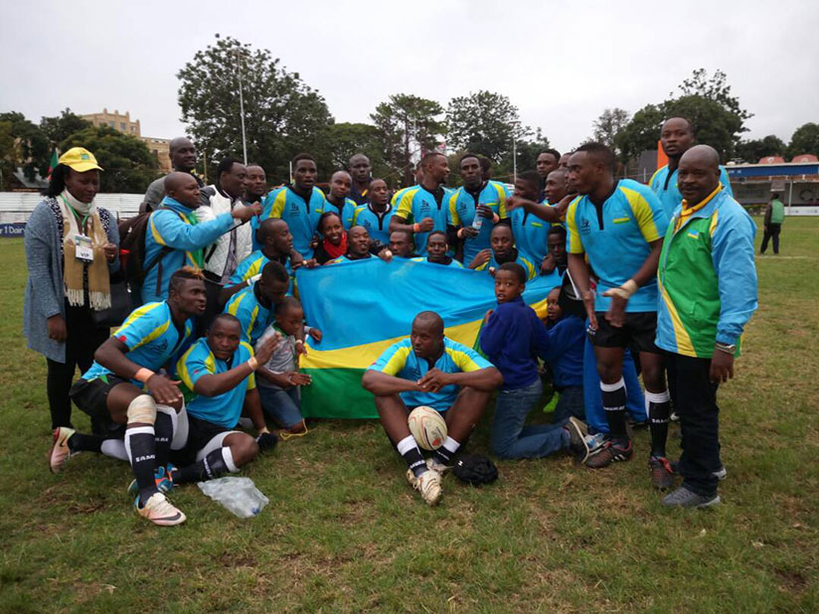
UKO AMAKIPE YASOJE AKURIKIRANA
1.ZAMBIA
2.RWANDA
3.MAURITIUS
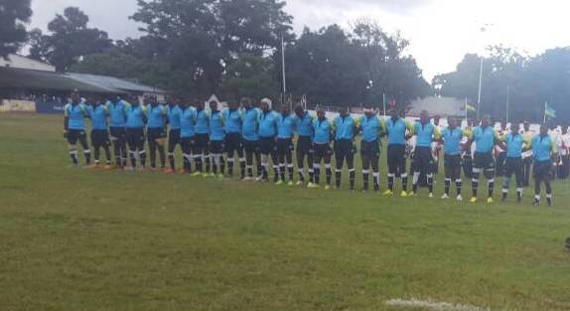
ZAMBIA niyo izazamuka muri Group 1B

CNOSR : INAMA NYUNGURANABITEKEREZO N’INTEKO RUSANGE IDASANZWE
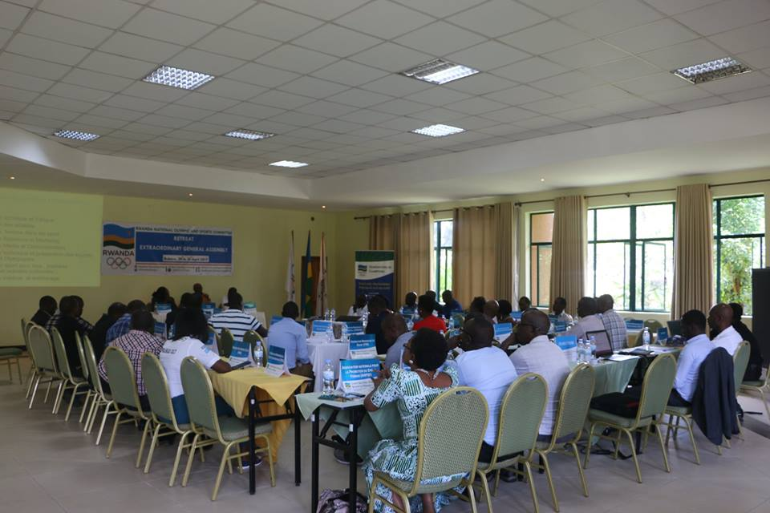
Kuva taliki 28 kugeza kuya 30.04.2017 i Rubavu hateranye inama nyunguranabitekerezo n’inama y’inteko rusange idasanzwe ya Komite Olempike y’u Rwanda (CNOSR).

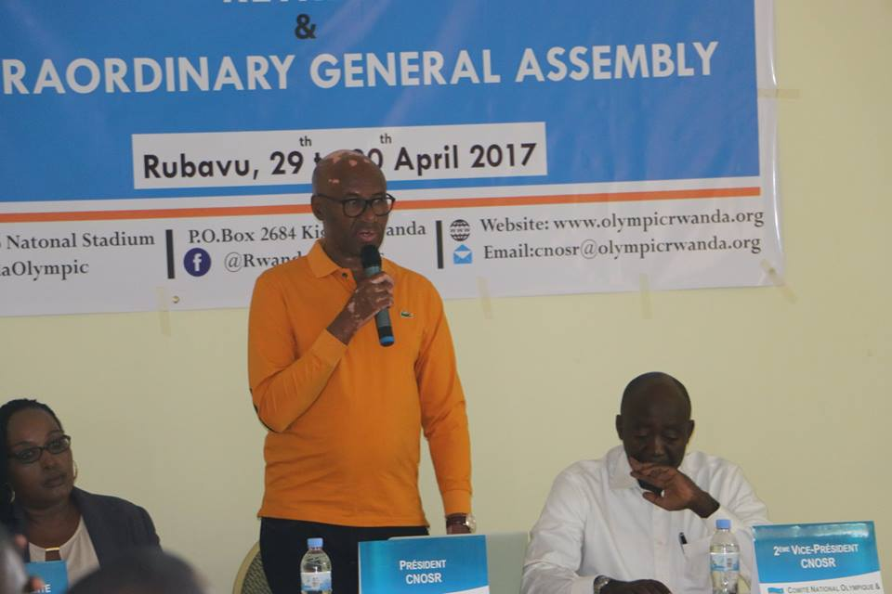
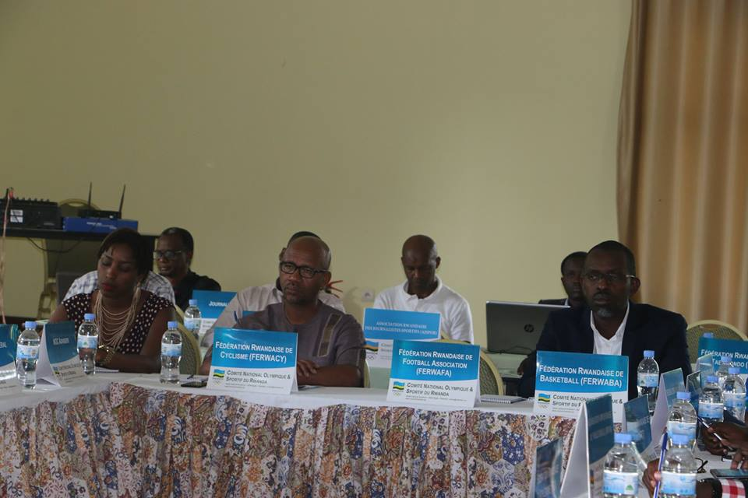
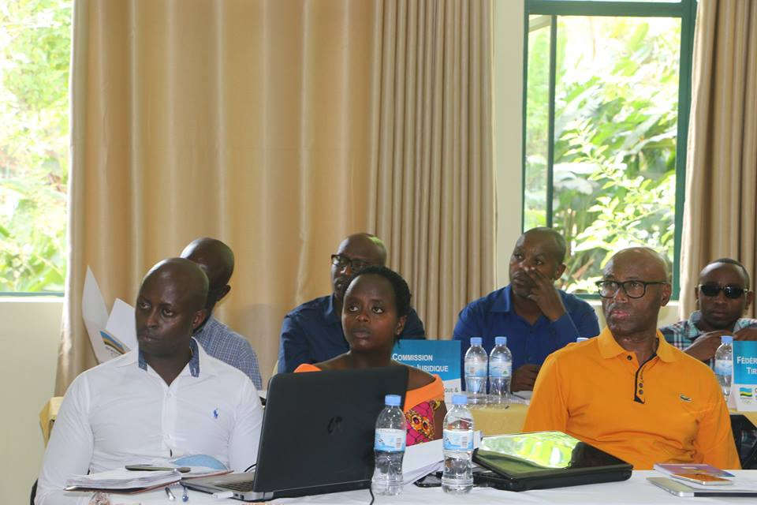
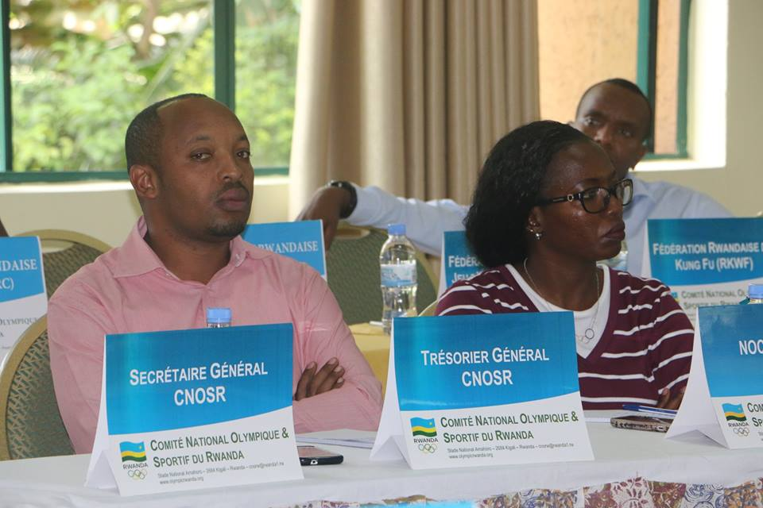
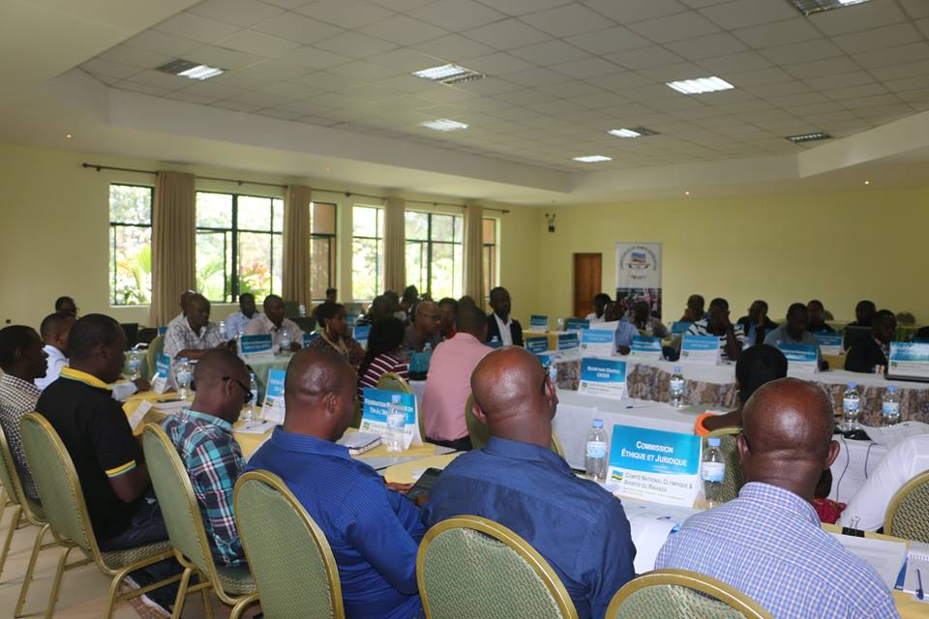
Habaye n’amatora yo kuzuza imyanya y’abagize inzego za CNOSR batari batowe mu nama y’inteko rusange yo kuwa 11.03.2017

ABAGENZUZI B’IMARI (3)
1.UMWALI JOSETTE (BOXE) yari yaratowe mu nama y’inteko rusange yo kuwa 11.03.2017
2.NZEYIMANA CELESTIN (NPC)
3.RUTIYOMBA EUSTACHE (TENNIS)
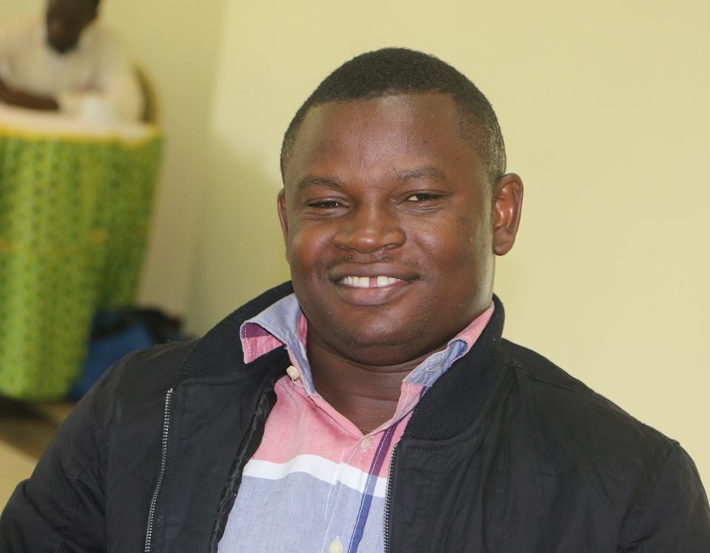
NZEYIMANA CELESTIN
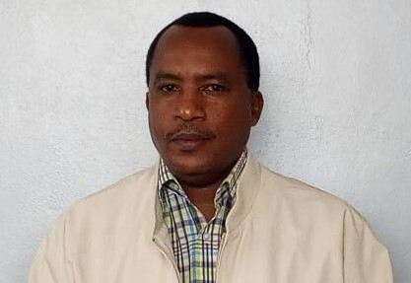
RUTIYOMBA EUSTACHE
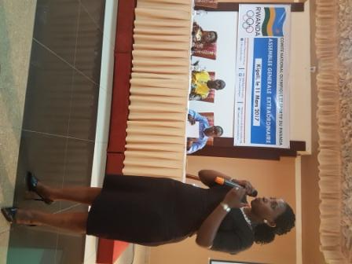
UMWALI JOSETTE

ABAGIZE AKANAMA NKEMURAMPAKA (3)
1.FURAHA JACQUES (AJSPOR)
2.RWABUHIHI INNOCENT (ARPST)
3.MUKANDEKEZI JULIENNE (NATATION)
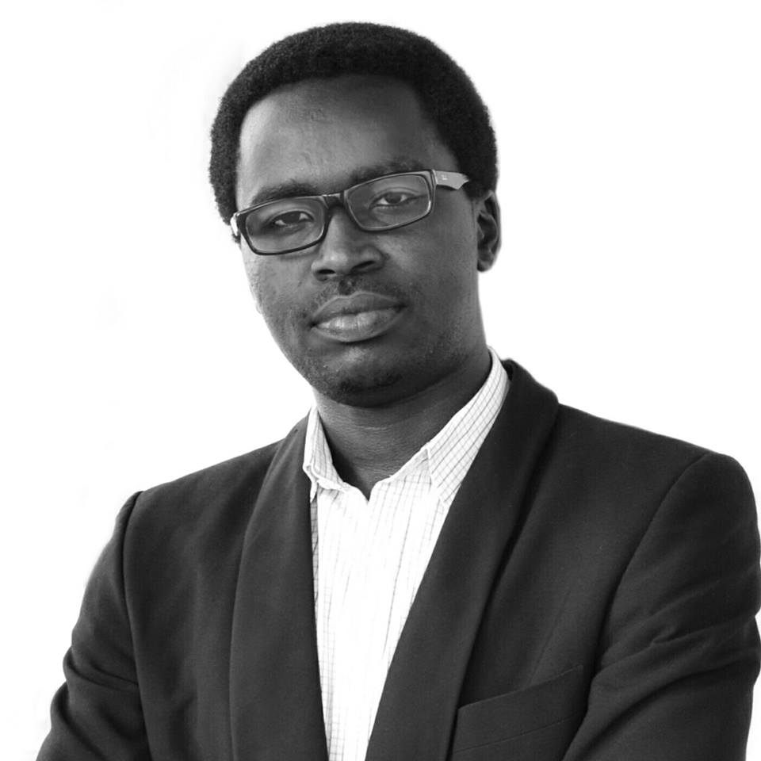
FURAHA JACQUES

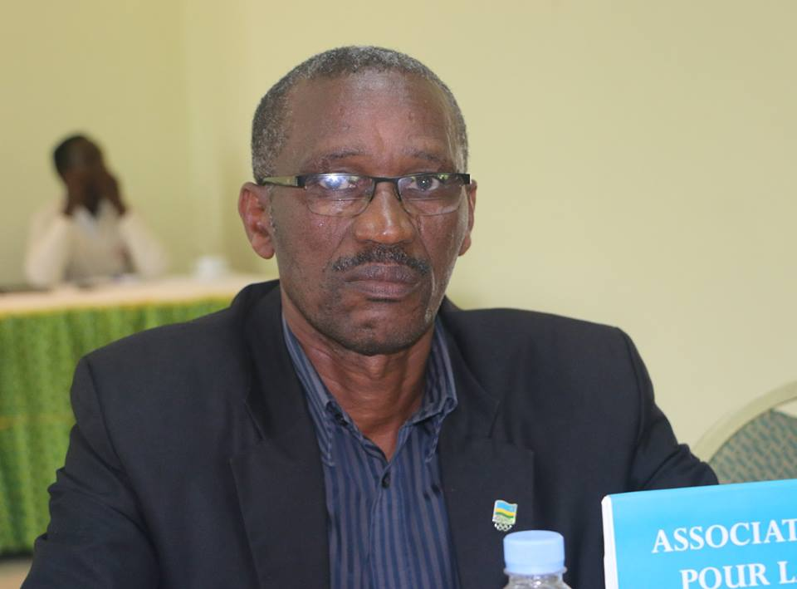
RWABUHIHI INNOCENT
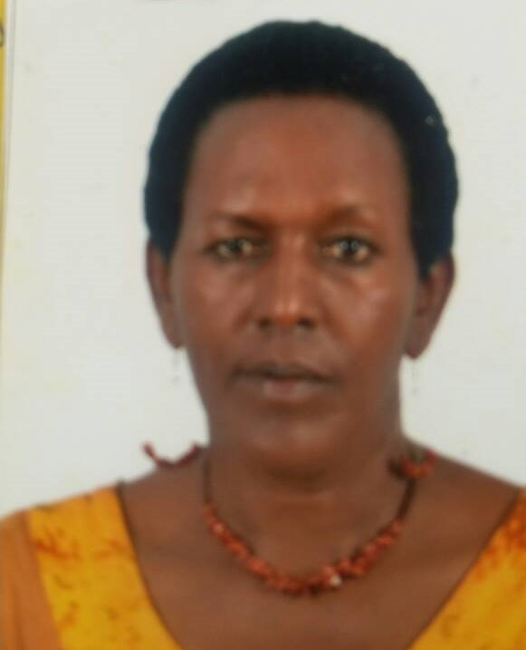
MUKANDEKEZI JULIENNE
TENNIS : ITF / CAT 12 & UNDER EAST AFRICA TEAMS JUNIOR CHAMPIONSHIP 2017
Irushanwa ryabereye i Nairobi muri Kenya kuva taliki 25 kugeza kuri 29.04.2017 u Rwanda rwahagarariwe n’abana 4 :
1.NISHIMWE CARINE
2.TUYISHIMIRE RONA
3.HAKIZUMWAMI JUNIOR
4.MANISHIMWE EMMANUEL
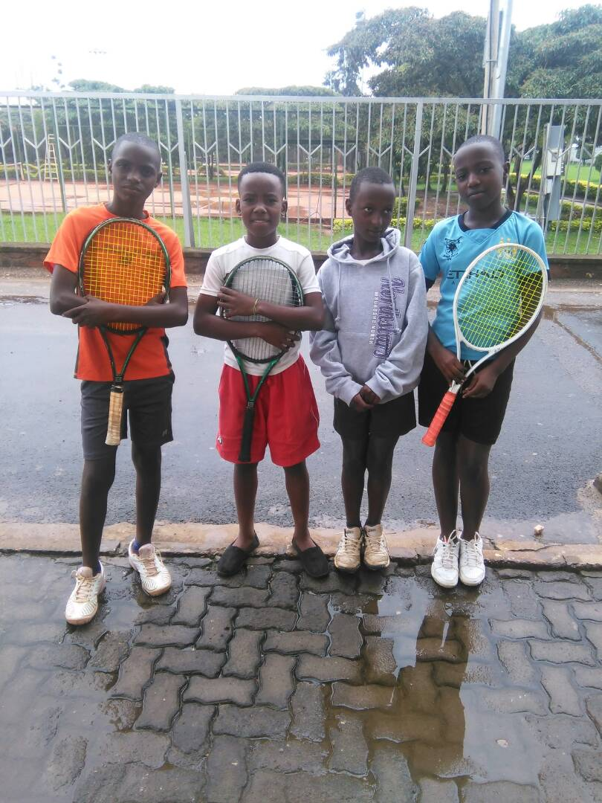

Irushanwa ryarimo ibihugu 6 : KENYA, TANZANIE, BURUNDI, COMORES, SEYCHELLES, RWANDA

UKO IBIHUGU BYASOJE BYAKURIKIRANA
ABAHUNGU
1.BURUNDI
2.RWANDA
3.KENYA
4.TANZANIE
5.SEYCHELLES
6.COMORES
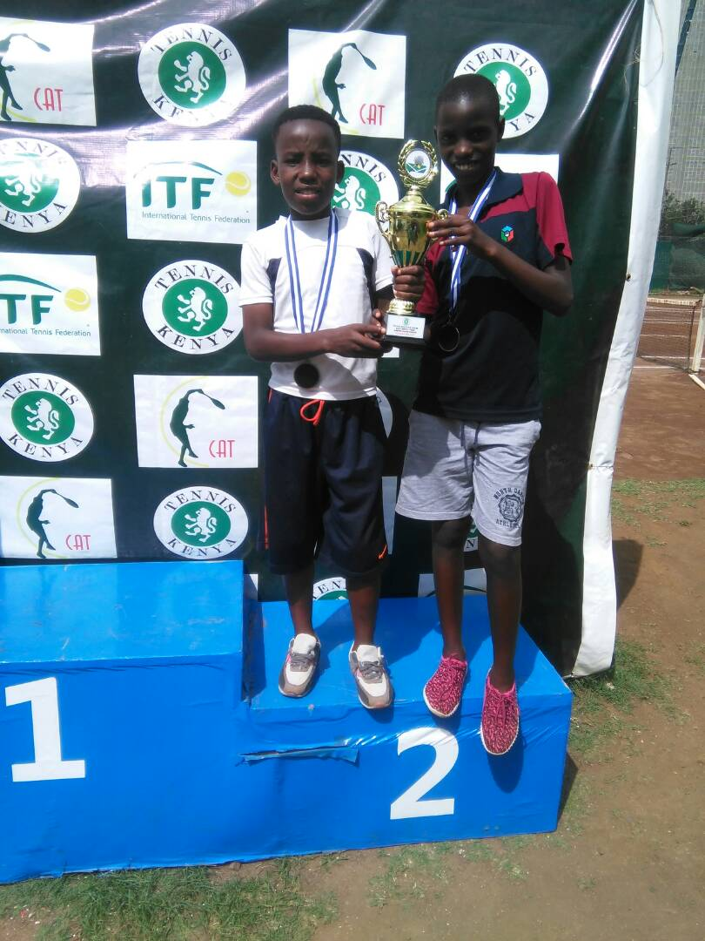
HAKIZUMWAMI JUNIOR na MANISHIMWE EMMANUEL
ABAKOBWA
1.KENYA
2.TANZANIE
3.RWANDA
4.BURUNDI
5.SEYCHELLES
6.COMORES
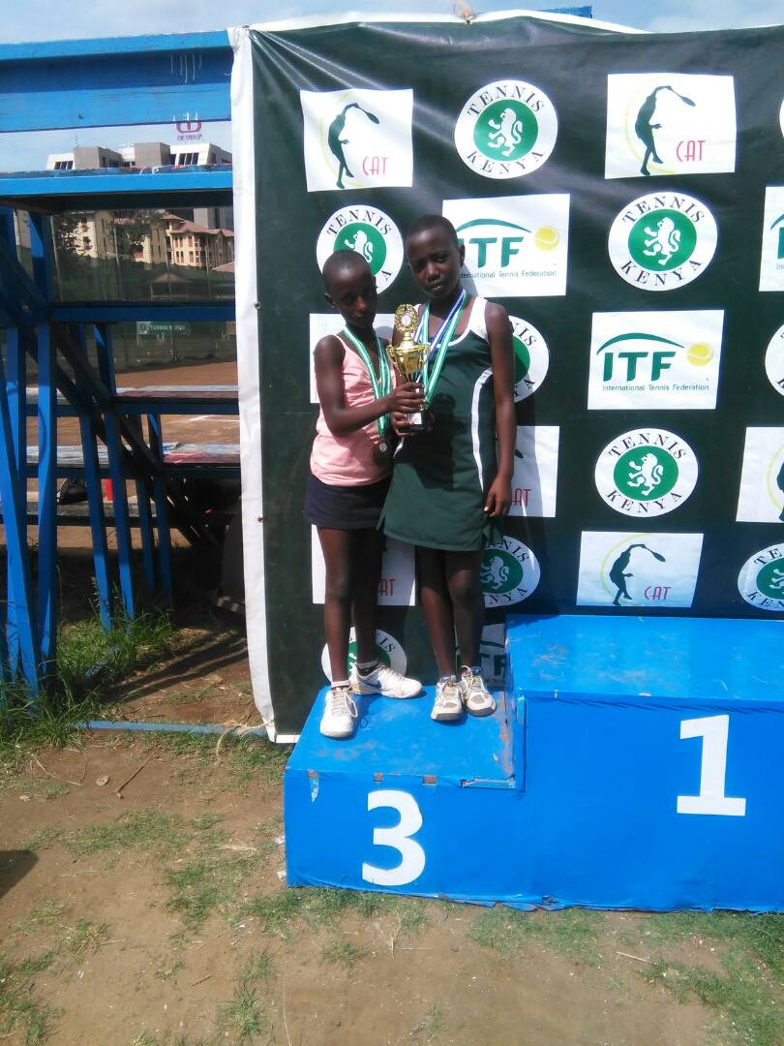
NISHIMWE CARINE na TUYISHIMIRE RONA

TRIATHLON : INTEKO RUSANGE
Taliki 22.04.2017 hateranye inama y’inteko rusange ya Rwanda Triathlon Federation yanabayemo amatora y’abagize komite nyobozi nshya.
Perezida : MBARAGA ALEXIS
Visi Perezida wa mbere : HUMUZA DE CORDIER IDA ALEXANDRA
Visi Perezida wa kabiri : VALOIS JEAN FELIX
Umunyamabanga Mukuru : MUCYO SERGE
Umubitsi : KANEZA ALICE

