TENNIS : ITF CAT EASTERN AFRICAN JUNIOR CHAMPIONSHIPS 2016

Irushanwa rya tennis rigenewe abakinnyi b’ingimbi ryabereye i Nairobi muri KENYA kuva kuwa 10 kugeza kuwa 16.01.2016, rihuza abakinnyi bo mu byiciro 3 hakurikijwe imyaka yabo: 12 & under, 14 & under na 16 & under.
Hakozwe urutonde rw’uko ibihugu 8 byari bifite abakinnyi muri iryo rushanwa byakurikiranye:
1.KENYA 835
2.BURUNDI 730
3.TANZANIE 350
4.SEYCHELLES 327
5.ETHIOPIE 297
6.RWANDA 265
7.SOUDAN 255
8.COMORES 49
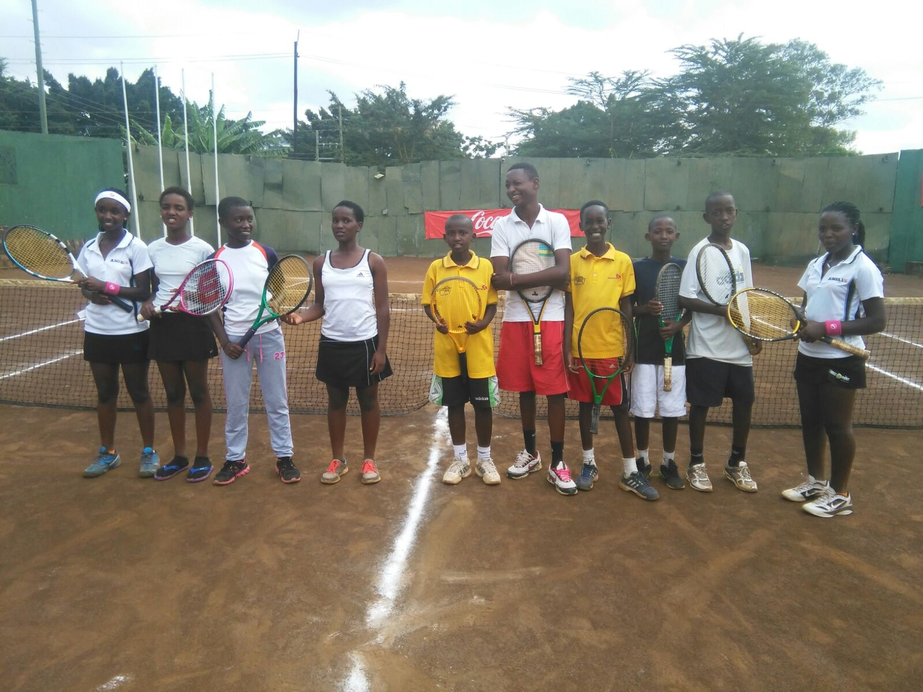ABAKINNYI B’IKIPE Y’U RWANDA

CYCLISME : LATROPOCALE AMISSA BONGO 2016

Team Rwanda yari igizwe n’abakinnyi 6 yagiye muri Gabon mu irushanwa mpuzamahanga ryo gusiganwa ku magare ryitwa “ La Tropicale Amissa Bongo 2016” ryabaye kuwa 18 - 24.01.2016.
Ku rutonde rwa rusange “ Classement Général” hagendewe ku mukinnyi ku giti cye, aba Team Rwanda basoje ku myanya ikurikira :
15.UWIZEYIMANA JEAN CLAUDE
25.HAKUZIMANA CAMERA
36.BYUYKUSENGE PATRICK
51.HADI JANVIER
63.ARERUYA JOSEPH
BINTUNIMANA EMILE ntiyashoboye gusoza kuko yagize impanuka

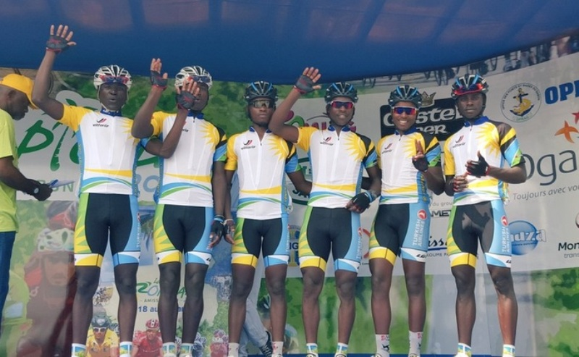TEAM RWANDA - LA TROPICALE AMISSA BONGO 2016
Irushanwa ryarimo amakipe 14, Team Rwanda ifata umwanya wa 14

FOOTBALL : CHAN RWANDA 2016

Mu Rwanda kuva kuwa 16.01.2016 kugeza kuwa 07.02.2016 habereye irushanwa ry’umupira w’amaguru ry’igikombe cy’Afurika “Championnat d’Afrique des Nations / CHAN 2016”.
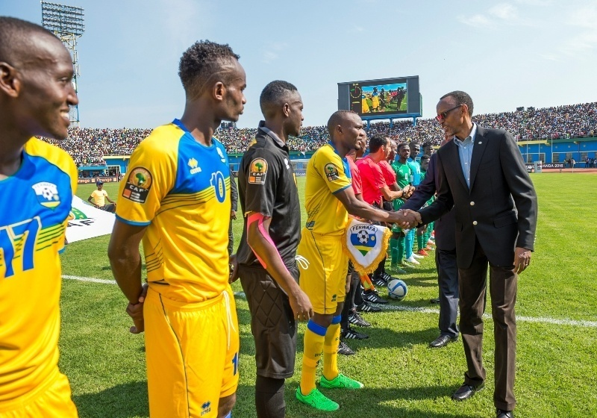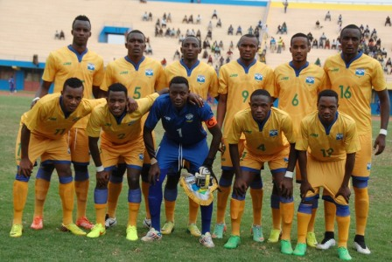
IKIPE Y’U RWANDA “AMAVUBI”
Ryahuje amakipe y’ibihugu 16 birimo n’u Rwanda, imikino yabereye i Kigali kuri stade Amahoro, kuri stade de Kigali, stade Huye no kuri stade Umuganda mu karere ka Huye
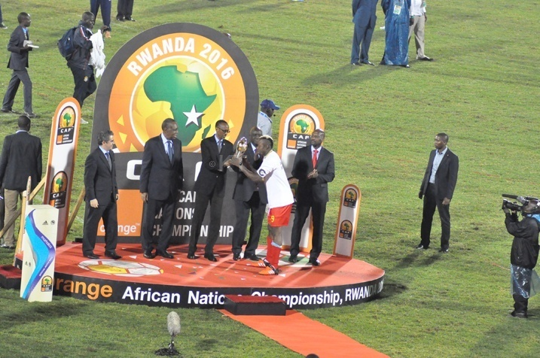
Ikipe y’u Rwanda “AMAVUBI” yagarukiye muri ¼ cy’irangiza ikuwemo na R.D.Congo ku birego 2 - 1.
Igikombe cya CHAN 2016 cyatwawe na R.D.Congo ku mukino wa nyuma yatsize Mali ibitego 3 - 0.

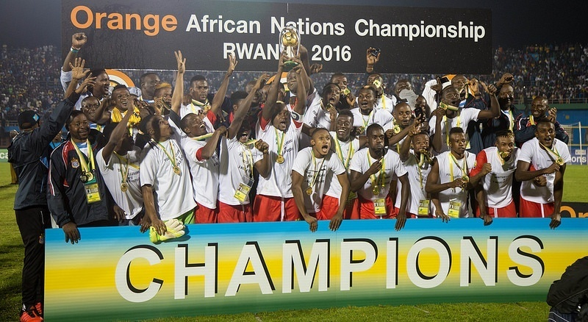R.D.CONGO

CYCLISME: 11è CHAMPIONNATS D’AFRIQUE

Casablanca muri Maroc kuwa 21 - 26.02.2016 habereye irushanwa rya 11 ry’Afurika ryo gusiganwa ku magare “Championnats d’Afrique”.
U RWANDA rwahagarariwe n’abakinnyi 11, abahungu 10 n’umukobwa 1. Bakinnye mu byiciro bitatu:
Mu cyiciro cya Elite & U23:
1.NDAYISENGA VALENS
2.UWIZEYIMANA BONAVENTURE
3.BYUKUSENGE PATRICK
4.KAREGEYA JEREMY
5.UWIZEYIMANA JEAN CLAUDE
6.ARERUYA JOSEPH
7.BIZIYAREMYE JOSEPH
8.MUGISHA SAMUEL

Mu cyiciro cya Junior:
1.DUKUZUMUREMYI FIDELE
2.UKINIWABO JEAN PAUL RENE

Umukinnyi umwe w’umukobwa : GIRUBUNTU JEANNE D’ARC

Muri Elite & U23 course contre la montre par équipe harimo amakipe 10, ikipe y’u Rwanda iba iya 5.
Muri course contre la montre individuel -Elites icyiciro cy’abagore, abasiganwa bari 16.
GIRUBUNTU JEANNE D’ARC yabaye uwa 2 ahabwa umudari wa feza.
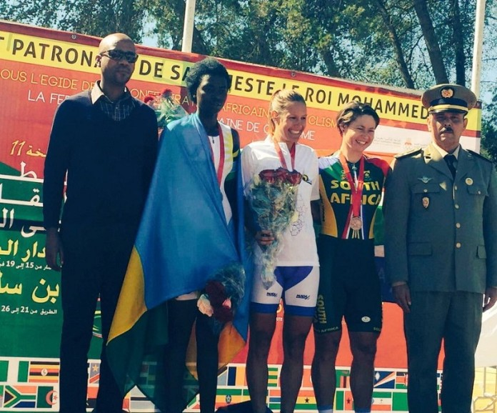GIRUBUNTU JEANNE D’ARC ni uwamabaye ibendera ry’u Rwanda
Muri course contre la montre individuelle Elites & U23
Abasiganwa bari 30 barimo abakinnyi 2 b’u RWANDA, by’umwihariko muri U23 Ndayisenga Valens yabaye uwa mbere ahabwa umudari wa zahabu, Areruya Joseph aba uwa 4. Ku rutonde rwa rusange “classement général” muri course contre la montre individuelle Elites & U23 Ndayisenga Valens yabaye uwa 6, Areruya Joseph aba uwa 9.
Mu cyiciro cya courseen ligne - Juniors, abasiganwa bari 19 barimo abanyarwanda 2: Ukiniwabo René yabaye uwa 6, Dukuzumuremyi Fidèle aba uwa 13.

CNOSR : INTEKO RUSANGE

Inama y’inteko rusange isanzwe ya Comité National Olympique et Sportif du Rwanda yateraniye i Rubavu kuwa 05.03.2016. Mu by’ingenzi byayisuzumiwemo hari raporo y’ibyakozwe muri 2015, gahunda ya 2016 n’ingengo y’imari yayo; kungurana ibitekerezo ku ishyirwa mu bikorwa ry’imihigo muri siporo.
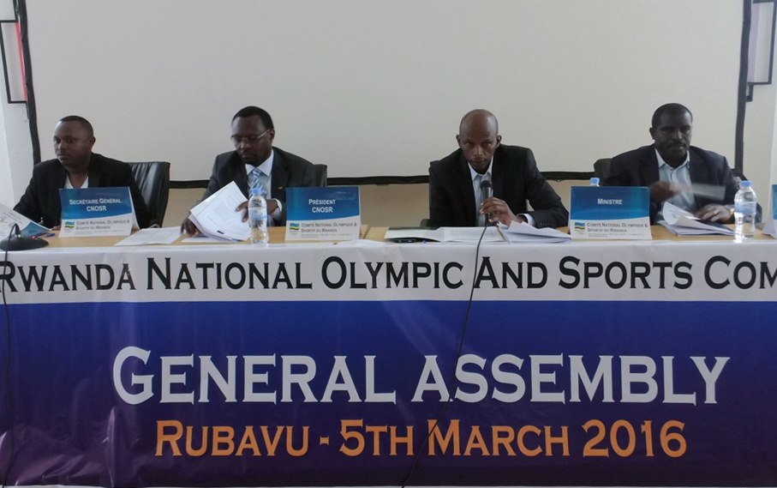
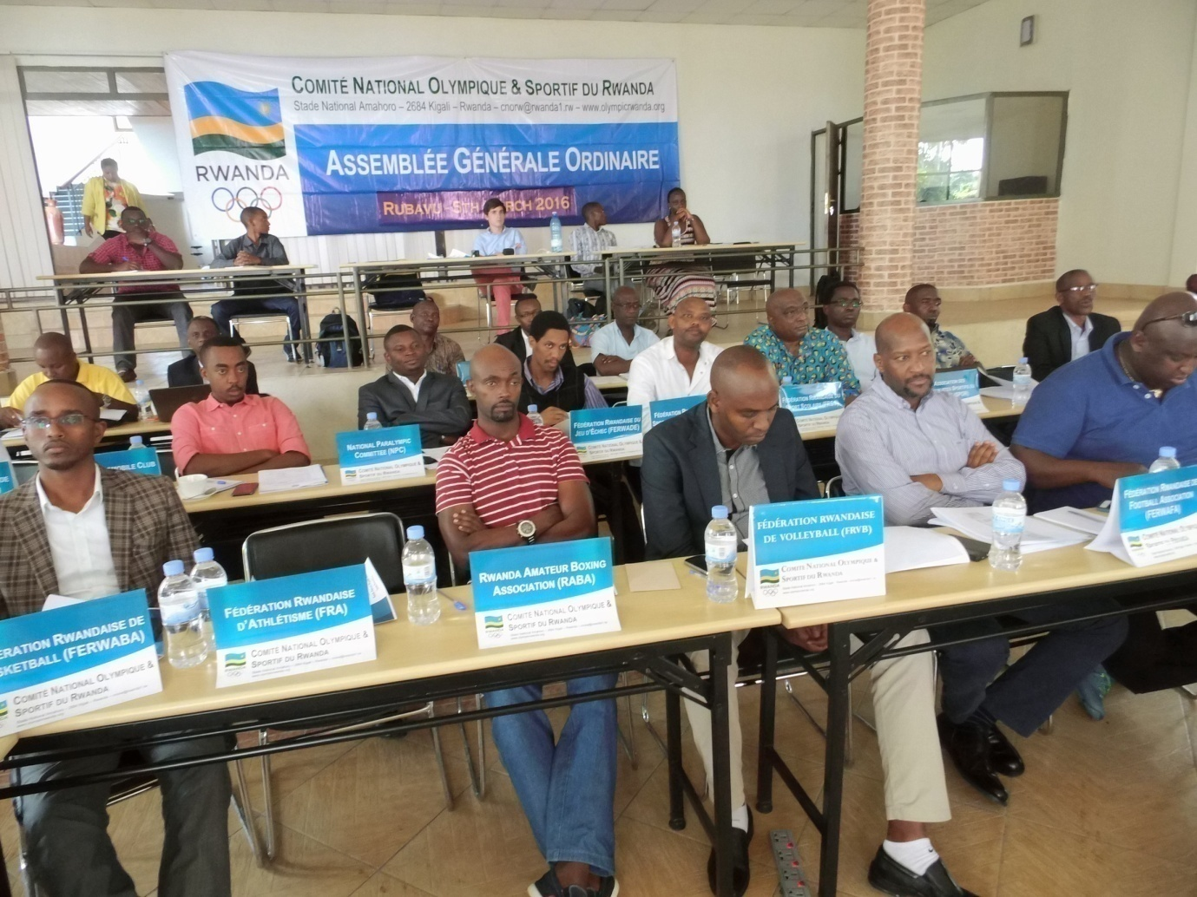

SPORTS POUR HANDICAPES: WORLD PARAVOLLEYBALL 2016 INTERCONTINENTAL SITTING VOLLEYBALL
Ikipe y’u Rwanda y’abagore ya sitting volleyball yagiye mu mikino mpuzamigabane yabereye muri Chine 17 - 23.03.2016, irushanwa ryahuje amakipe y’ibihugu 13.
Ikipe y’u RWANDA nta mukino yashoboye gutsinda.
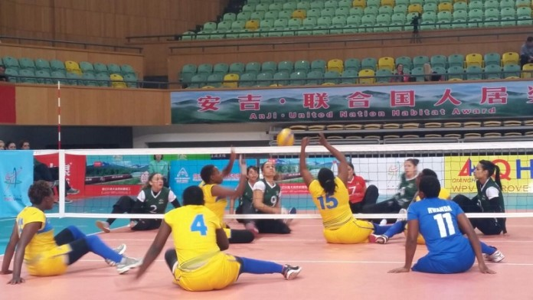RWANDA(umuhondo) - BRESIL (icyatsi cyijimye)

FOOTBALL
CAF / LIGUE DES CHAMPIONS
APR FC yahagarariye u Rwanda mu irushanwa ry’Afurika ry’umupira w’amaguru “Ligue des champions”.
Mu ijonjora ry’ibanze APR FC yasezereye Mbabane Swallows yo muri Swaziland, naho muri 1/16 cy’irangiza APF FC isezererwa na Yanga yo muri Tanzania.
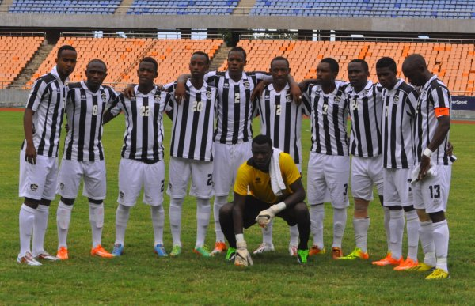APR FC
CAF / COUPE DE LA CONFEDERATION
Mu irushanwa ry’Afurika “Coupe de la Confédération” u Rwanda rwahagarariwe na Police FC. Mu ijonjora ry’ibanze Police FC yakuyemo Atlabara FC yo muri Soudan du Sud, muri 1/16 Police isezererwa na Club Mokanda yo muri Congo Brazzaville.
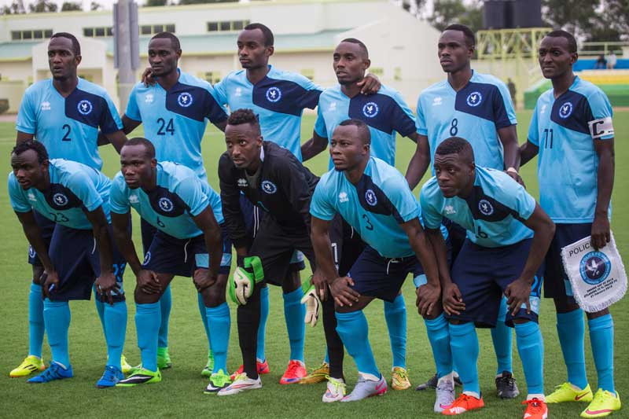POLICE FC
INTERNATIONAL DAY OF SPORT FOR DEVELOPMENT AND PEACE (IDSDP)
Muri gahunda ya IDSDP 2016 umunsi wizihizwa buri taliki 06 Mata, ikipe yoherejwe na Comité International Olympique yaje mu RWANDA gufata amashusho yifashishijwe mu gutegura film ku bikorwa bya siporo bigamije amahoro bya Football for Hope, Peace & Unity (FHPU), umuryango washinzwe na MURANGWA Eugène. Iyo film yasohotse kuwa 05 Mata 2016.
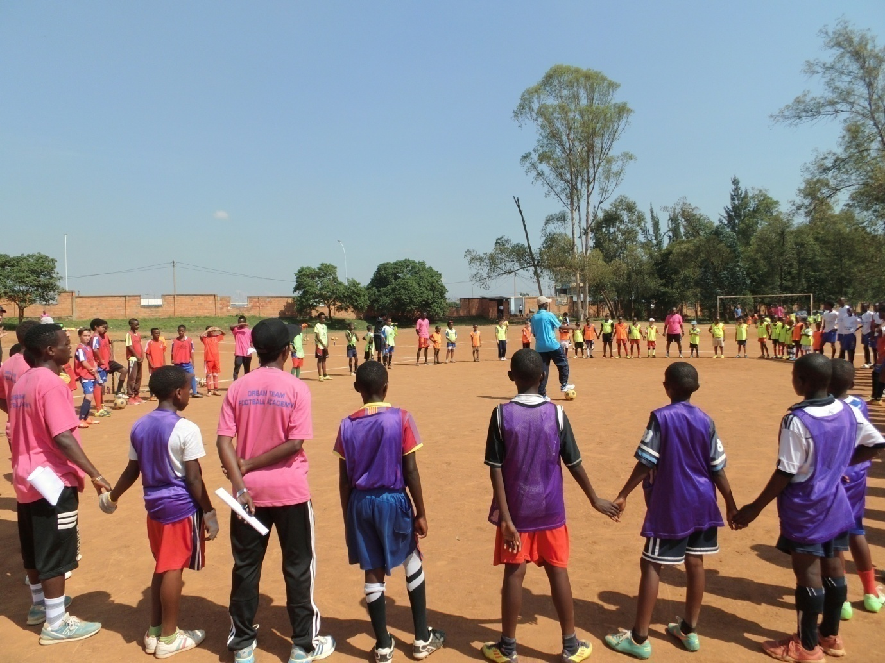
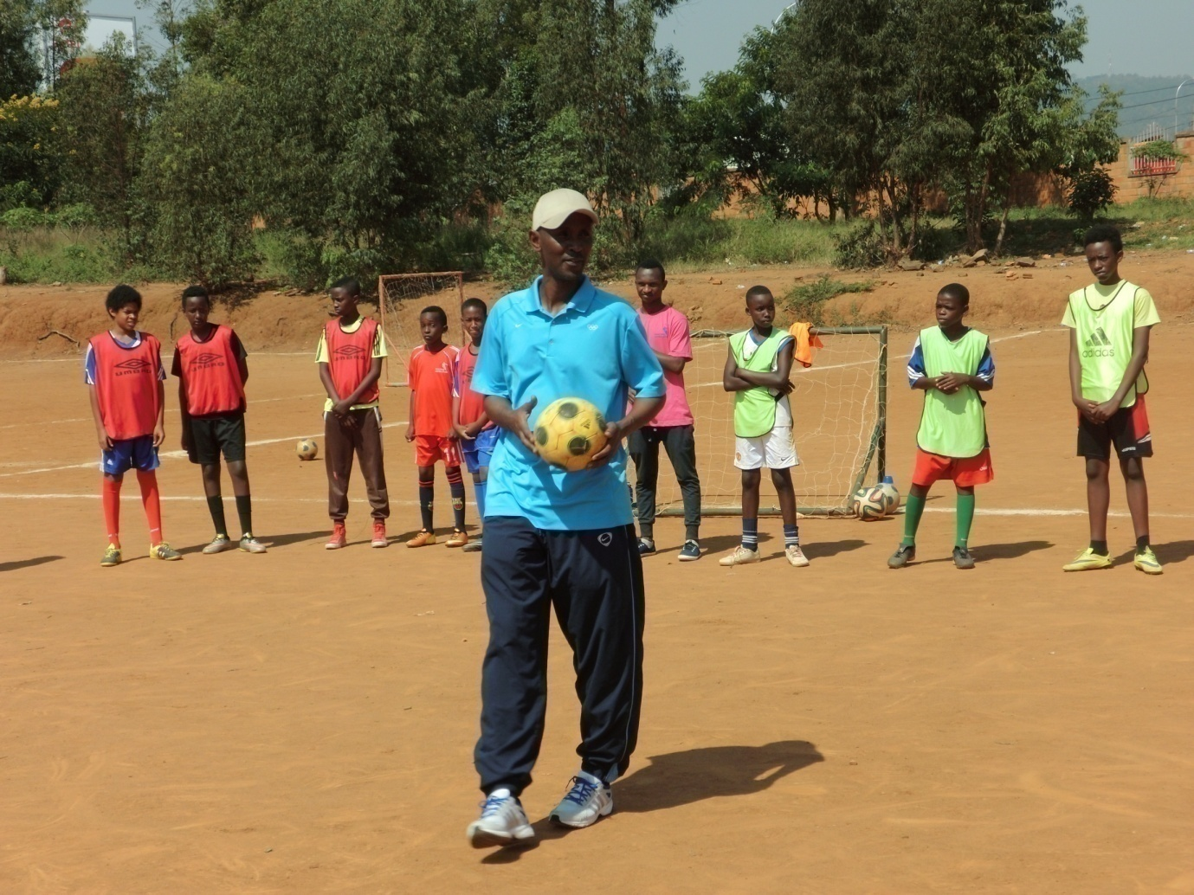

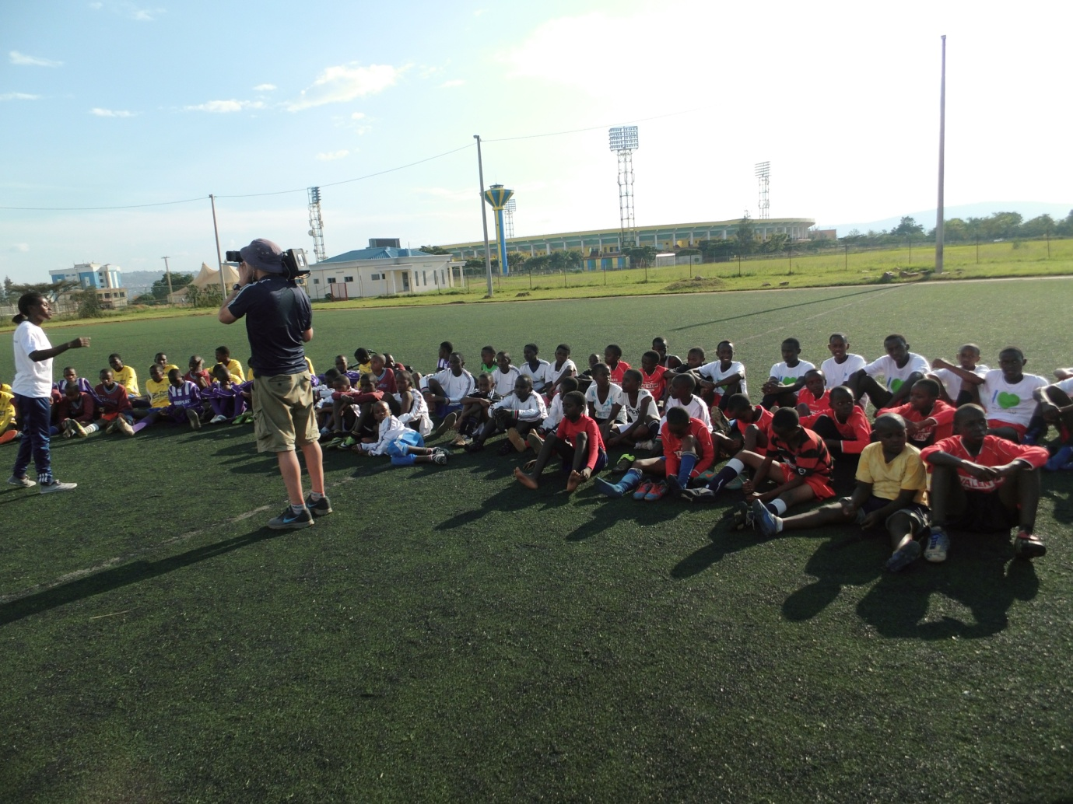

CYCLISME: TOUR INTERNATIONAL DU CAMEROUN 2016
Irushanwa mpuzamahanga ryabereye muri Cameroun mu kwezi kwa 3.2016, ryarimo Team Rwanda yari igizwe n’abakinnyi 6 bafashe imyanya ikurikira ku rutonde rusange “classement general”:
3.HAKUZIMANA CAMERA
8.TUYISIMIRE EPHREM
16.GASORE HATEGEKA
21.RUHUMURIZA ABRAHAM
22.TWIZERANE MATHIEU
36.NDUWAYO ERIC

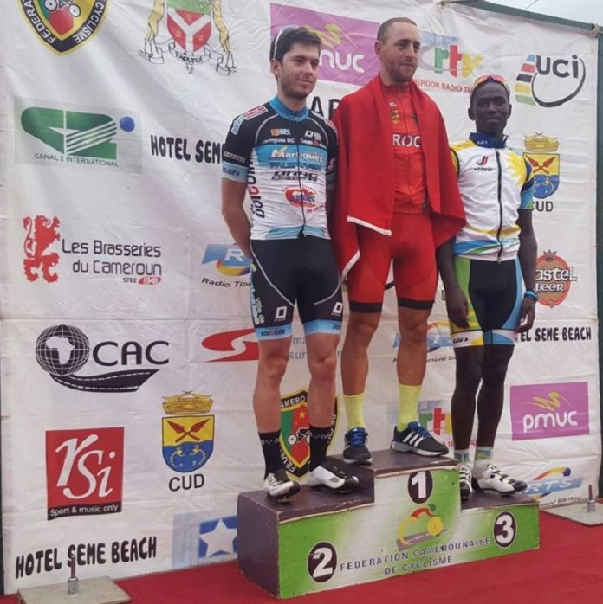HAKUZIMANA CAMERA (iburyo kuri 3)

MOUNTAIN BIKE: ABSA CAPE EPIC 2016
Muri Afrique du Sud kuva kuwa 13 kugeza kuwa 20.03.2016 habereye irushanwa mpuzamahanga ryo gusiganwa ku magare “vélo tout terrain /mountain bike” aho buri kipe iba igizwe n’abakinnyi 2 ariko bitari ngombwa ko bakomoka mu gihugu kimwe.
Umunyarwanda BYUKUSENGE NATHAN witegura Jeux Olympiques Rio 2016 yafatanyije na THINUS wo muri Afrique du Sud, basoje ku mwanya wa 3 mu bakinnyi b’abanyafurika batwara umudari wa bronze, ku rutonde rwa rusange bafashe umwanya wa 18.
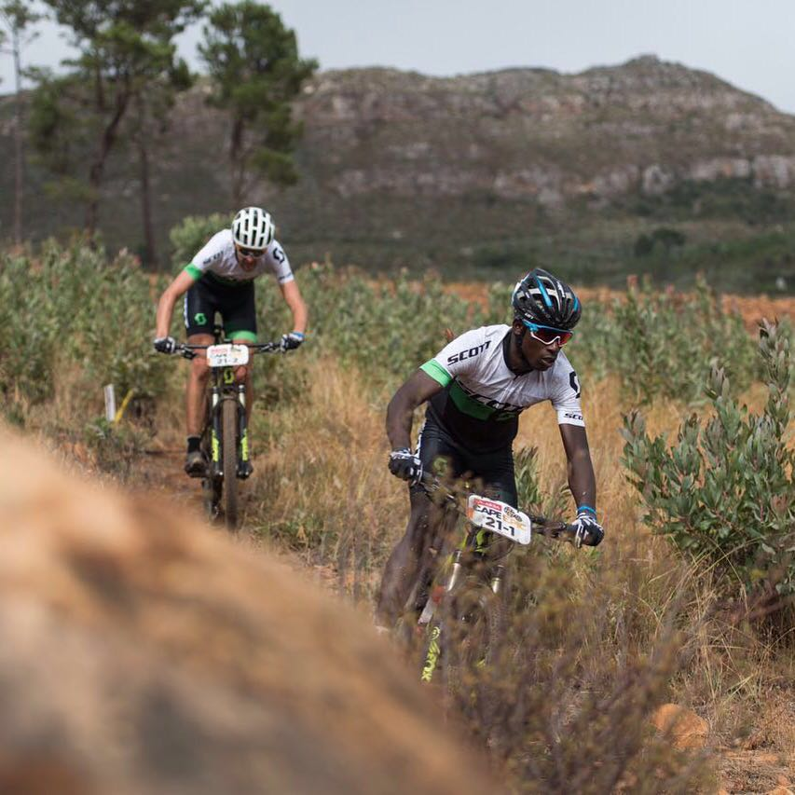
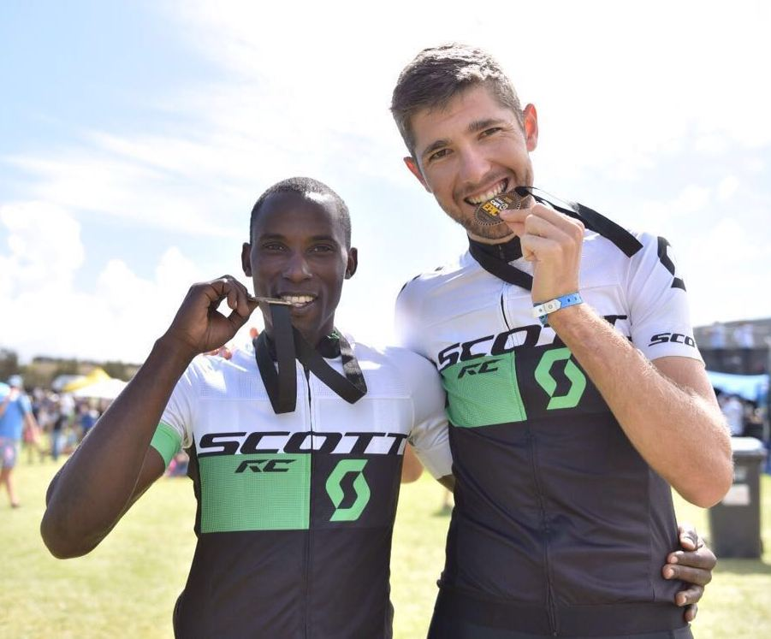BYUKUSENGE NATHAN (ibumoso) - THINUS (iburyo)
CYCLISME: 2016 AFRICAN CONTINENTAL MOUNTAIN BIKE CHAMPIONSHIPS
Mu irushanwa ry’Afurika ry’umukino wo gusiganwa ku magare “vélo tout terrain /mountain bike” ryabereye muri Lesotho kuva kuwa 30.03.2016 kugeza kuwa 01.04.2016, u Rwanda rwari ruhagarariwe na BYUKUSENGE NATHAN wabaye uwa 6.
SPORTS POUR HANDICAPES /ATHLETISME: “ IPC GRAND PRIX DE TUNIS”
Mu mikino ngororamubiri y’abafite ubumuga yabereye muri Tunisie kuwa 20 - 27.03.2016
U RWANDA rwahagarariwe n’abakinnyi 2 begukanye imidari 3:
Muvunyi Hermas yatwaye imidari 2: uwa zahabu muri 400m T46, n’uwa bronze muri 1.500m T46
Ndayisenga Jean Claude yatwaye umudari wa bronze muri 400m T47
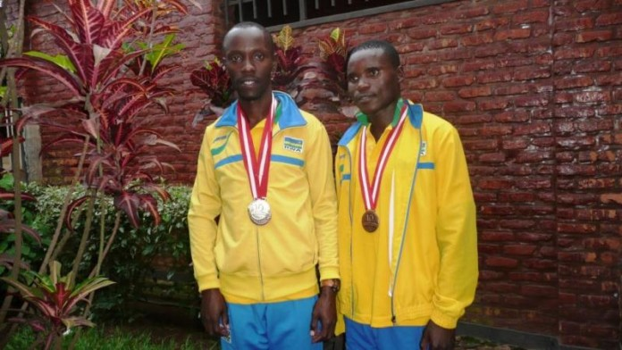MUVUNYI HERMAS (ibumoso) - NDAYISENGA JEAN CLAUDE (iburyo)

CHESS: NATIONAL CHESS LEAGUE
Mu irushanwa ry’umukino wa chess / jeu d’echecs, kuwa 03.04.2016 hasojwe irushanwa ryo ku rwego rw’igihugu ryahuje amakipe 6.
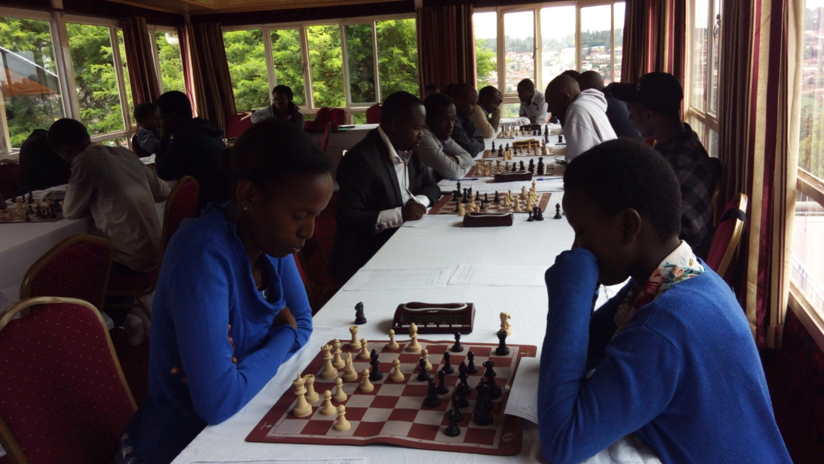
Amakipe 6 yari muri irushanwa National Chess League yakurikiranye ku buryo bukurikira:
1.EAGLES B : amanota 20/20 itwara igikombe
2.EAGLES A : 12
3.KNIGHT : 11
4.VISION : 9
5.KIST : 8
6.NUR : 0
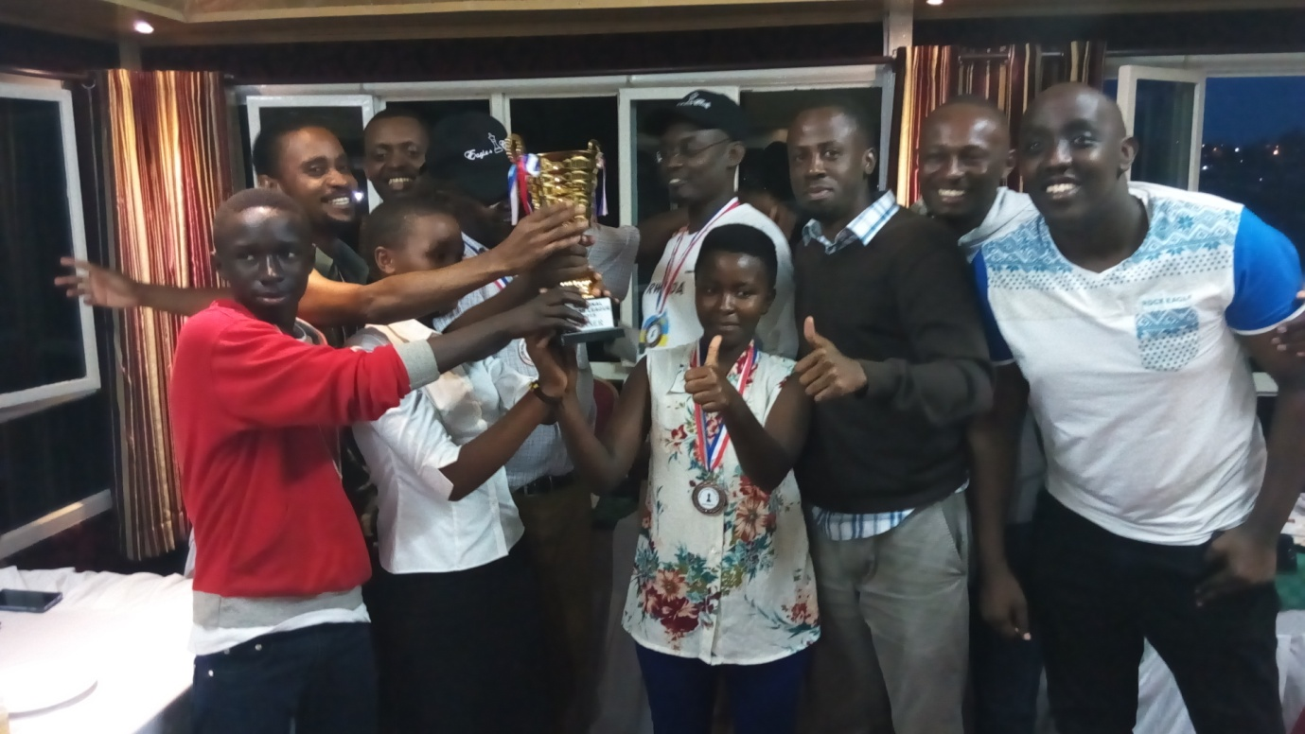EAGLES CLUB

NATATION: TRAINING CAMP
Mu mukino wo kwoga, abatoza n’abakinnyi bose hamwe 50 mu kwezi kwa 4.2016 bahawe amahugurwa yayobowe na RICK POWER (USA) woherejwe na FINA, yabereye i Kigali kuri La Palisse Hotel i Nyandungu. 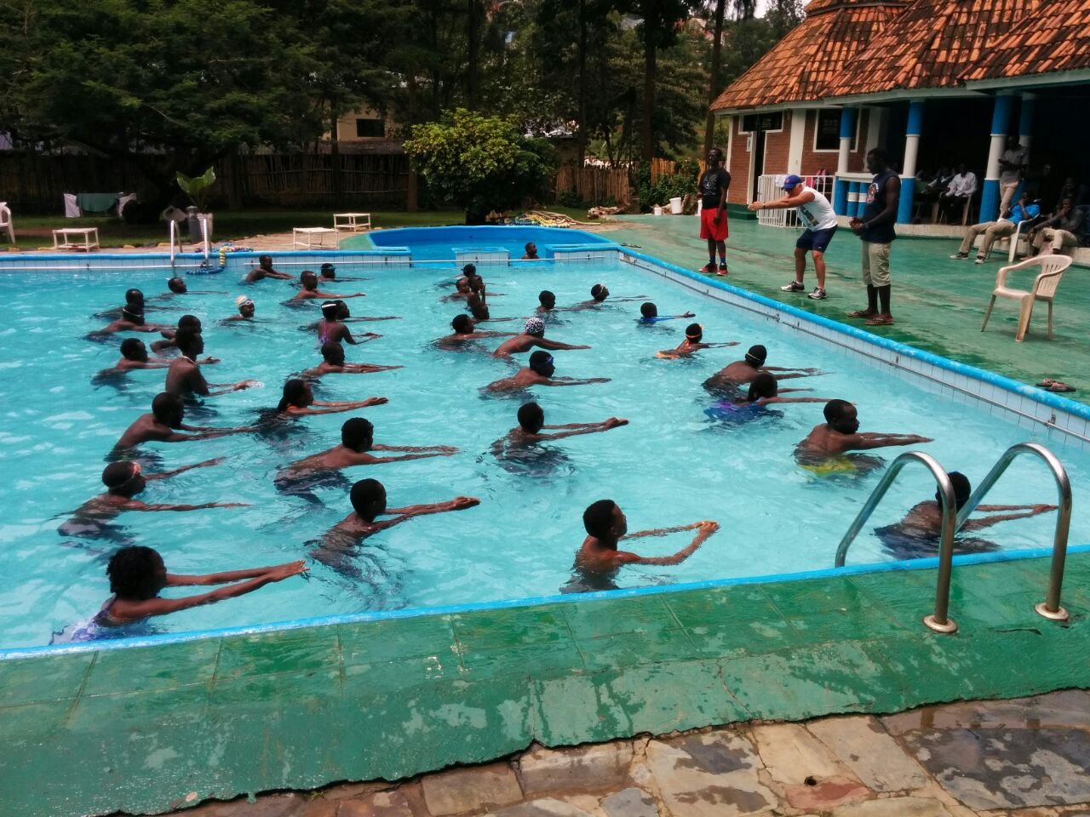

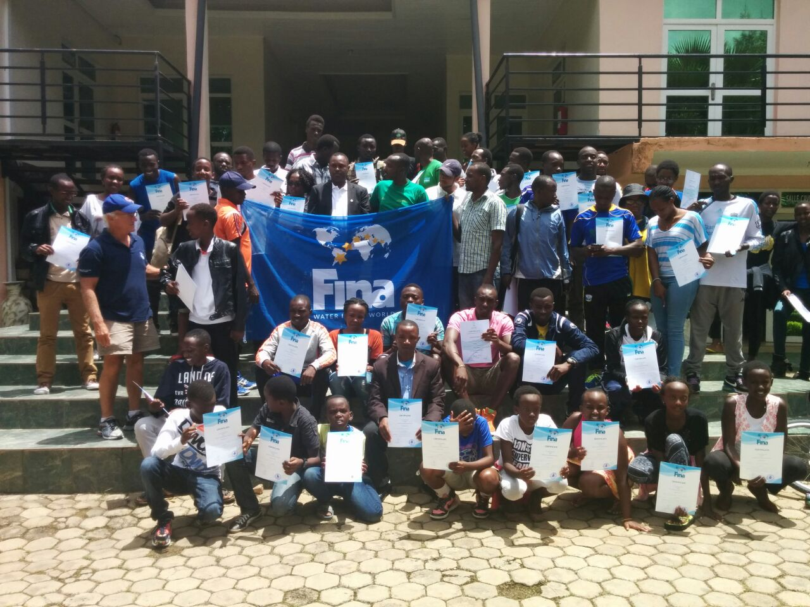
VOLLEYBALL : COUPE D’AFRIQUE DES CLUBS CHAMPIONS 2016 - DAMES
Mu irushanwa ry’igikombe cy’Afurika cy’amakipe y’abagore yabayeaya mbere mu bihugu byayo ryabereye Sidi Bou Said muri Tunisie kuwa 22 - 30.04.2016, u Rwanda rwahagarariwe n’ikipe ya Rwanda Revenue Authority yabaye iya 4 mu makipe 17.
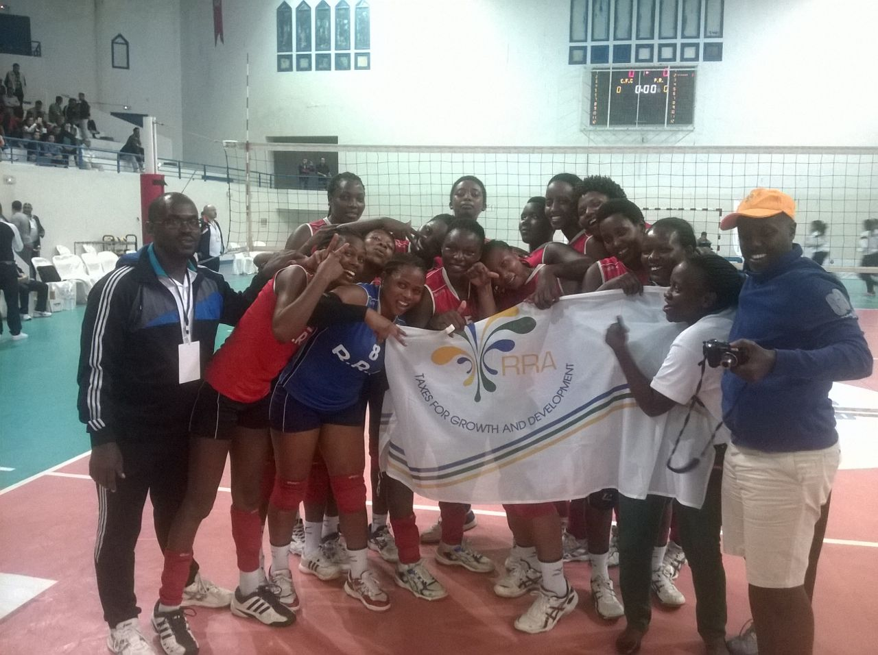RWANDA REVENUE AUTHORITY

ATHLETISME: EAST AFRICAN JUNIOR ATHLETICS CHAMPIONSHIP 2016
Irushanwa ry’imikino ngororamubiri ry’abakinnyi b’ingimbi bo mu bihugu biherereye muri Afurika y’iburasirazuba ryabereye i Dar Es Salaam muri Tanzanie. U Rwanda rwahagarariwe n’abakinnyi 7: abakobwa 4 n’abahungu 3. Abakinnyi 2 batsindiye imidari:
IRIBAGIZA HONORINE muri 800 m yabaye uwa 2 ahabwa umudari wa feza: 2’07’’
NISHIMWE BEATHA muri 1.500 m yabaye uwa 3 ahabwa umudari wa bronze: 4’18’’

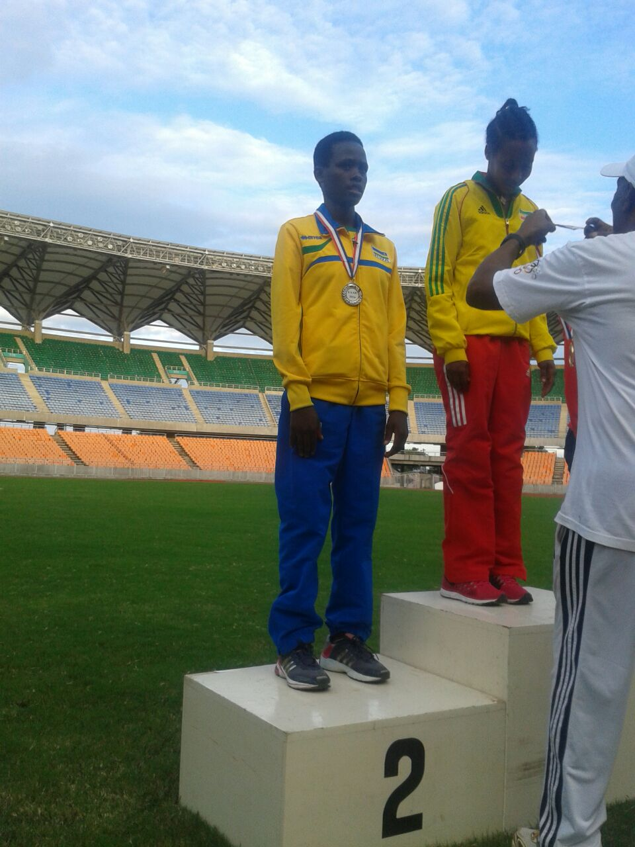
IRIBAGIZA HONORINE (uhagaze kuri 2)

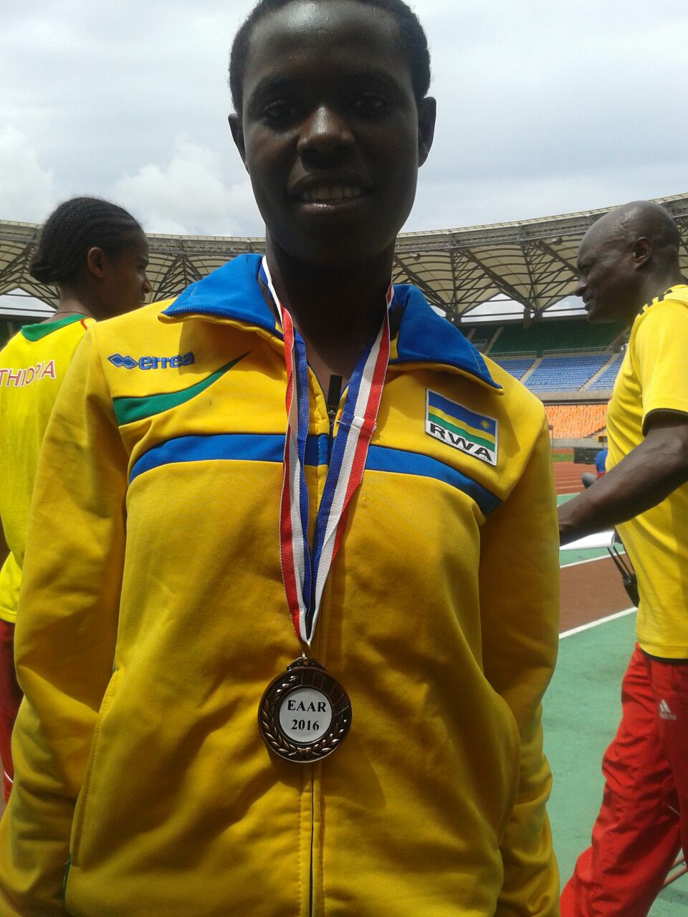
NISHIMWE BEATHA
Abakinnyi 3 babonye “minima” yo kujya muri championnat du monde junior muri Pologne 07.2016 :
MYASIRO JEAN MARIE VIANNEY: 10.000 m
SUGIRA JAMES: 1.500 m
NYIRARUKUNDO SALOME: 5.000 m

CHESS: ZONE 4.2 INDIVIDUAL CHESS CHAMPIONSHIP 2016
Mu mukino wa chess/jeu d’echecs, kuwa 23 - 30.04.2016 i Dar Es Salaam muri Tanzanie habereye irushanwa mpuzamahanga, u Rwanda ruhararirwa n’abakinnyi 2.
RUKIMBIRA VALENTIN yagize amanota 4/9 : yatsinze imikino 2, anganya 4, atsindwa 3. Yiyongereyeho amanota 22 ku rutonde rwa FIDE, afite amanota 1.680. Uwatsinze irushanwa wo muri Egypte yagize amanota 7/9
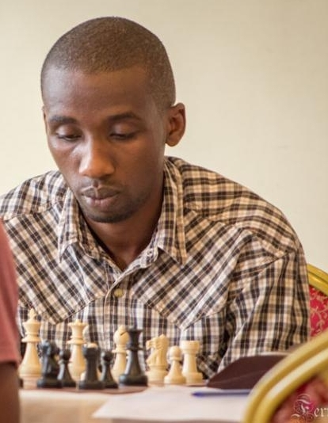R
RUKIMBIRA VALENTIN
SHIMWA MARIE FAUSTINE yagize amanota 4/9: yatsinze imikino 3, anganya 2, atsindwa 4. Uwatsinze irushanwa wo muri Egypte yagize amanota 9/9.
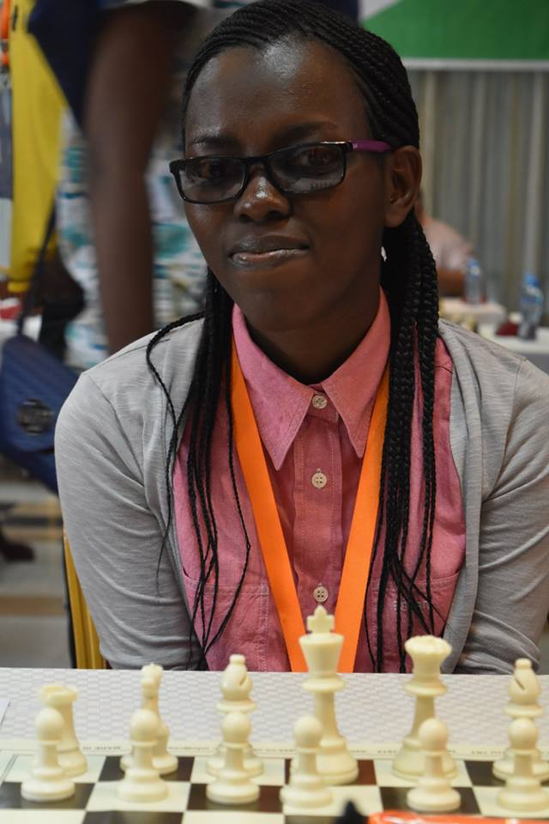
SHIMWA MARIE FAUSTINE
CNOSR - CGSA INDINAPOLIS
Nyuma y’amasezerano y’ubufatanye (MOU) hagati ya Comité National Olympique et Sportif du Rwanda (CNOSR) na Center for Global Sport Advancement (CGSA) - Indianapolis yashyizweho umukono mu kwezi kwa 11.2015, intumwa za CGSA zagiriye uruzinduko rw’akazi mu Rwanda kuva kuwa 20.04.2016 kugeza kuwa 07.05.2016. Bagiranye ibiganiro n’abayobozi ba CNOSR, MINEDUC, Fédération Rwandaise de Basketball, Fédération Rwandaise du Sport Scolaire; banasura hamwe mu hateganywa kuzakorerwa ibijyanye n’iterambere ry’imikino cyane cyane y’abakiri bato.
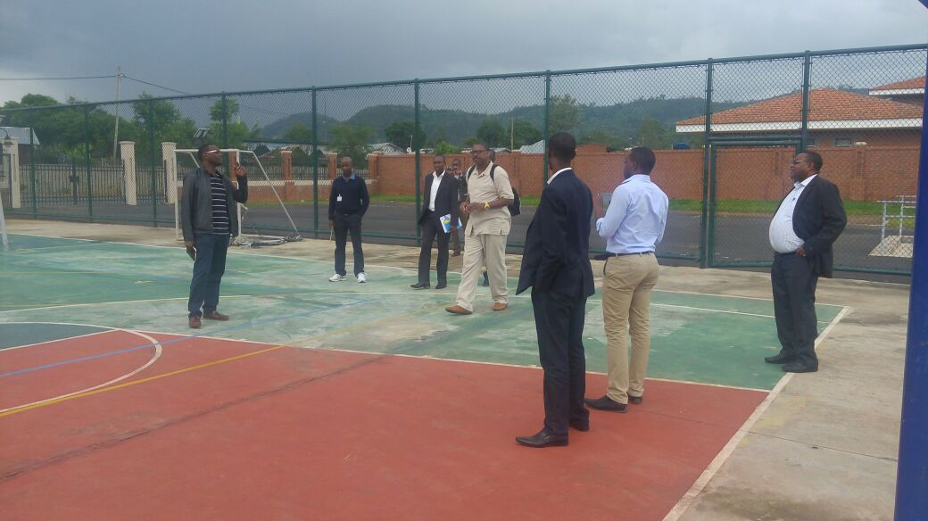
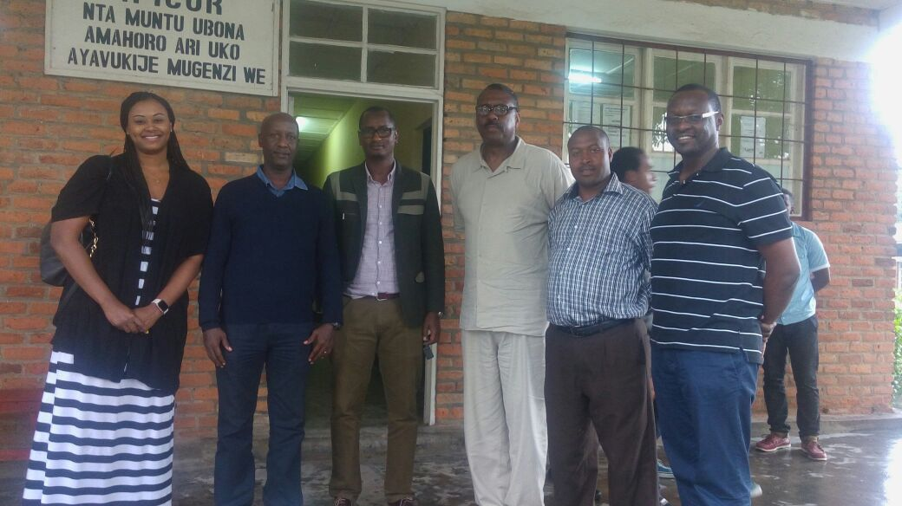
Intumwa za CNOSR, CGSA INDINAPOLIS n’abakuriye iterambere rya siporo y’abagore mu Rwanda, banagiranye ibiganiro na Honorable MUKAZIBERA AGNES ukuriye komisiyo y’uburezi, urubyiruko, umuco n’ikoranabuhanga mu nteko ishinga amategeko umutwe w’abadepute wari kumwe na Honorable UWILINGIYIMANA PHILIBERT nawe uri muri iyo komisiyo.

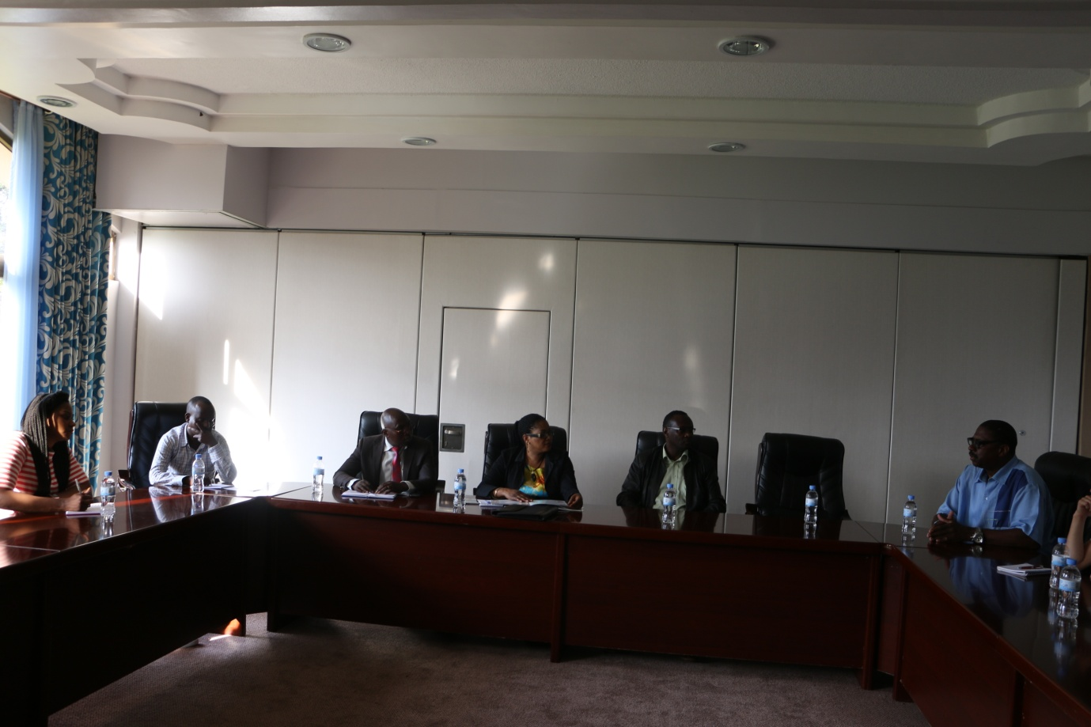

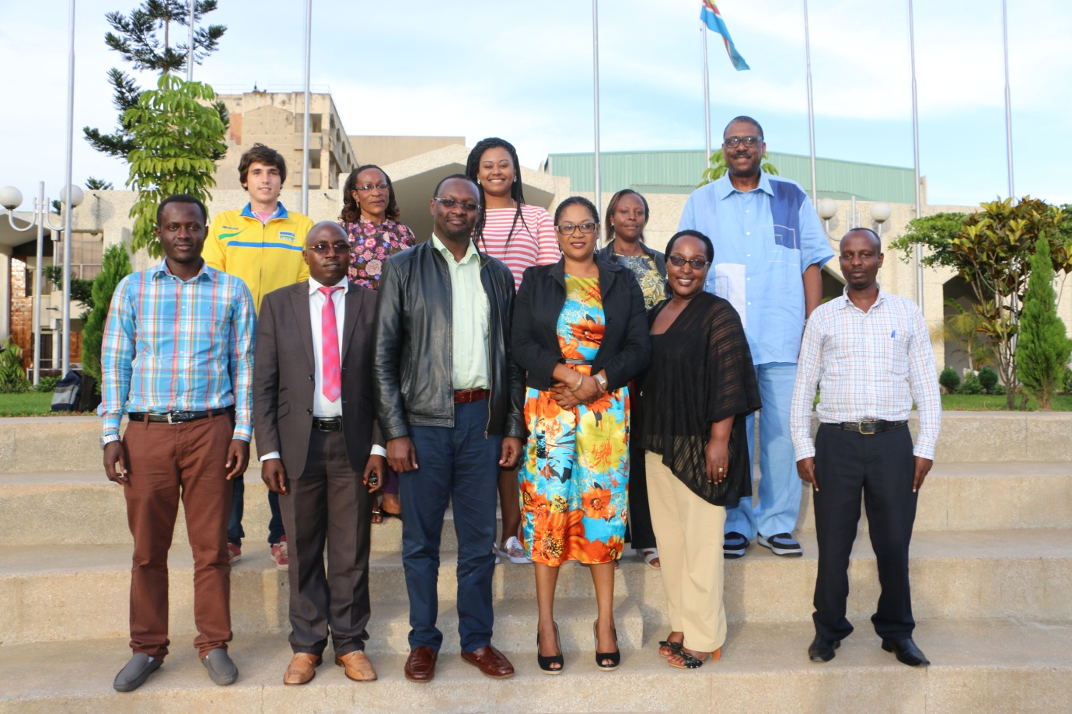

JO RIO 2016 : ATHLETISME
Umukinnyi UWIRAGIYE AMBROISE kuwa 10.04.2016 yabonye minima yo kujya muri Jeux Olympiques Rio 2016, mu irushanwa rya marathon ryitwa “NN Marathon Rotterdam”ryabereye i Rotterdam muri Hollande.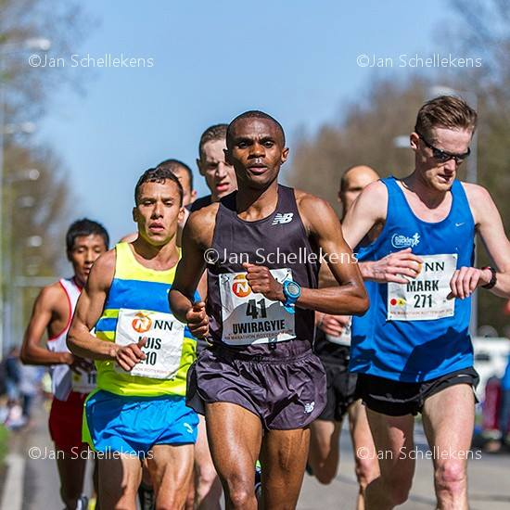UWIRAGIYE AMBROISE (41)

BEACH VOLLEYBALL: QUALIFICATIONS JO RIO 2016
Mu ijonjora rya nyuma ku rwego rw’Afurika mu mukino wa beach volleyball ryo kujya muri Jeux Olympiques - Rio 2016, amakipe y’abagore yahuriye Abuja muri Nigeria kuwa 14 - 17.07.2016. U Rwanda rwahagarariwe n’amakipe 2:
MUTATSIPUNDU DENISE afatanyije na NZAYISENGA CHARLOTTE, MUKANTAMBARA SERAPHINE afatanyije na HAKIZIMANA JUDITH. U Rwanda rwafashe umwanya wa 2, Misiri yabaye iya mbere ikazahagararira Afurika muri Jeux Olympiques Rio 2016.
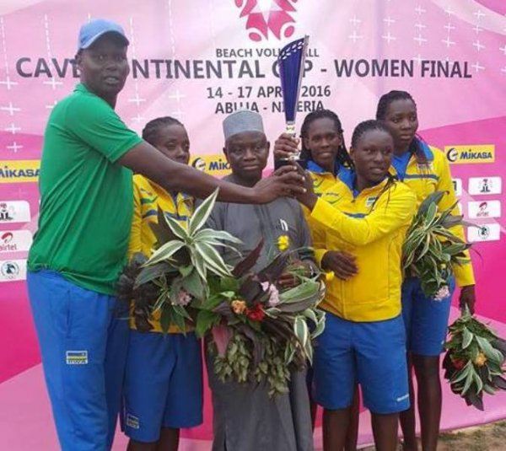RWANDA
Amakipe y’abagabo yo yahuriye Hammem Gezaz muri Tunisie kuwa 05 - 09.05.2016. Irushanwa ryahuje ibihugu 11 byarimo n’u RWANDA rwahagarariwe n’amakipe 2: iyari igizwe na Ntagengwa Olivier afatanyije na Kavalo Patrick, hamwe n’iya Kwizera Pierre Marschal afatanyije na Ndamukunda Flavien.
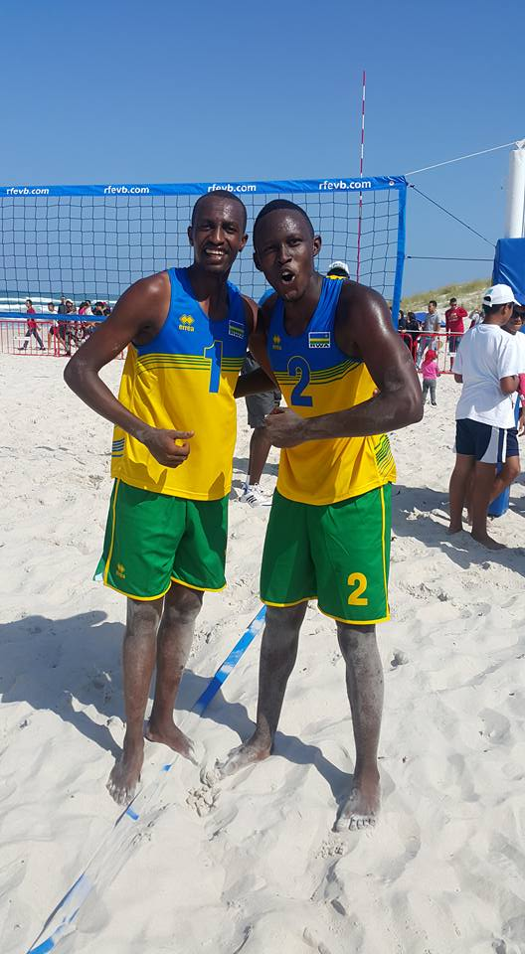
NTAGENGWA OLIVIER (1) & KAVALO PATRICK (2)
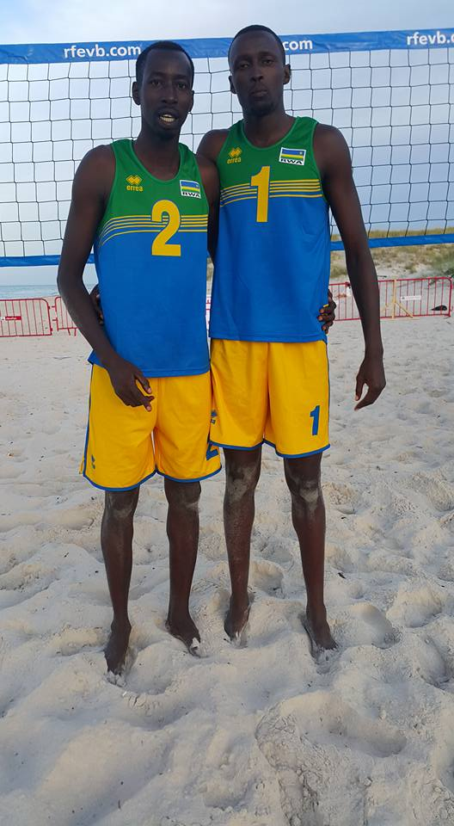
KWIZERA PIERRE MARSCHAL (2) & NDAMUKUNDA FLAVIEN (1)
Mu bihugu 11 u Rwanda rwafashe umwanya wa 5, Tunisie yabaye iya mbere itsindira kuzahagararira Afurika muri Jeux Olympiques - Rio 2016.

SPORT AUTOMOBILE : 1st RALLY SPRINT 2016
Irushanwa mpuzamahanga ryo gusiganwa mu modoka ryabereye i Bugesera kuwa 07.05.2016 ritangirwa n’imodoka 8 hasoza 3.
1.MOHAMED ABBAS ROSHANALI wari kumwe na HABIMANA YUSSOUF LEE bo muri Momo Rally Team baturutse i Burundi, bakinishije imodoka yo mu bwoko bwa Subaru N10.
2.MWANANTEBA ZAMIN na MERCERI DIAS baturutse i Burundi muri Zulu Mike Rally Team bakinishije imodoka yo mu bwoko bwa Toyota Celica.
3.NYIRIDANDI FABRICE na NIYIGENA AUDACE bo mu Rwanda muri Huye Motorsport bari muri Toyota Corolla.
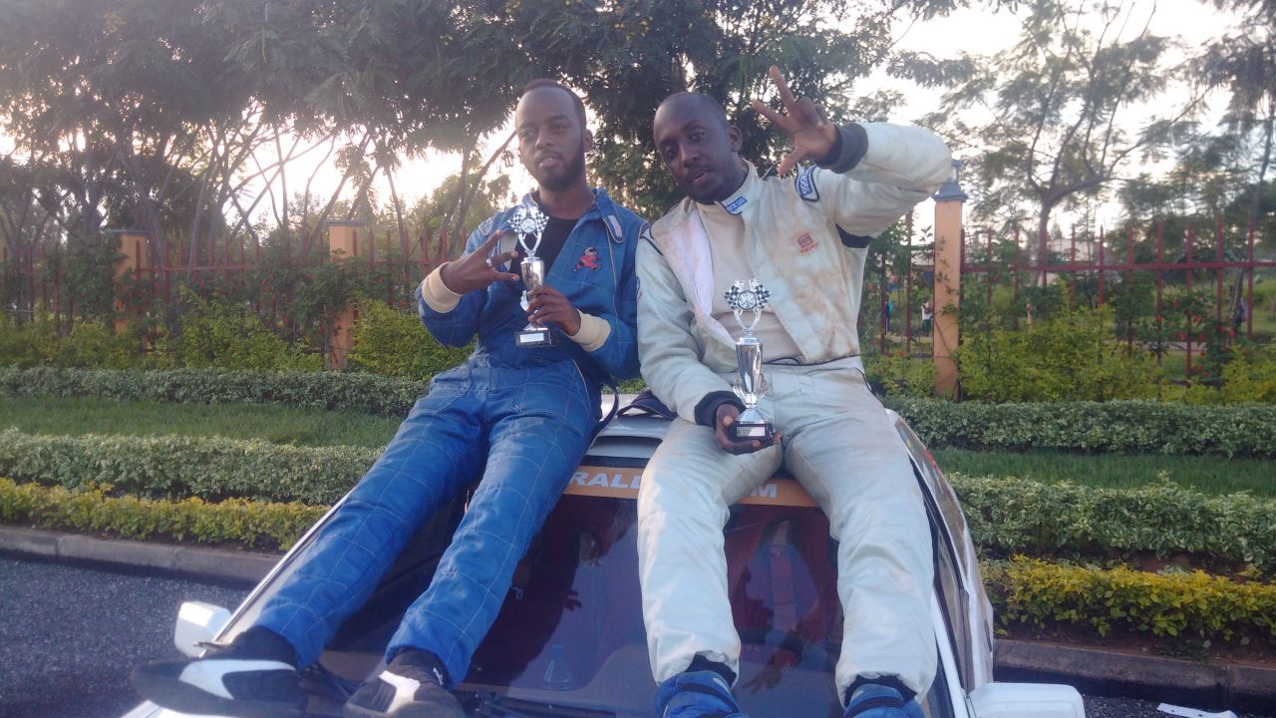NYIRIDANDI FABRICE & NIYIGENA AUDACE (HUYE MOTORSPORT)
CRICKET: GUINNESS WORLD RECORD
Umunyarwanda DUSINGIMANA ERIC yesheje umuhigo w’isi wo kumara amasaha 51 akina cricket. Yatangiye gukina kuwa 11.05.2016 ageza kuwa 13.05.2016 i saa tanu z’amanywa (11H00); yakinaga ijoro n’amanywa adahagaze.
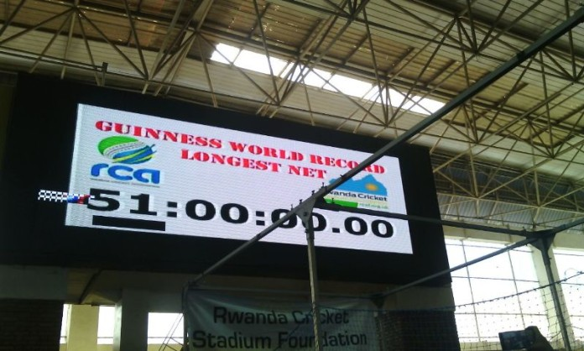
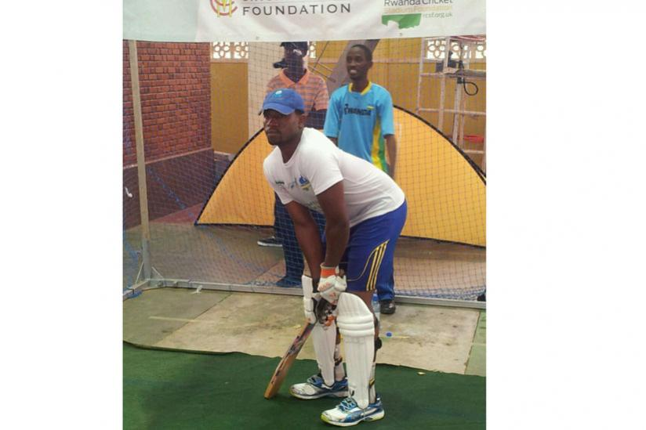DUSINGIZIMANA ERIC
DUSINGIZIMANA ERIC yakuyeho umuhigo wo gukina cricket amasaha 50 wari ufitwe n’Umuhinde VIRAG MALE.

FOOTBALL: URUPFU RWA KALISA JEAN PAUL “MOURINHO”
KALISA JEAN PAUL wari uzwi ku izina ry’irihimbano rya “MOURINHO” wari umutoza wungirije muri MUSANZE FC, yitabye Imana kuwa kabiri 17.05.2016 azize uburwayi.
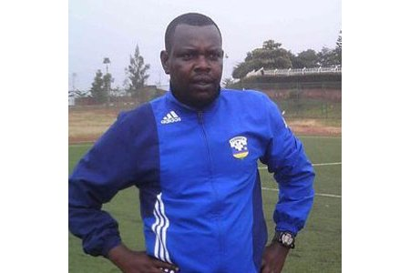
Nyakwigendera KALISA JEAN PAUL “MOURINHO”

CYCLISME: UCI MTB WORLD CUP 2016
Mu kwitegura Jeux Olympiques Rio 2016, BYUKUSENGE NATHAN yakinnye irushanwa ry’isi rya vélo tout terrain ryabereye Albstadt muri Allemagne kuwa 22.05.2016 asoza ku mwanya wa 134 mu basiganwa 150.
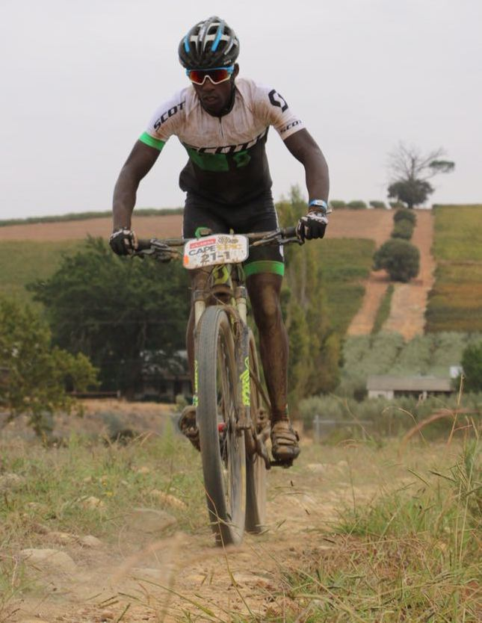
BYUKUSENGE NATHAN
ATHLETISME: KIGALI INTERNATIONAL PEACE MARATHON 2016
Irushanwa mpuzamahanga ngarukamwaka ryo gusiganwa kwiruka ku maguru ryabaye kuwa 22.05.2016. Abafashe imyanya 3 ya mbere:
Mu cyiciro cya half marathon (21 km)
ABAGORE
1.JERUTO AGNES (KENYA): 1H13’28’’
2.NYIRARUKUNDO SALOME (RWANDA): 1H13’54’’
3.KIMENTO PURITY KANGOGO (KENYA): 1H17’23’’
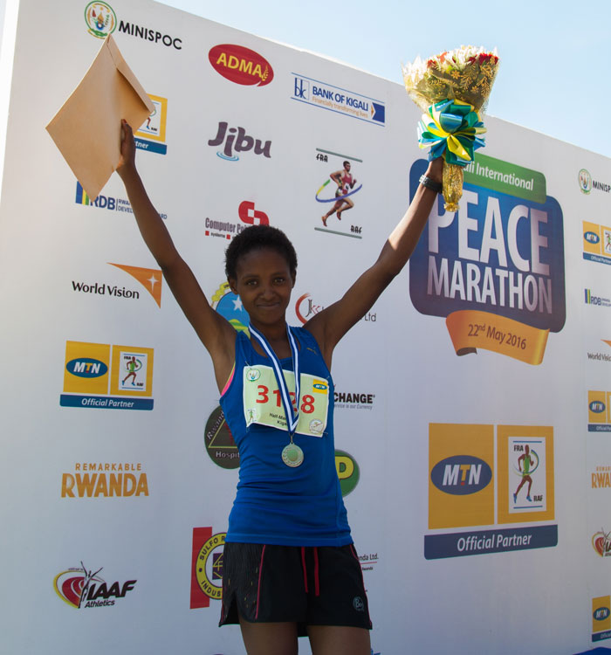NYIRARUKUNDO SALOME
ABAGABO
1.BENSON KIPRUTO (KENYA): 1H04’13’’
2.BOWEN JOSPHAT KIPCHIRCHIR (KENYA): 1H04’26’’
3.CHEBIL DOUGLAS KIPSANAI (KENYA): 1H04’33’’

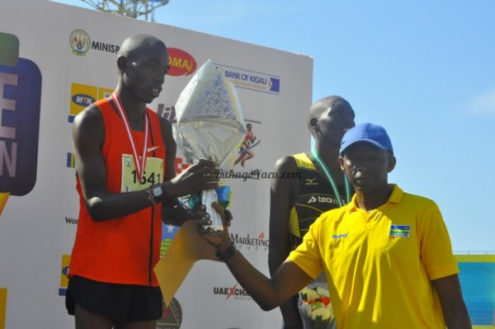KIPRUTO BENSON
Muri full marathon (42 km)
ABAGORE
1.CHEMWENO JURUIOT (KENYA): 2H38’12’’
2.MIGO SELSER ALICE (KENYA): 2H41’26’’
3.JACQUELINE KIPLIMO (KENYA): 2H43’49’’

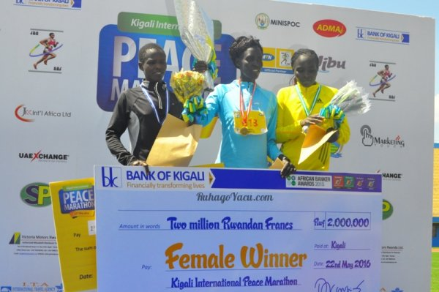
ABAGABO
Mu myanya 3 ya mbere:
1.TALLAM JAMES CHERITISH (KENYA): 2H19’03’’
2.KIBET RONO (KENYA): 2H..’16’’
3.WILLIAM TUTHO CHEBDI (KENYA): 2H20’08’’
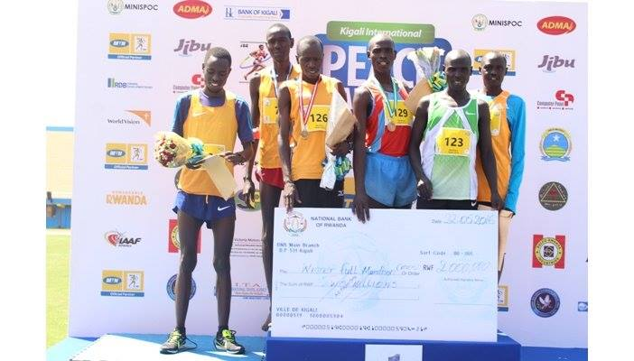

BASKETBALL: U18 WORLD BASKETBALL CLASSIC
Muri basketball, ikipe y’igihugu y’abahungu U18 yiteguraga AFROBASKET U18 - RWANDA 2016 yakoreye imyitozo ARIZONA muri USA n’imikino ya gicuti n’amakipe ya college yo mu mujyi wa TUCSON.

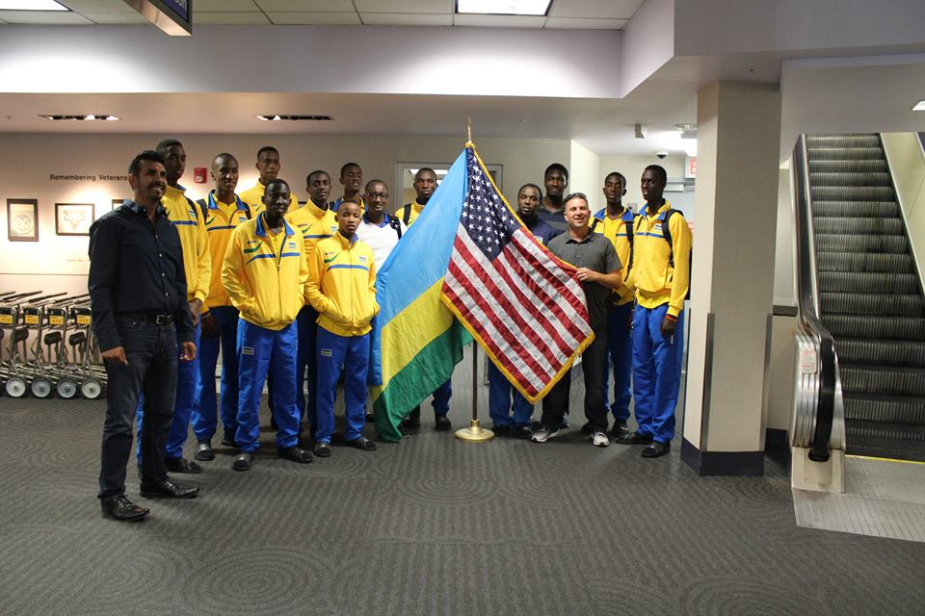U18 BOYS TEAM MURI USA
1.RWANDA 58 - 91 TUCSON
2.RWANDA 39 - 100 TUCSON
3.RWANDA 53 - 73 TUCSON
4.RWANDA 59 - 64 TUCSON
5.RWANDA 58 - 82 TUCSON
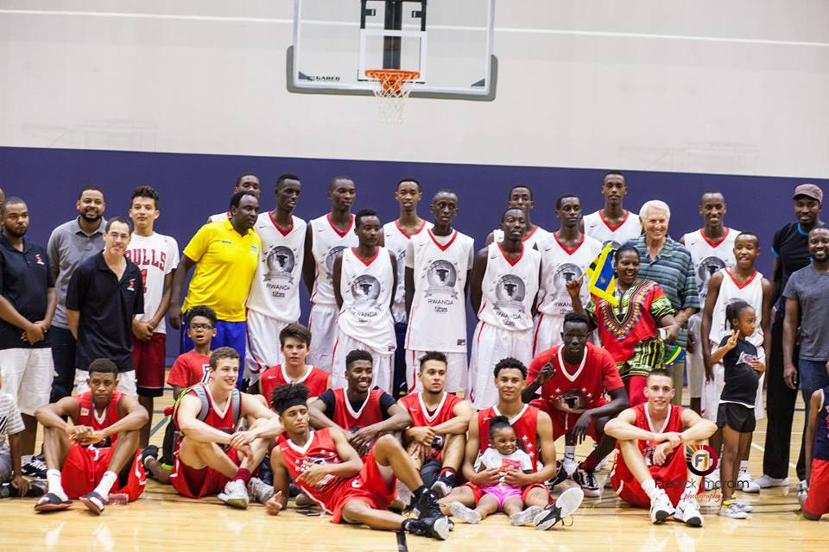

TAEKWONDO : TAEKWONDO AFRICAN CHAMPIONSHIP 2016
Ikipe y’u RWANDA y’umukino wa taekwondo yagiye mu irushanwa ry’Afurika ryabereye i Port Said muri Egypte 19 - 21.05.2016. Ikipe y’u Rwanda yari igizwe n’abakinnyi 11 yegukanye imidari 5 ya bronze mu irushanwa ryabaye mu byiciro bibiri: Kyrogi & Poomse.
Muri Kyrogi
NDACYAYISENGA ALINE ( - 63 kg)
UWABABYEYI DELPHINE (- 46 kg)
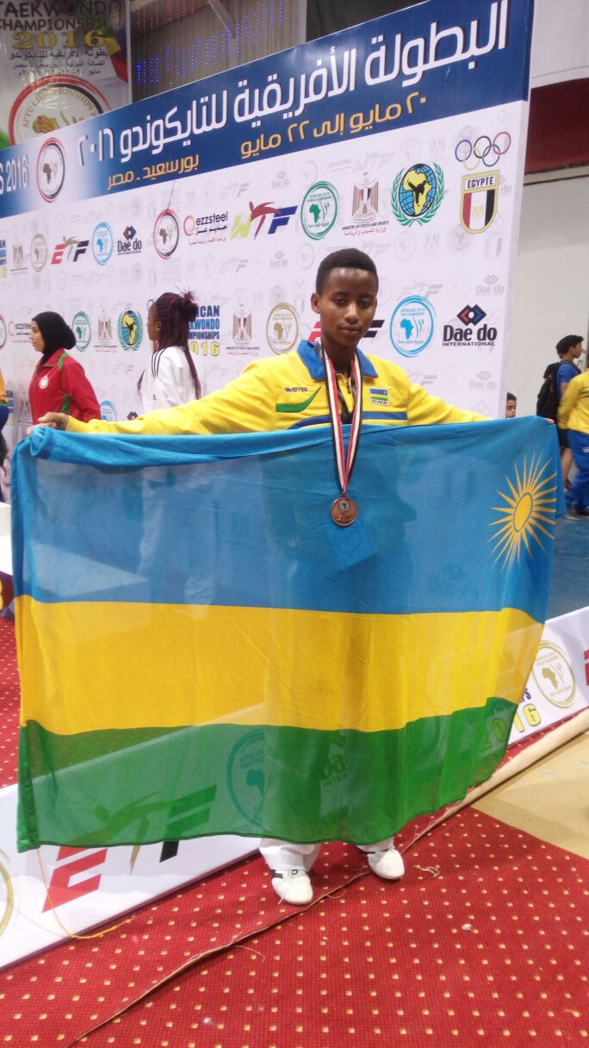
NDACYAYISENGA ALINE

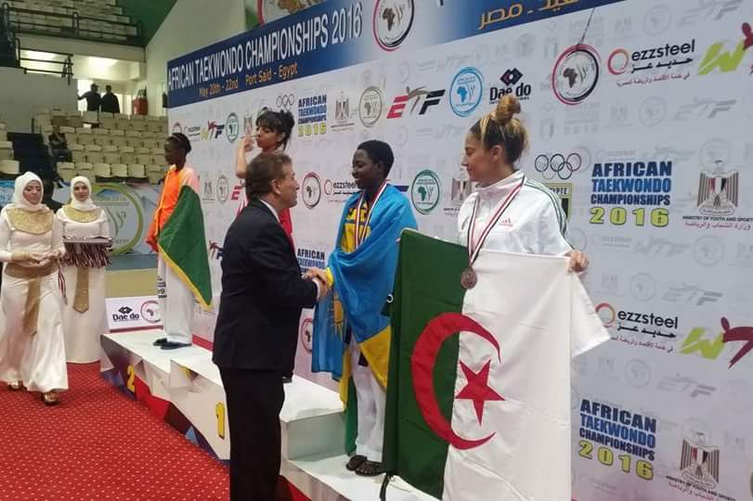UWABABYEYI DELPHINE
Muri Poomse
BIRUSHYA EMMANUEL
MUSHAMBOKAZI ZURA
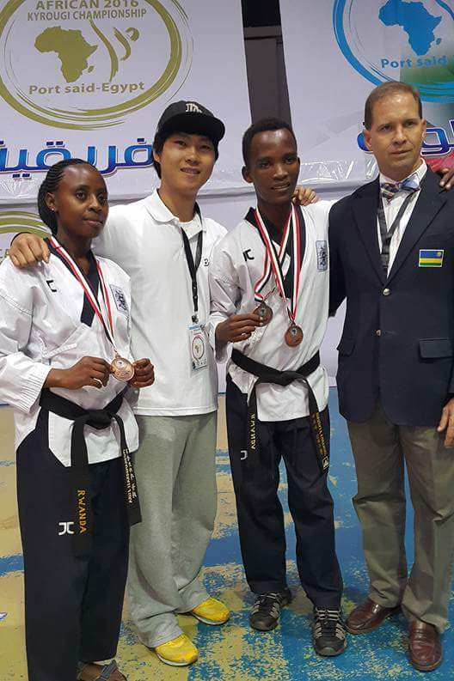

FERWABA NATIONAL LEAGUE 2015 - 2016
Muri championnat ya basketball “saison régulière”, mu makipe 10 y’abagabo igikombe cyatwawe na PATRIOTS, mu makipe 5 y’abagore gitwarwa na APR.
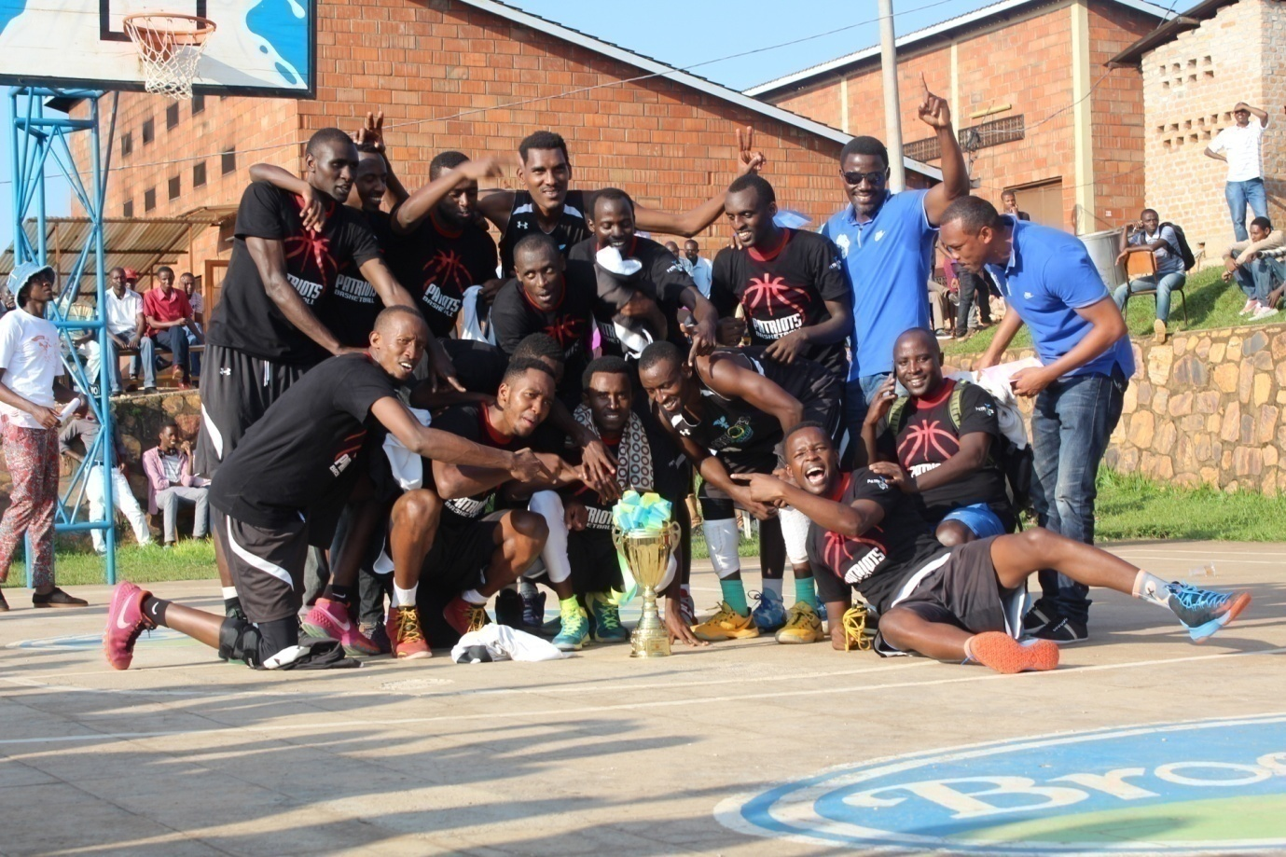PATRIOTS BBC
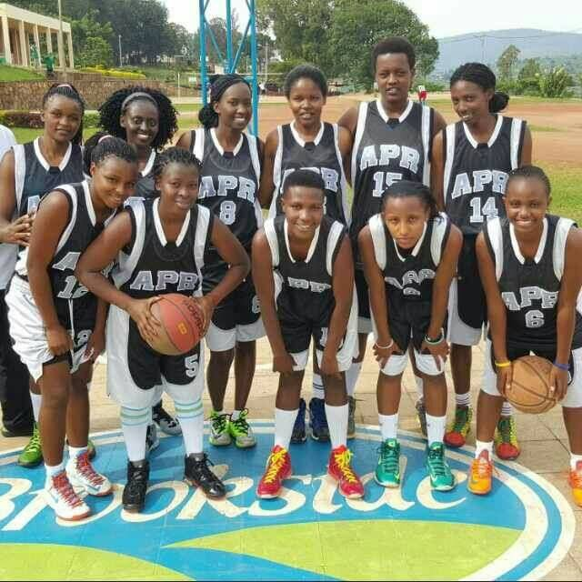APR BBC
RUGBY: AFRICA RUGBY DIVISION 2 CUP
Irushanwa mpuzamahanga rya rugby ryahuje amakipe y’abagabo y’ibihugu 4: Rwanda, Burundi, R.D.Congo, Lesotho; ryabereye i Kigali kuwa 17 na 20.05.2016. Igikombe cyatwawe n’ikipe ya R.D.Congo, ku mukino wa nyuma yatsinze iy’u Rwanda “Silverbacks” ibitego 12 ku 9.
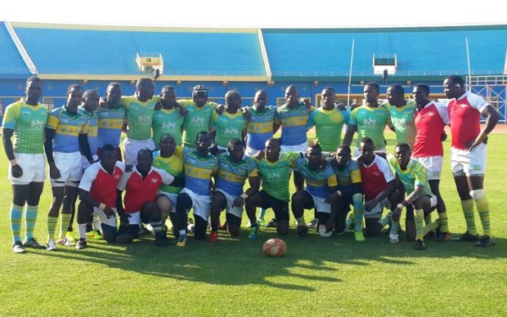 IKIPE Y’U RWANDA “SILVERBACKS”
CAR FREE DAY
Kuwa 29.05.2016 mu mujyi wa Kigali hatangijwe gahunda ngarukakwezi yo kubuza imodoka kugenda mu mihanda imwe n’imwe, igakoreshwa n’abagenda n’amaguru cyangwa ku magare hagamijwe gukangurira abantu kwirinda indwara zitandura.
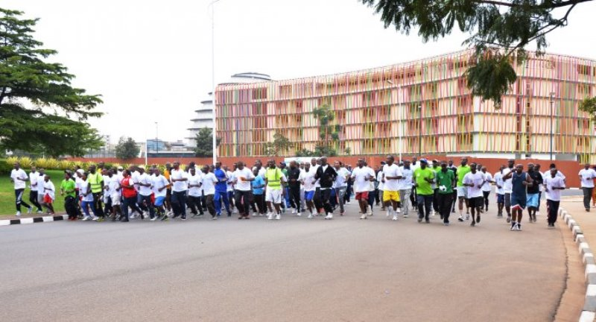
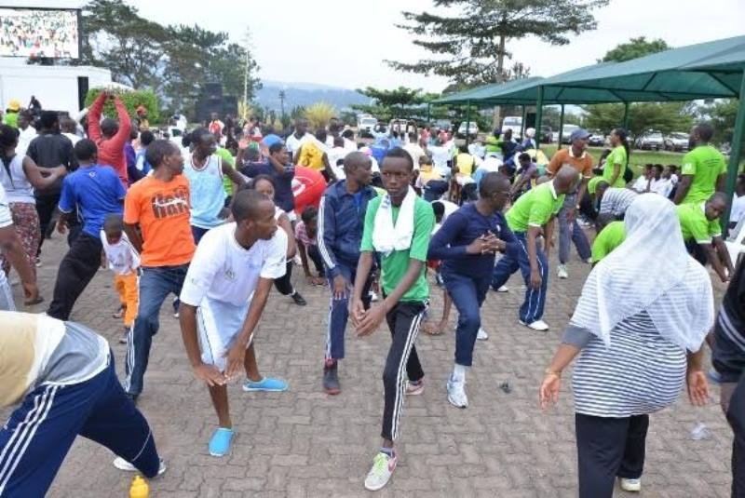
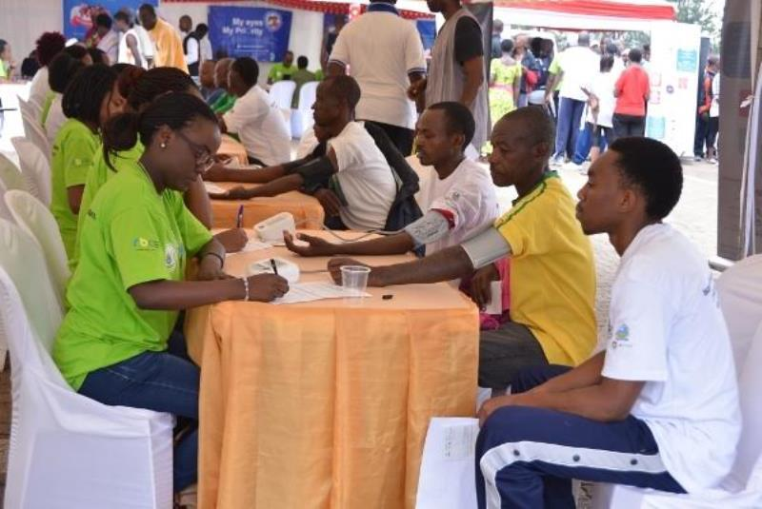
SPORT SCOLAIRE: FOOTBALL / COPA COCA-COLA 2016
Mu karere ka Rubavu kuwa 29.05.2016 habereye imikino ya nyuma y’irushanwa ngarukamwaka “Copa Coca - Cola” ry’amakipe y’umupira w’amaguru y’abana.
Mu makipe y’abakobwa igikombe cyatwawe n’akarere ka Rwamagana, mu makipe y’abahungu gitwarwa n’akarere ka Nyarugenge 1.
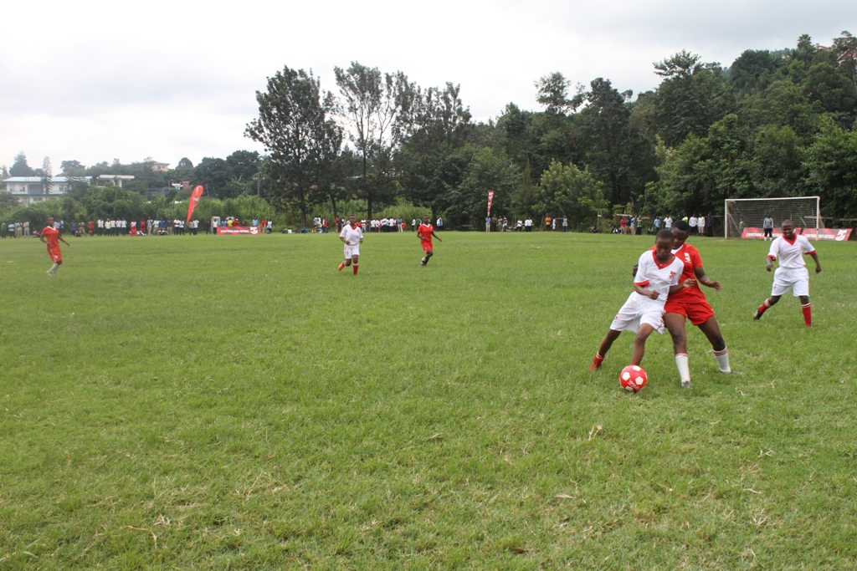
KWIBUKA 22 & GENOCIDE MEMORIAL TOURNAMENTS “GMT” 2016

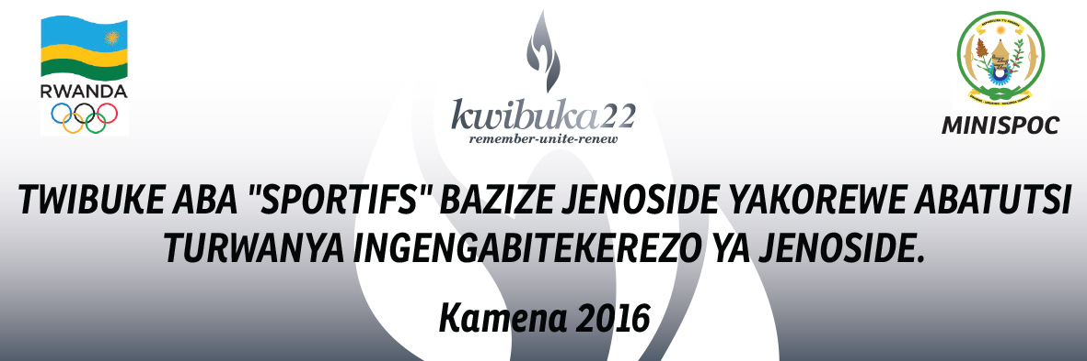
Muri gahunda yo kwibuka ku nshuro ya 22 jenoside yakorewe abatutsi, na gahunda ngarukamwaka iba mu kwezi kwa Kamena yo kwibuka aba”sportifs” bishwe muri jenoside yakorewe abatutsi; kuwa gatanu 03.06.2016 habaye igikorwa cyo kunamira abishwe muri jenoside bashyinguwe mu rwibutso rwo ku Gisozi.
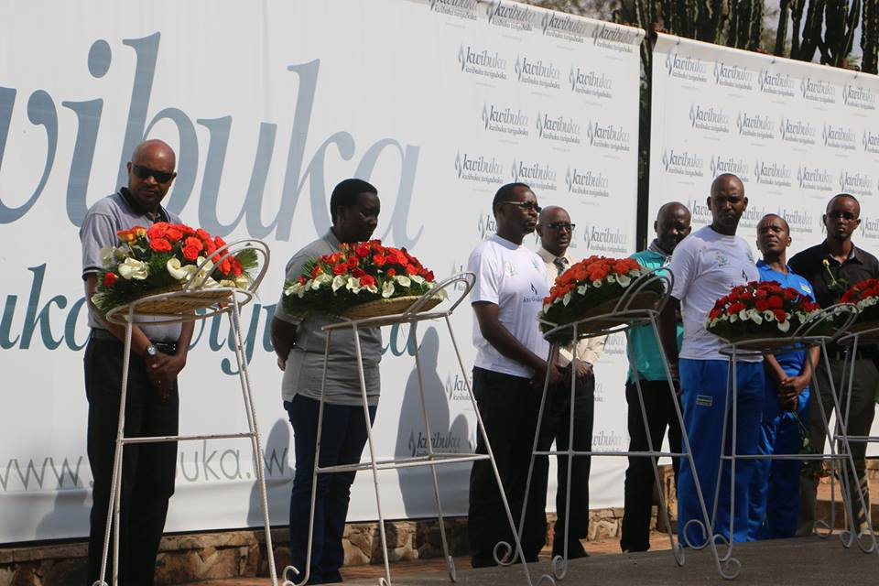
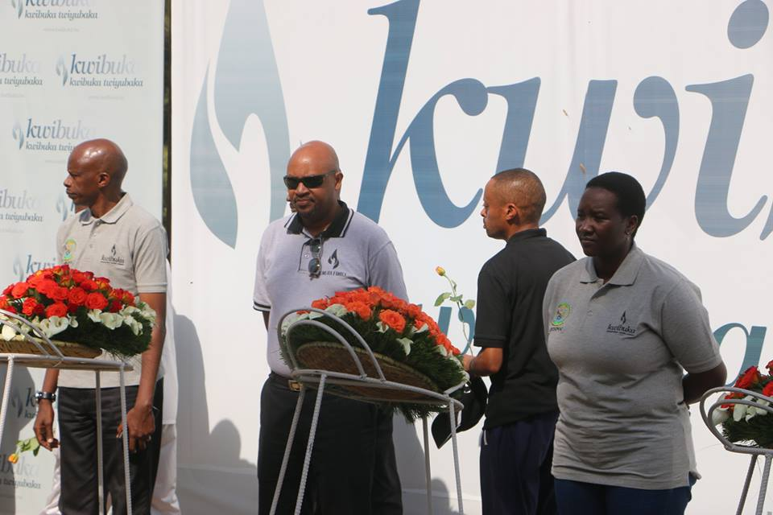
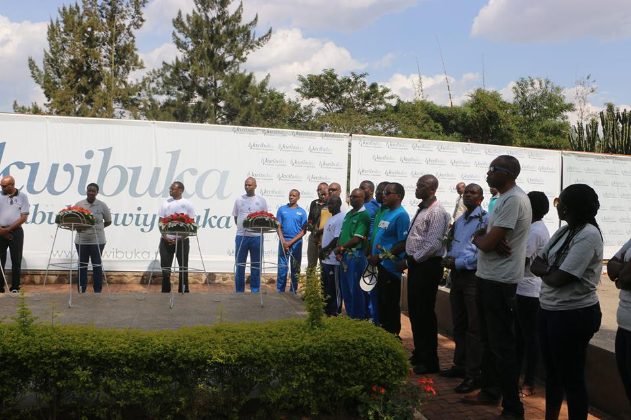
Kuwa gatanu 03.06.2016 habaye kandi urugendo rwo kwibuka rwatangiriye kuri rond point ya KBC ku Kimihurura, rusorezwa kuri stade Amahoro i Remera, hanatangiwe ubutumwa n’abayobozi banyuranye. Herekanwe kandi amazina n’amafoto ya bamwe mu ba”sportifs” bishwe muri jenoside.
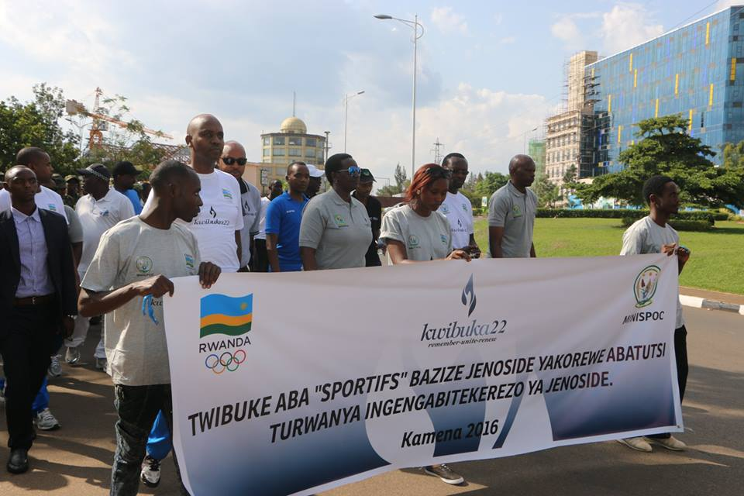
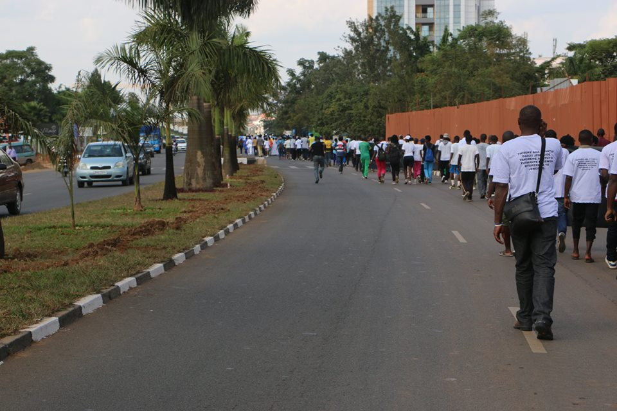

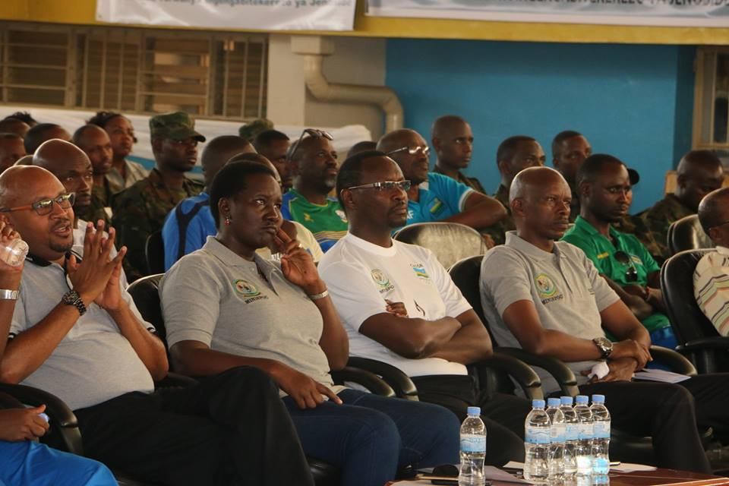
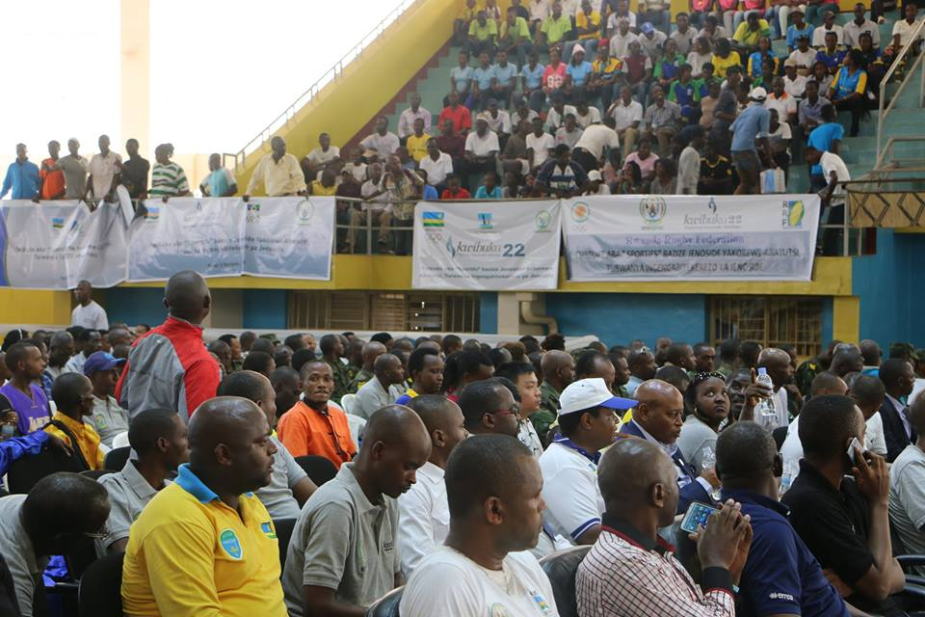
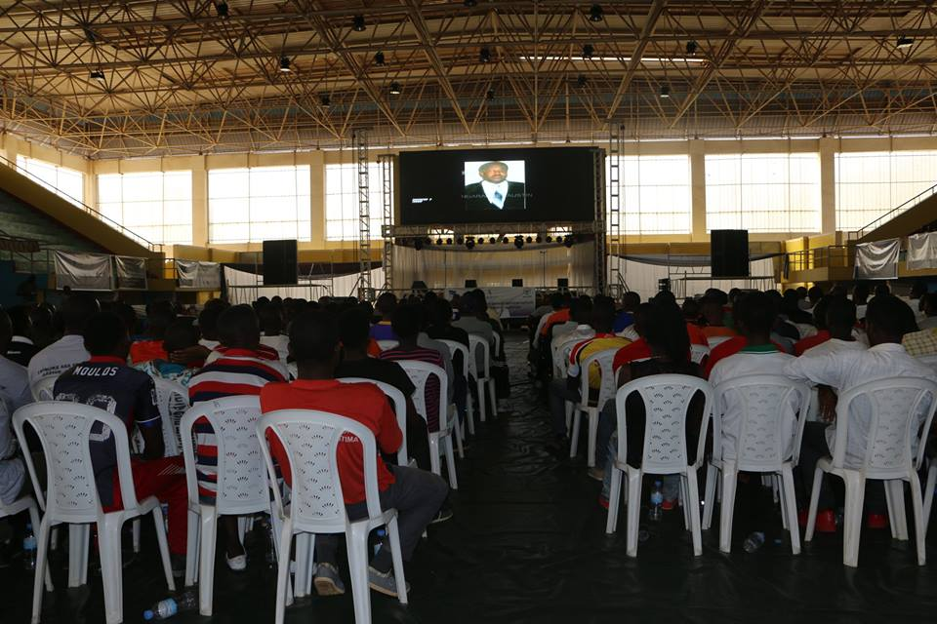
Habaye imikino inyuranye yo kwibuka aba”sportifs” bishwe muri jenoside muri : volleyball, basketball, tennis, cricket, handball, skating, golf, boxe, archery, taekwondo, fencing, athletisme, chess, cyclisme, kung - fu wushu, football, sport automobile, sport scolaire, karate, natation. Imwe muri iyo mikino yabayemo amarushanwa mpuzamahanga yajemo amakipe yo bihugu binyuranye: Uganda, Burundi, Tanzanie, R.D.Congo, Kenya, Soudan du Sud.
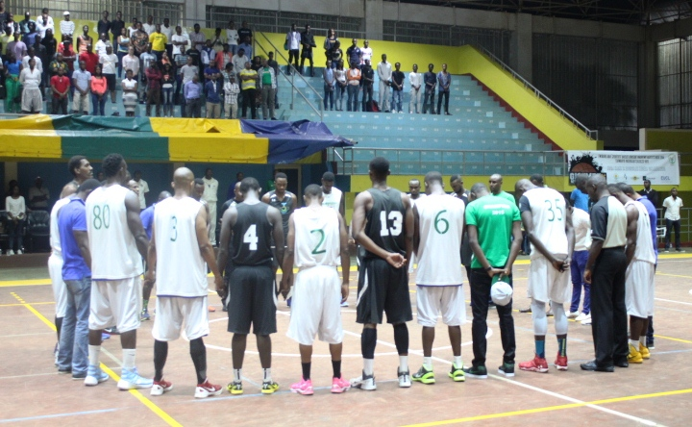
Muri iyo gahunda yo kwibuka ku nshuro ya 22 jenoside yakorewe abatutsi mu Rwanda, n’iyo kwibuka by’umwihariko aba ”sportifs” bishwe muri jenoside yakorewe abatutsi, kuwa 30.06.2016 hatangijwe ku mugaragaro isanwa ry’inzu y’imfubyi za jenoside zibana mu Gacurabwenge mu karere ka Kamonyi. Icyo gikorwa cyabimbuwe n’umuganda wakozwe n’abahagarariye MINISPOC, CNOSR, amashyirahamwe y’imikino mu Rwanda, IBUKA, GAERG, umurenge n’abaturage.

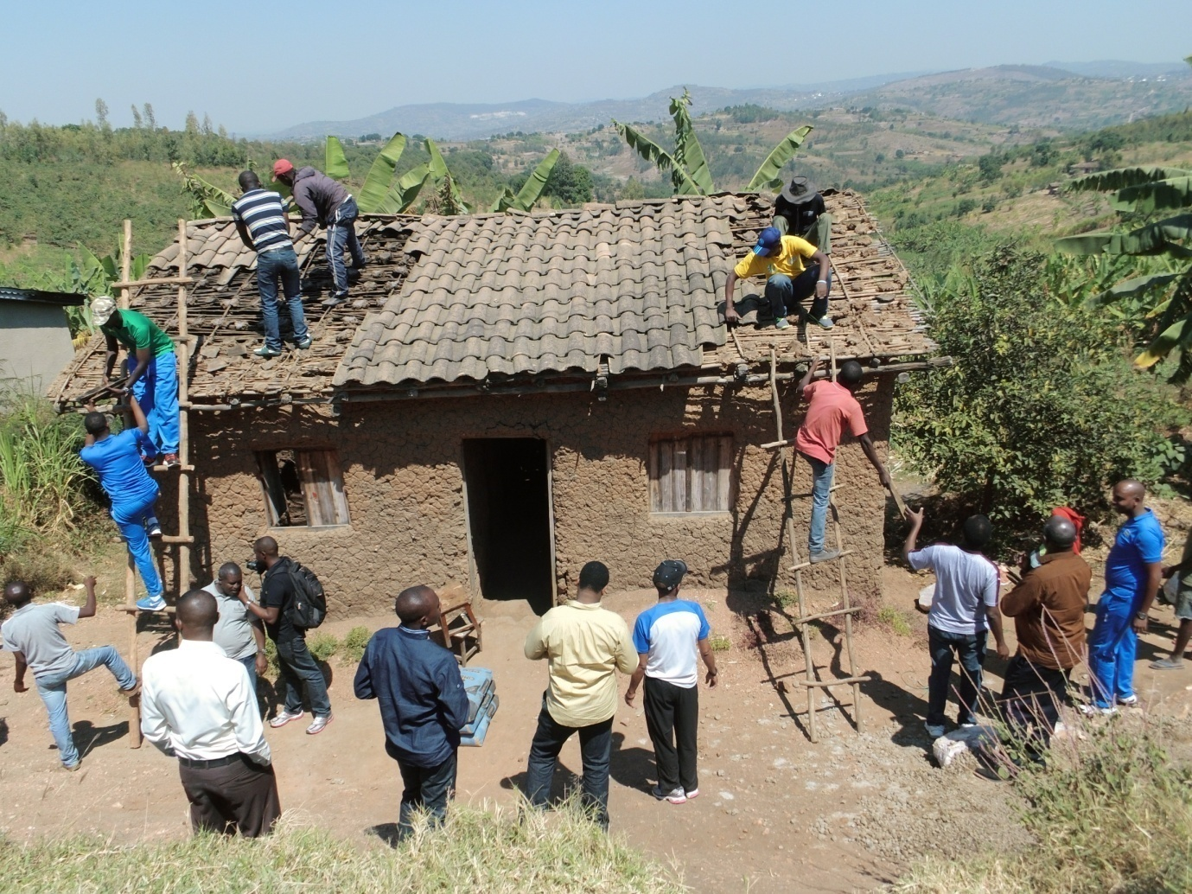
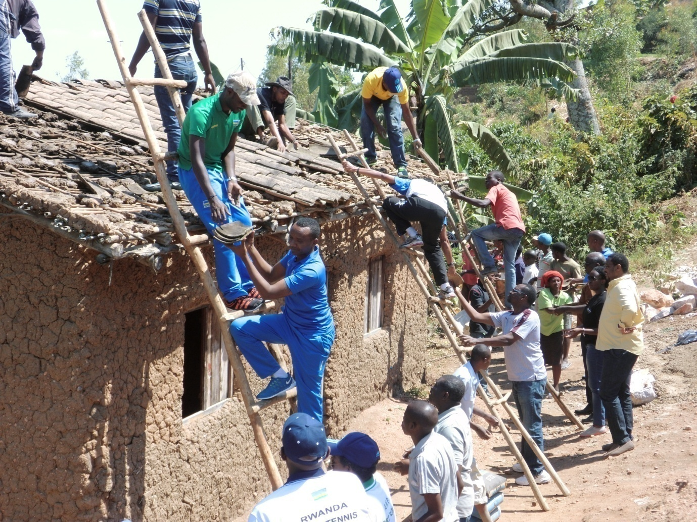
FOOTBALL: ELIMINATOIRES CAN GABON 2017
Mu mikino y’ijonjora mu matsinda yo kujya mu irushanwa ry’igikombe cy’Afurika kizakinirwa muri Gabon mu 2017, ikipe y’u Rwanda “Amavubi” iri mu itsinda rya H. Mu mukino wabereye muri Ile Maurice, kuwa 26.03.2016 Ile Maurice yatsinze 1 - 0 Rwanda, naho mu mukino wo kwishyura kuwa 29.03.2016 wabereye i Kigali, u Rwanda rwatsinze 5 - 0 Ile Maurice.
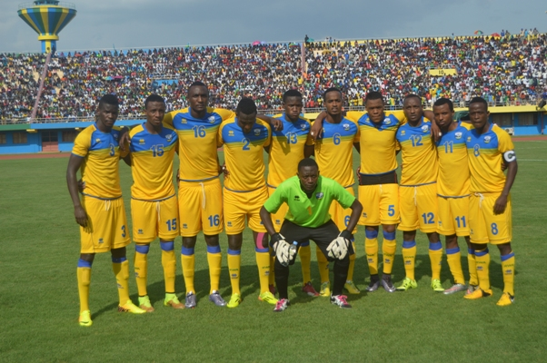IKIPE Y’U RWANDA “AMAVUBI”
Naho mu mukino w’ijonjora wabereye i Kigali kuwa 04.06.2016, ikipe y’u Rwanda yatsinzwe 2 - 3 Mozambique
UNHCR - CIO - MIDIMAR - CNOSR
Dr JACQUES ROGGE envoyé special du SG de l’ONU pour les jeunes réfugiés et le sport yagiriye uruzinduko mu Rwanda kuwa 06 - 09.06.2016. Yagiranye ibiganiro n’abakuriye MINISPOC, MIDIMAR, CNOSR, HCR - RWANDA, asura urwibutso rwa genocide rwo ku Gisozi n’inkambi z’impunzi za Mahama na Gihembe.
MURI CNOSR
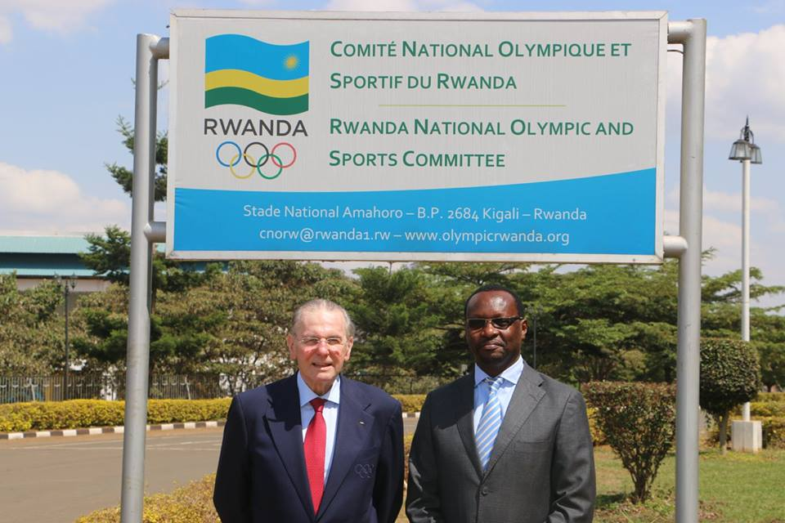
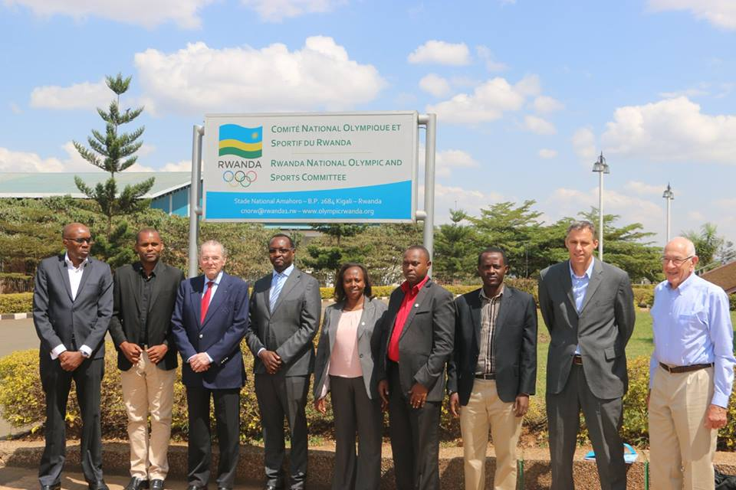

MURI MINISPOC
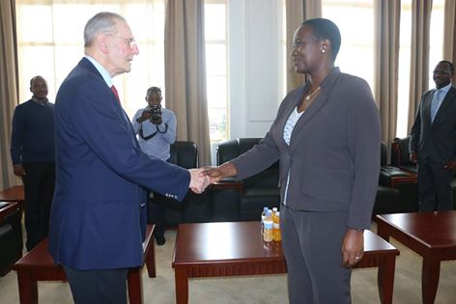
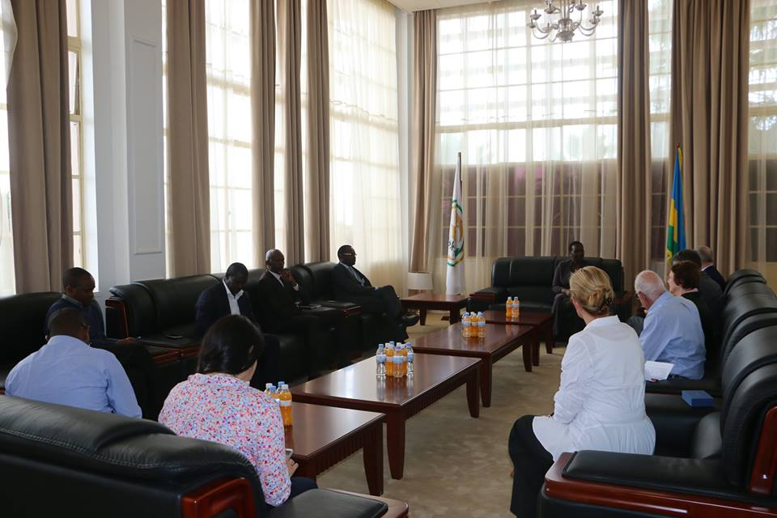

KURI KIGALI GENOCIDE MEMORIAL
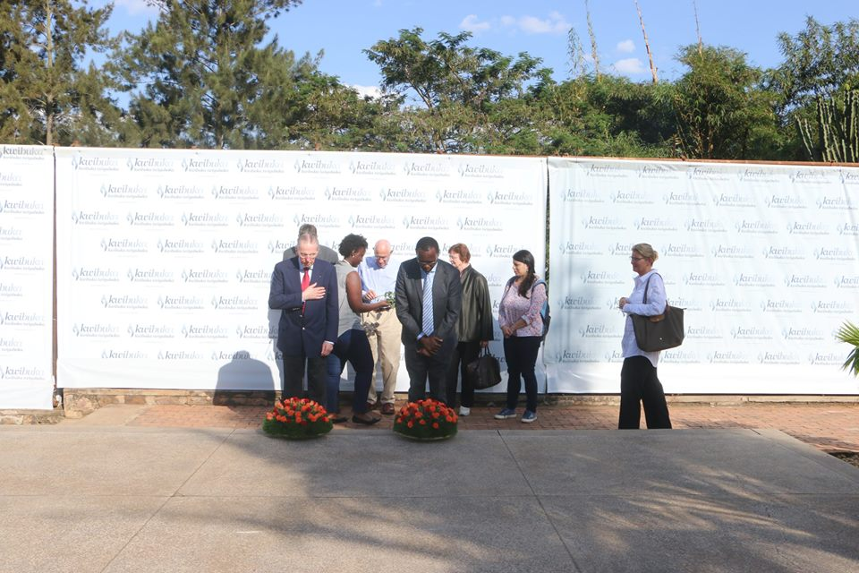

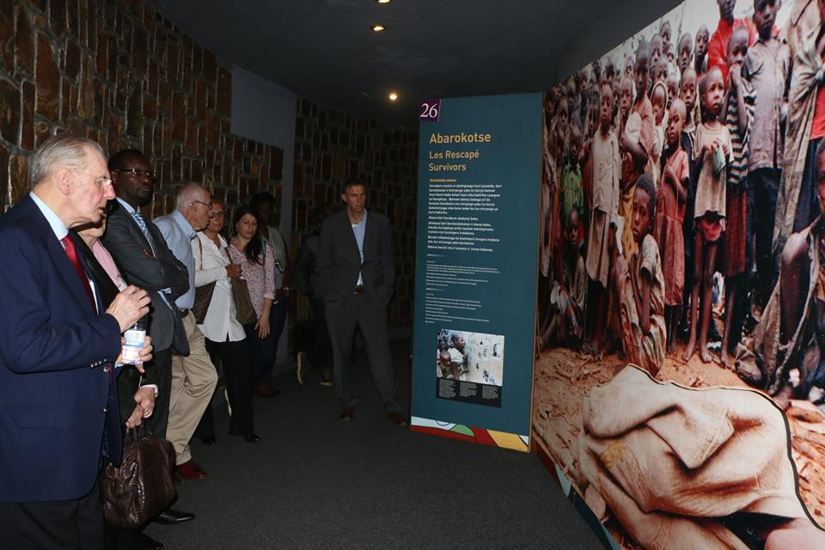

MU NKAMBI Y’IMPUNZI Z’ABARUNDI Y’I MAHAMA (KIREHE)

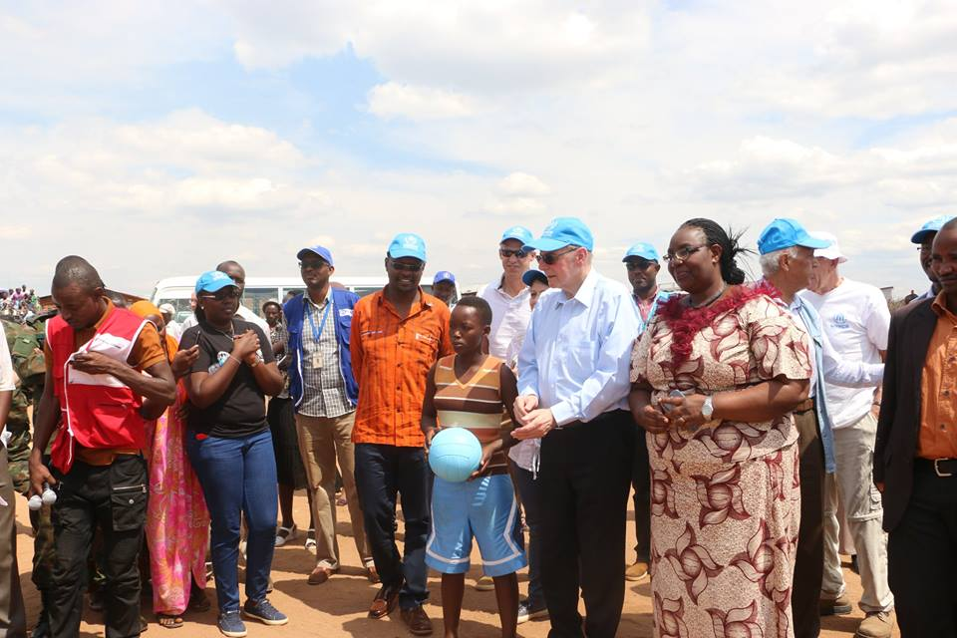
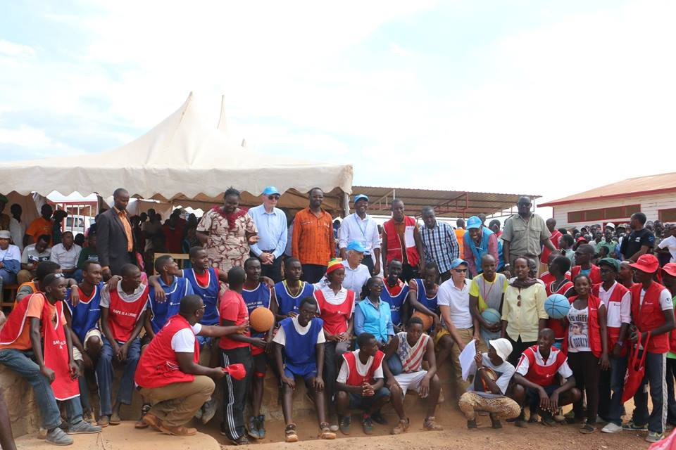

MU NKAMBI Y’IMPUNZI Z’ABANYECONGO Y’I GIHEMBE (GICUMBI)
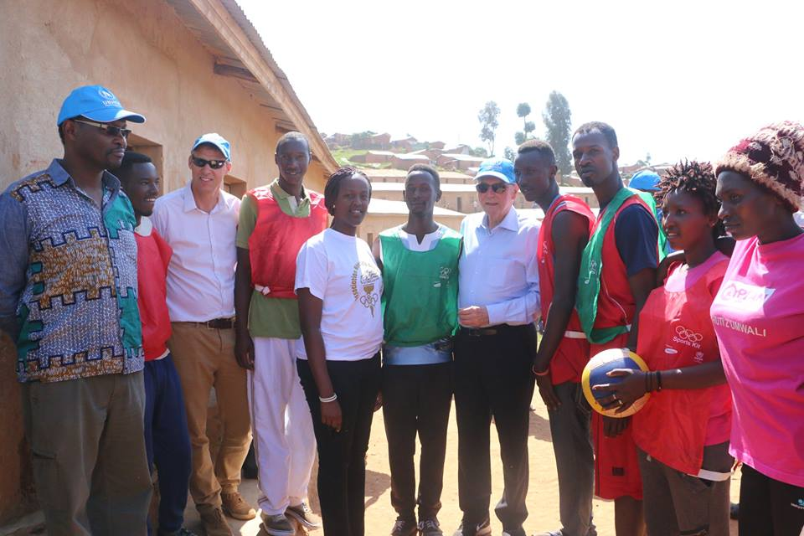

FOOTBALL: ELIMINATOIRES CAN U20 ZAMBIE 2017
Mu mikino w’umupira w’amaguru w’ijonjora ryo kuzajya mu irushanwa ry’igikombe cy’Afurika cy’amakipe y’ibihugu y’abatarengeje imyaka 20 , mu kwezi kwa 4.2016 ikipe y’u Rwanda mu ijonjora ry’ibanze yahuye n’iya Uganda. Mu mukino ubanza amakipe yombi yanganyije 1 -1 i Kigali, mu mukino wo kwishyura Uganda itsinda u Rwanda 2 - 1. Uganda yaje gukurwa mu irushanwa kubera ko yakinishije umukinnyi wari ufite ibimuranga bibiri binyuranye, hakomeza ikipe y’u Rwanda.
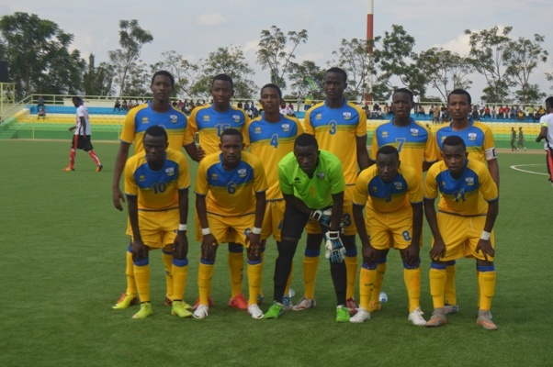IKIPE Y’U RWANDA U20
Mu ijonjora rya kabiri ikipe y’u Rwanda yahuye n’iya Egypte. Mu mukino ubanza wabereye i Kigali, Egypte yatsinze u Rwanda 1- 0, mu mukino wo kwishyura i Caire, ikipe y’u Rwanda nayo itsinda iya Egypte 1 - 0. Hatewe penaliti ikipe ya Egypte iba ariyo ikomeza nyuma yo gutsinda penaliti 3 kuri 2 z’ikipe y’u Rwanda.
EAST LOTHIAN COUNCIL
Intumwa zaturutse muri East Lothian Council - Scotland, kuwa 11 - 23.06.2016 zagiriye uruzinduko rw’akazi mu Rwanda. East Lothian Council kuva mwaka wa 2014 ifatanye amasezerano y’ubufatanye na CNOSR, agamije iterambere ry’imikino.
Izo ntumwa zari zigizwe ahanini n’abatoza b’umupira w’amaguru bo muri Trenent Community Football Club, na bamwe mu bari mu nzego zaho z’umupira w’amaguru nka East Lothian Council Football Development Officer, Heart of Midlothian FC Football Development Officer

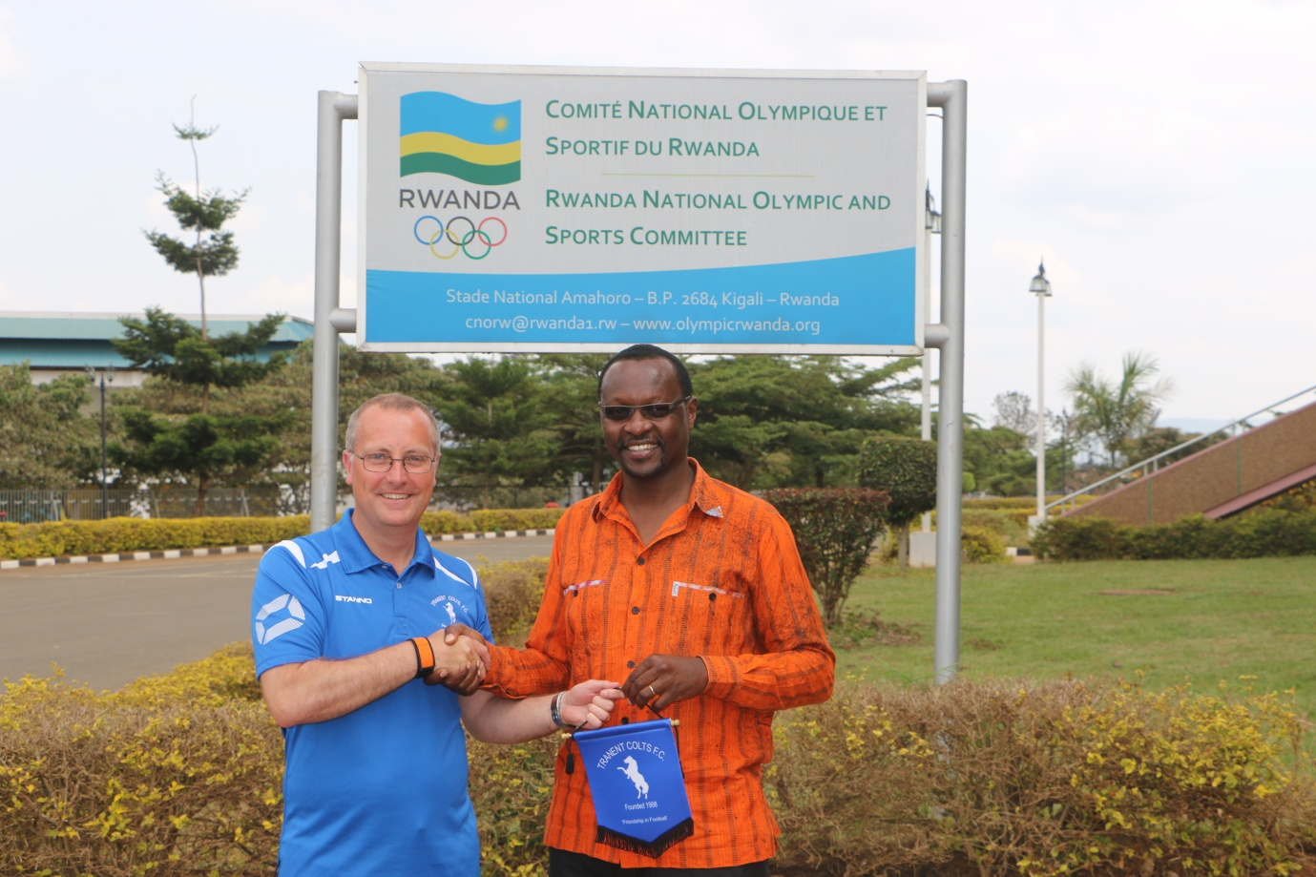

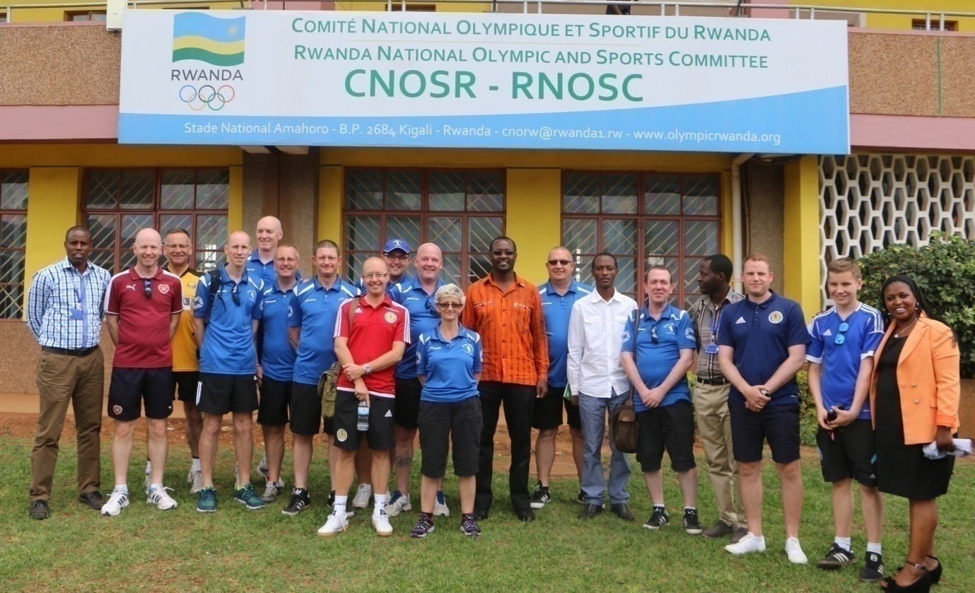

SPORTS POUR HANDICAPES: SPORTS FOR PEOPLE WITH HEARING IMPAIRMENT
Imikino yo gutangiza amarushanwa ya basketball na volleyball y’abafite ubumuga bwo kutumva ntibavuge yabaye kuwa 16.06.2016, muri buri cyiciro harimo amakipe atatu.
Uko amakipe yakurikiranye muri volleyball :
1.NDCB NYABIHU
2.VDN NYARUGENGE
3.CJSM HUYE
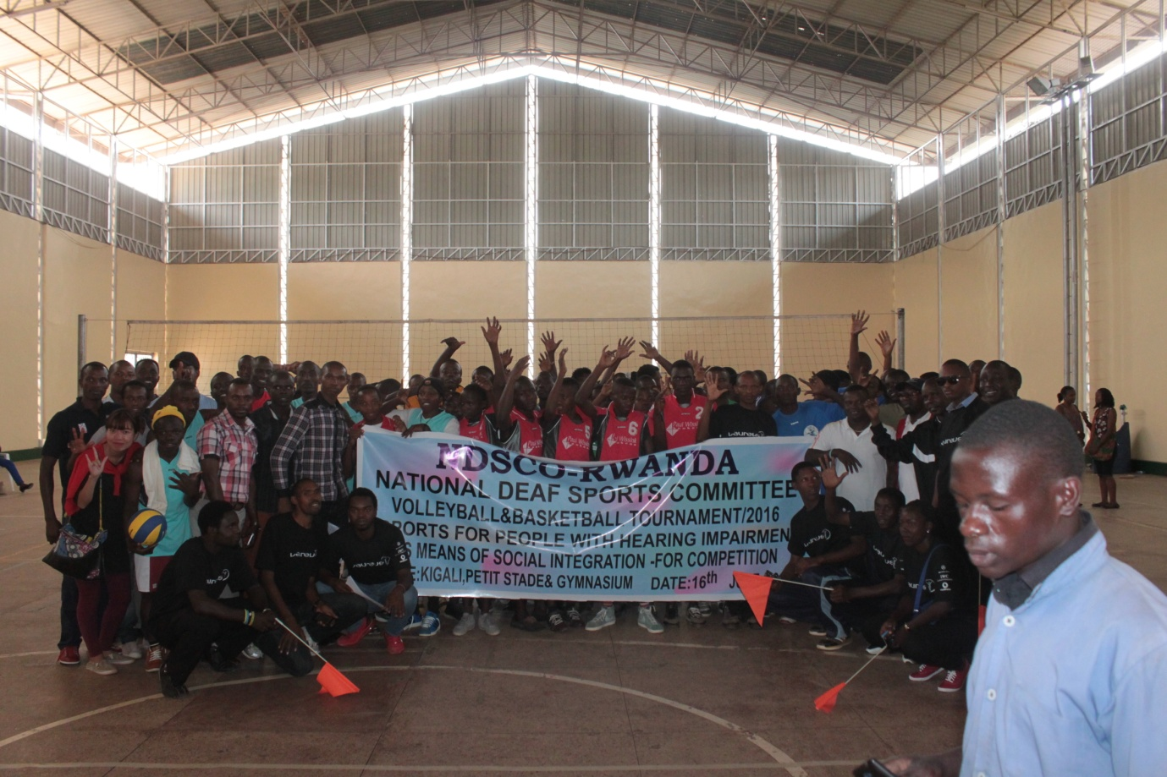
Uko amakipe yakurikiranye muri basketball :
1.HVP GATAGARA
2.MAE RULINDO
3.IFS NYARUGENGE

KUNG - FU WUSHU: AMAHUGURWA Y’ABARIMU
Amahugurwa y’abarimu b’umukino wa Kung - Fu Wushu yabaye kuwa 14 - 26.06.2016 yayobowe n’umutoza w’umushinwa .
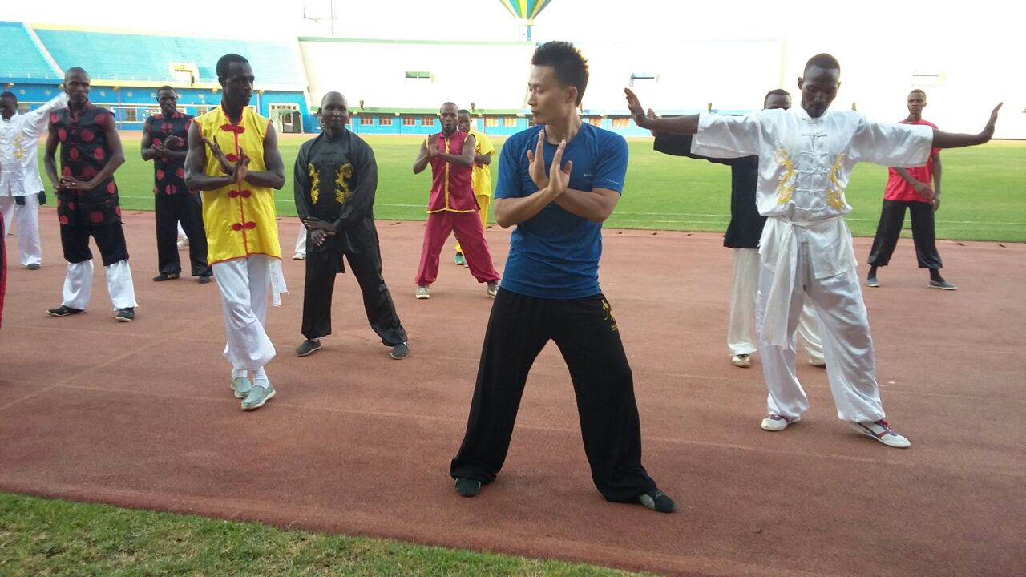
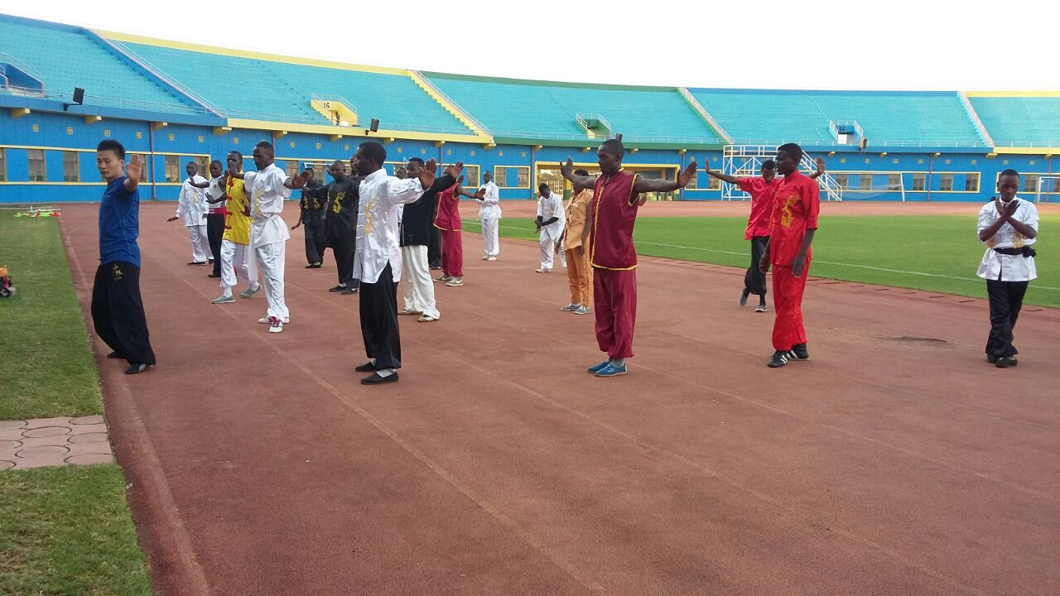
JOURNEE OLYMPIQUE / OLYMPIC DAY 2016
Muri Ecole Internationale des Parents de Butare habereye ibikorwa bya Journée Olympique kuwa 22 - 23.06.2016. Habaye amarushanwa mu gusiganwa kwiruka, football, mini-tennis, natation, demonstration karate n’imbyino ndangamuco.
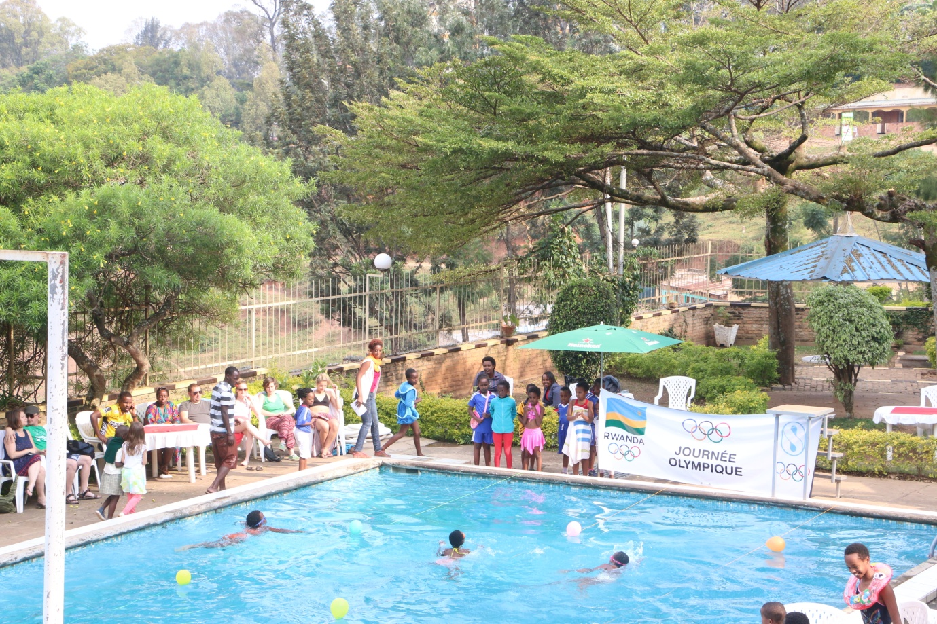
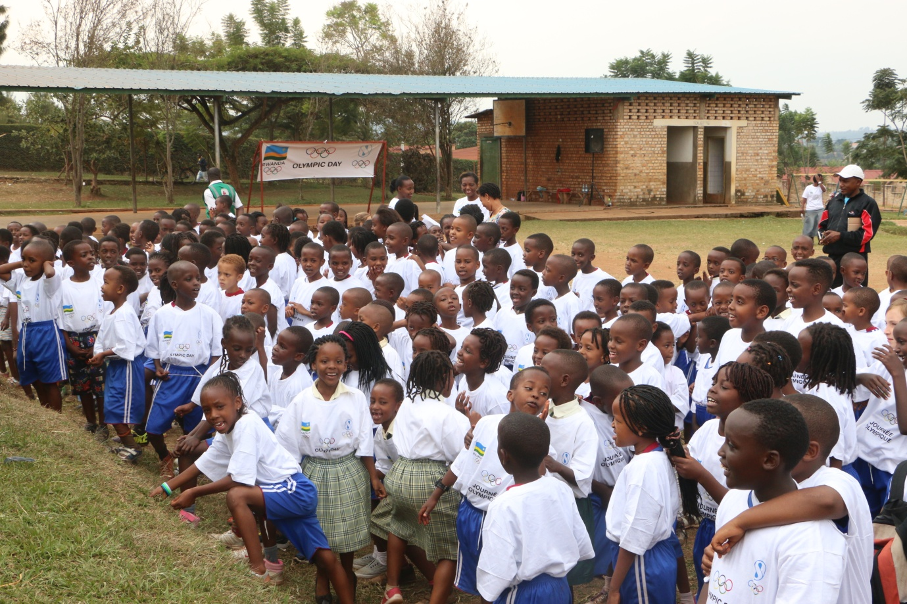

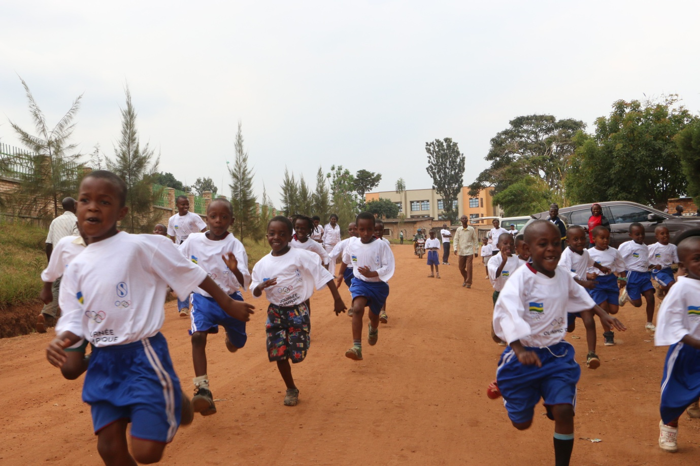

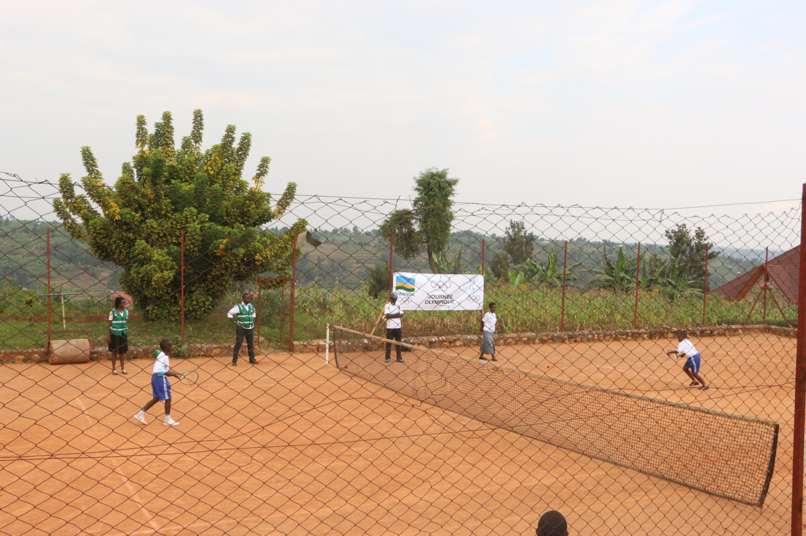

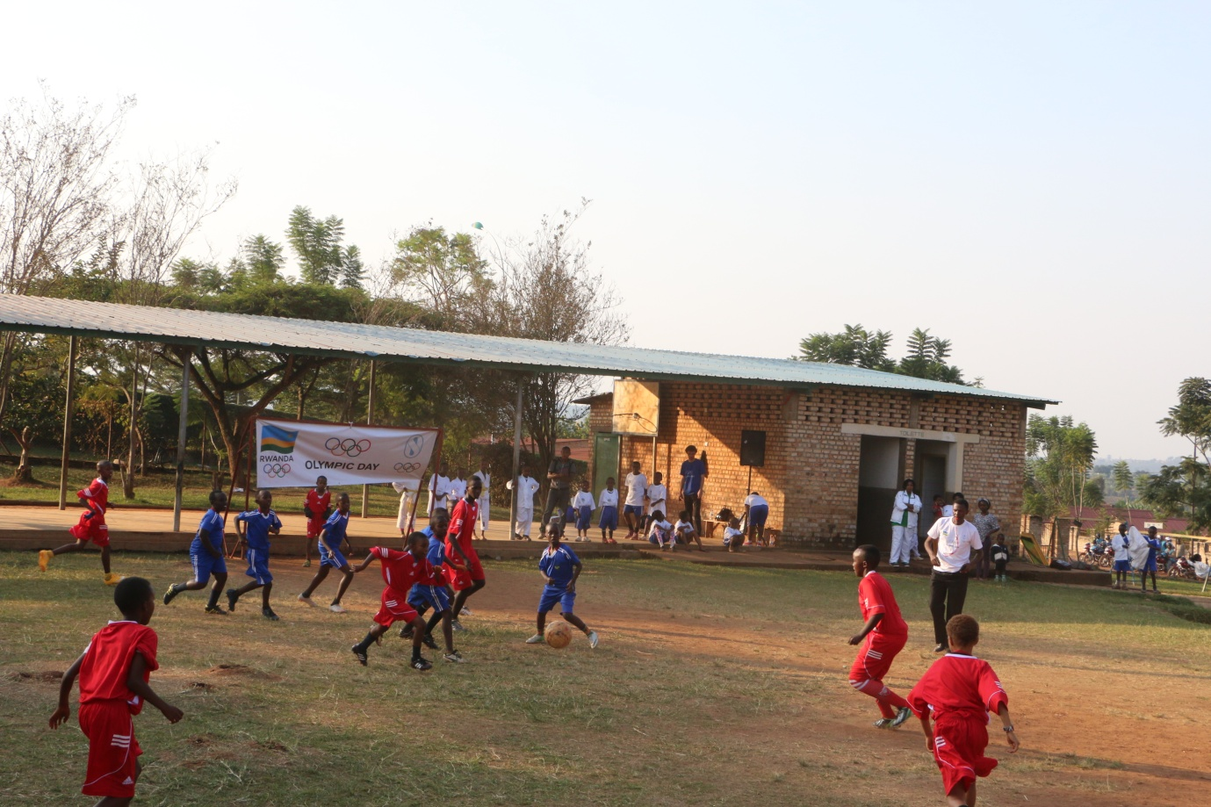

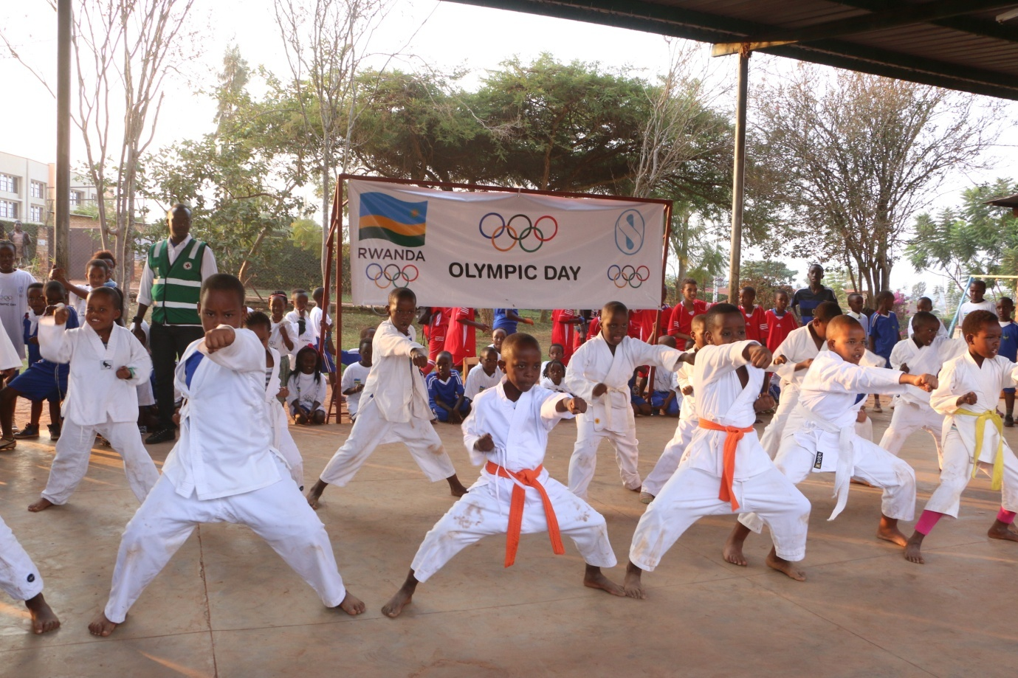

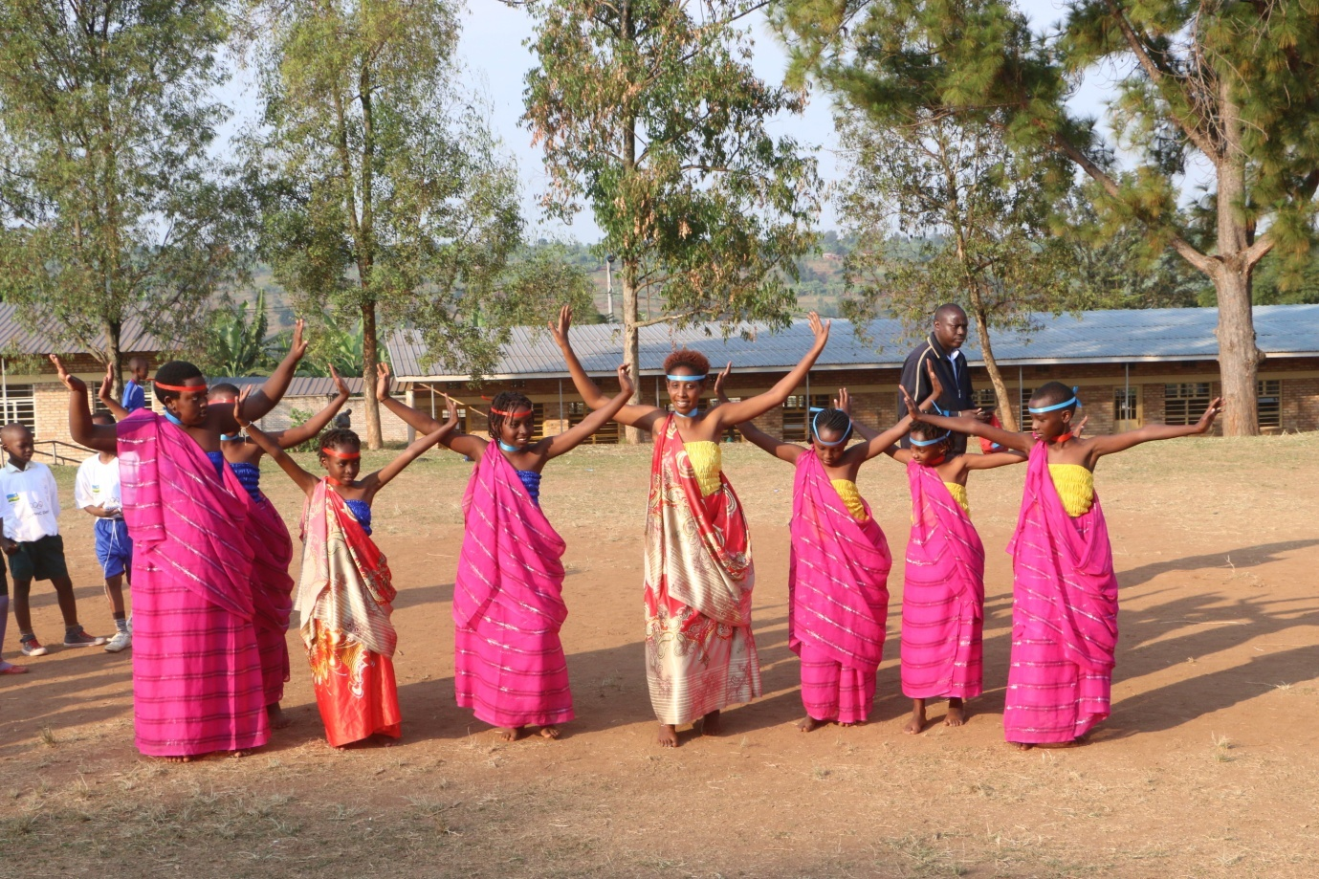

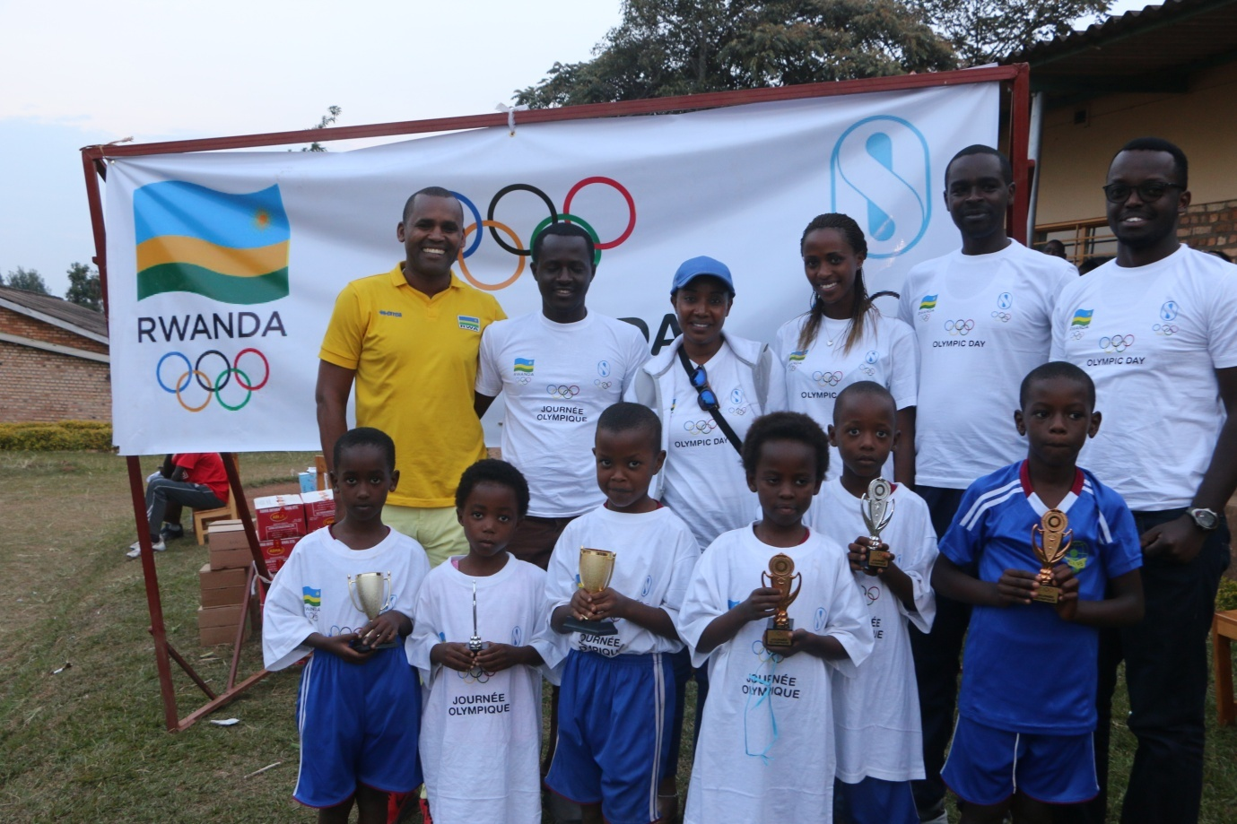

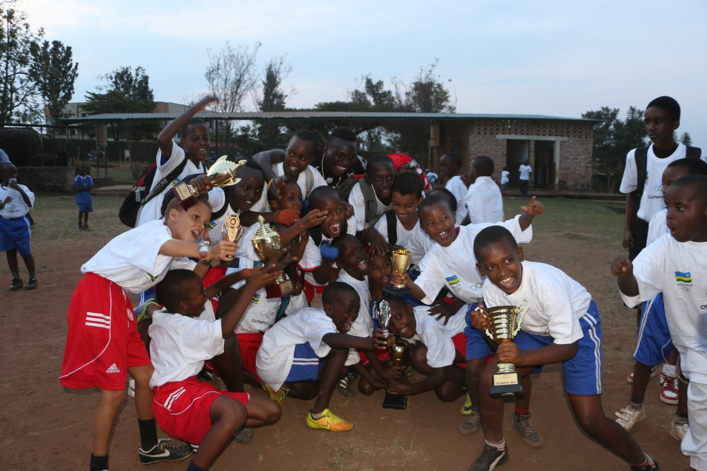
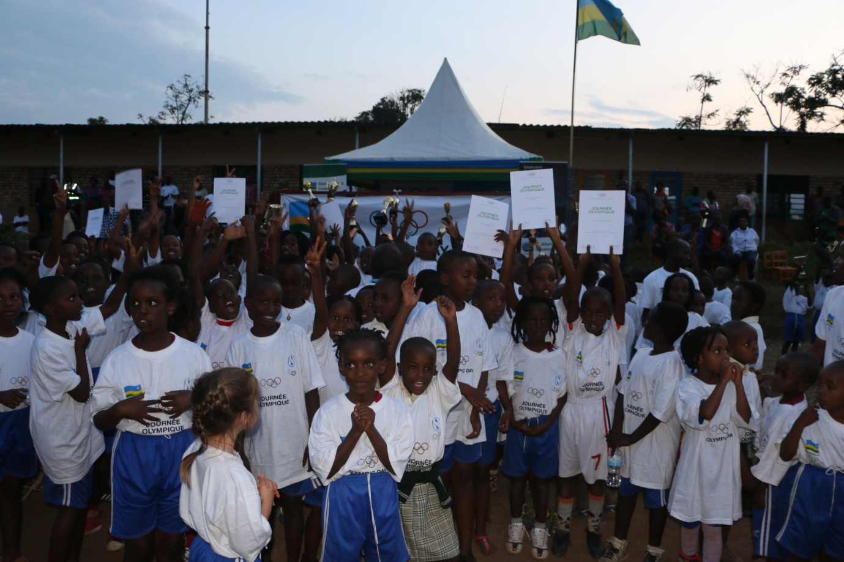
ATHLETISME: 20èmes CHAMPIONNATS D’AFRIQUE SENIOR
Abakinnyi batatu bahagarariye u Rwanda mu irushanwa ry’Afurika mu mikino ngororamubiri ryabereye i Durban muri Afrique du Sud 22 - 26.06.2016
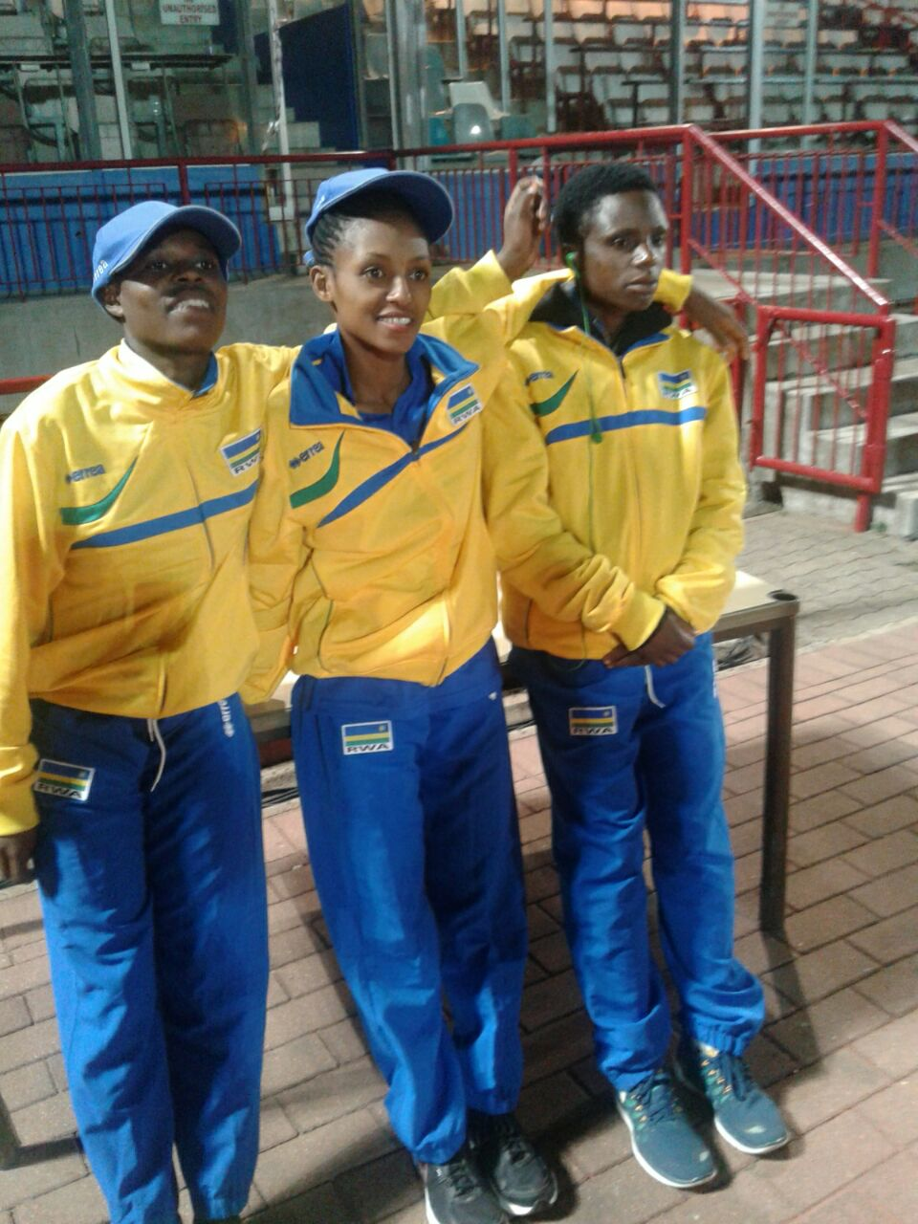
NISHIMWE BEATHA (ibumoso), NYIRARUKUNDO SALOME (hagati), MUKANDANGA CLEMENTINE (iburyo)
NYIRARUKUNDO SALOME (imyaka 19) yabaye uwa 4 muri 10.000 m akoresheje 31’45’’32 bityo abona minima (32’15’’) zo kujya muri Jeux Olympiques - Rio 2016.
MUKANDANGA CLEMENTINE yabaye uwa 7 muri 10.000 m akoresheje 33’28’64
NISHIMWE BEATA: yabaye uwa 7 muri 1.500 m akoresheje 04’08’’75

CYCLISME: CHAMPIONNAT NATIONAL 2016
Mu mukino wo gusiganwa ku magare kuwa 25 - 26.06.2016 habaye championnat national yakinwe mu byiciro bibiri: individual time trial na road race.
Muri individual time trial :
Abakobwa : uwa mbere yabaye GIRUBUNTU JEANNE D’ARC
Junior abahungu : uwa mbere yabaye UKINIWABO RENE
Elite & U23 : uwa mbere yabaye NIYONSHUTI ADRIEN
UKINIWABO RENE (ibumoso), GIRUBUNTU JEANNE D’ARC (hagati), NIYONSHUTI ADRIEN (iburyo)
Muri road race : Muhanga - Huye
Abakobwa (78.3 km) : uwa mbere yabaye GIRUBUNTU JEANNE D’ARC akoresheje 02H25’40’’
Junior abahungu (89.3 km) : uwa mbere yabaye UKINIWABO RENE akoresheje 02H12’46’
Elite & U23 (111.3 km) : uwa mbere yabaye UWIZEYIMANA BONAVENTURE akoresheje 02H53’17’’
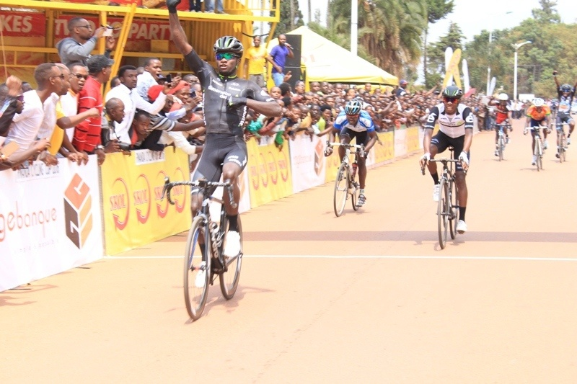UWIZEYIMANA BONAVENTURE

