CNOSR - SO: FORMATION SUR LA GESTION, LE SUIVI ET L’EVALUATION DES PROGRAMMES DE LA SOLIDARITE OLYMPIQUE
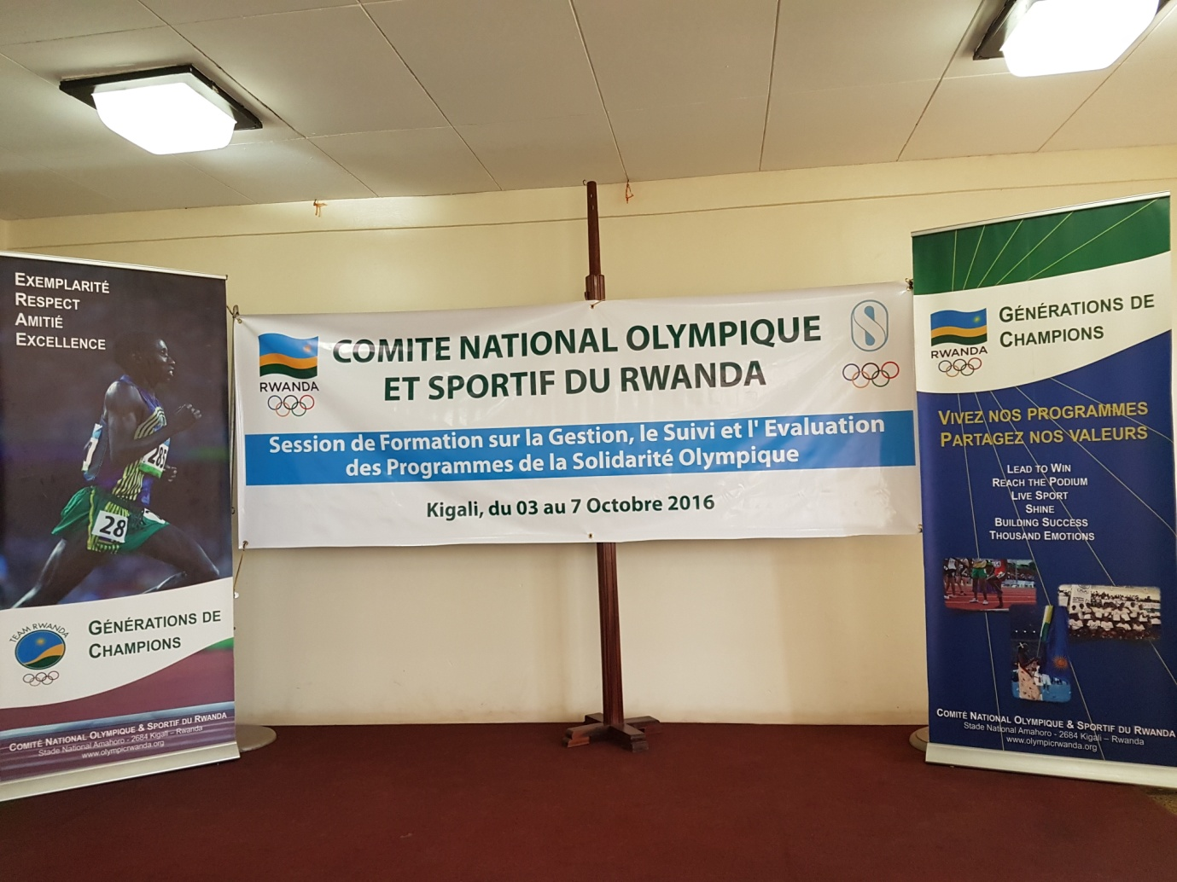
Impuguke zaturutse mu mashyirahamwe y’imikino hamwe n’abakozi ba CNOSR, bahawe amahugurwa yari agamije kubongerera ubumenyi mu micungire, gukurikirana n’isuzuma rya gahunda za Solidarité Olympique.
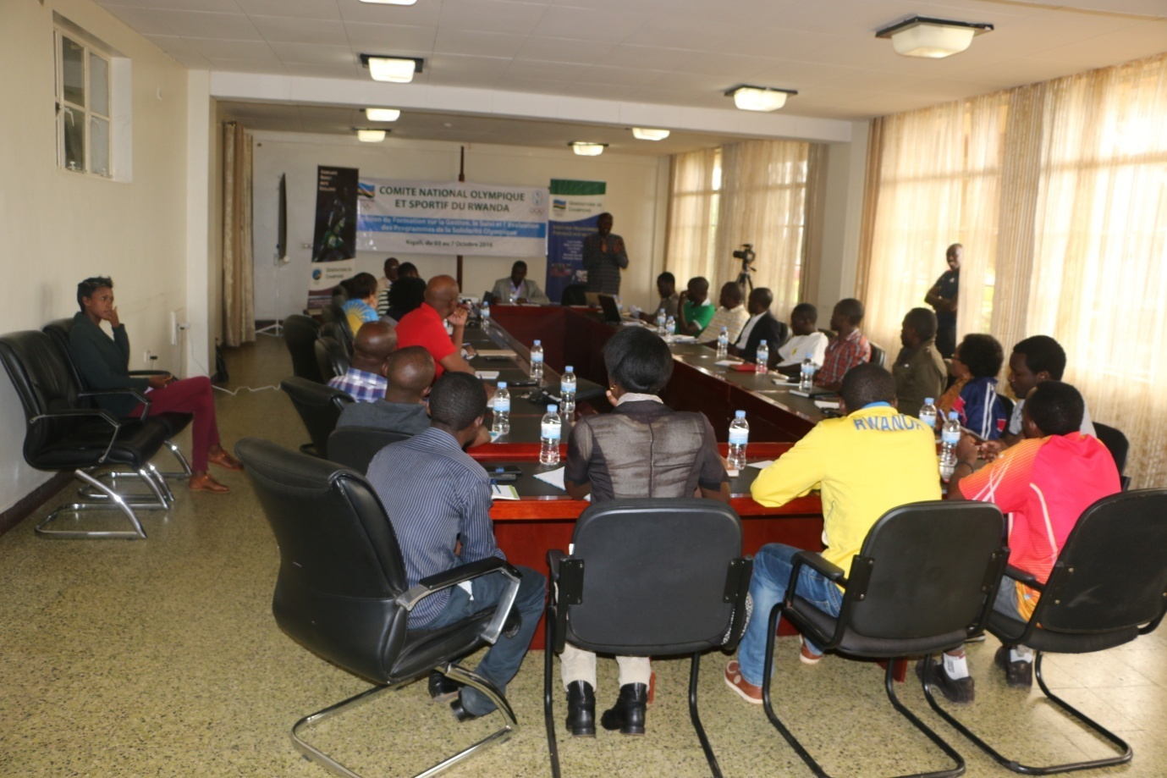
Amahugurwa yayobowe n’impuguke yoherejwe na SO HARERIMANA Tharcisse, ukomoka mu Burundi, yabereye i Kigali kuva kuwa 03.10.2016 kugeza kuwa 07.10.2016
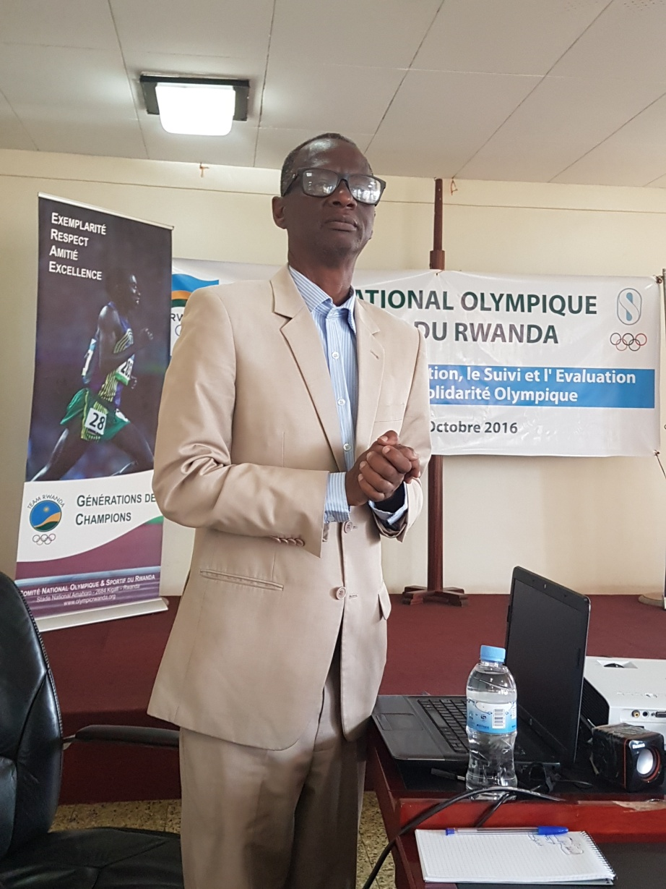
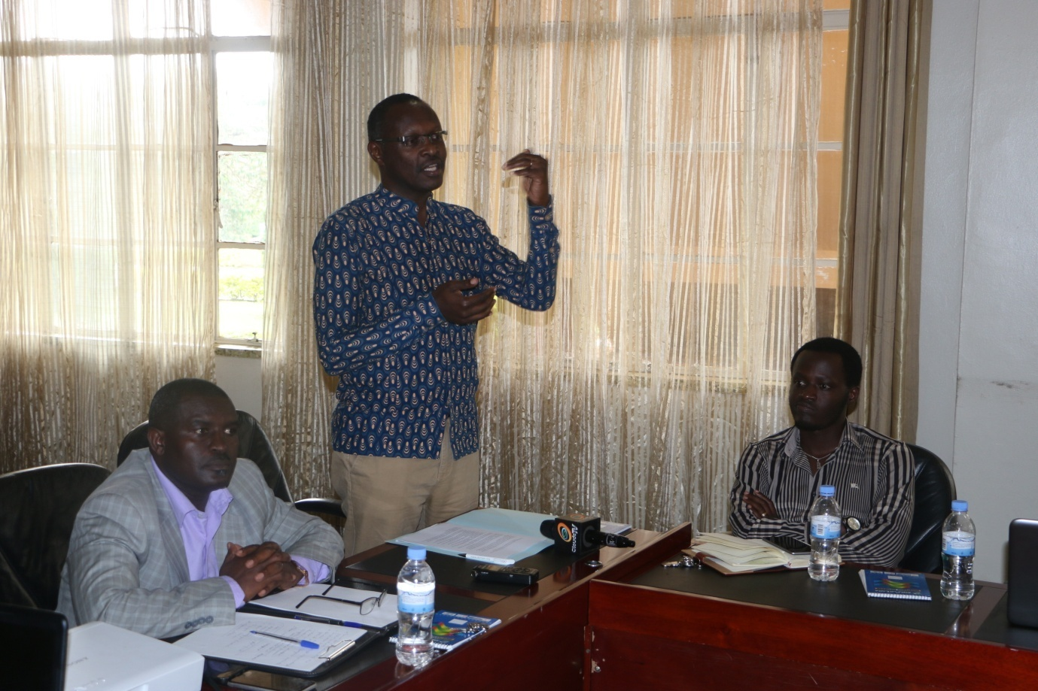

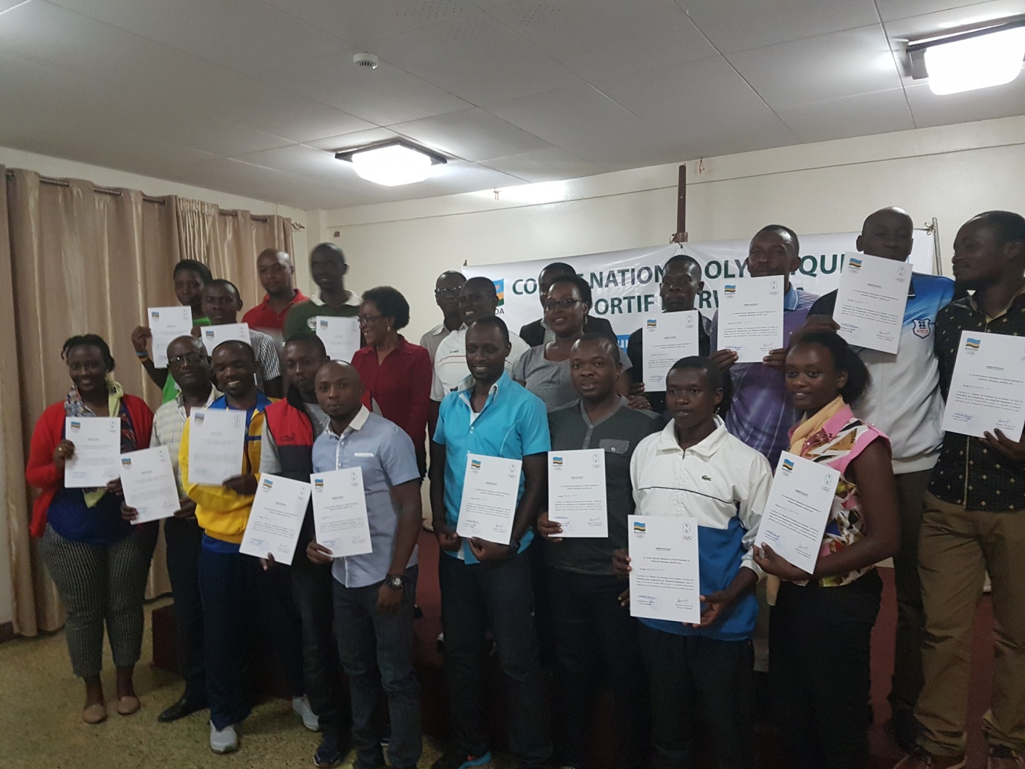
Hashyizweho commission technique ihuriweho n’abo mu mashyirahamwe y’imikino na CNOSR, izajya ikorana bya hafi na CNOSR hamwe n’amashyirahamwe y’imikino, mu guhuza no gukurikirana imishinga n’amahugurwa biterwa inkunga na Solidarité Olympique.
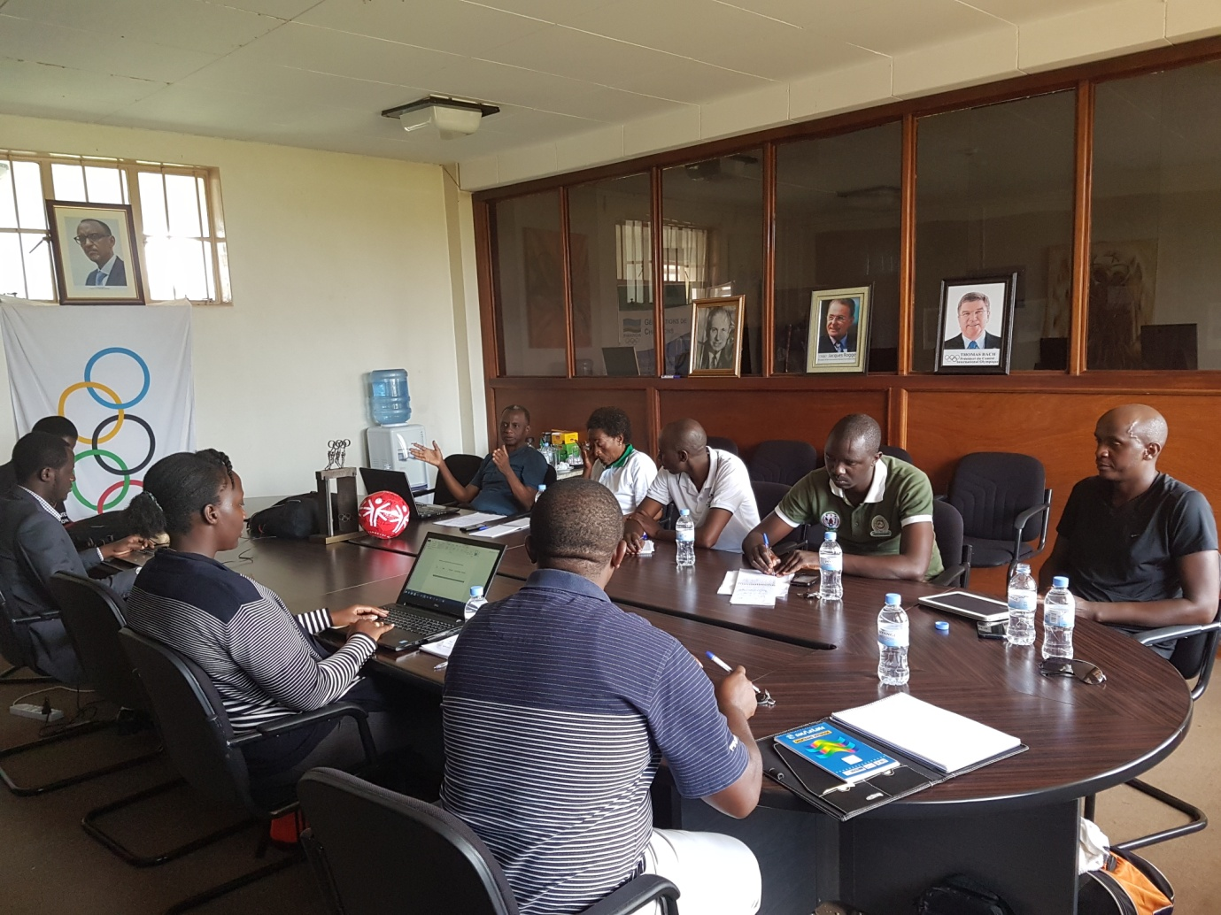

BASKETBALL : FIBA ZONE 5 CLUB CHAMPIONSHIP 2016
Irushanwa ryabereye i Dar Es Salaam muri Tanzanie kuva kuwa 01.10.2016 kugeza kuwa 07.10.2016 u Rwanda rwahagarariwe n’amakipe 2 y’abagabo : ESPOIR, PATRIOTS; n’ikipe 1 y’abagore UBUMWE.
Amakipe 10 y’abagabo yashyizwe mu matsinda 2 y’imikino y’ijonjora.
ITSINDA A
1.PATRIOTS (RWANDA)
2.SAVIO (TANZANIE)
3.NATIONAL ENGINEERING (SOUDAN DU SUD)
4.USIUI (KENYA)
5.UCU (UGANDA)

ITSINDA B
1.ESPOIR (RWANDA)
2.ULINZI (KENYA)
3.CITIZEN (SOUDAN DU SUD)
4.CITY OILERS (UGANDA)
5.ABC (TANZANIE)
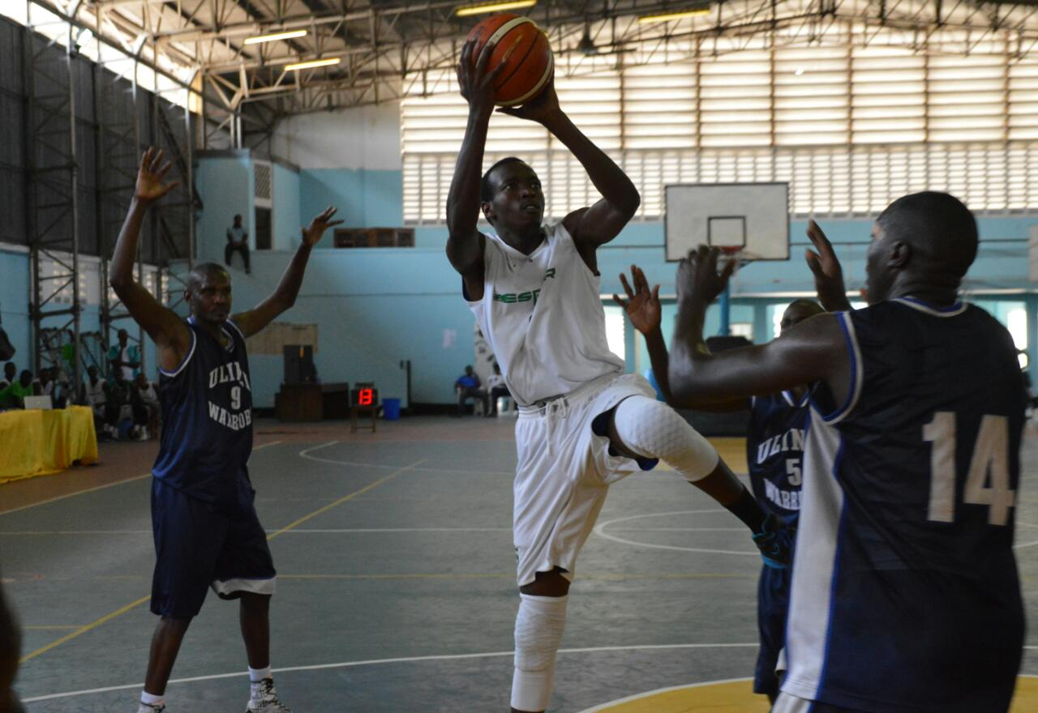

Amakipe 7 y’abagore yose yarahuye hagati yayo:
1.UBUMWE (RWANDA)
2.KCCA (UGANDA)
3.USIU (KENYA)
4.UCU (UGANDA)
5.JKT (TANZANIE)
6.KPA (KENYA)
7.DON BOSCO (TANZANIE)
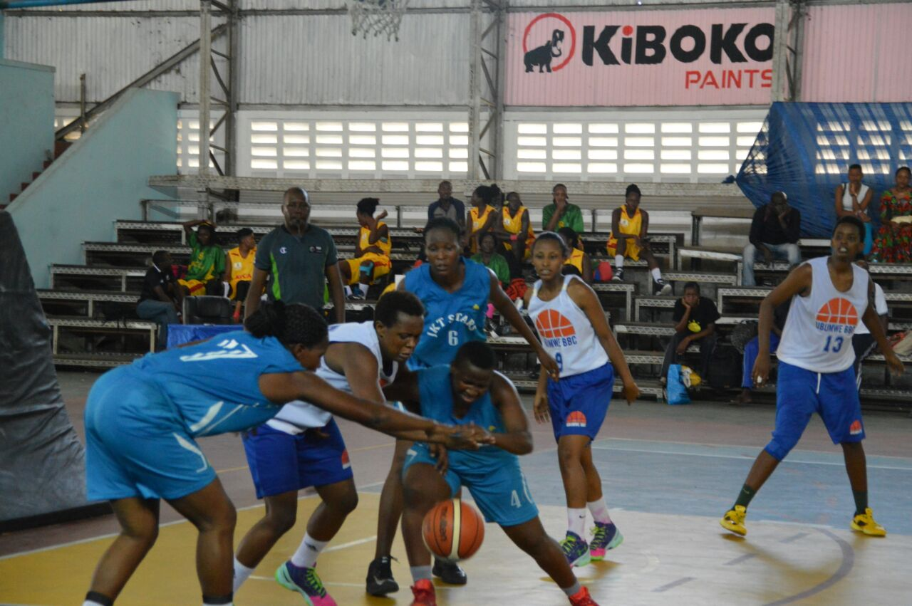
UKO AMAKIPE YO MU RWANDA YASOJE
ABAGORE
Amakipe 7 y’abagore yose yarahuye UBUMWE iba iya 3, igikombe cyatwawe na KPA (KENYA)
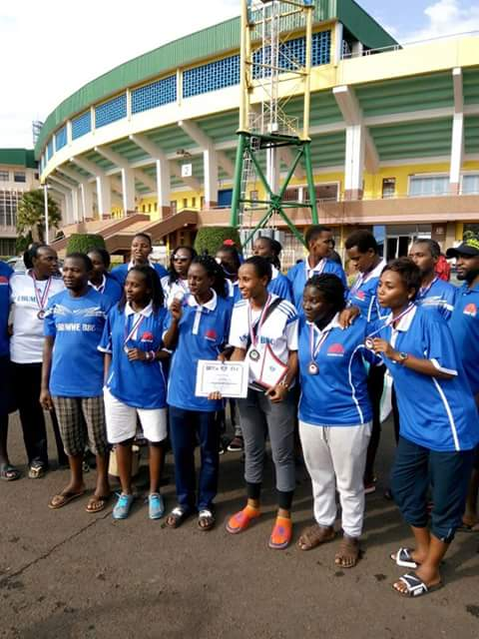
UBUMWE BBC
ABAGABO
GUKINIRA IMYANYA YA 5 - 6
ESPOIR (RWANDA) 69 - 47 UCU (UGANDA)
ESPOIR yasoje ku mwanya wa 5

GUKINIRA IMYANYA 3 - 4
PATRIOTS (RWANDA) 67 - 60 USIU (KENYA)
PATRIOTS yafashe umwanya wa 3
Igikombe cyatwawe na CITY OILERS (UGANDA)
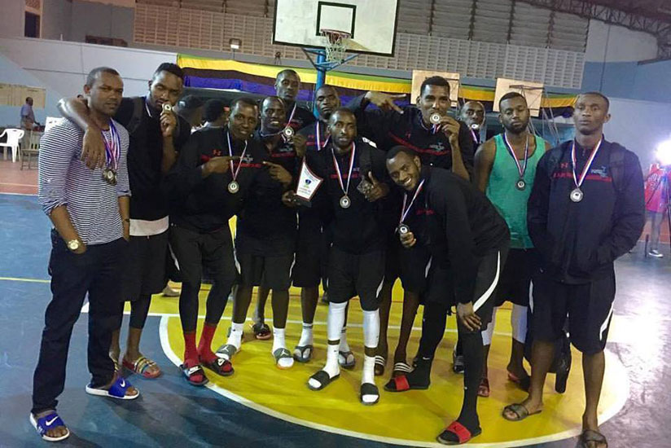PATRIOTS BBC

SPORTS POUR HANDICAPES : PEACE FOR COLOMBIA
Ikipe y’u Rwanda y’abagabo ya sitting volleyball yari muri Colombie, aho kuwa 01.10.2016 yakinnye umukino wa gicuti wari muri gahunda y’ibikorwa byo gushyigikira amasezerano y’amahoro muri icyo gihugu.
COLOMBIE 1 - 1 RWANDA
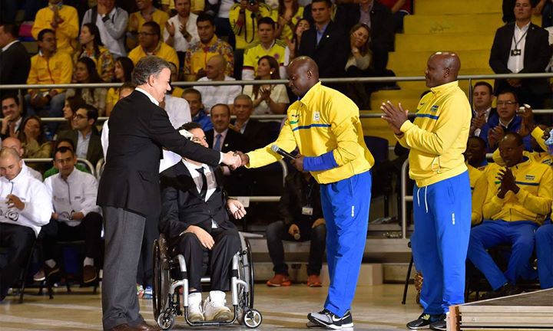
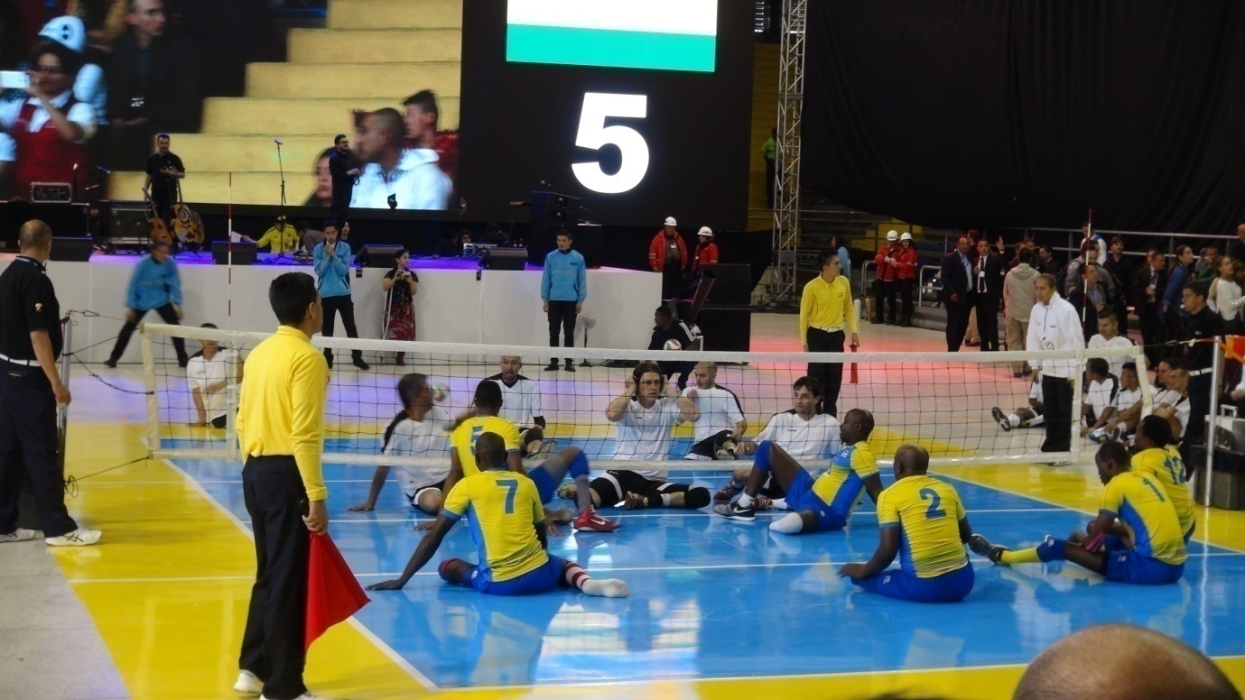
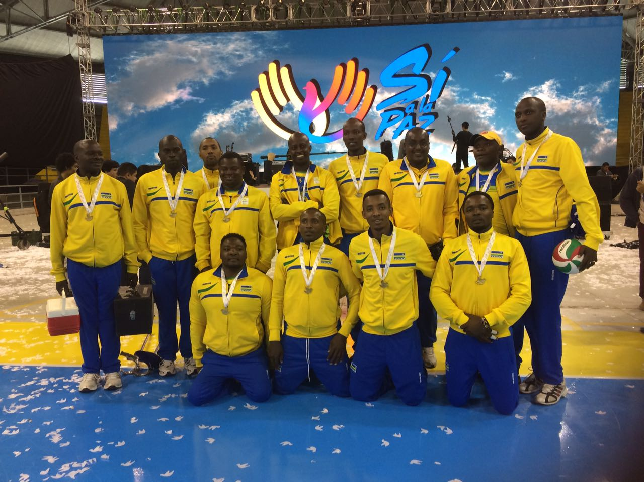
VOLLEYBALL : TOURNOI MEMORIAL RUTSINDURA 2016
Irushanwa ryabereye mu karere ka Huye kuwa 01.10.2016 no kuwa 02.10.2016 ryahuje amakipe yari mu byiciro 3.
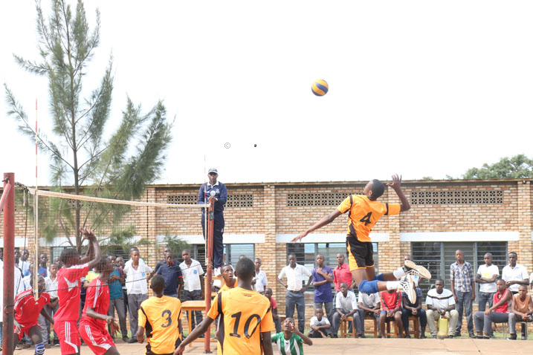
UKO AMAKIPE YATWAYE IBIKOMBE MURI BURI CYICIRO

AMAKIPE YO MU MASHURI YISUMBUYE
GROUPE SCOLAIRE OFFICIEL DE BUTARE (GSOB)
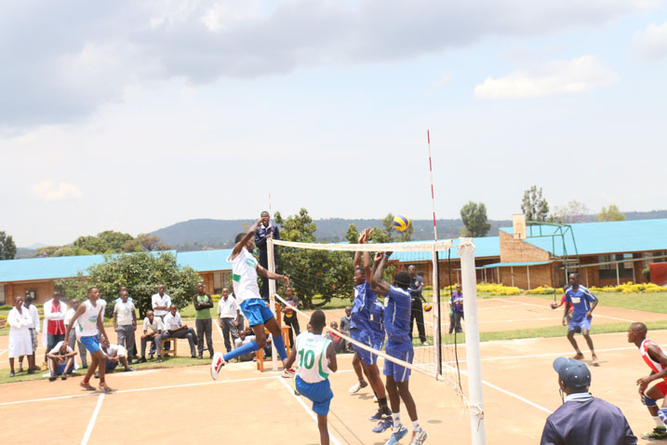

AMAKIPE Y’ABAGORE
RWANDA REVENUE AUTHORITY (RRA)
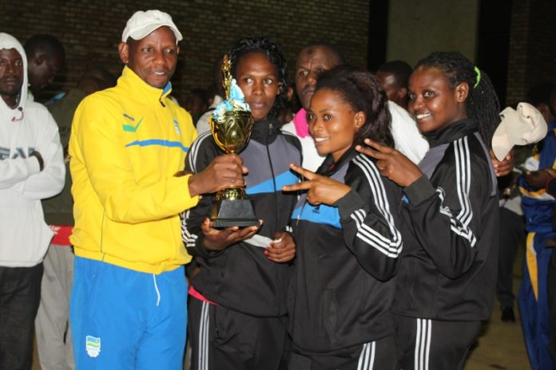RRA VC
AMAKIPE Y’ABAGABO
UNIVERSITY OF TOURISM, TECHNOLOGY AND BUSINESS STUDIES (UTB)
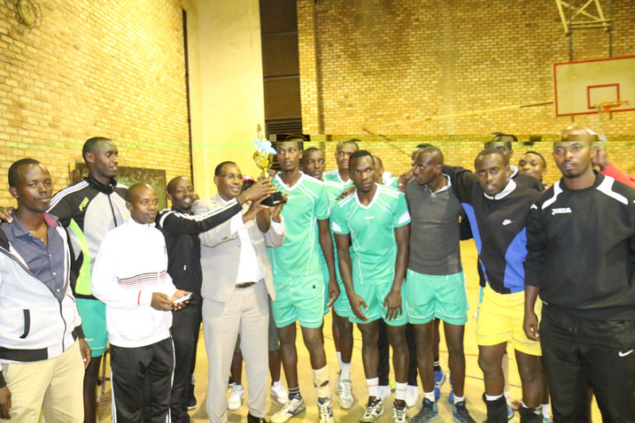UTB VC
CYCLISME : UCI WORLD CHAMPIONSHIPS 2016
Abakinnyi 6 ba Team RWANDA bakinnye amarushanwa yabereye i Doha muri Qatar kuva kuwa 10.10.2016 kugeza kuwa 16.10.2016.
Abagize Team RWANDA bari mu byiciro bikurikira:
U23 ROAD RACE
NDAYISENGA VALENS
UWIZEYE JEAN CLAUDE
U23 ROAD RACE & INDIVIDUAL TIME TRIAL
ARERUYA JOSEPH
ELITE MEN’S ROAD RACE
UWIZEYIMANA BONAVENTURE
ELITE WOMEN’S ROAD RACE
INGABIRE BEATHA
JUNIOR ROAD RACE & INDIVIDUAL ROAD RACE
UKINIRIWABO RENE

UKO ABAKINNYI BA TEAM RWANDA BITWAYE :

U 23 INDIVIDUAL TIME TRIAL (28.6 km)
ARERUYA JOSEPH yabaye uwa 57 abasiganwa bari 74
ELITE INDIVIDUAL TIME TRIAL (28.9 km)
Mucyiciro cy’abagore INGABIRE BEATHA yabaye uwa 39, abasiganwa bari 40
JUNIOR INDIVIDUAL TIME TRAIL (28.9 km)
UKINIWABO RENE JEAN PAUL yabaye uwa 67, abasiganwa bari 83.
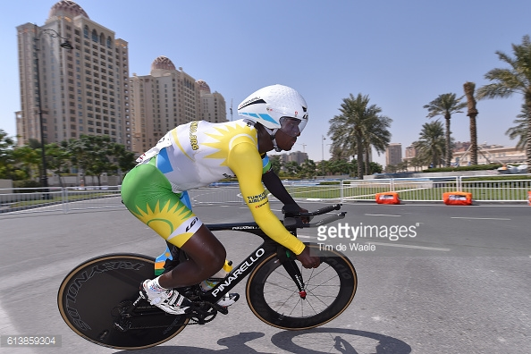

ELITE INDIVIDUAL TIME TRIAL (40 km)
UWIZEYIMANA BONAVENTURE (RWANDA) yabaye uwa 59, abasiganwa bari 66

U23 ROAD RACE (166 km)
Abasiganwa bari 186, abagize Team RWANDA bafashe imyanya ikurikira:
84.UWIZEYE JEAN CLAUDE
98.ARERUYA JOSEPH
113.NDAYISENGA VALENS
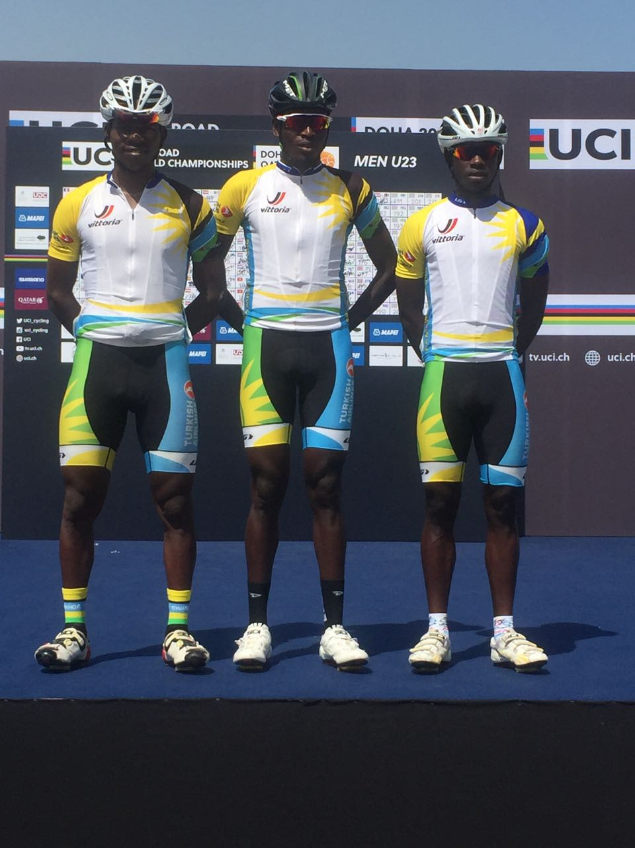TEAM RWANDA U23 ROAD RACE

JUNIOR ROAD RACE (135.5 km)
UKINIWABO RENE JEAN PAUL ntiyashoboye gusoza isiganwa

ELITE MEN’S ROAD RACE
UWIZEYIMANA BONAVENTURE ntiyashoboye gusoza isiganwa

RUGBY : CHAMPIONNAT 2015 - 2016
Championnat y’igihugu y’umukino wa rugby yasojwe kuwa 08.10.2016 haba umukino umwe.
THOUSAND HILLS 45 - 0 RUSIZI RESILIENCE
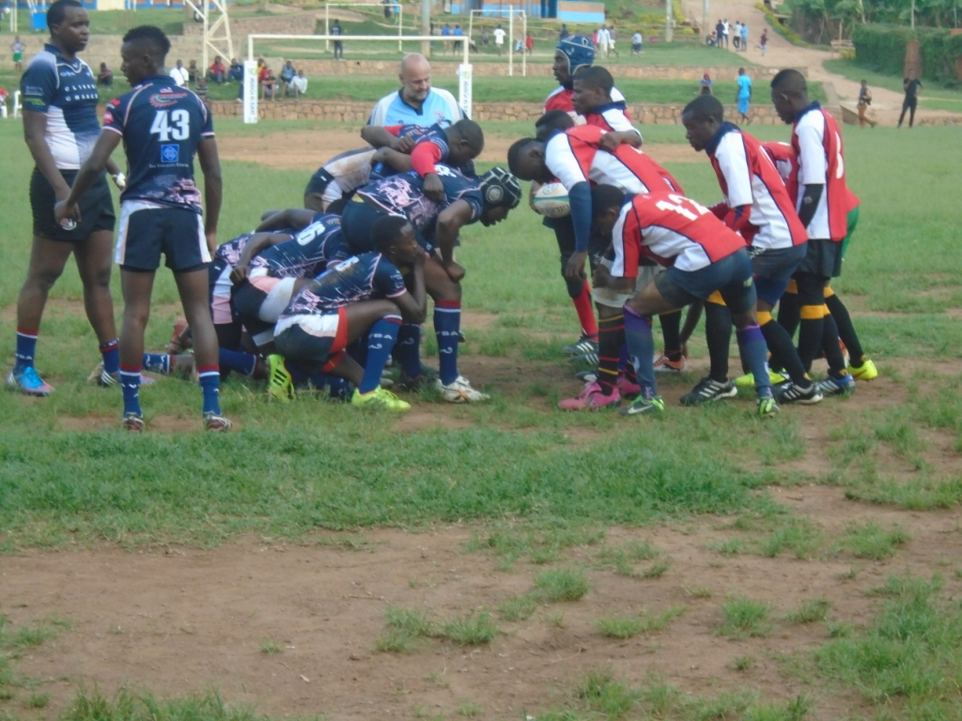
UKO AMAKIPE YASOJE CHAMPIONNAT AKURIKIRANA
1.THOUSAND HILLS
2.RUSIZI RESILIENCE
3.LION DE FER
4.PUMA KAMONYI
5.KIGALI SHARKS
6.REMERA BUFFALOES
7.UR GRIZZLIES
8.MUHANGA RFC
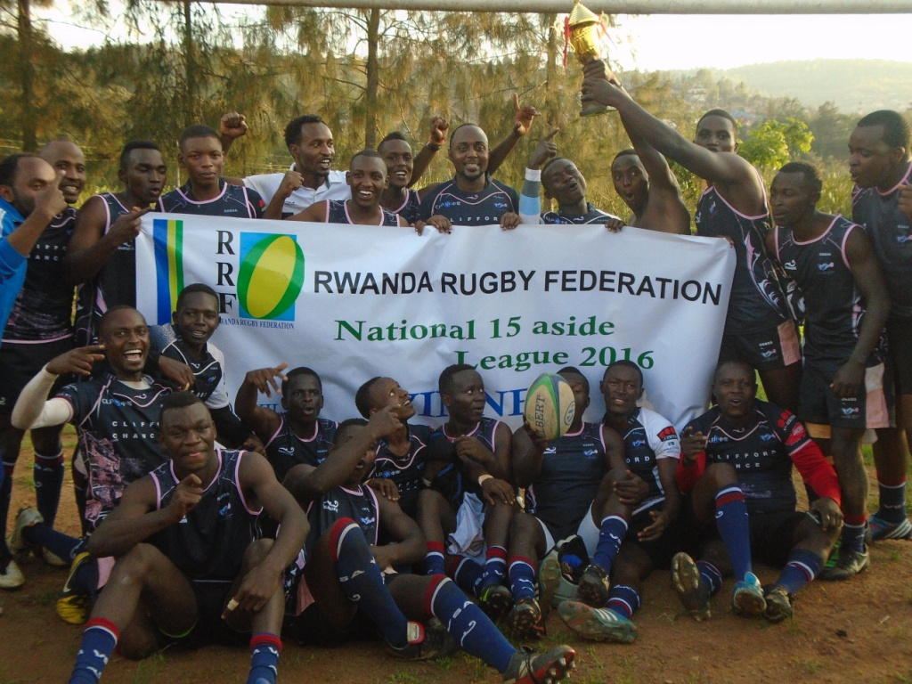
HANDBALL : CHAMPIONNAT NATIONAL 2016
Imikino yasoje championnat y’umukino wa handball yabaye kuwa 08.10.2016 no kuwa 09.10.2016
AMAKIPE Y’ABAGORE
Umukino wa nyuma
GS APPEGA GAHENGERI 25 - 21 TSS HANIKA
GS APPEGA GAHENGERI yabaye iya mbere muri championnat 2016

AMAKIPE Y’ABAGABO
ES KIGOMA 41 - 23 ES URUMURI
APR 31 - 31 POLICE
POLICE yabaye iya mbere muri championnat 2016

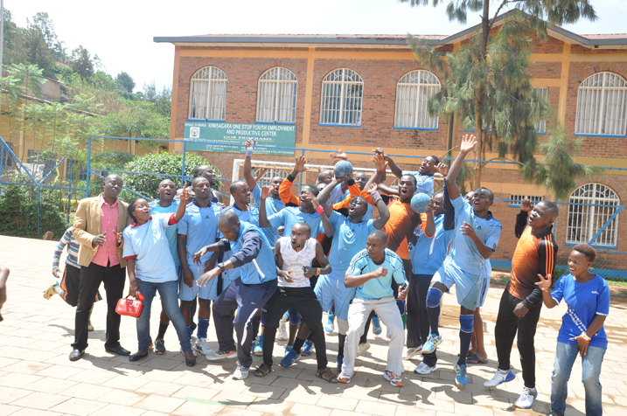

CYCLISME : GRAND PRIX INTERNATIONAL CHANTAL BIYA 2016
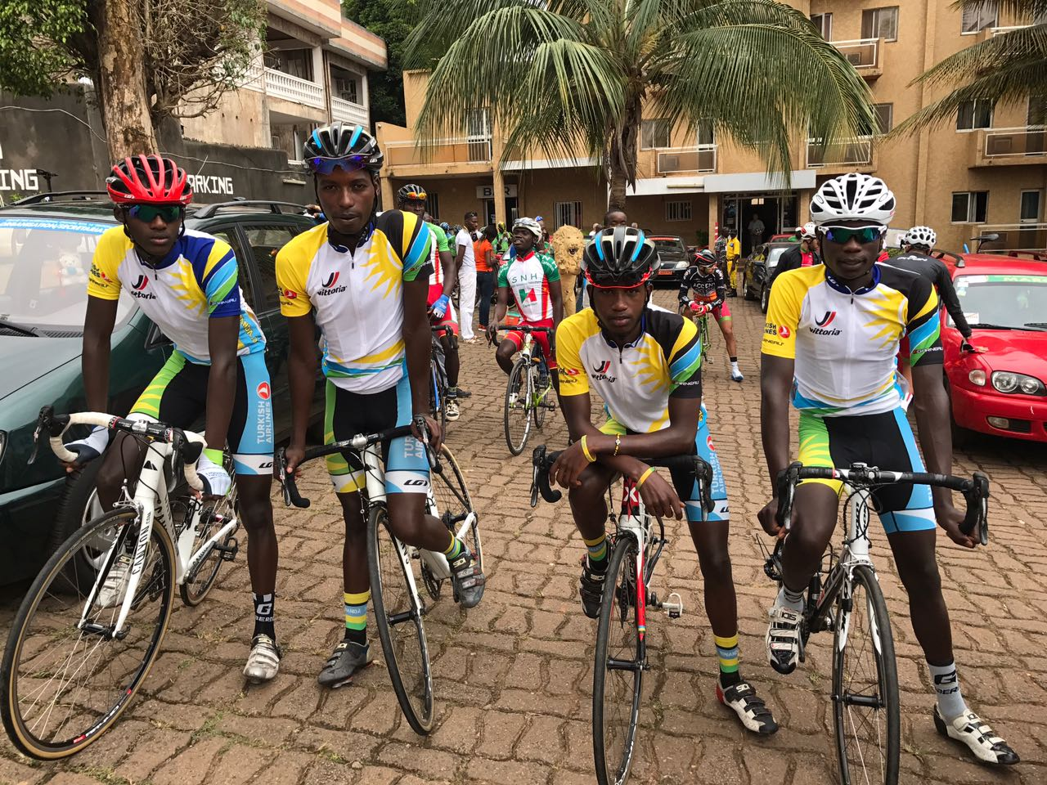
Irushanwa mpuzamahanga ryabereye muri Cameroun kuva kuwa 13.10.2016 kugeza kuwa 16.10.2016, Team RWANDA yari igizwe n’abakinnyi 5:
1.BYUKUSENGE NATHAN
2.TUYISHIMIRE EPHREM
3.MUGISHA SAMUEL
4.KAREGEYA JEREMIE
5.NSENGIMANA JEAN BOSCO

NSENGIMANA JEAN BOSCO yegukanye umwanya wa mbere kuri étape ya nyuma SANGMELIMA - YAOUNDE (169 km) ku mwanya wa kane haje MUGISHA Samuel w’imyaka 19.

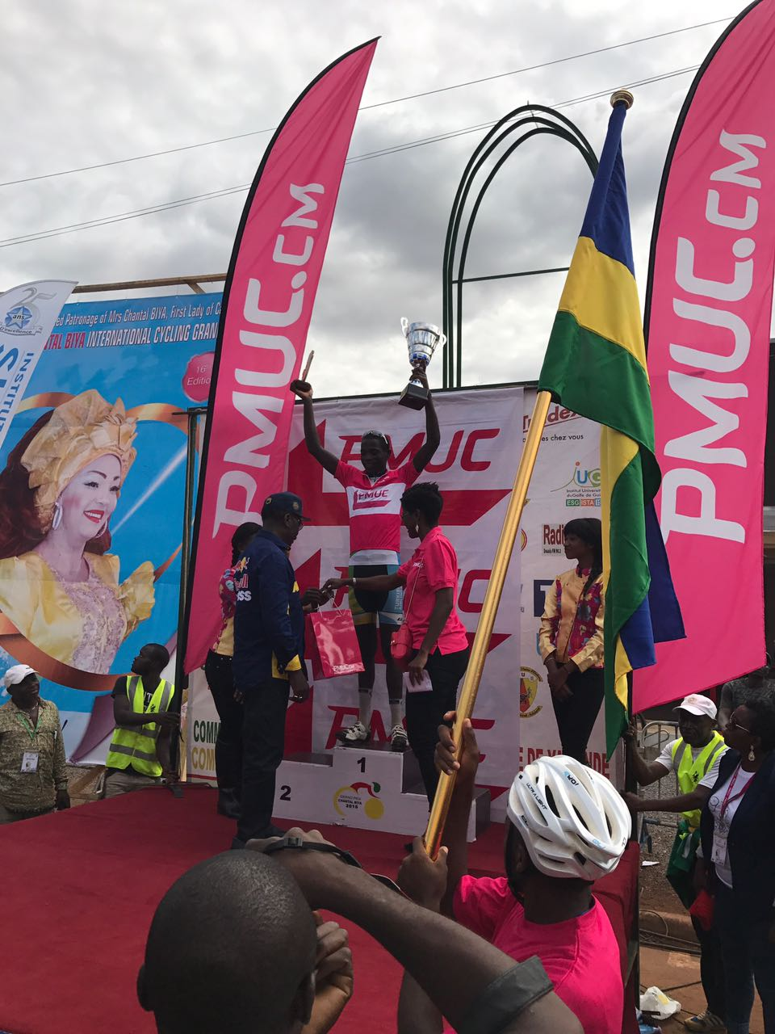NSENGIMANA JEAN BOSCO
IMYANYA Y’ABAGIZE TEAM RWANDA KU RUTONDE RWA RUSANGE (classement général)
NSENGIMANA Jean Bosco yabaye uwa 11
BYUKUSENGE Nathan uwa 13
KAREGEYA Jérémie uwa 14
MUGISHA Samuel uwa 18
TUYISHIMIRE Ephrem uwa 19 mu
Abakinnyi 38 nibo basoje isiganwa.

Ku rutonde rw’amakipe 9 yari mu isiganwa, TEAM RWANDA yafashe umwanya wa 2.
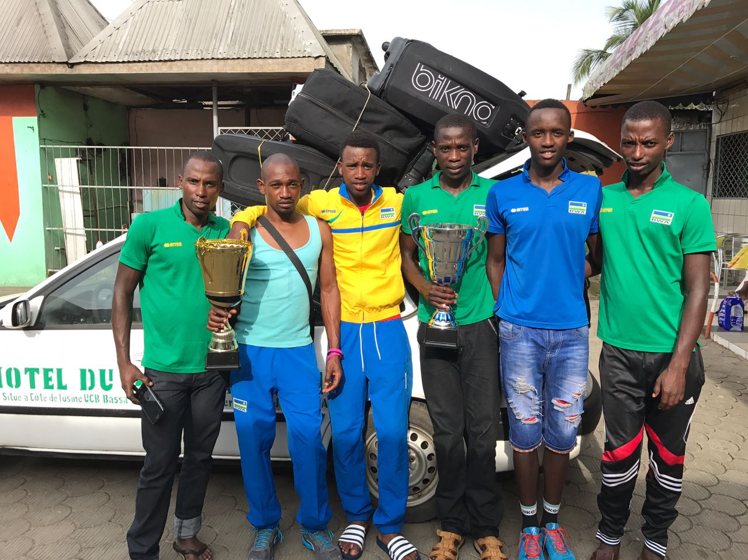TEAM RWANDA

BASKETBALL : INTERNATIONAL BASKETBALL FOUNDATION
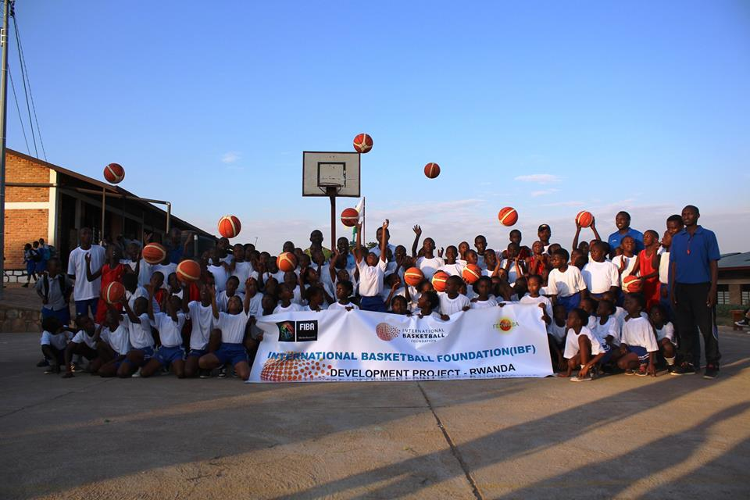
RAMAROSON JEAN MICHEL umwe mu bayobozi ba IBF kuva 11.10.2016 kugeza kuwa 14.10.2016 yari mu Rwanda, aho yatangije umushinga wa IBF mu mashuri abanza abiri yo mu Rwanda: Gacuba II ry’i Rubavu na Saint André ry’i Muhanga.

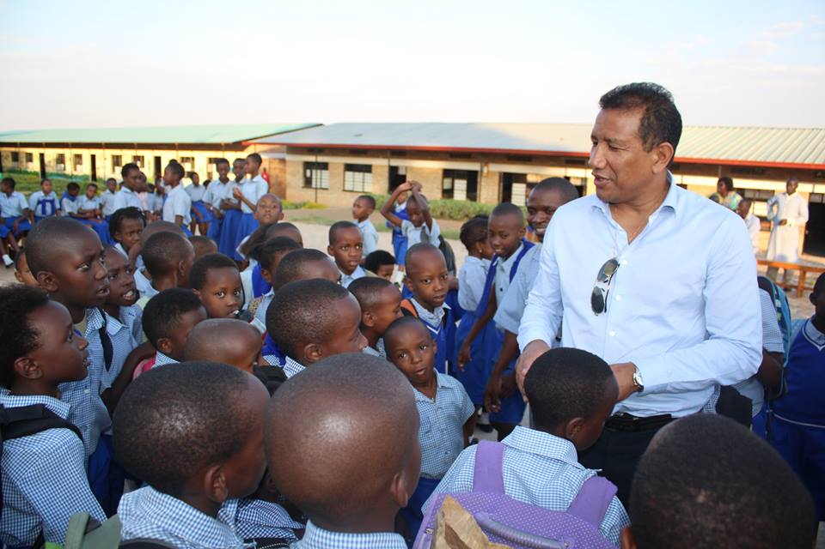
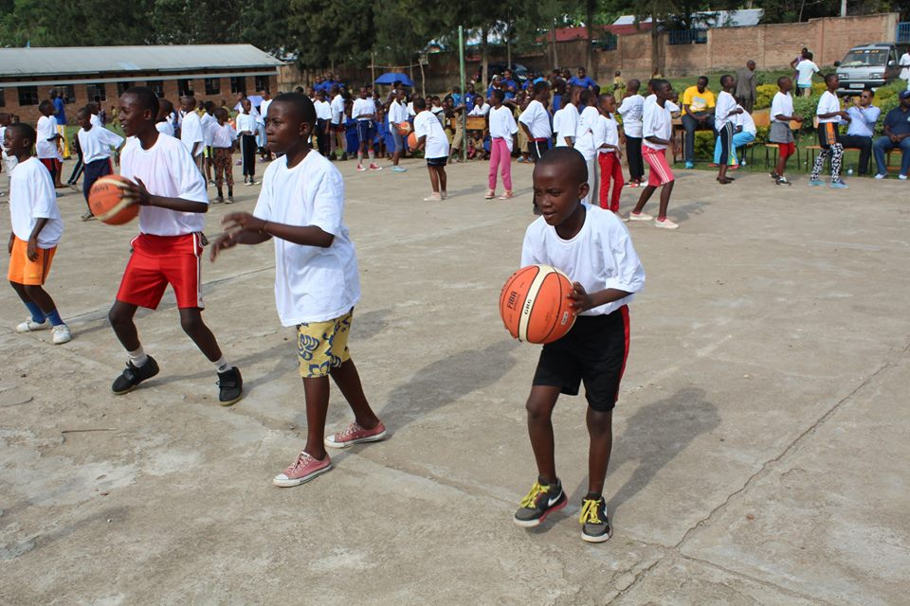

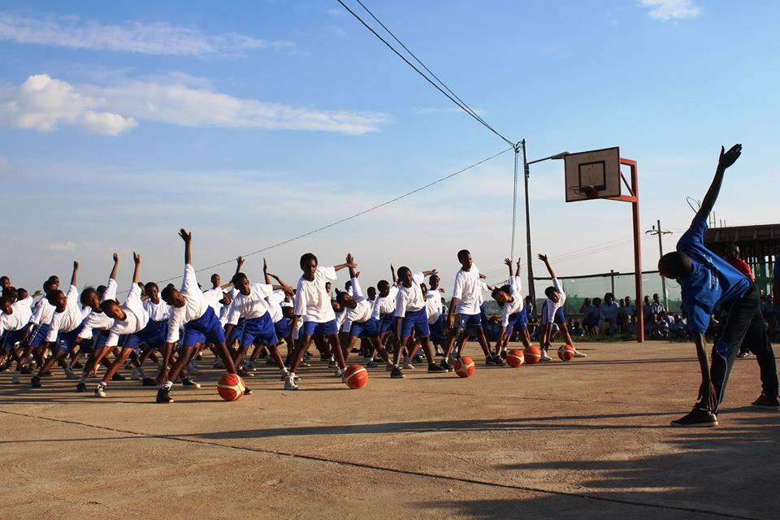

ATHLETISME : DAR ROTARY HALF MARATHON 2016
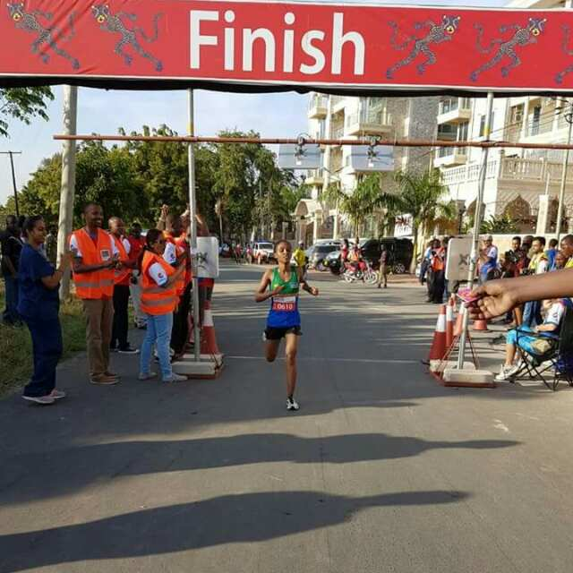
Mu irushanwa mpuzamahanga ryo gusiganwa kwiruka 21 km (semi - marathon) kuwa 14.10.2016 ryabereye i Dar Es Salaam muri Tanzanie, NYIRARUKUNDO SALOME yegukanye umudari wa zahabu akoresheje 1h11’34’’.
IRANZI CELINE yabaye uwa 6 akoresheje 1h15’40’’.

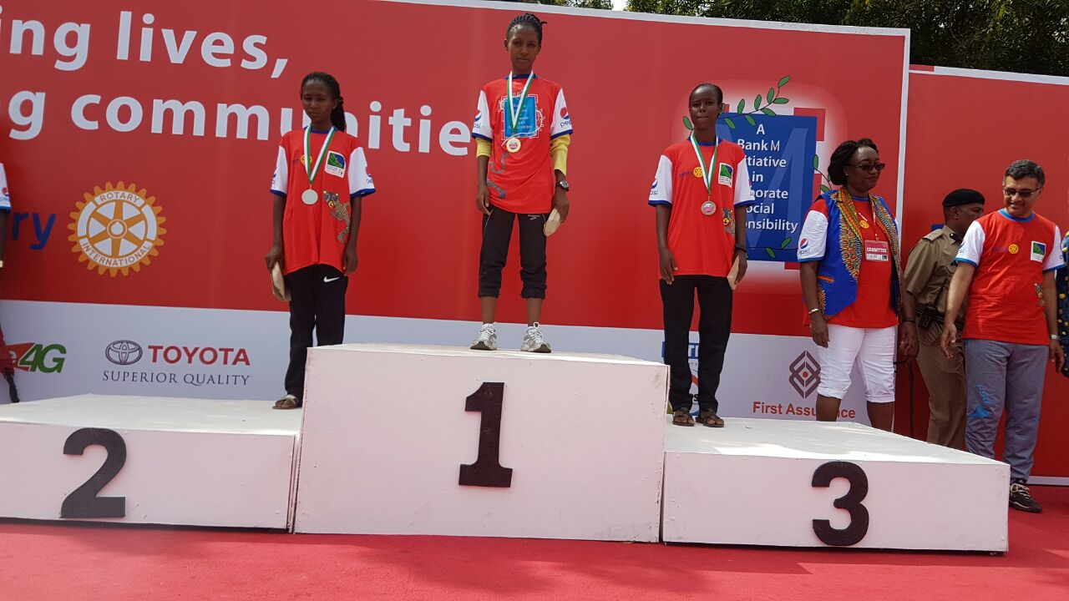NYIRARUKUNDO SALOME (uhagaze kuri 1)

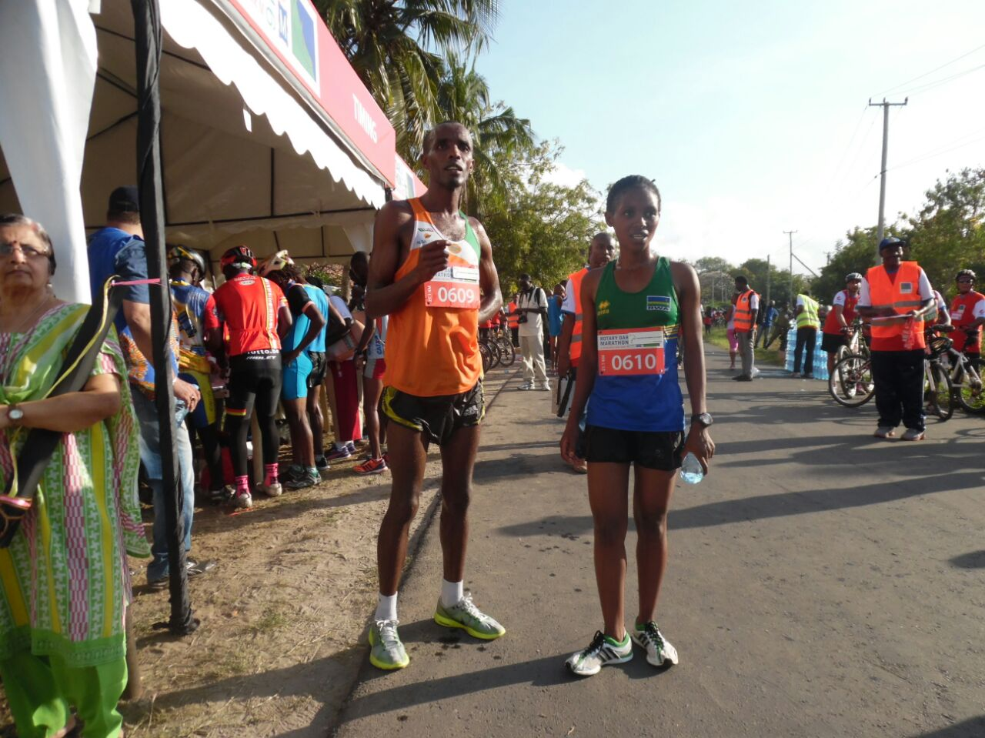

Mu bagabo SEBAHIRE Eric yabaye uwa 12 akoresheje 1h04’

SPORT AUTOMOBILE : HUYE RALLY 2016 “MEMORIAL GAKWAYA”
Huye - Gisagara kuwa 15 & 16.10.2016
Irushanwa mpuzamahanga ry’isiganwa mu modoka ryabereye i Huye kuwa 15.10.2016 na 16.10.2016 ryarimo imodoka 12 zaturutse muri Uganda, Burundi, Rwanda. Hasoje imodoka 10.
MU MYANYA 3 YA MBERE:
1.MOHAMED ROSHANALI & GIESEN JEAN JEAN (BURUNDI)
2.GAKWAYA CLAUDE & MUGABO CLAUDE (RWANDA)
3.SERWANGA JACKSON & KAVUMBA MUHAMAD (UGANDA)
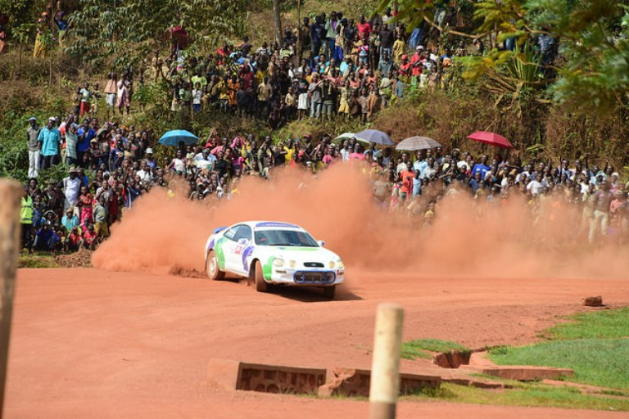
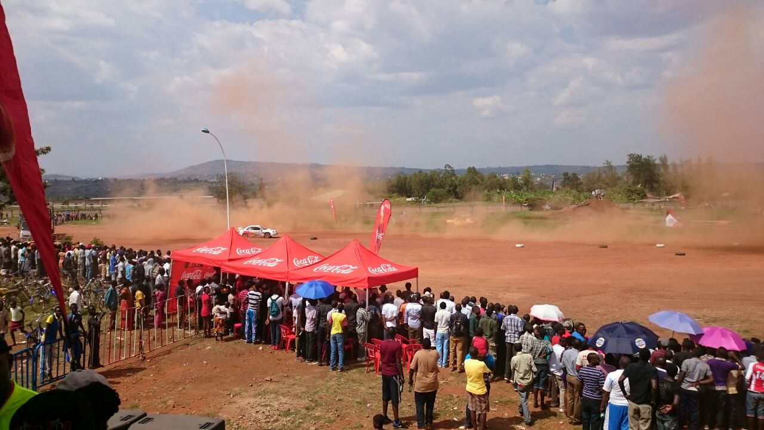

Habaye n’ukwiyerekena “demonstration” kw’abatwara motos baturutse muri Afrique du Sud
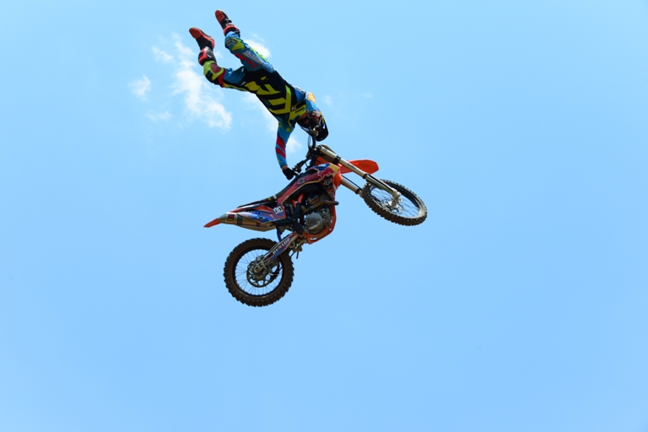
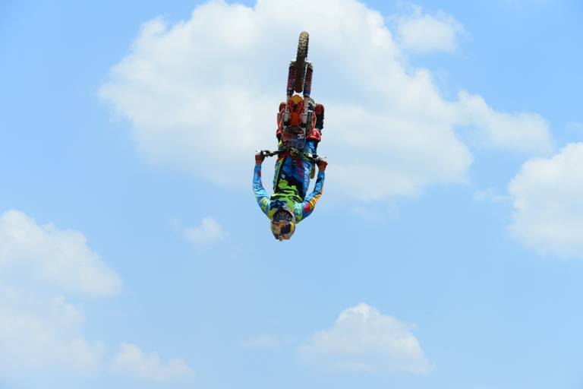
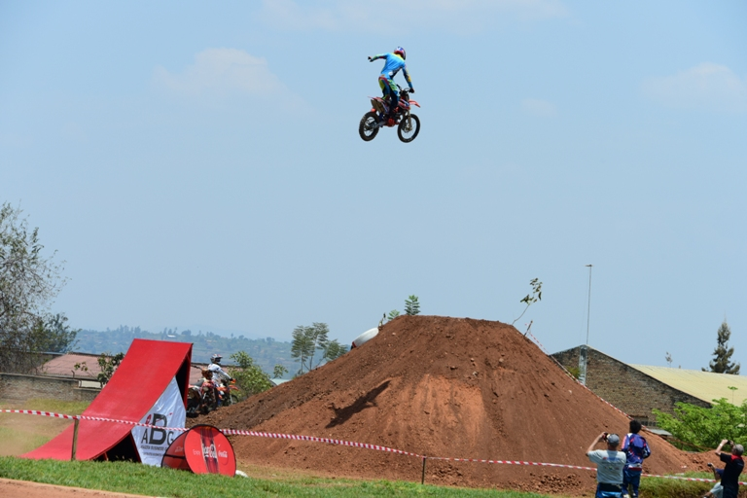
HANDBALL : CARRE D’AS 2016
Irushanwa risoza umwaka w’imikino muri handaball rihuza amakipe yafashe imyanya 4 ya mbere muri championnat ryabaye kuwa 15.10.2016
POLICE 35 - 18 NYAKABANDA
APR 35 - 25 ES KIGOMA
UMUKINO WA NYUMA
POLICE 41 - 36 APR

POLICE yatwaye igikombe cya championnat n’icya carré d’as 2016
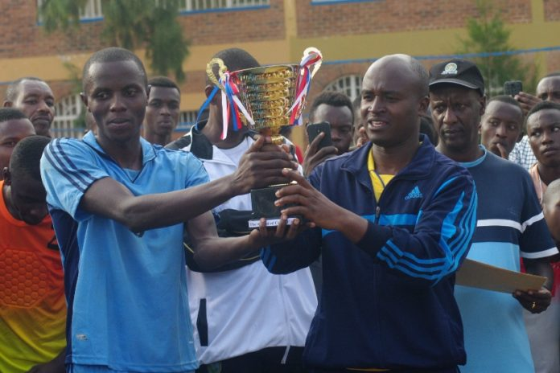
VOLLEYBALL : 2016 WOMEN’S U23 AFRICAN NATIONS CHAMPIONSHIP
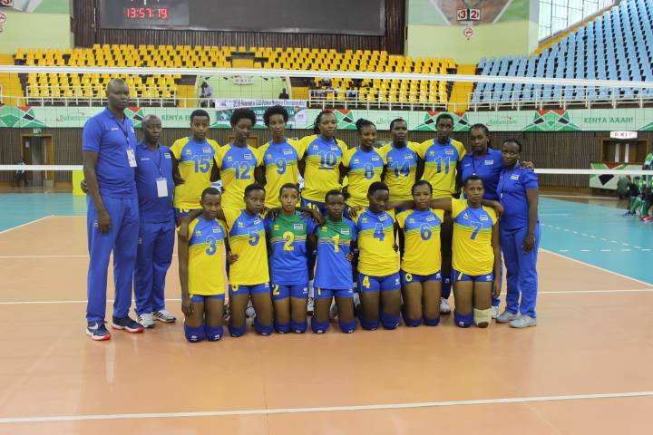
Ikipe y’igihugu ya volleyball y’abakobwa batarengeje imyaka 23 yari i Nairobi muri Kenya kuva kuwa 23.10.2016 kugeza kuwa 28.10.2016, mu irushanwa ry’igikombe cy’Afrika ryahuje amakipe y’ibihugu 5: Kenya, Egypte, Botswana, Rwanda, Senegal
IMIKINO Y’IKIPE Y’U RWANDA
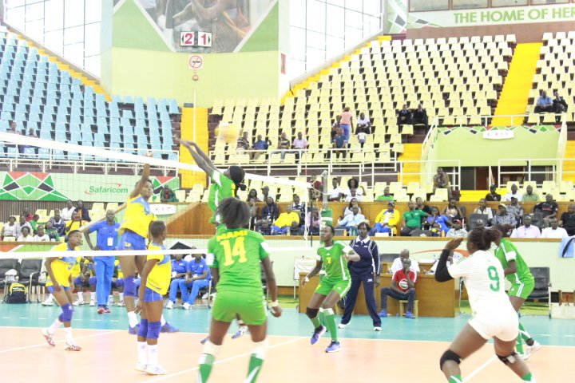
RWANDA 3 - 1 SENEGAL
RWANDA 0 – 3 EGYPTE
RWANDA 3 – 0 BOTSWANA
RWANDA 1 – 3 KENYA

UKO AMAKIPE YASOJE AKURIKIRANA
1.EGYPTE
2.KENYA
3.RWANDA
4.BOTSWANA
5.SENEGAL

HANDBALL : CHAMPIONNAT D’AFRIQUE DES CLUBS CHAMPIONS 2016
Ikipe ya POLICE HBC yahagarariye u Rwanda mu irushanwa ryabereye Ouagadougou muri Burkina Faso kuva kuwa 21.10.2016 kugeza kuwa 30.10.2016. Mu mikino y’ijonjora mu matsinda POLICE yari hamwe na AL AHLY (EGYPTE), ESPERANCE DE TUNIS (TUNISIE), MINUH (CAMEROUN), CAIMAN (CONGO BRAZZA)
UKO IMIKINO YA POLICE YAGENZE
POLICE (RWANDA) 20 – 43 AL AHLY (EGYPTE)
POLICE (RWANDA) 33 - 36 CAIMAN (CONGO BRAZZAVILLE)
POLICE (RWANDA) 24 - 44 MINUH (CAMEROUN)
POLICE (RWANDA) 12 - 40 ESPERANCE DE TUNIS (TUNISIE)
GUKINIRA IMYANYA YA 9 – 11
POLICE (RWANDA) 32 – 34 AS DOUANES (BURKINA FASO)
POLICE (RWANDA) 17 – 33 RED STAR (COTE D’IVOIRE)
POLICE yasoje ku mwanya wa 11 mu makipe 11

WOMEN FOOTBALL LEAGUE 2016
Championnat y’amakipe y’abagore yasojwe n’umukino wabaye kuwa 23.10.2016
RAMBURA 0 – 2 AS KIGALI
AS KIGALI WFC yatwaye igikombe cya championnat 2016
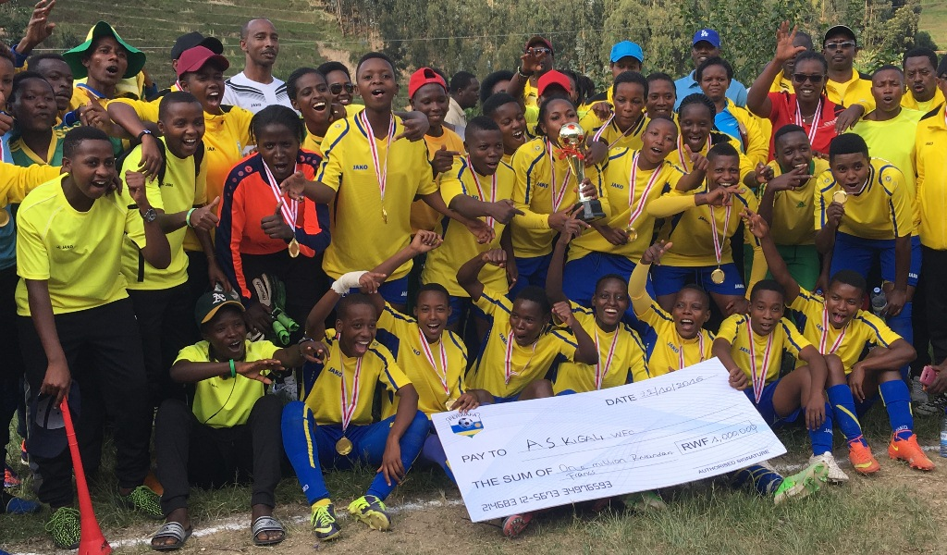
AS KIGALI WFC
KARATE : 23rd WORLD KARATE CHAMPIONSHIP
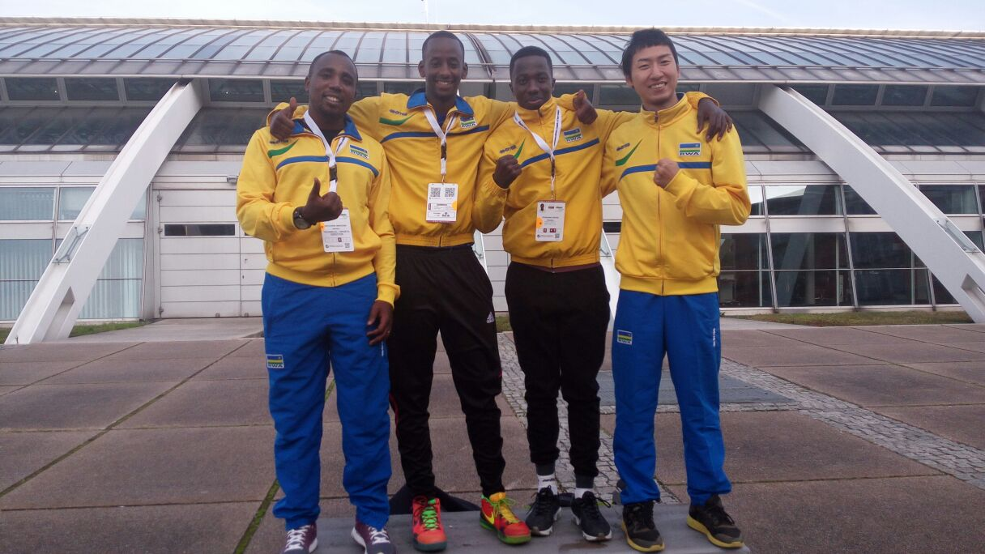
Muri championnat y’isi y’umukino wa karate yabereye i Linz muri Autriche kuva kuwa 25.10.2016 kugeza kuwa 30.10.2016 u Rwanda rwahagariwe n’abakinnyi 2 :
NGARAMBE VANILY : male kumite - 75 kg
NTUNGANE ESPOIR : male kumite - 69 kg

NGARAMBE VANILY yagarukiye muri round ya kabiri akuwemo na ASIBARI ALIASGHAR wo muri Iran
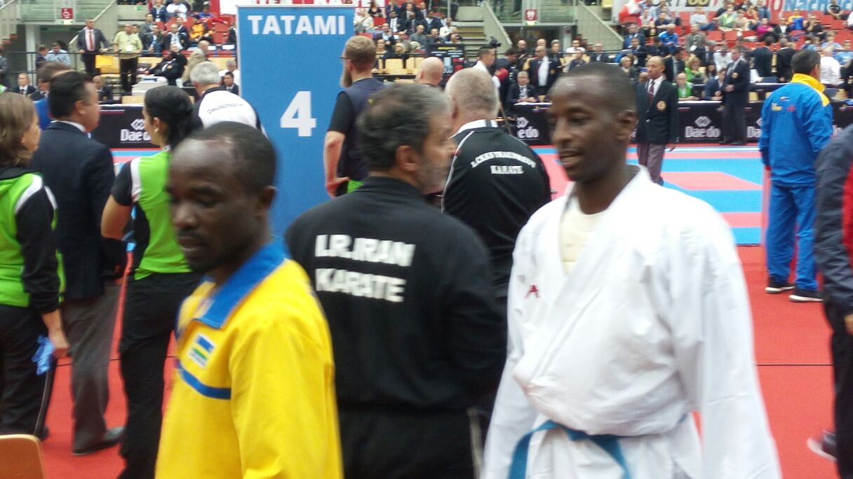NGARAMBE VANILY (uwambaye kimono)
NTUNGANE ESPOIR yagarukiye muri round ya mbere akuwemo na RAMIREZ GUTIERREZ wo muri Colombie

CNOSR - SO : SPORT SCOLAIRE - FN - JOURNALISTES DES SPORTS
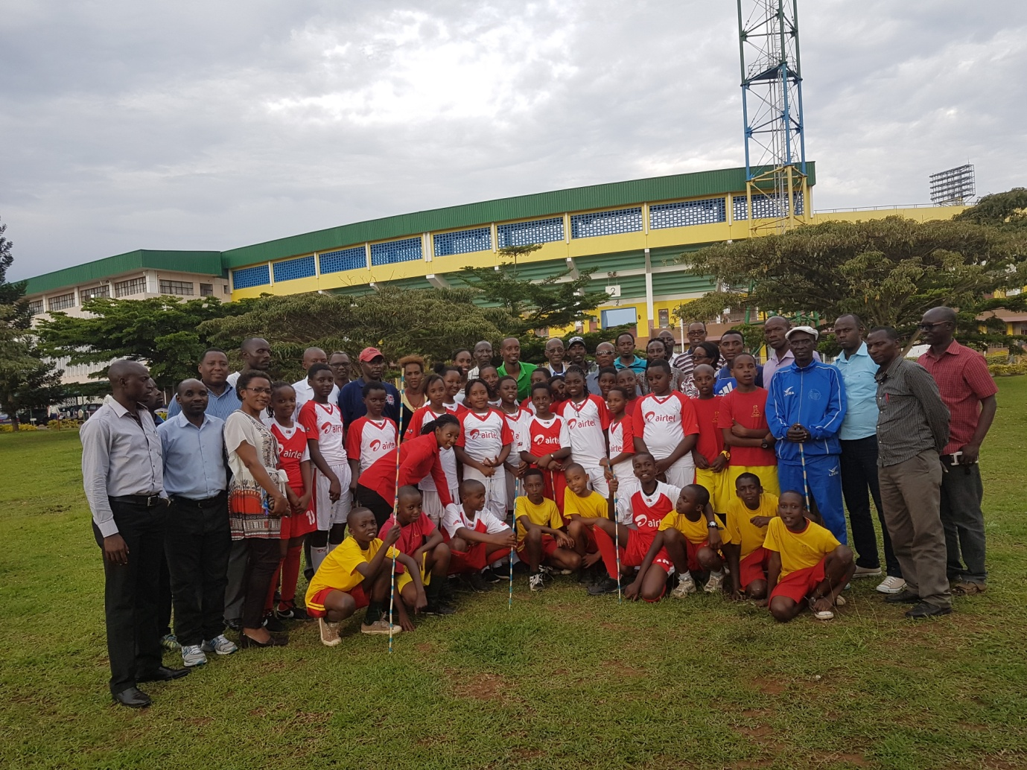
Abahagarariye sport scolaire hirya no hirya mu gihugu, amashyirahamwe y’imikino n’abanyamakuru b’imikino bahawe amahugurwa ku mateka ya Jeux Olympiques no kuri Valeurs Olympiques, yabereye i Kigali kuva kuwa 31.10.2016 kugeza kuwa 04.11.2016.
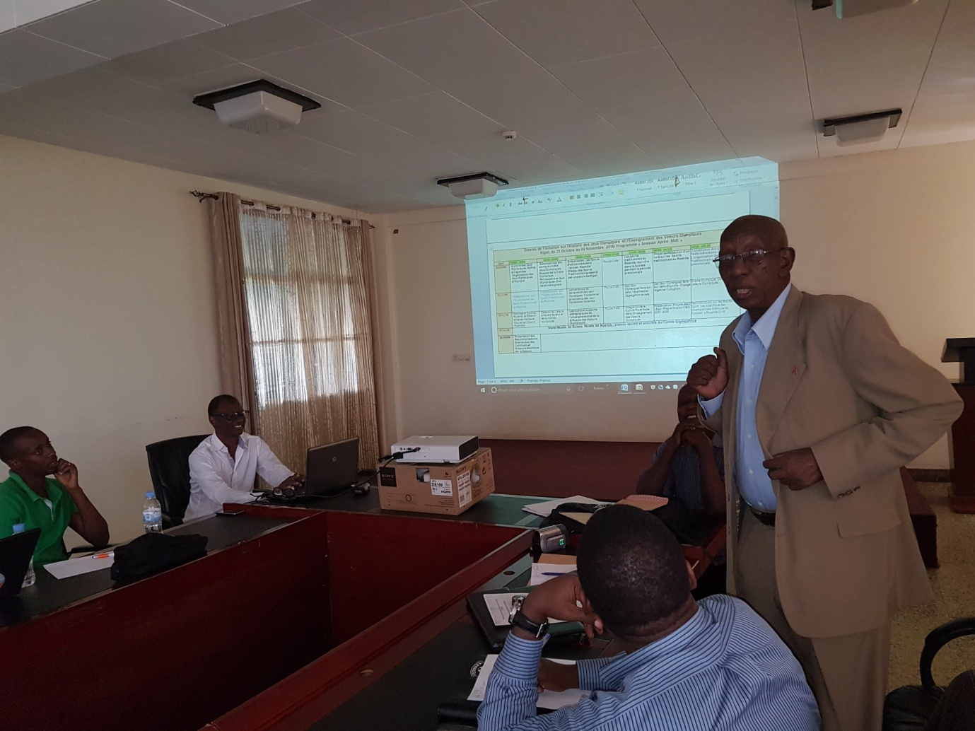
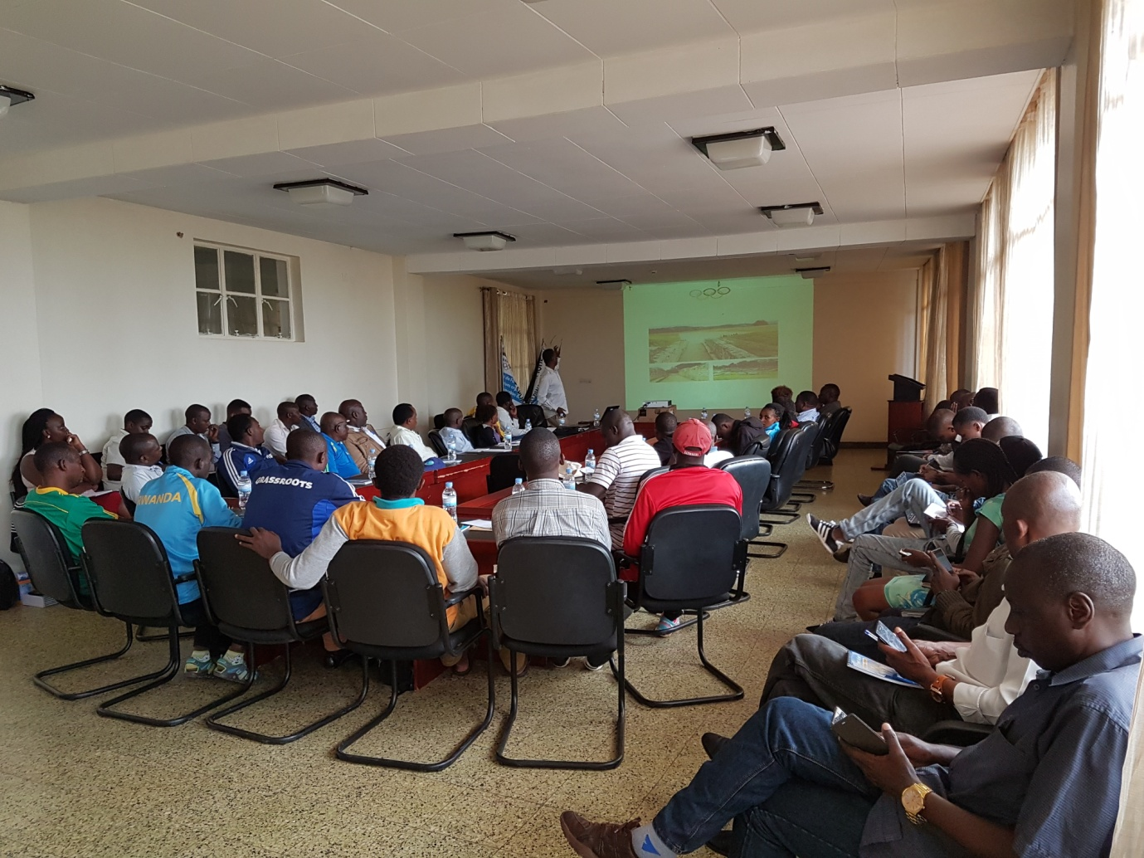
Amahugurwa yayobowe na HARERIMANA Tharcisse, impuguke yoherejewe na Solidarité Olympique yibanze no mateka, uburere, agaciro k’umuco n’imikino gakondo by’u Rwanda.
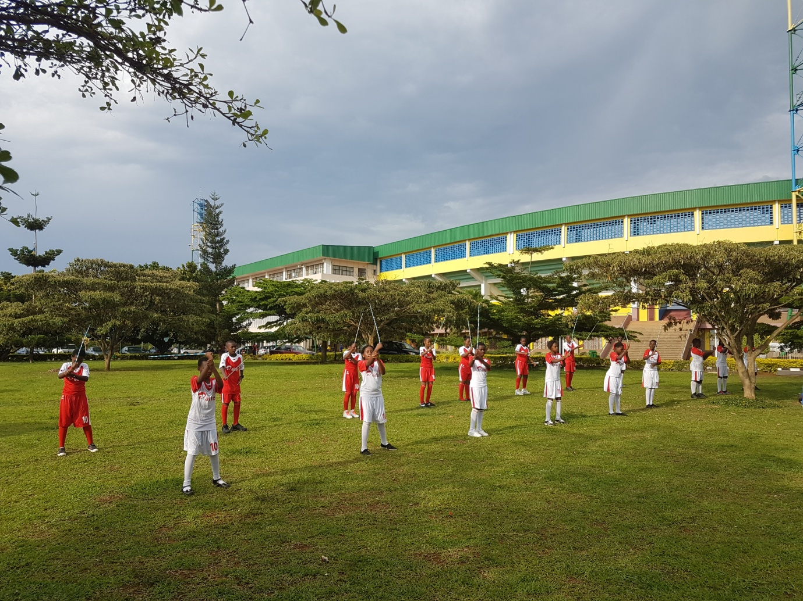
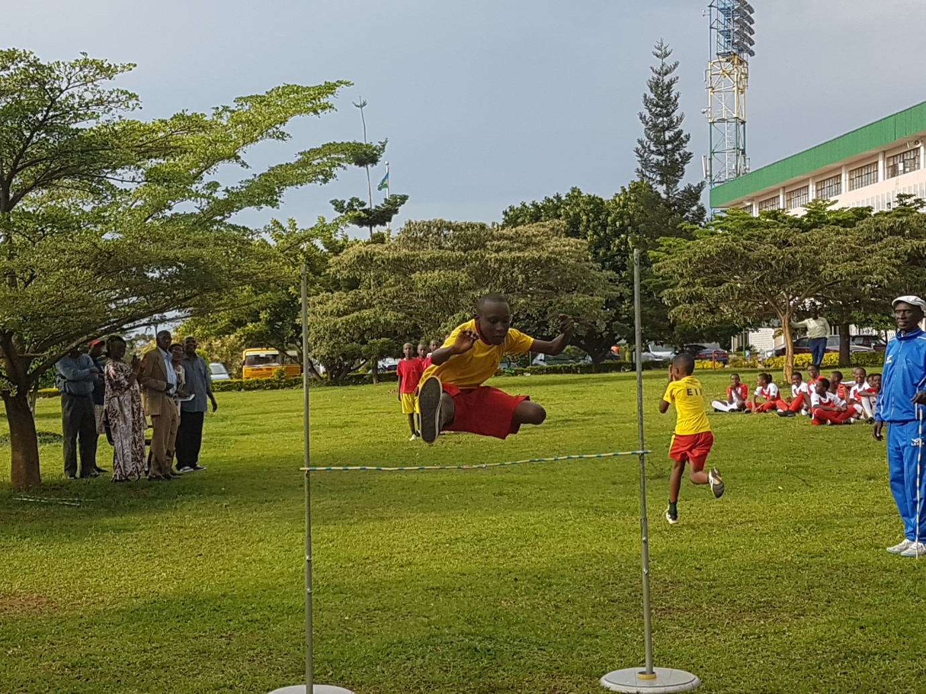

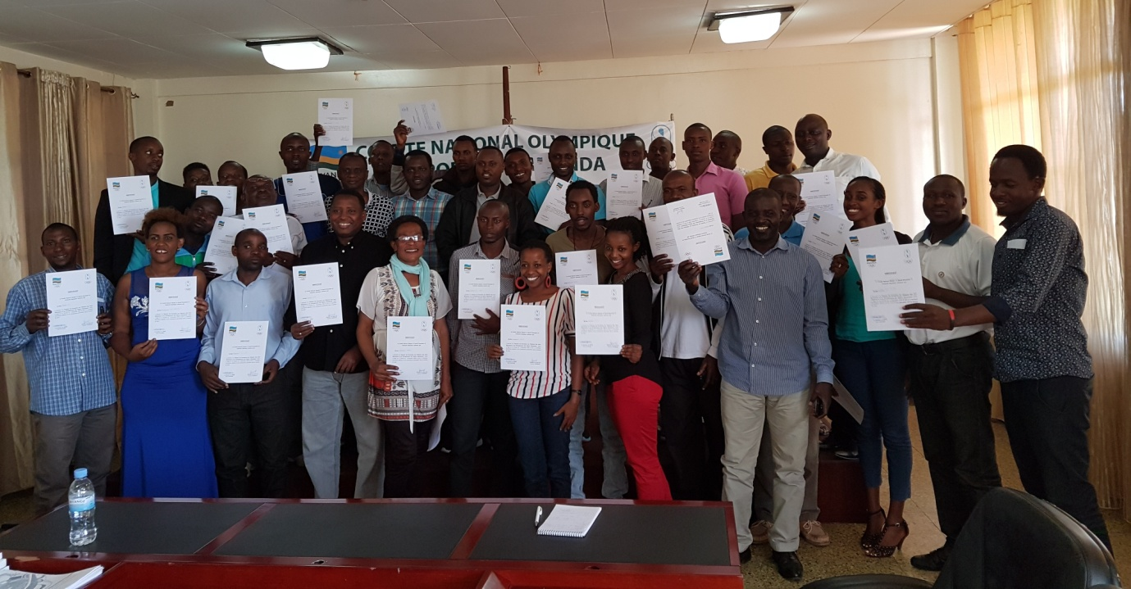

SPORTS POUR HANDICAPES
NATIONAL PARALYMPIC COMMITTEE - RWANDA (NPC)kuwa 01.11.2016 yizihije isabukuru y’imyaka 15 imaze ishinzwe.
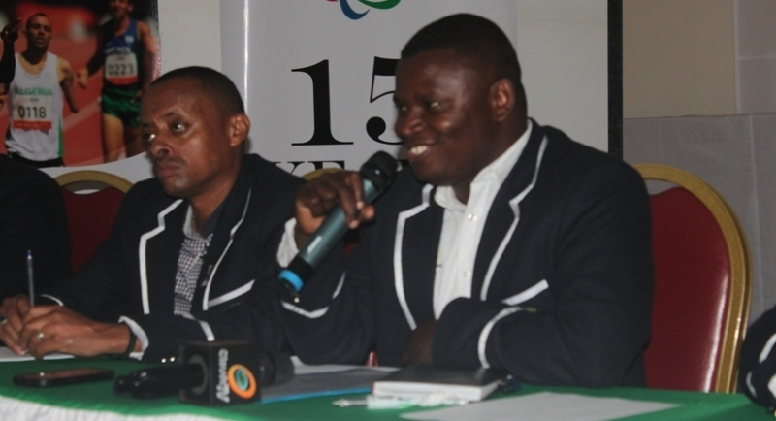

CIO - CNOSR: IOC AWARDS 2016 WOMEN SPORT TROPHIES
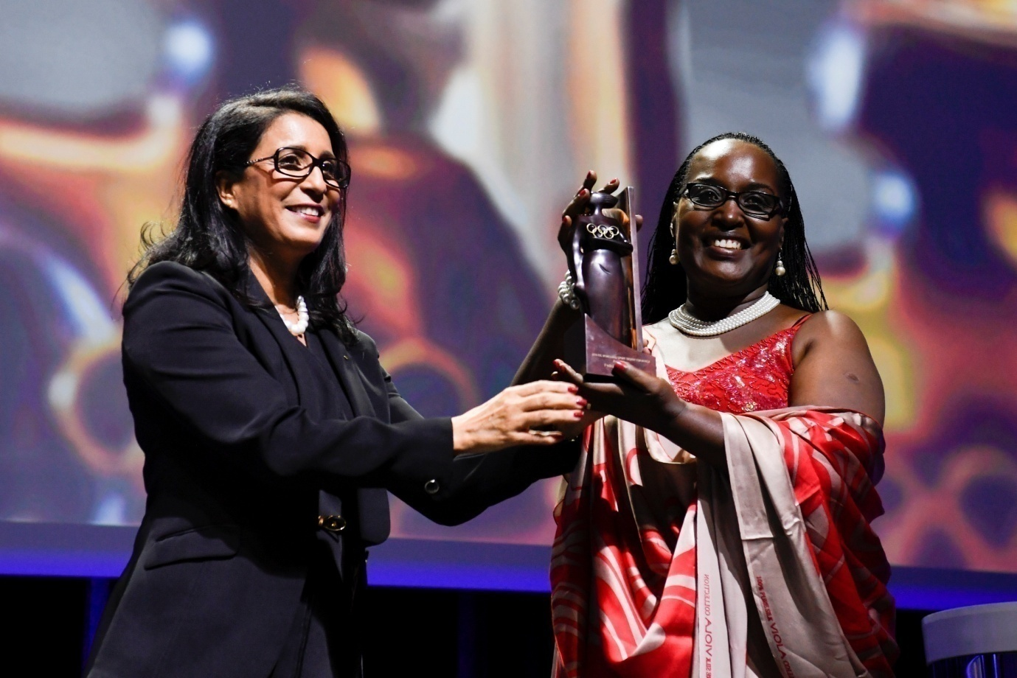
Mme RWEMARIKA FELICITE yashyikirijwe igihembo “2016 IOC Women and Sport Award winner for Africa” gitangwa na International Olympic Committee (IOC), cyo gushimira abagize ibikorwa by’indashyikirwa mu buringanire n’iterambere rya siporo y’abagore ku migabane yabo no ku isi.
Uwo muhango wabereye i Lausanne muri Suisse ku cyicaro cya IOC kuwa 07.11.2016.

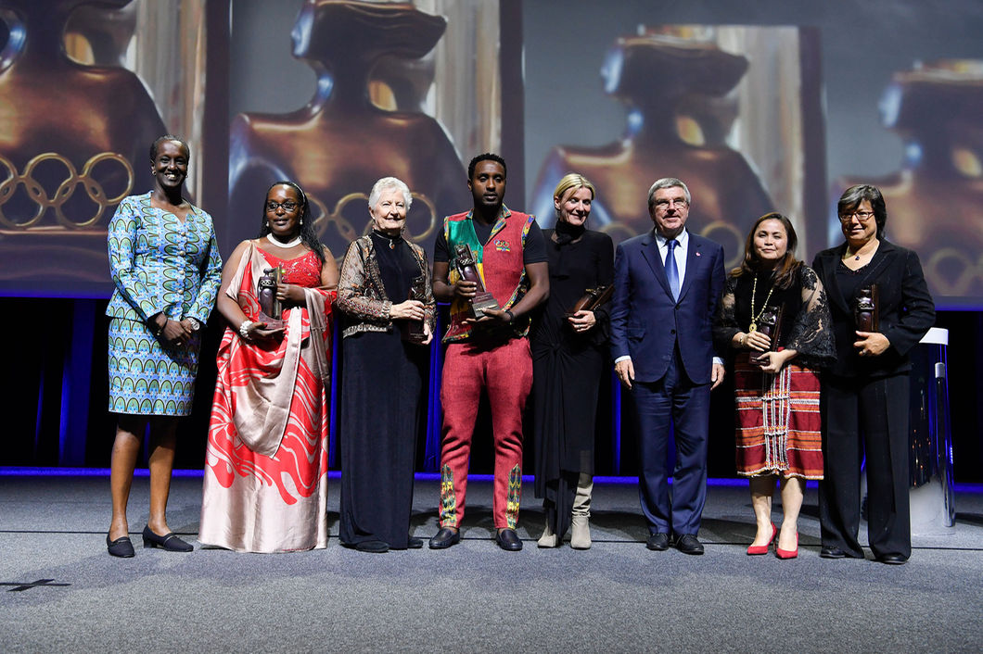
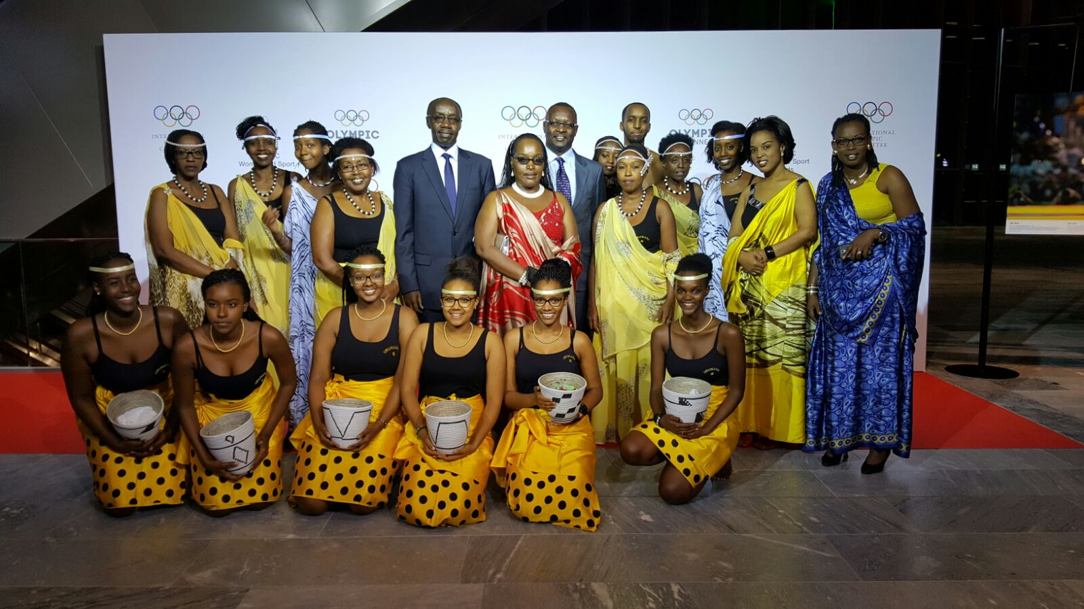

BASKETBALL : INTEKO RUSANGE FERWABA
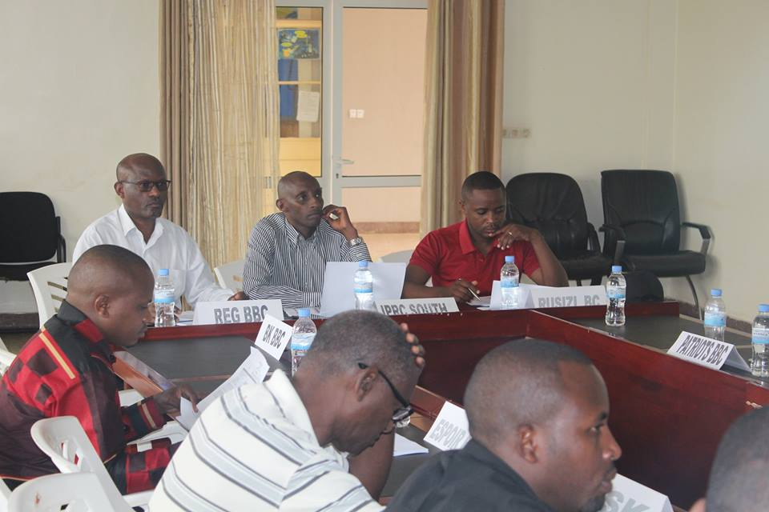
Kuwa 06.11.2016 hateranye inama y’inteko rusange isanzwe y’ishyirahamwe ry’umukino wa basketball FERWABA yabereye i Kigali. Imwe mu myanzuro yayifatiwemo :
- Buri mukinnyi agomba kugirana amasezerano “contrat” yanditse n’ikipe ye
- Buri kipe senior igomba kugira junior yayo, nazo zigakina championnat muri format yazo izagenwa
- Hemejwe italiki y’itangira rya championnat 2016 - 2017 kuwa 25.11.2017
- Hemejwe n’igihe cy’amatora y’ubuyobozi bwa FERWABA mu kwezi kw’Ukoboza 2016
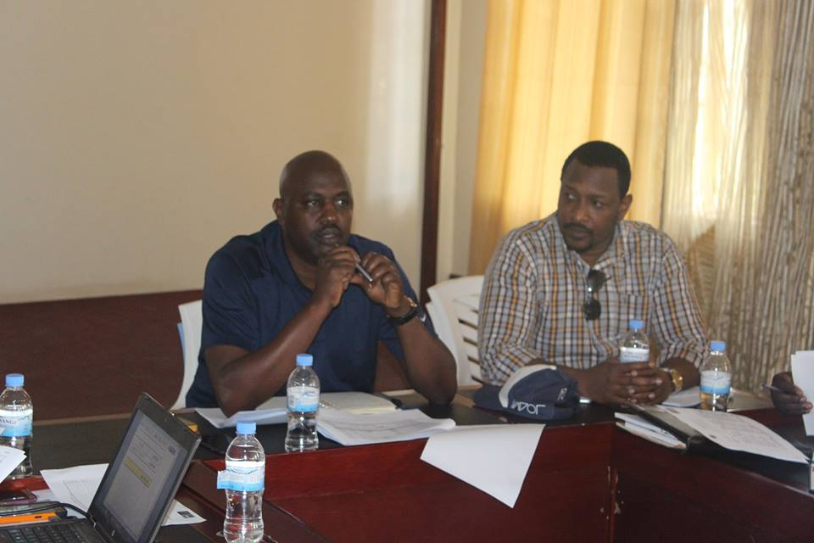

VOLLEYBALL : INTEKO RUSANGE FRVB

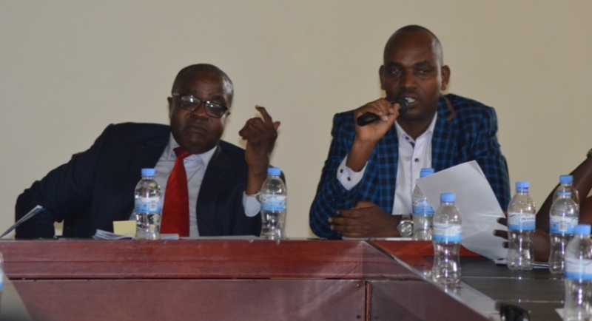
Inama y’inteko rusange idasanzwe y’ishyirahamwe ry’umukino wa volleyball (FRVB) yateraniye I Kigali kuwa 12.11.2016. Mu by’ingenzi byemejwe n’iyo nama y’inteko rusange harimo :
Itangira rya championnat 2016 - 2017 taliki ya 17.12.2016
Hakiriwe abanyamuryango bashya 5, bemererwa no kuzakina championnat , amakipe 4 y’abagabo arimo 3 azakina muri cyiciro cya mbere:
1.GISAGARA VC
2.RWANDA ENERGY GROUP (REG) VC
3.UNIVERSITY OF TOURISM, TECHNOLOGY AND BUSINESS STUDIES (UTB) VC
N’ikipe imwe izakina mu cyiciro kabiri :
IPRC WEST (KARONGI)
Ikipe 1 y’abagore izakina mu cyiciro cya kabiri:
IPRC NORTH (TUMBA COLLEGE OF TECHNOLOGY)
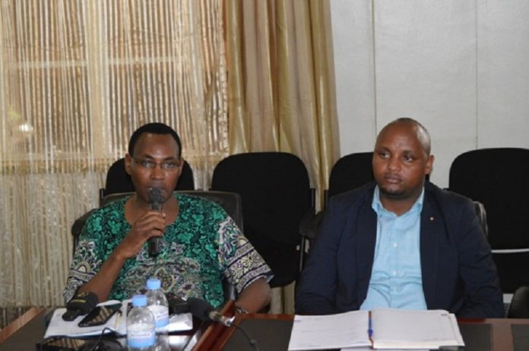

TAEKWONDO : WORLD JUNIOR TAEKWONDO CHAMPIONSHIP
Mu irushanwa ry’isi ry’umukino wa taekwondo ku bakinnyi b’ingimbi ryabereye i Burnaby muri Canada kuva kuwa 16.11.2016 kugeza kuwa 20.11.2016, u Rwanda rwahagarariwe n’abakinnyi 3 : MUNYAKAZI VINCENT, KAYITARE BENOIT , UMURERWA RAISSA.
Bose baviriyemo mu ijonjora rya mbere

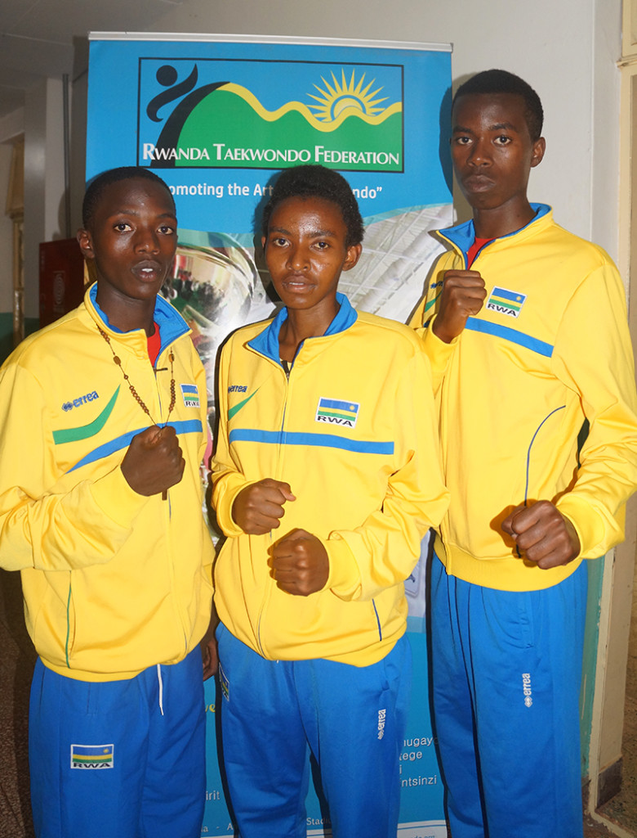Uhereye ibumoso KAYITARE BENOIT, UMURERWA RAISSA, MUNYAKAZI VINCENT

SO - CISéL - CNOSR :
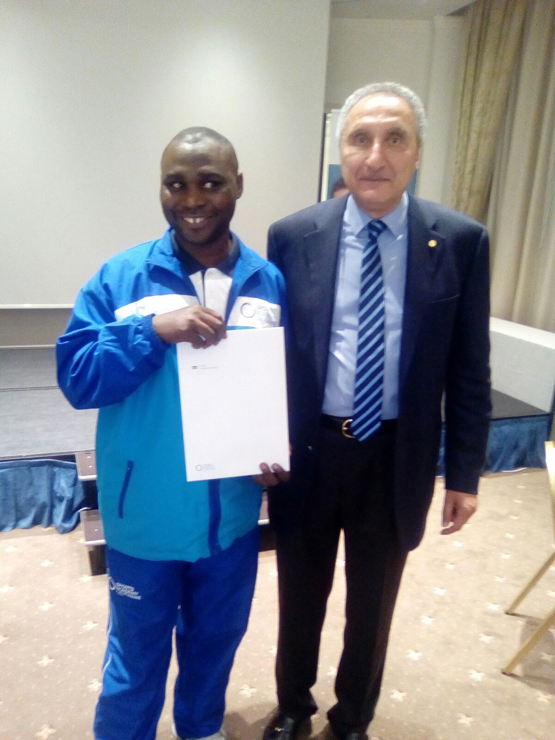
AIP NTABANGANYIMANA Antoine umutoza wa Police Handball Club n’uw’ikipe y’igihugu ya handball, yasoje kandi atsinda amasomo y’ubutoza yo ku rwego rwo hejuru “Cycle International du Sport d’élite (CISéL )” yari arimo i Lausanne muri Suisse kuva taliki 23.09.2016. Ayo masomo atangwa na Sports Academy binyuze muri Solidarité Olympique, yayasoje kuwa 17.11.2016.

GOLF : RWANDA OPEN 2016
Irushanwa mpuzamahanga ry’umukino wa golf ryarimo abakinnyi barenga 150 batabigize umwuga ryabereye i Kigali kuva kuwa 16.11.2016 kugeza kuwa 19.11.2016. Abatsinze irushanwa :
ABAGABO
MWENE VICTOR JOSEPH (TANZANIE)
ABAGORE
SHEATAL PHILIPS

TENNIS : ITF / EAST AFRICA JUNIOR CIRCUIT
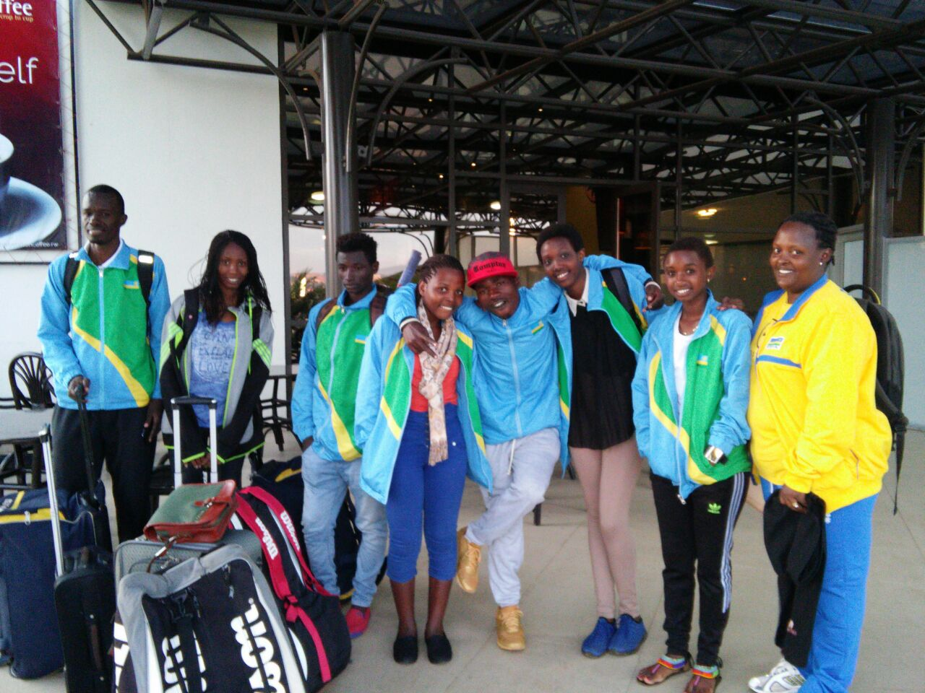
Irushanwa mpuzamahanga rya tennis ku bakinnyi b’ingimbi ryabereye i Nairobi muri Kenya kuva kuwa 21.11.2016 kugeza kuwa 10.12.2016. U Rwanda ruzaba ruhagarariwe n’abakinnyi 7:
Abahungu 3 : HABIYAMBERE ERNEST, TUYISHIME FABRICE, NIYIGENA ETIENNE
Abakobwa 4 : NIYONSHIMA CLENIA, KWIZERA EVELYNE, MUTUYIMANA CHANTAL, TUYISENGE OLIVE
Nta washoboye kurenga ijonjora rya gatatu
HANDBALL : EAST & CENTRAL AFRICA HANDBALL COMPETITION / “ECAHF SENIOR CLUB CHAMPIONSHIP”
Mu irushanwa mpuzamahanga rya handball ryabereye i Nairobi muri Kenya kuva kuwa 19.11.2016 kugeza kuwa 26.11.2016 ryahuje amakipe yabaye aya mbere mu bihugu iwayo, u Rwanda rwahagarariwe na POLOCE HBC.
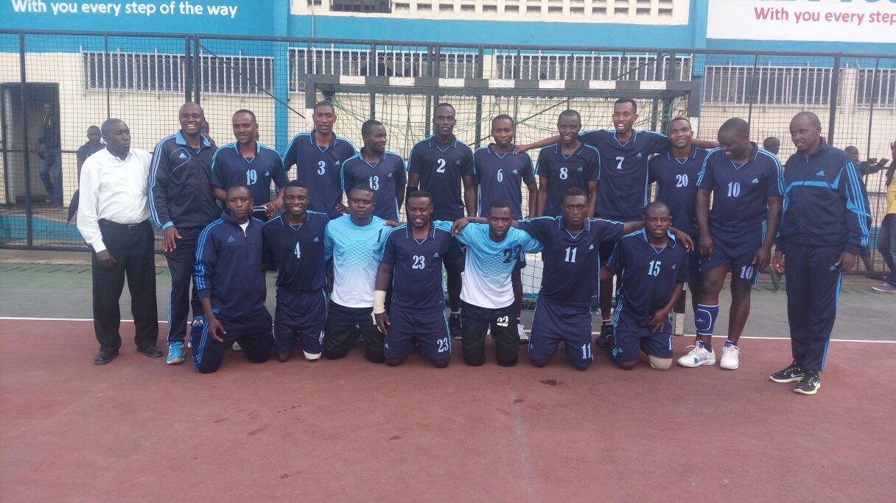
IMIKINO Y’IKIPE YA POLICE
POLICE (RWANDA) 32 – 29 CEREALS (KENYA)
POLICE (RWANDA) 40 - 38 BLACK MAMBA (KENYA)
POLICE (RWANDA) 41 – 43 KDF (KENYA)
Ikipe ya POLICE HBC yasoje ku mwanya wa 2

BASKETBALL : YOUNG COACH CLINICS : YOUNG COACHES MODULE 1
Amahugurwa yahawe abatoza basketball abana bafite munsi y’imyaka 14, yayobowe n’impuguke BLAISE LOUAMBA BALEKETA woherejwe na FIBA, yabereye I Kigali kuva kuwa 17.11.2016 kugeza kuwa 26.11.2016.

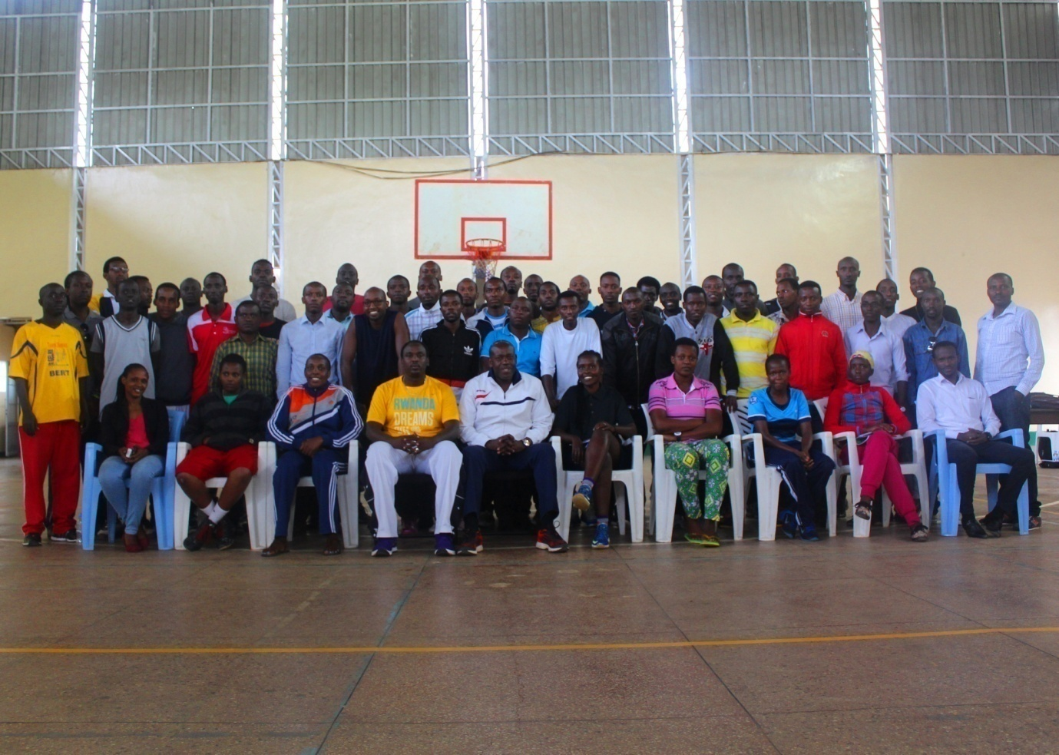

CHESS : JUNIOR CHESS CHAMPIONSHIP 2016
Irushanwa ryahuje abana 51 batarengeje imyaka 20 bari mu byiciro bine : U10/U14 /U17 / U20; ryabereye i Kigali kuwa 19.11.2016 no kuwa 20.11.2016.
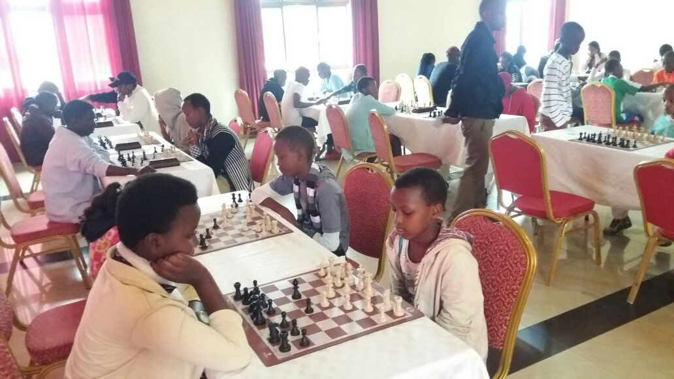
U20 HARIMO ABAKINNYI 8
Uko 3 ba mbere bakurikiranye :
1.THOZAMILE CALVIN yagize 5/6
2.MUHAWENIMANA VANESSA 3/6
3.JABIRO PAULA ANNETTE 3/6

U17 HARIMO ABAKINNYI 16
Uko 3 ba mbere bakurikiranye :
1.MUNYURANGABO LONGIN 5/6
2.UWASE SANDRINE 5/6
3.CYUBAHIRO BEN PATRICK 4.5/6
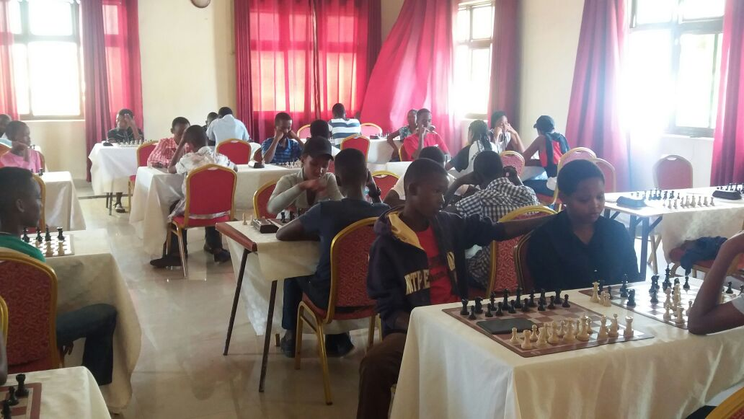
U14 HARIMO ABAKINNYI 11
Uko 3 ba mbere bakurikiranye :
1.MUCYO IRADUKUNDA GUY 6/6
2.UWACUNGUWE KEVIN 4.5/6
3.RUSA GONTRA IGOR 4/6

U10 HARIMO ABAKINNYI 16
Uko 3 ba mbere bakurikiranye
1.BIKORIMANA BERTIN 5/6
2.NGWINONDEBE AMANDA 4/6
3.NYEMINA JORDAN 4/6

CYCLISME : TOUR DU RWANDA 2016
Irushanwa mpuzamahanga ngarukamwaka ryo gusiganwa ku magare ryabereye mu Rwanda kuva kuwa 13.11.2016 kugeza kuwa 20.11.2016. Ryahuje abakinnyi bari mu makipe 15 yarimo 3 yo mu Rwanda: TEAM RWANDA, CLUB LES AMIS SPORTIFS (RWAMAGANA), CLUB BENEDICTION (RUBAVU)
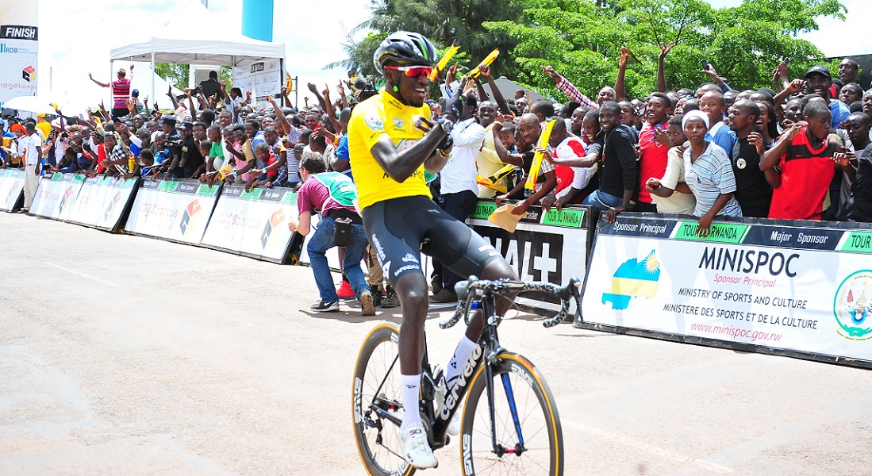 NDAYISENGA VALENS
ABAFASHE IMYANYA ITATU YA MBERE :
1.NDAYISENGA VALENS (TEAM DIMENSION DATA FOR QHUBEKA / AFRIQUE DU SUD)
2.EYOB METKEL (TEAM DIMENSION DATA FOR QHUBEKA)
3.OKUBAMARIAM TESFOM (ERITREA NATIONAL TEAM)
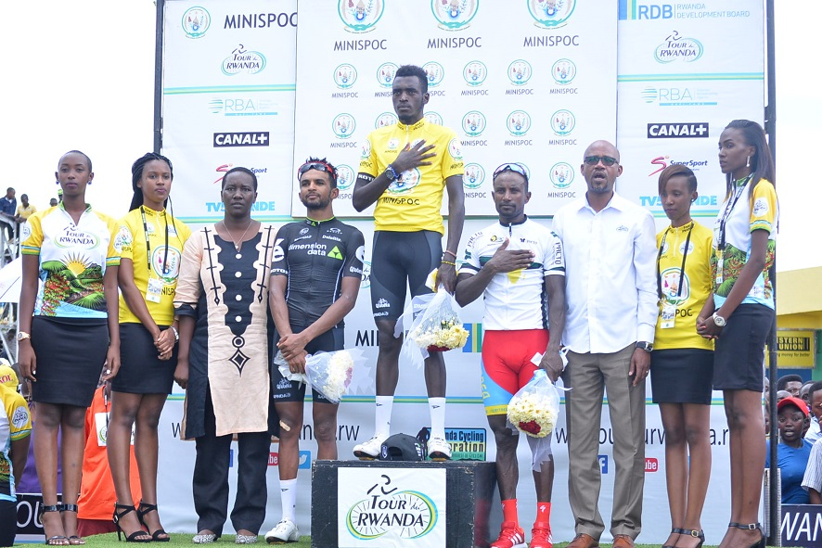
NDAYISENGA VALENS yanahembwe nka :
Meilleur jeune
Meilleur africain
Meilleur rwandais

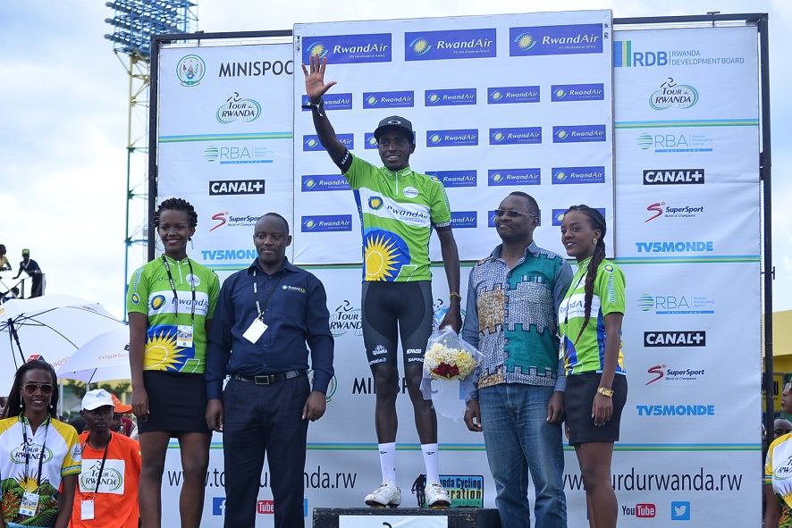
ABAFASHE IMYANYA 3 YA MBERE YA MOUNTAIN CLASSIFICATION / MEILLEUR GRIMPEUR
1.MUGISHA SAMUEL (CLUB BENEDICTION / RWANDA)
2.GIDAY KIBROM HAILAY (ETHIOPIA NATIONAL TEAM)
3.BYUKUSENGE PATRICK (CLUB BENEDICTION)
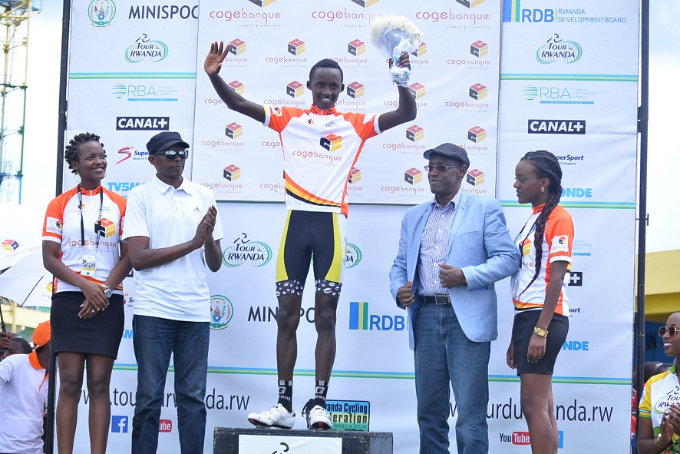MUGISHA SAMUEL
AMAKIPE ATATU YA MBERE :
1.TEAM DIMENSION DATA FOR QHUBEKA
2.ETHIOPIA NATIONAL TEAM
3.TEAM RWANDA
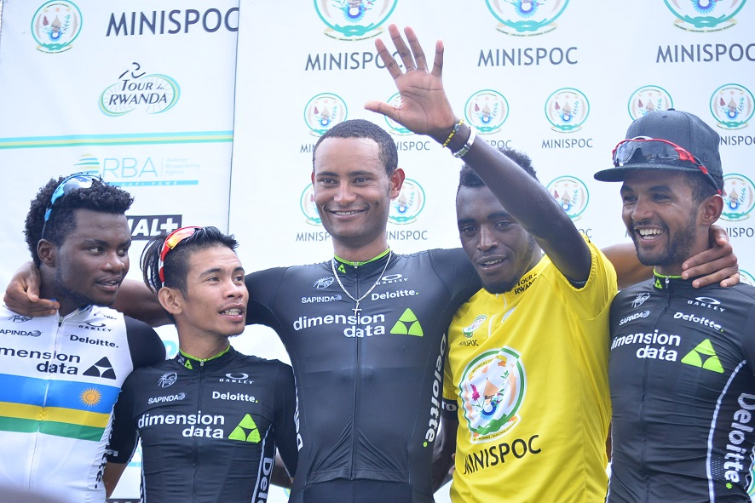TEAM DIMENSION DATA FOR QHUBEKA
SPORT SCOLAIRE : CAMPS D’ENTRAINEMENT 2016 U15 & U17
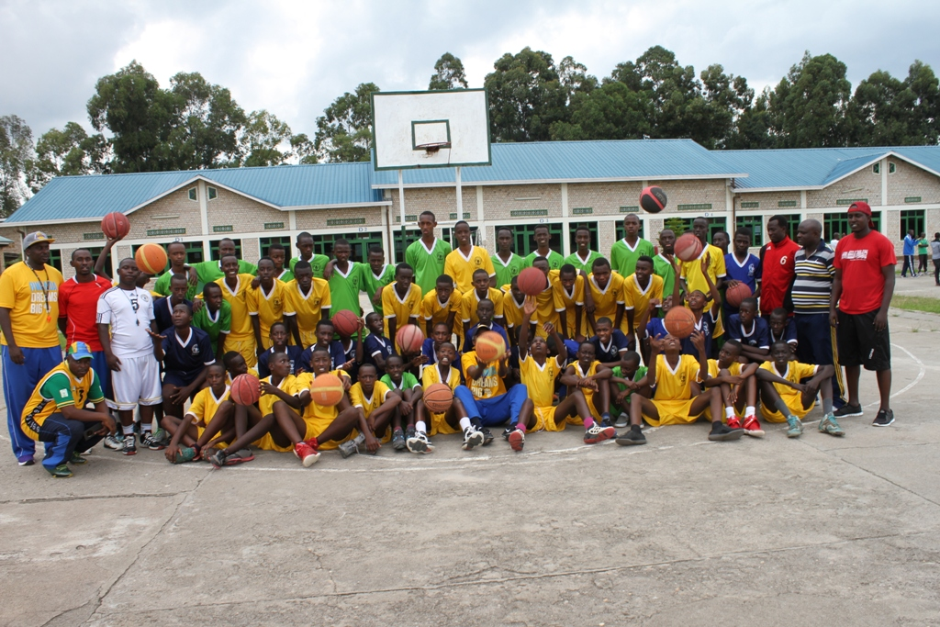
Mu biruhuko byo mu kwezi kwa 11 n’ukwa 12.2016 habaye umwiherero wo gushaka abana bafite impano mu mikino football, volleyball, basketball, handball

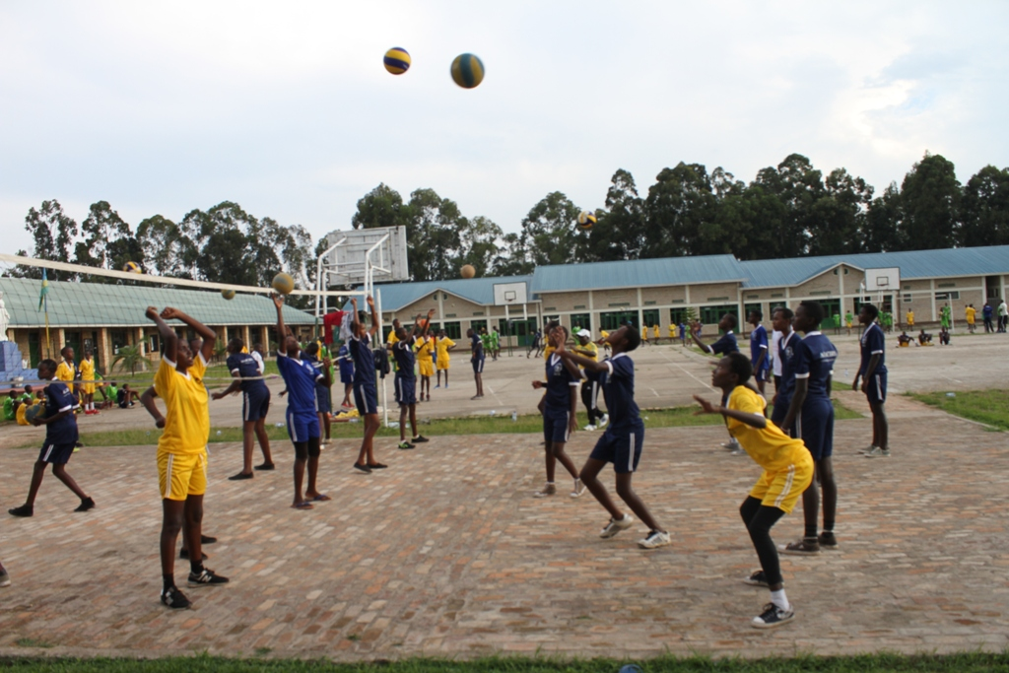
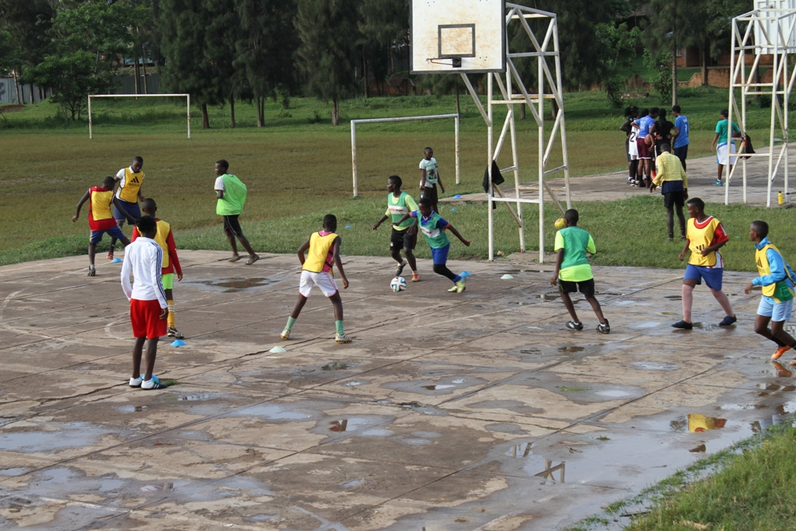
CYCLISME
BYEMAYIRE LAMBERT wari visi perezida wa FERWACY akaba n’umuyobozi wa CYCLING CLUB FOR ALL (Huye) yitabye Imana kuwa 28.11.2016.
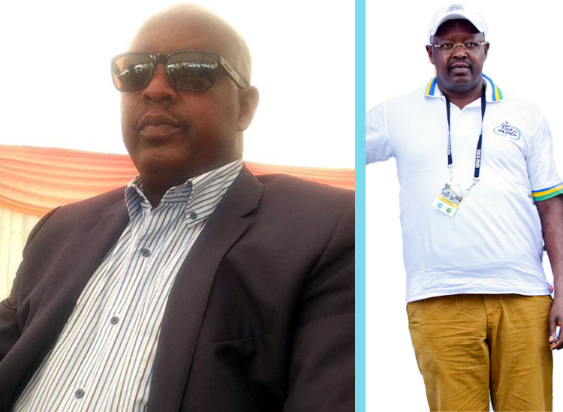

KUNG FU WUSHU : NATIONAL CHAMPIONSHIP 2016
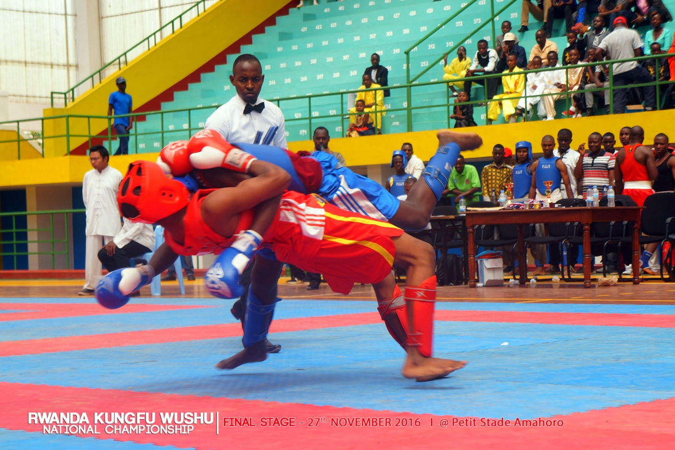
I Kigali kuwa 27.11.2016 habereye irushanwa ryasoje championnat y’igihugu y’umukino wa kung fu wushu, ryahuje abakinnyi 36 batsinze amajonjora yabereye hirya no hino mu ntara

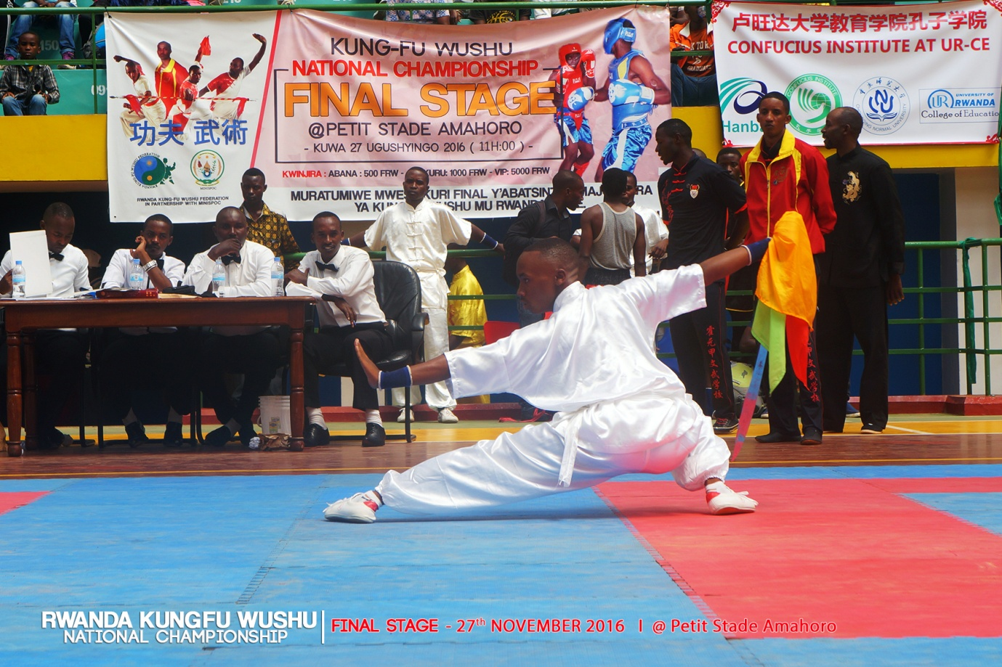
ABAKINNYI BAFASHE UMWANYA WA MBERE MURI BURI BYICIRO

UMUKINNYI KU GITI CYE
TAOLU CATEGORY
DAO SHOU (ABANA)
NIZEYIMANA YASILI (NGOMA)
CHUJI CHAN QUAN
HADARI JUSTIN (KARONGI)
QIANG SHOU (ABAKURU)
TWIZEYIMANA THIERRY (TIGER WUSHU)
WUBU CHAN
MUGISHA PRINCE (TIGER WUSHU)
NAN CHAN (ABAKURU)
TWIZEYIMANA THIERRY (TIGER WUSHU)
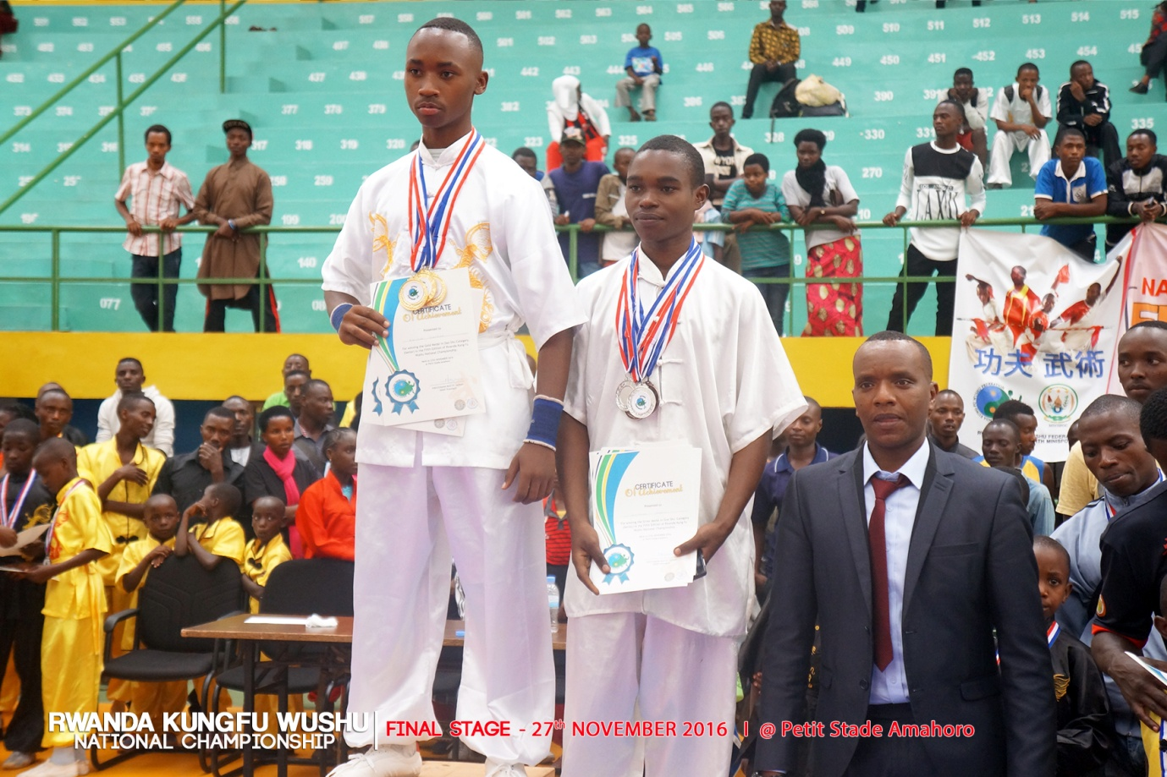
GUN SHOU (ABANA)
RUKUNDO FABRICE (NGOMA)
CHAN QUAN (ABANA)
DUSINGIZIMANA ANSELME (NGOMA)
GUN SHOU (ABAKURU)
KWIZERA CLAUDIEN (TIGER WUSHU)
DAO SHOU
KWIZERA CLAUDIEN (TIGER WUSHU)
WUBU CHAN (ABANA)
MUGISHA PRINCE (TIGER WUSHU)
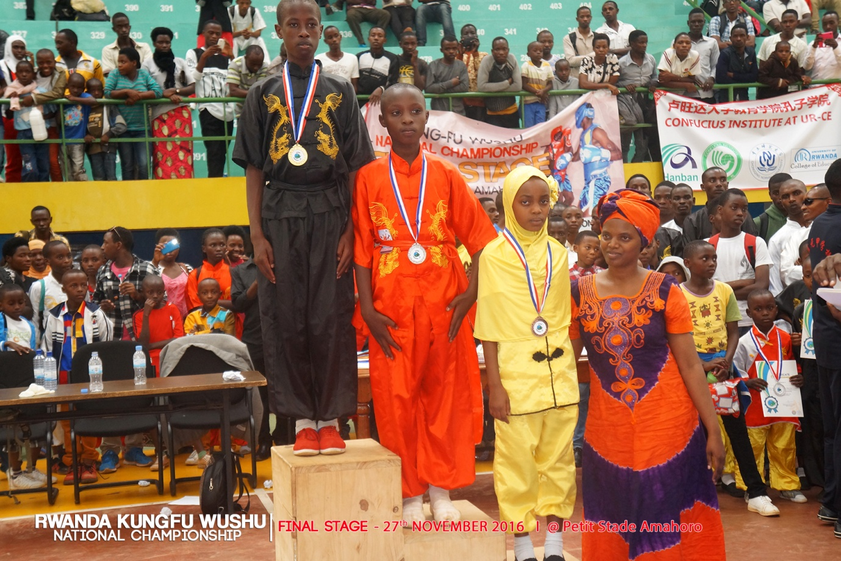

SANDA CATEGORY
78 - 82 kgs : NZABONIMPA ELIAS
73 - 77 kgs : TUYIZERE AMUZA
68 - 71 kgs : HAVUGIMANA LOUIS
63 - 67 kgs : TWIZEYIMANA THIERRY
58 - 62 kgs : HABUMUGISHA ARIEL
53 - 58 kgs : HABUMUGISHA EUGENE

AMAKIPE
Mu cyiciro cy’abana igikombe cyatwawe na BLACK EAGLES yo mu karere ka Ngoma
Mu cyiciro cy’amakipe y’abakuru igikombe cyatwawe na TIGER WUSHU yo ku Kimisagana / Nyarugenge.
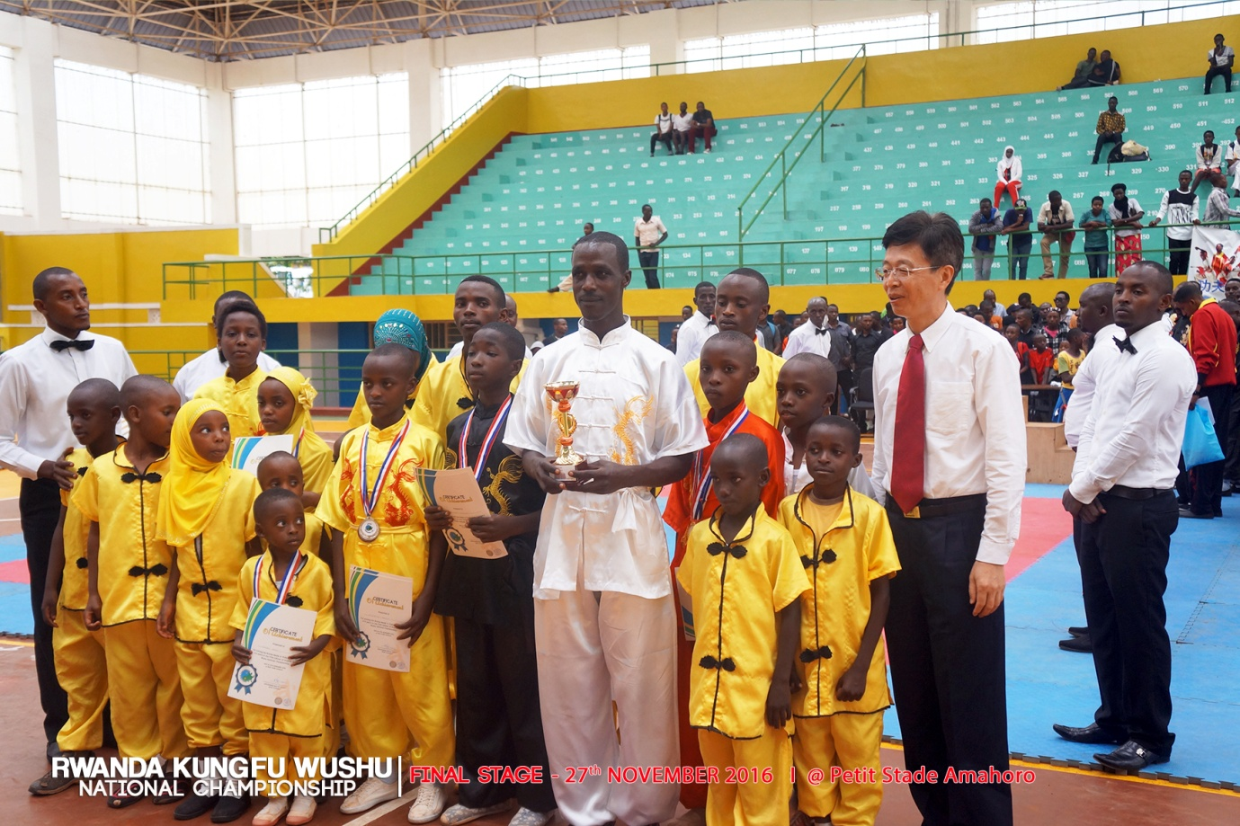

SPORT POUR HANDICAPES : ATHLETISME - KIGALI MEETING
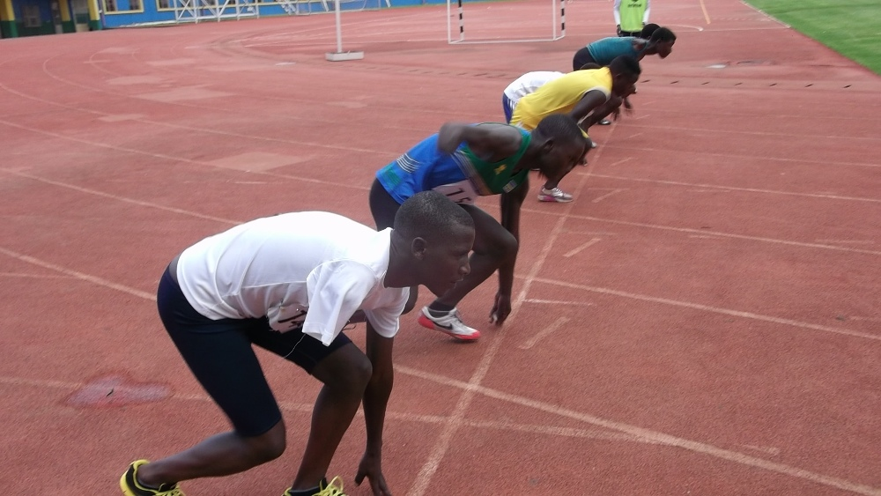
Irushanwa ry’igihugu ry’imikino ngororamubiri ku bafite ubumuga ryabereye i Kigali kuwa 27.11.2016. Habaye amarushanwa mu gusiganwa kwiruka, kujugunya intosho, kujugunya ingasire, kujugunya umuhunda.
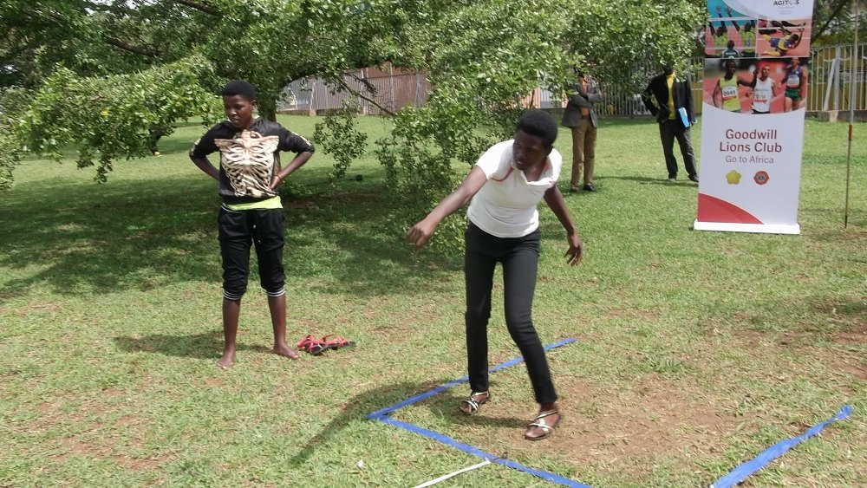

UKO AMAKIPE ATATU YA MBERE YAKURIKIRANYE
ABAGABO
1.MUSANZE
2.GASABO
3.NGORORERO
ABAGORE
1.BUGESERA
2.MUSANZE
3.NGORORERO
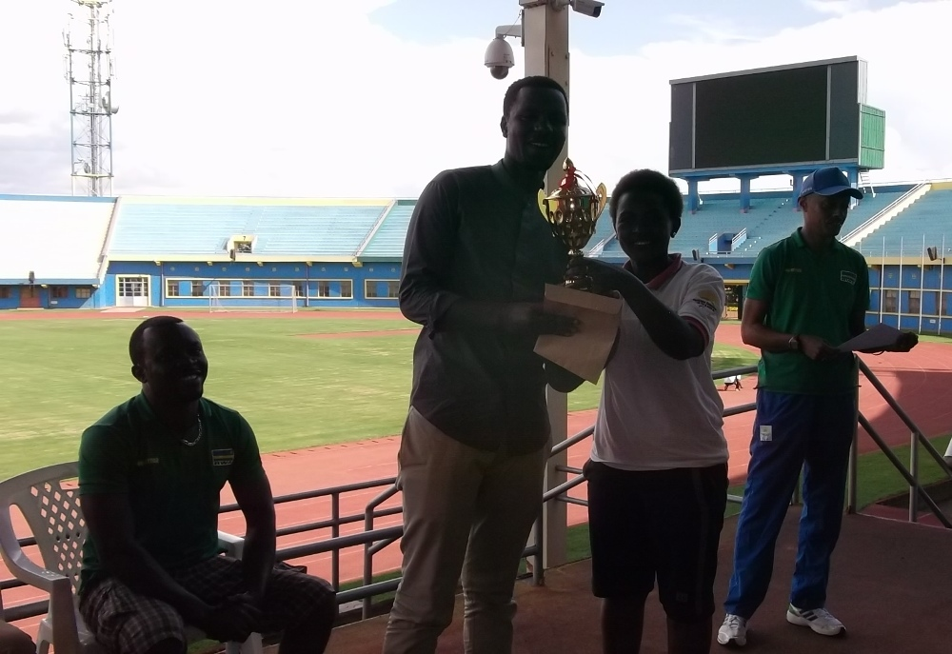

SO - CNOSR - JUDO : DEVELOPPEMENT DE LA STRUCTURE SPORTIVE NATIONALE
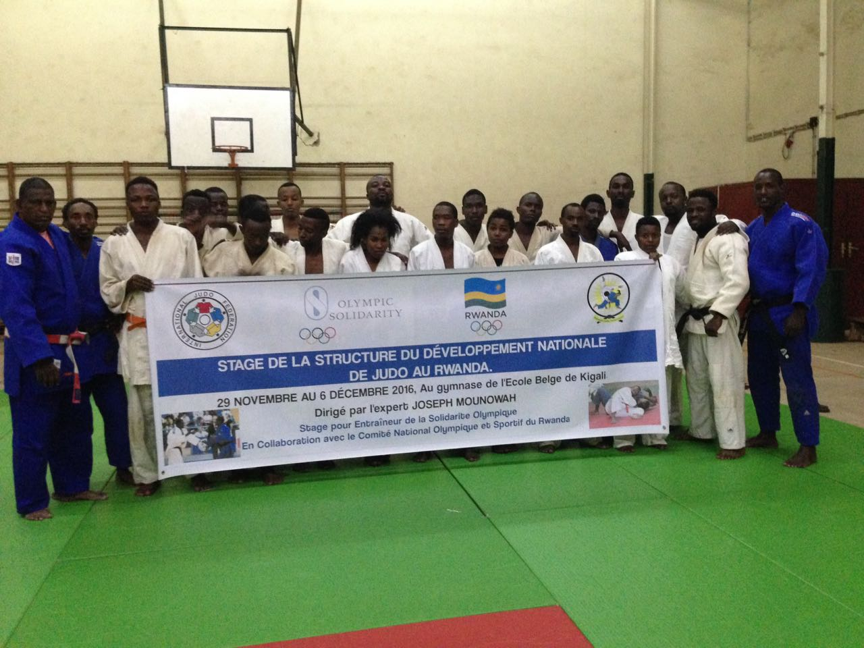
Gahunda y’amahugurwa y’abatoza 25 ba judo yayobowe n’impuguke yaturutse muri Fédération Internationale de Judo, MOUNOWAH GUY EMMANUEL PAUL ukomoka muri Ile Maurice, yarakomeje i Kigali kuva kuwa 30.11.2016 asozwa kuwa 05.12.2016.
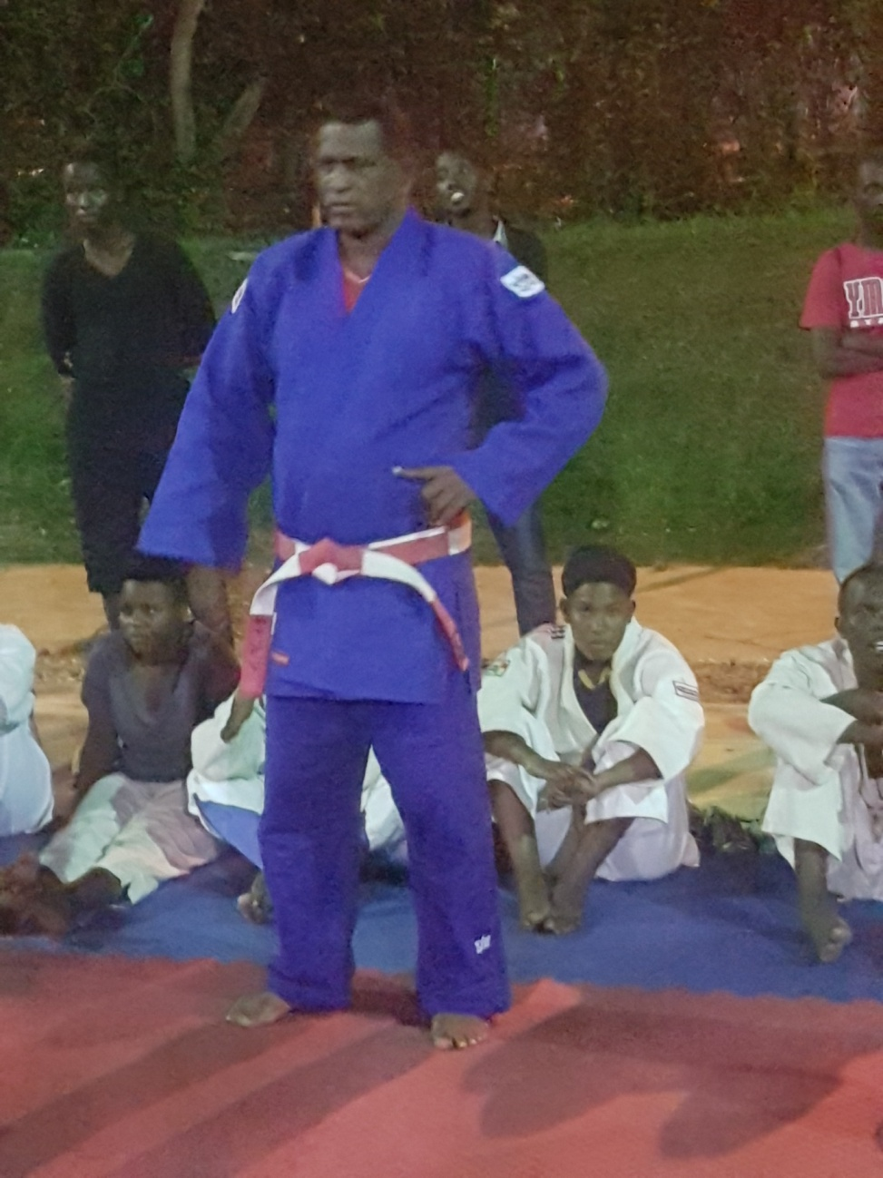

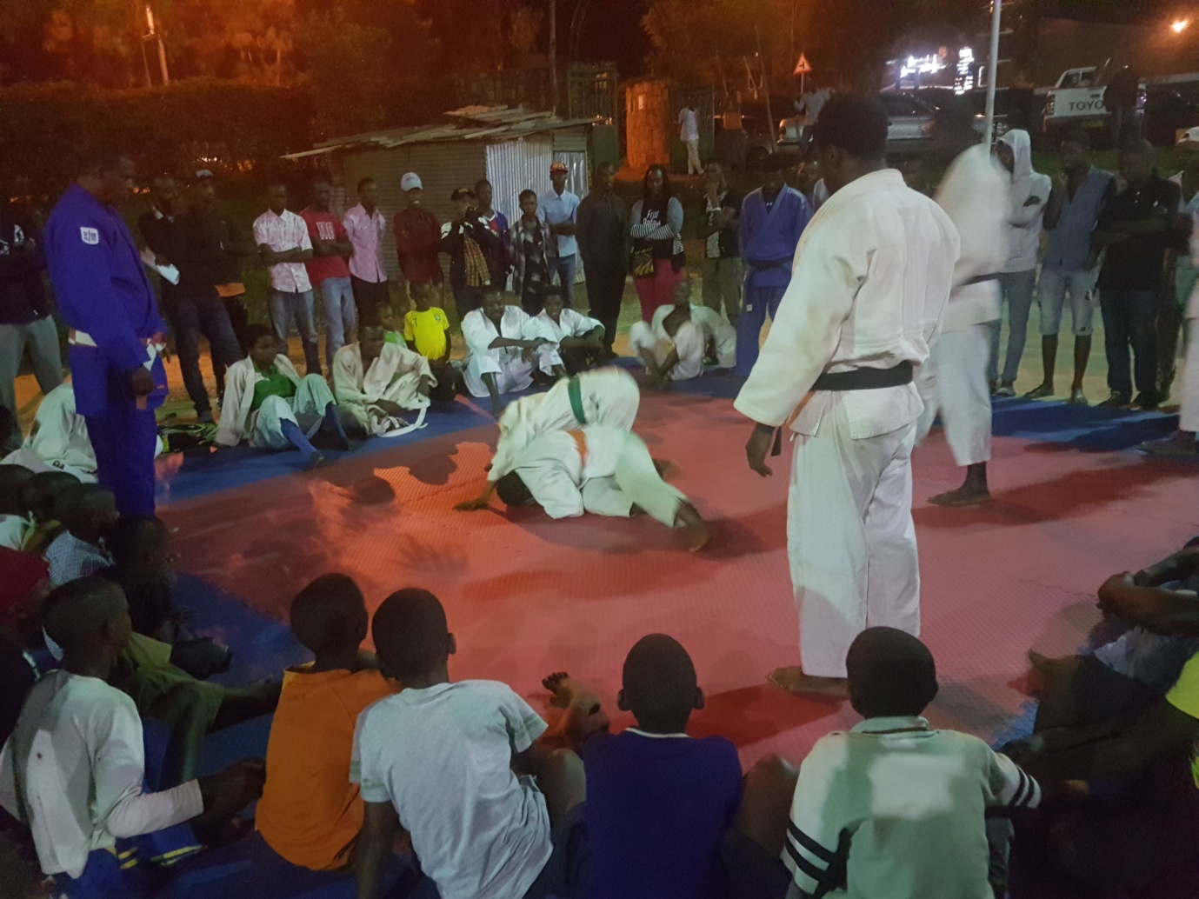
CHESS
MABONEZA SANA wabaye umuyobozi wa Rwanda Chess Federation kuva mu kwezi kwa 4.2012 kugeza mu mpera za 2013 agiye mu kazi k’igihugu muri USA, yitabye Imana.
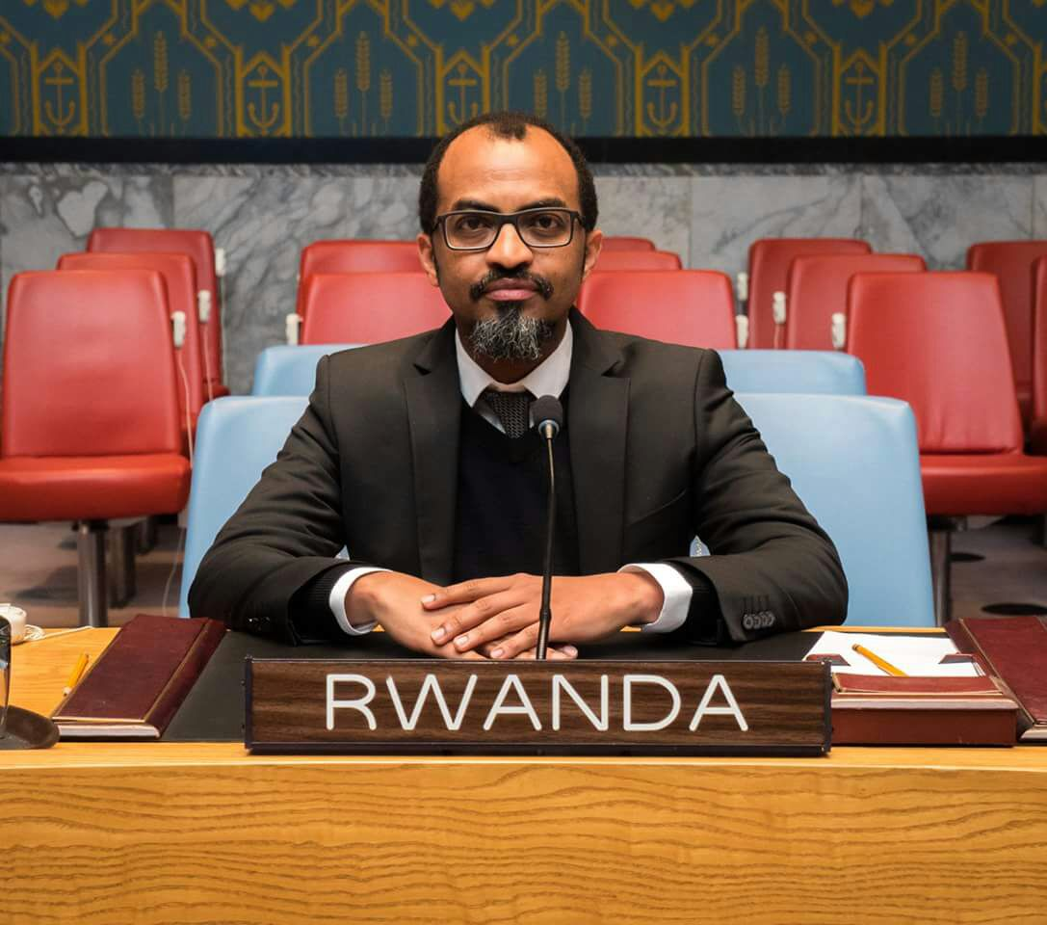
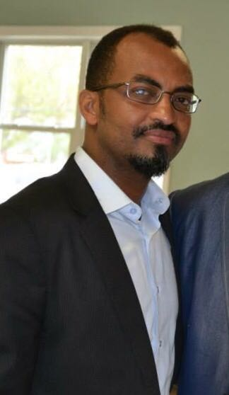

CNOSR - IUSN – FN : GUTERA IBITI NO KURENGERA IBIDUKIKIJE

Mu kwezi kwa 11 n’ukwa 12 habaye gahunda y’ubukangurambaga bwanyujijwe mu mikino bwo gutera ibiti no kurengera ibidukikije.
Iyo gahunda yabereye hirya no hino mu gihugu ku bufatanye bwa Comité National Olympique et Sportif du Rwanda (CNOSR), IUCN n’amashyirahamwe y’imikino.
Kuwa 26.11.2016 i Kigali hatewe ibiti hatangwa n’ubutumwa bwanyujijwe mu mukino w’umupira w’amaguru
Kuwa 04.12.2016 i Gicumbi hatewe ibiti hatangwa n’ubutumwa bunyuze mu mukino wahandball
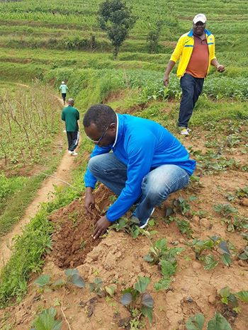
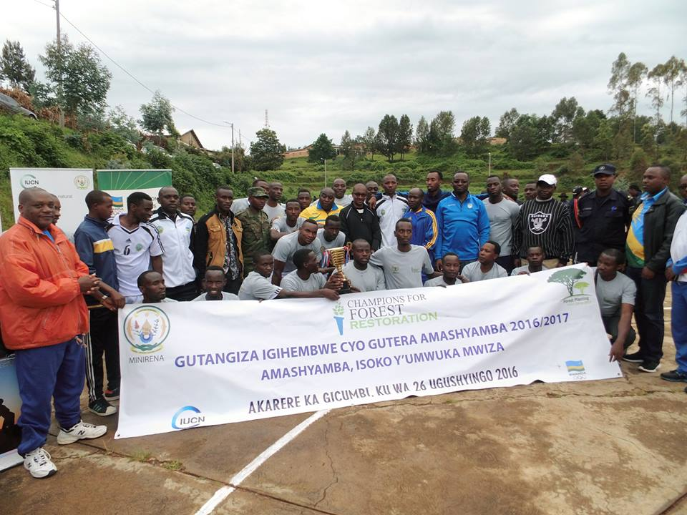

FOOTBALL : NATIONAL U15 GIRLS FOOTBALL TEAM SELECTION
I Rubavu guhera mu kwezi kwa 11.2016 habereye igikorwa cyo gutoranya no gutoza abana b’abakobwa batarengeje imyaka 15 bazashyirwa mu ikipe y’igihugu.
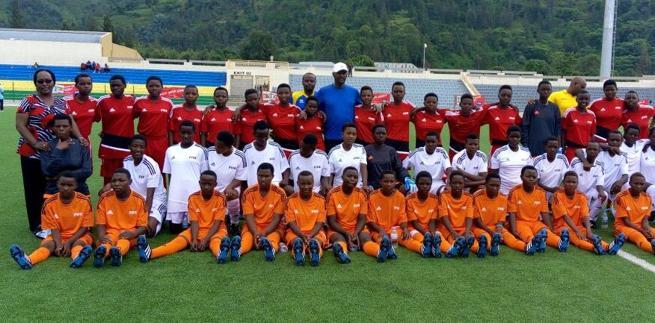
BOXE : TANZANIA INDEPENDANCE & MANDELA BINGWA WAMABINGWA CHAMPIONSHIP
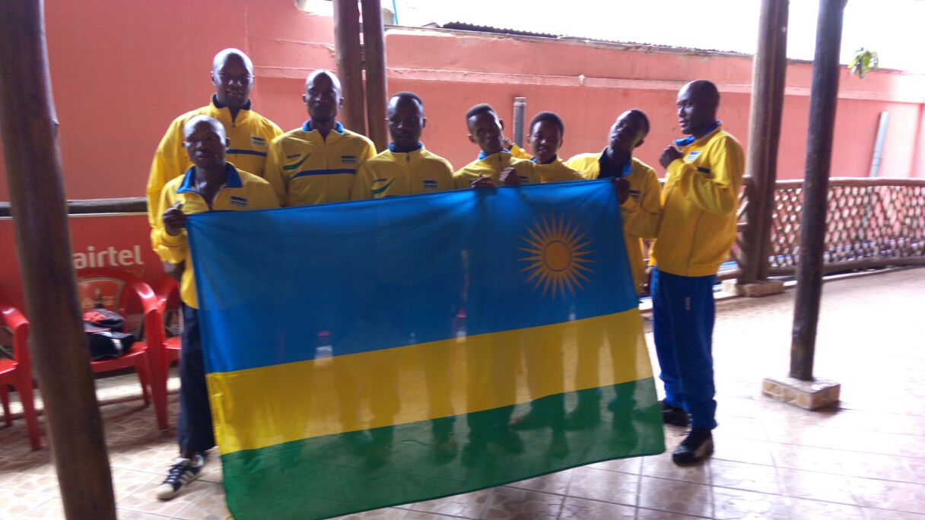
Irushanwa mpuzamahanga ry’umukino w’iteramakofe ryabereye i Dar Es Salaam muri Tanzanie kuva kuwa 09.12.2016 kugeza kuwa 15.12.2016 ; u Rwanda rwahagarariwemo n’abakinnyi 4 :
1.MUGISHA MARTIN 51 kgs
2.NSENGIYUMVA VINCENT 81 kgs
3.NIYONAGIZE ZAKARIYA 54 kgs
4.IRATUJE RACHEL 50 kgs
NIYONAGIZEZAKARIYA (54 kgs)
Mu mukino wa mbere yatsinze umukinnyi wo muri Tanzania 3 -0
Mu mukino wa kabiri atsindwa n’umukinnyi wo muri Tanzania 1 – 2
MUGISHA MARTIN (51 kgs)
Yatsinzwe n’umukinnyi wo muri Uganda kuri round ya 2
IMIKINO YA ½ CY’IRANGIZA
IRATUJE RACHEL yatsinze uwo muri Tanzanie 2 - 1
NSENGIYUMVA VINCENT yatsinze uwo muri Tanzanie 2 – 1
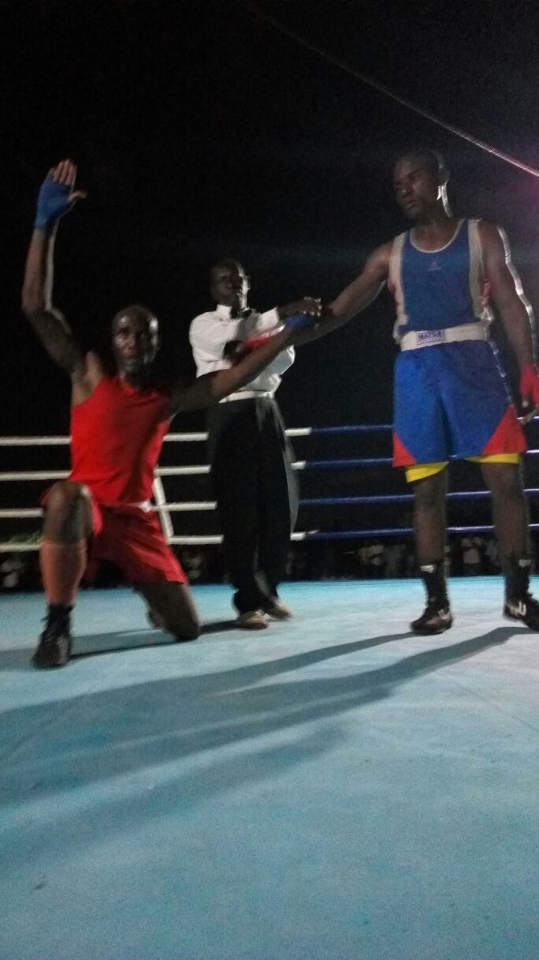
NSENGIYUMVA VINCENT (upfukamye)
IMIKINO YA NYUMA
IRATUJE RACHEL yatsinzwe n’uwo muri Uganda 1 - 2
NSENGIYUMVA VINCENT yatsinzwe n’uwo muri Uganda 1 - 2
IRATUJE RACHEL & NSENGIYUMVA VINCENT bahawe imidari ya feza

TAEKWONDO : RWANDA NATIONAL TAEKWONDO CHAMPIONSHIP 2016
Irushanwa ry’igihugu ry’umukino wa taekwondo ryabereye i Kigali kuva kuwa 06.12.2016 kugeza kuwa 10.12.2016 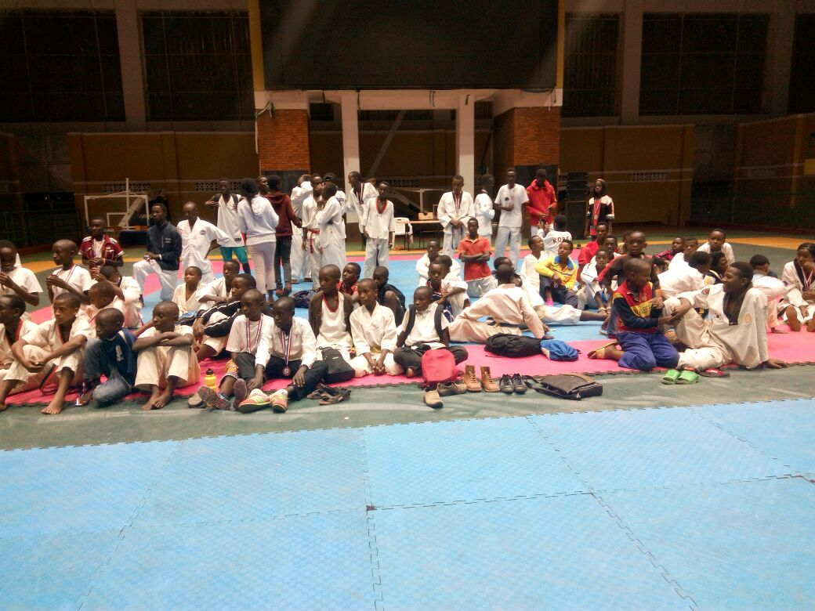
FIRST TEAM CHAMPION : DREAM TAEKWONDO CLUB - GATENGA
SENIOR
BEST MALE PLAYER : NIZEYIMANA SAVIO
BEST FEMALE PLAYER : NDACYAYISENGA ALINE
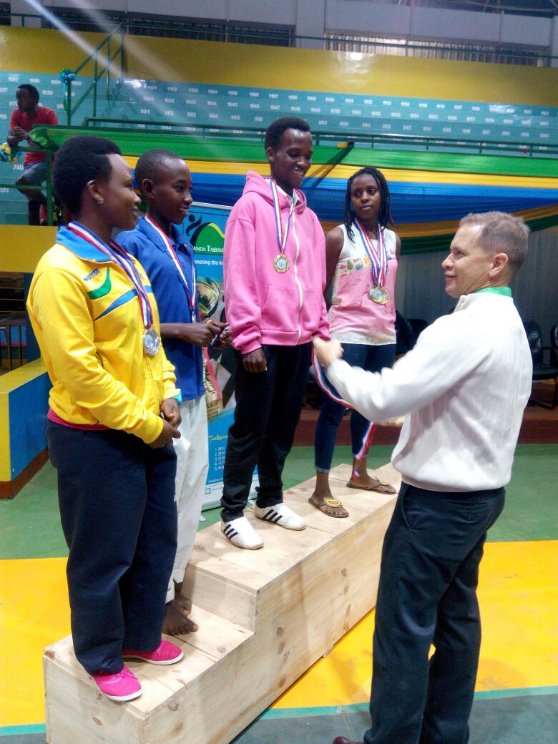
JUNIOR
BEST MALE PLAYER : PACIFIQUE
BEST FEMALE PLAYER : UMURERWA NADEGE
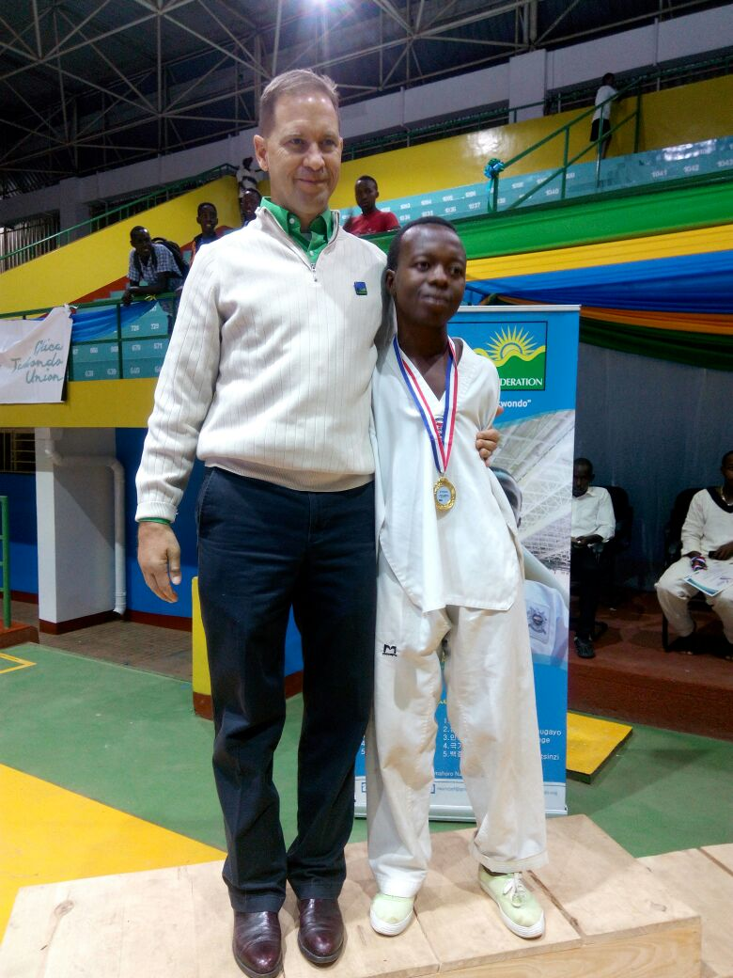

SPORT AUTOMOBILE : RALLYE DES MILLE COLLINES
Irushanwa mpuzamahanga ryo gusiganwa mu modoka ryabereye mu karere ka Bugesera kuwa 10.12.2016
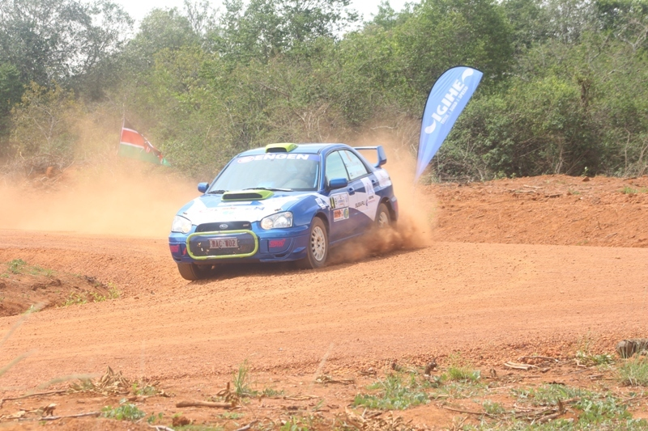
Irushanwa ryarimo imodoka 11 zo mu bihugu 3: UGANDA (3), KENYA (5), RWANDA (3), hasoza imodoka 5.
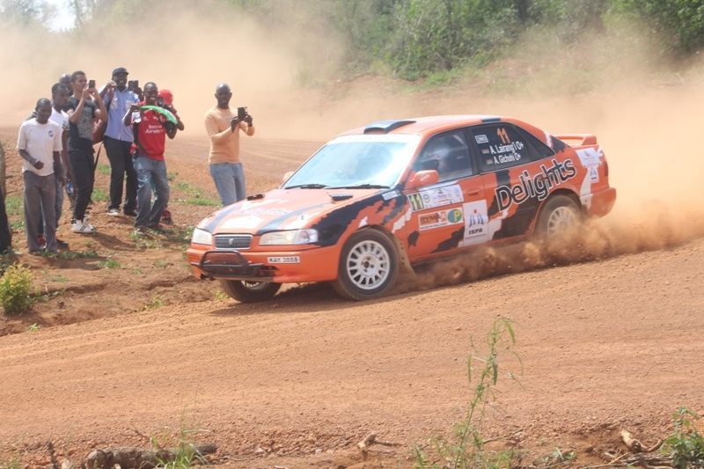

MU MYANYA ITATU YA MBERE
1.POLEPOLE WILBERT & BONGOLE JOSEPH (UGANDA) bari mu modoka ya Mitsubishi
2.MWANGI STEVE & KOSGEI JONATHAN (KENYA) bari mu modoka ya Subaru
3.LAIRANGI ALEX & GICHOHI TONY (KENYA) bari mu modoka ya Toyota Sprinter
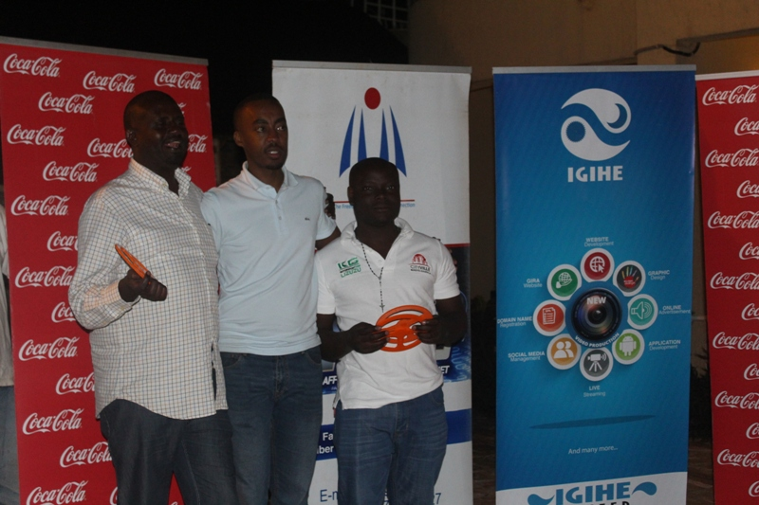
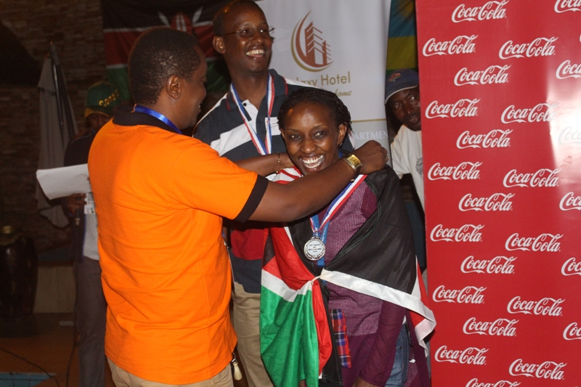

RUGBY : INTEKO RUSANGE
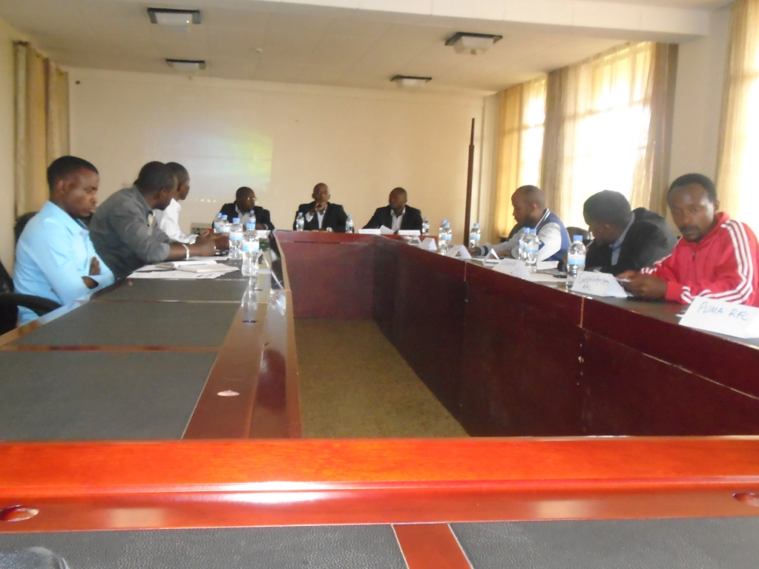
Inama y’inteko rusange isanzwe ya Rwanda Rugby Federation yateranye kuwa 11.12.2016 i Kigali, yitabiriwe n’abahagarariye club 10 za rugby, yasuzumye :
- Ibikorwa byabaye muri 2016
- Gahunda y’ibizakorwa muri 2017
- Imikoreshereze y’umutungo
- Habaye itora ry’umubitsi wa RRF, MUHIRE JOHN LIVINGSTONE (MUHANGA RFC)
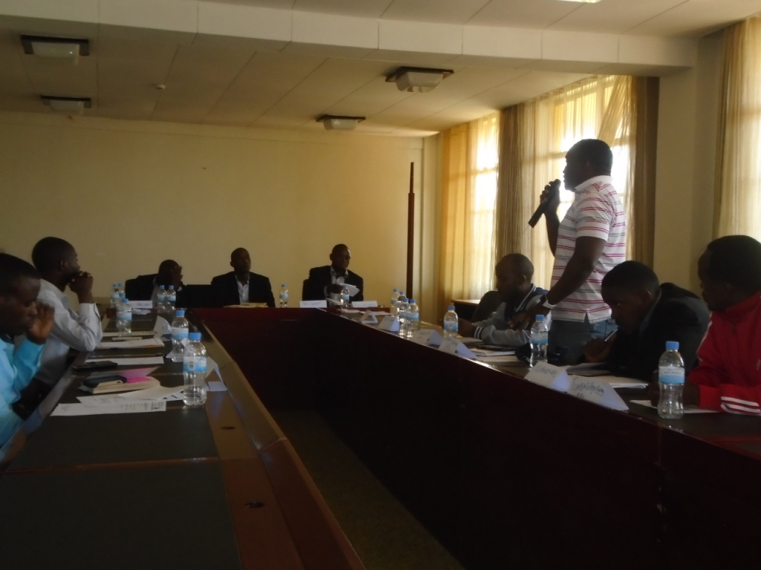
CGF - CNOSR - FN
Volunteers bakorana na Olympic Committees muri gahunda za Commonwealth Games Federation (CGF) bo muri ZAMBIE, NIGERIA, BOTSWANA, NAMIBIE, RWANDA bahuriye mu mahugurwa i Kigali kuwa 13.12.2016 no kuwa 14.12.2016 yayobowe na ELLEN BARWISE waturutse muri CGF
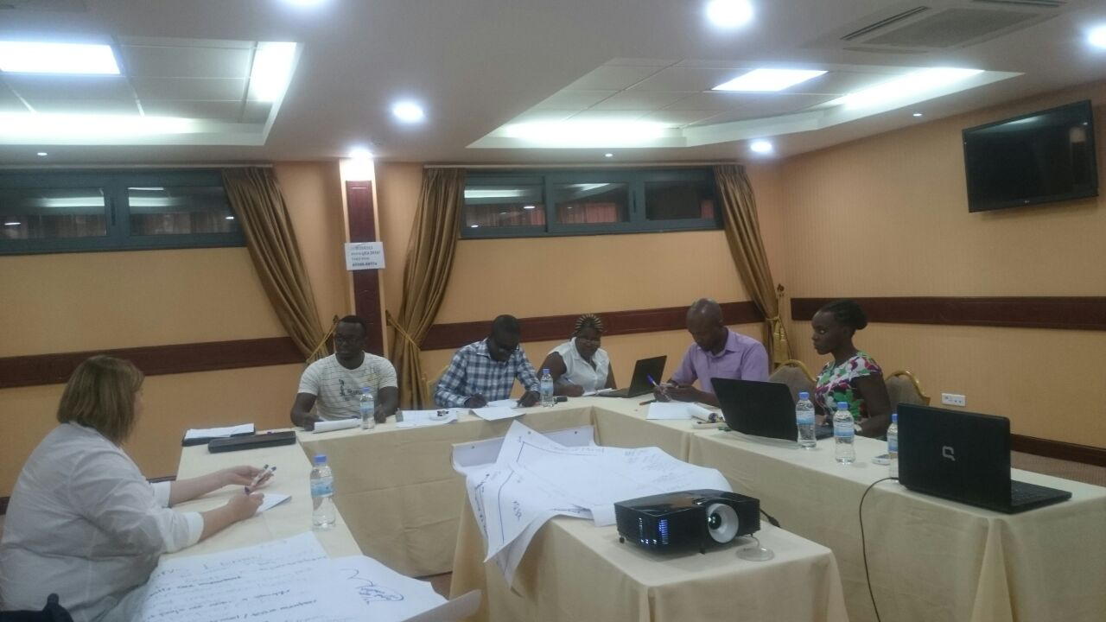
Kuwa 15.12.2016 no kuwa 16.12.2016 amahugurwa yahawe abakozi ba CNOSR n’abamashyirahamwe y’imikino ku bijyanye no gukora accreditation na database z’abakinnyi mu bijyanye n’amarushanwa ya Commonwealth Games; yayobowe na ELLEN BARWISE waturutse muri CGF
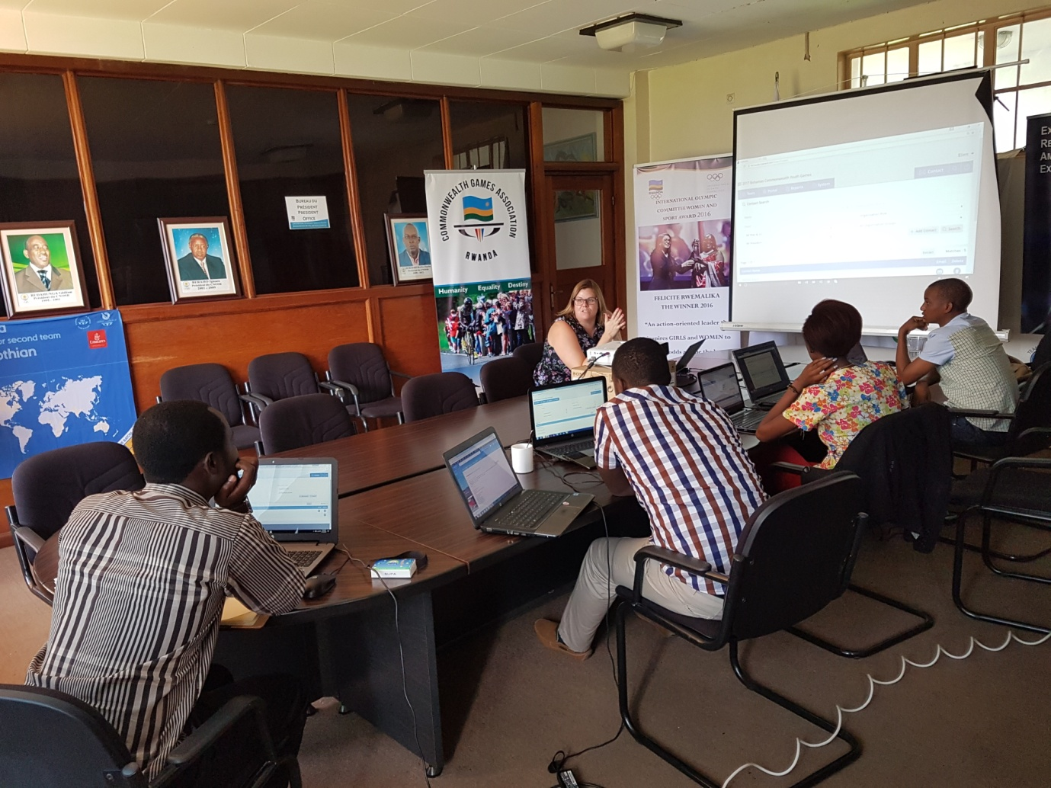

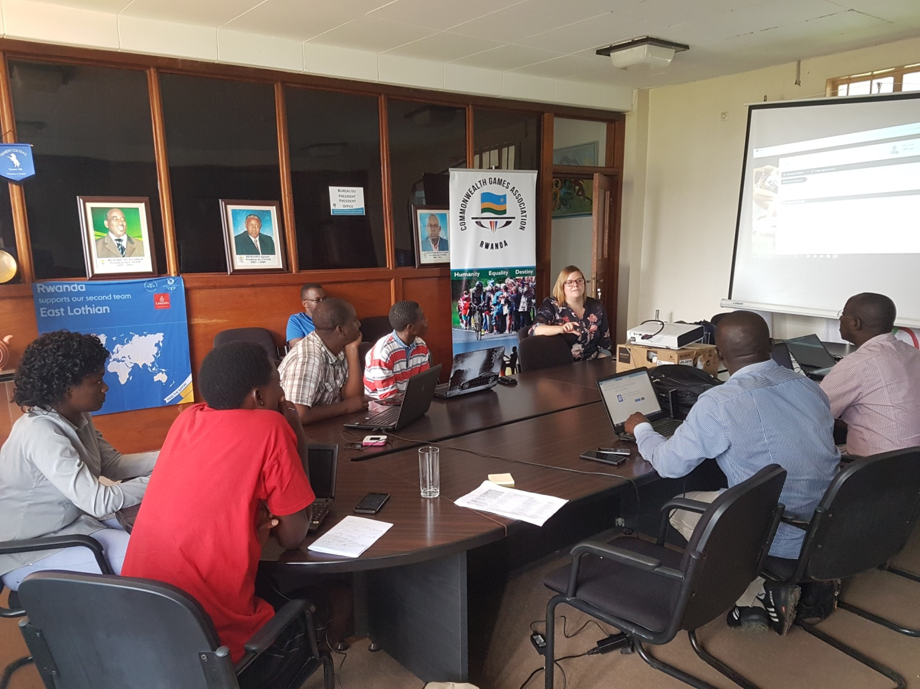
KWIBUKA 22 & KWIBUKA ABASPORTIFS BISHWE MURI JENOSIDE:GUTAHA INZU Y’IMFUBYI
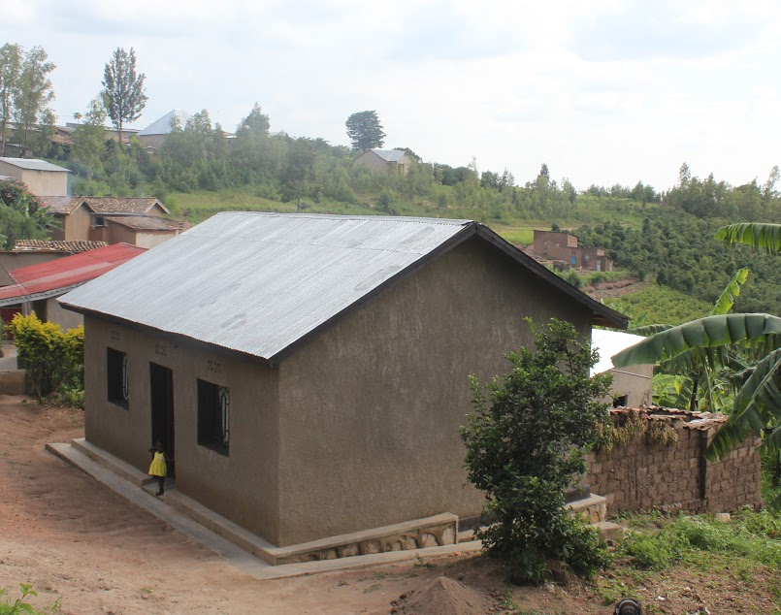
Inzu y’abana b’imfubyi za jenoside bo mu karere ka Kamonyi yasanwe ku bufatanye bwa MINISPOC, CNOSR,n’amashyirahamwe y’imikino, kuwa 15.12.2016 yaratashywe.
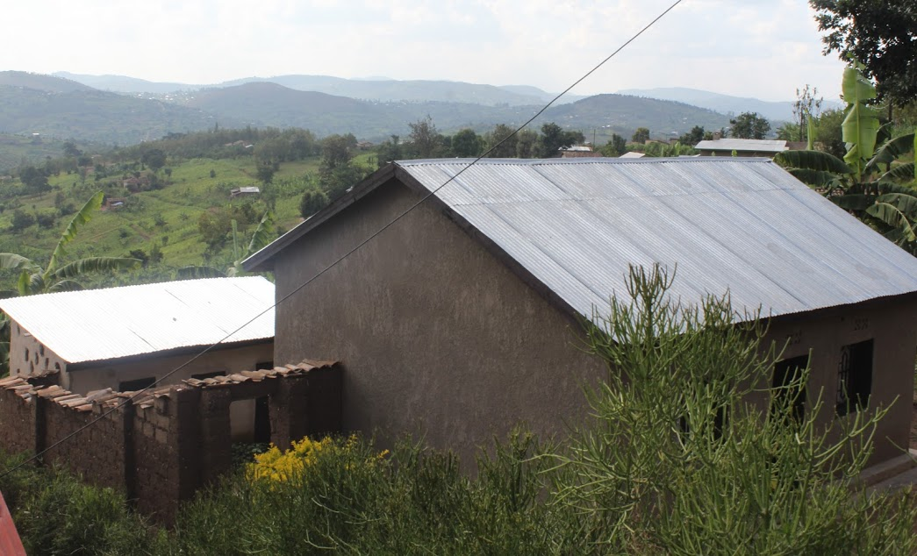
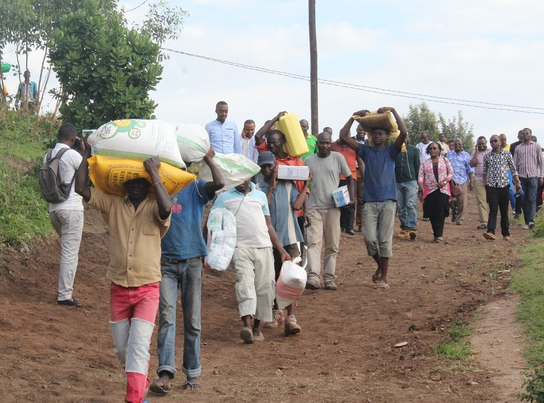
Bashyikirijwe n’inkunga y’aamafaranga 500.000 bagenewe na SEMIGABO Eugène (Perezida wa FRTT) yo kubafasha gutangiza umushinga, hamwe n’igare ryatanzwe na FERWACY ryo kwifashisha mu mirimo yabo ya buri munsi.

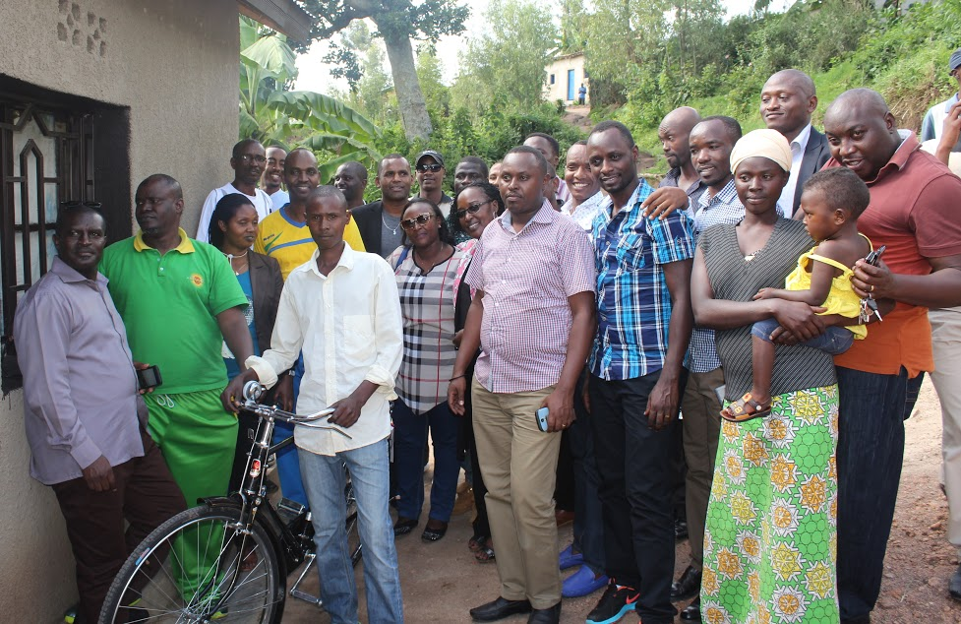
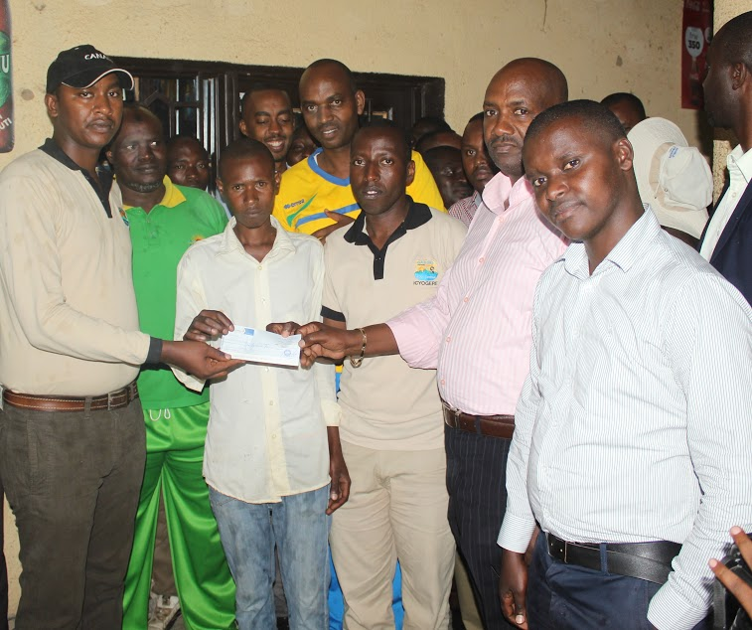
CNOSR : CHILDREN SPORTS DAY 2016
Kuwa 21.12.2016
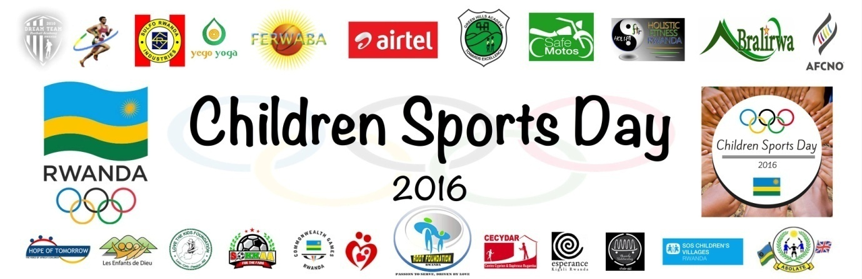
Habaye imikino n’imyidagaduro yo gufasha abana bahoze mu mihanda n’abatagira kivurira kwizihihiza iminsi mikuru isoza umwaka wa 2016
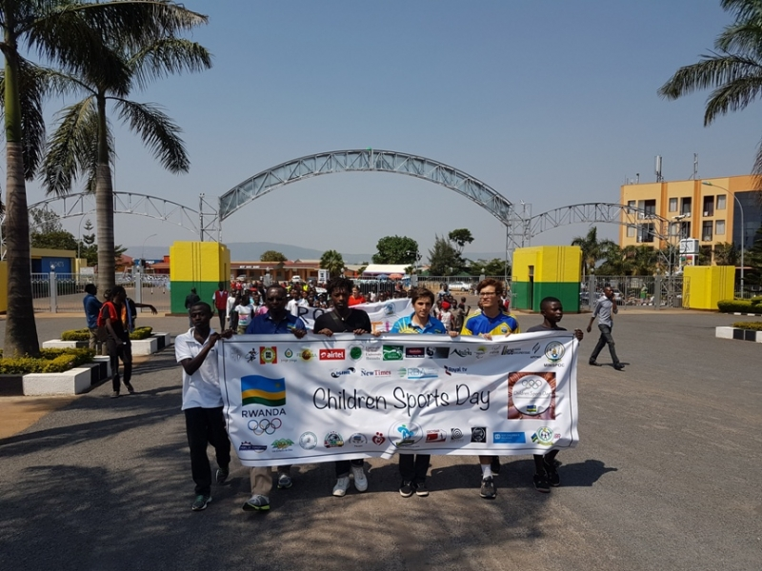
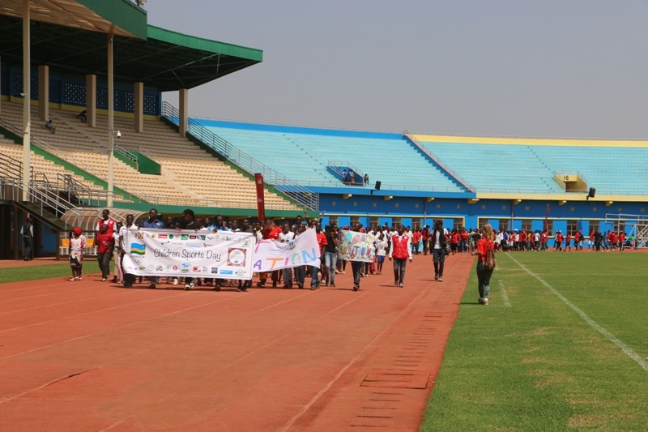
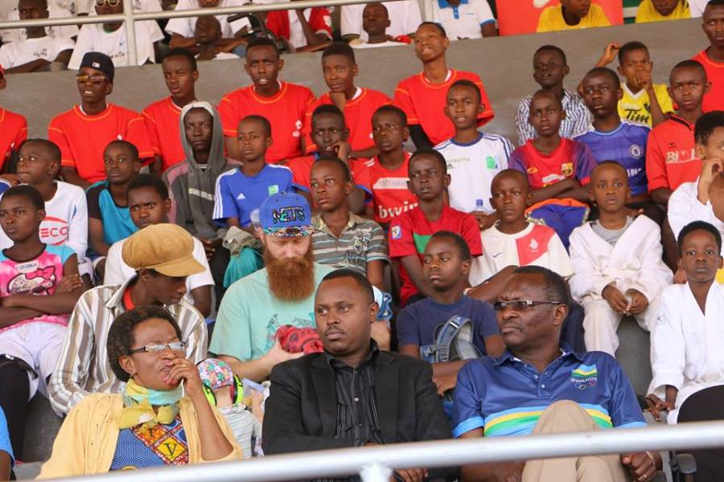
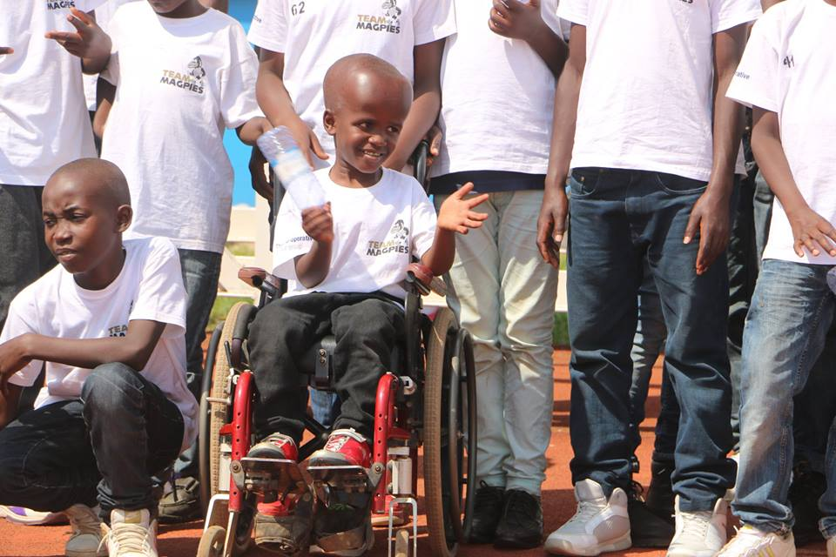
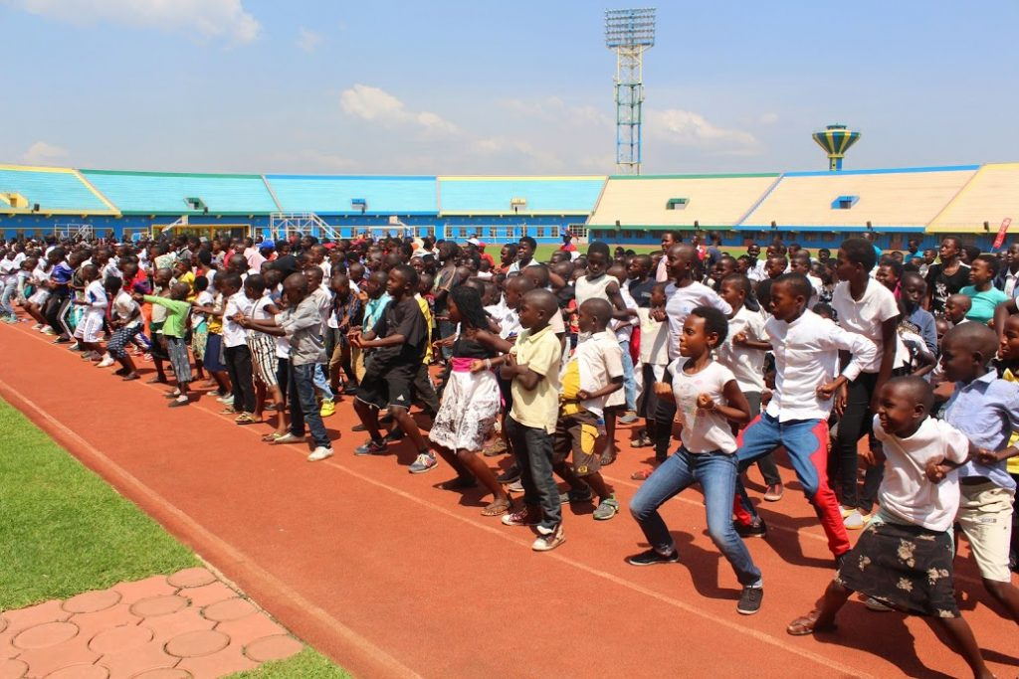
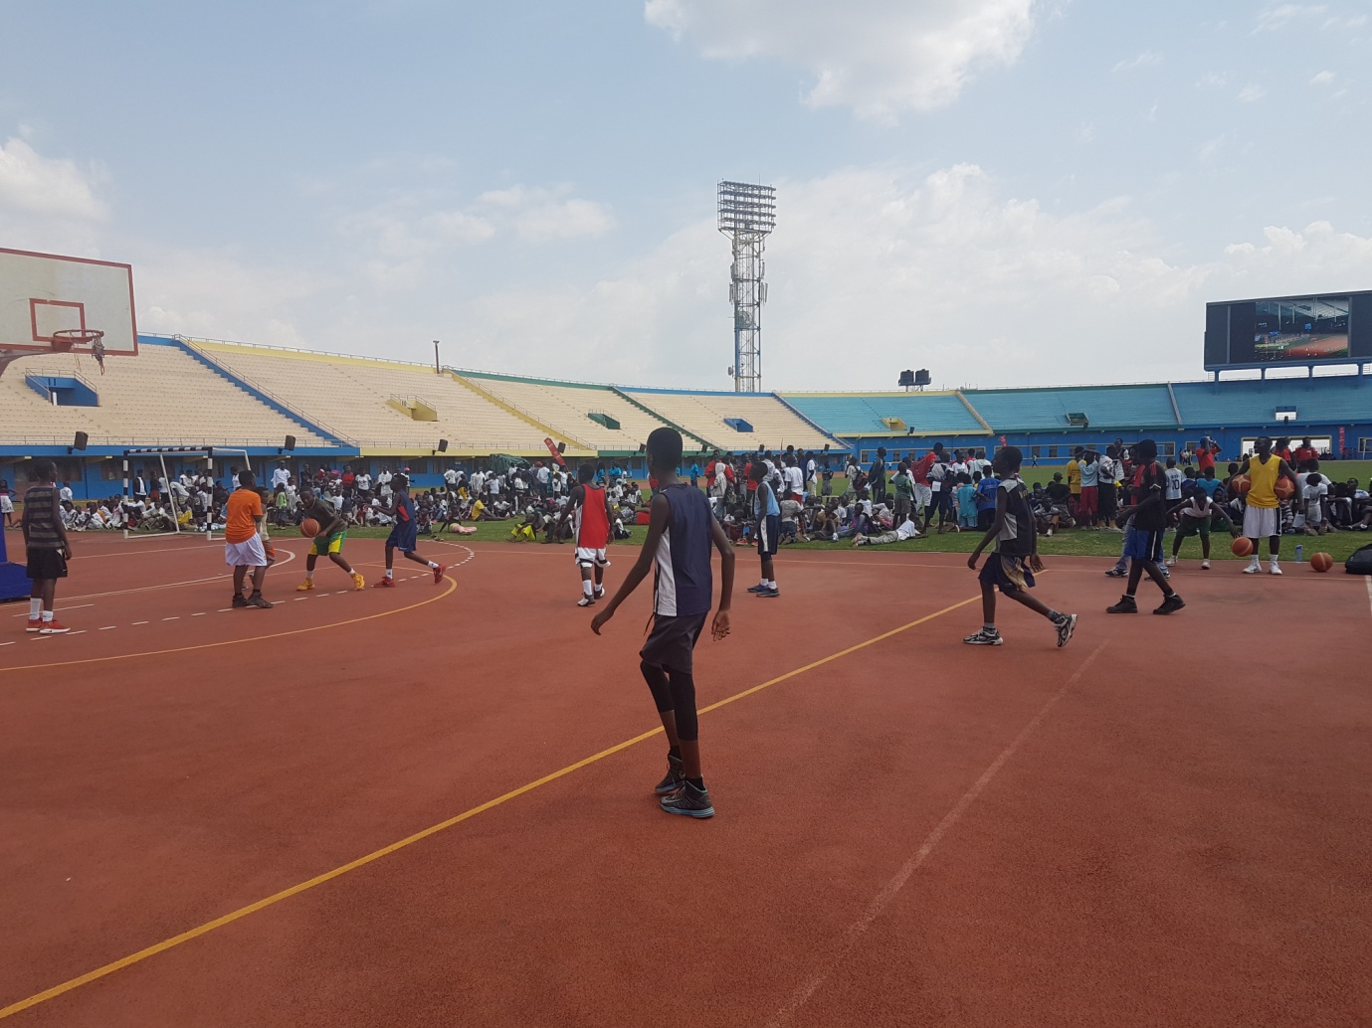
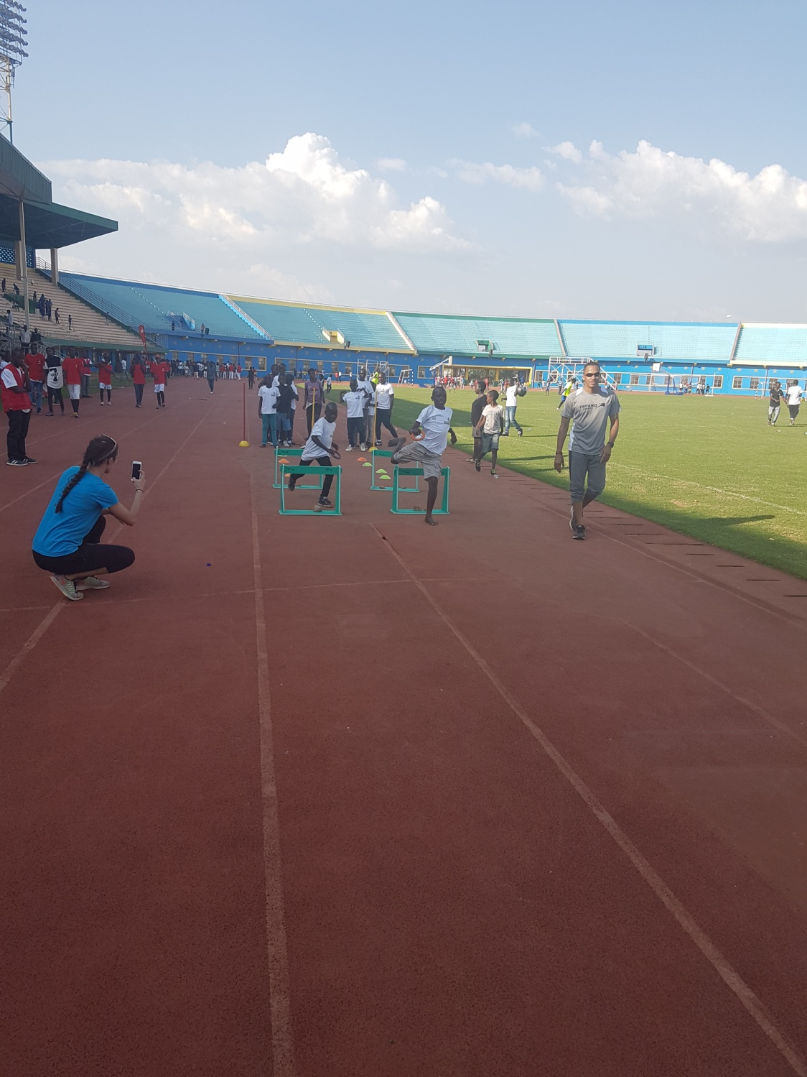

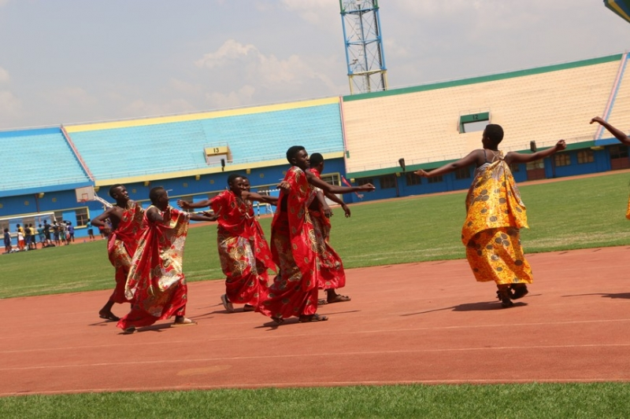
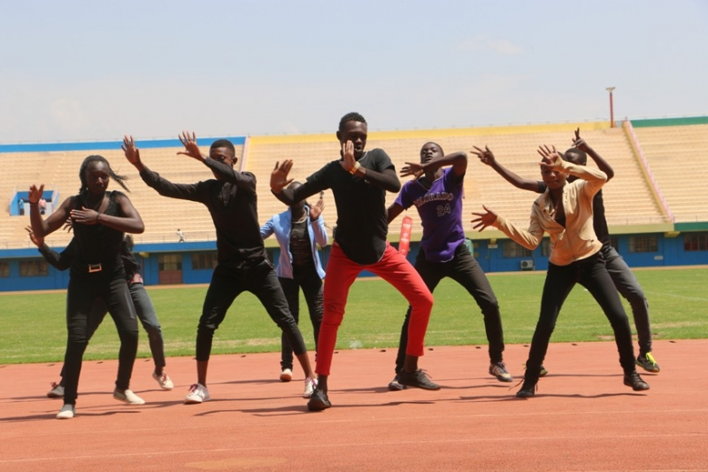
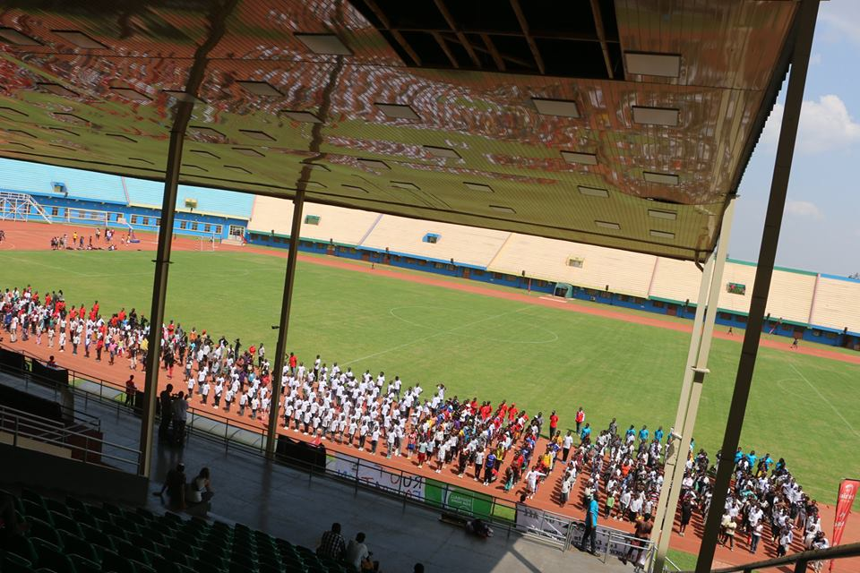

HANDBALL: U20 IHF CHALLENGE TROPHY
KAMPALA – UGANDA / kuwa 17 – 21.12.2016
Irushanwa mpuzamahanga ryahuje amakipe 6 y’abahungu: UGANDA, KENYA, BURUNDI, RWANDA, SOUDAN DU SUD, TANZANIE
Kuwa gatatu 21.12.2016
UMUKINO WA NYUMA
RWANDA 38 – 32 UGANDA
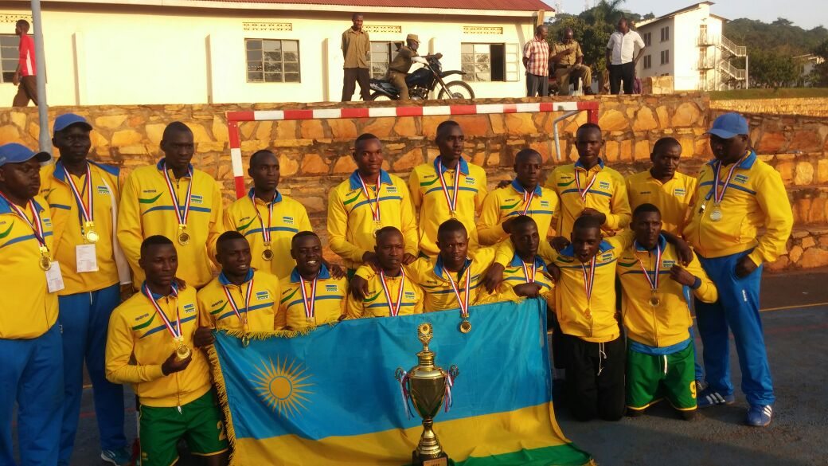
Ikipe y’u Rwanda yatsindiye kuzakina irushanwa ry’igikombe cy’Afrika U20 rizabera muri Gabon mu kwezi kwa 3.2017

